**Assignment Q & A**

**Question1:** Which are the top three variables in your model which contribute most towards the probability of a lead getting converted?

**Answer :** The top three variables in the model which contribute most toward higher lead conversion can be seen from the below image.

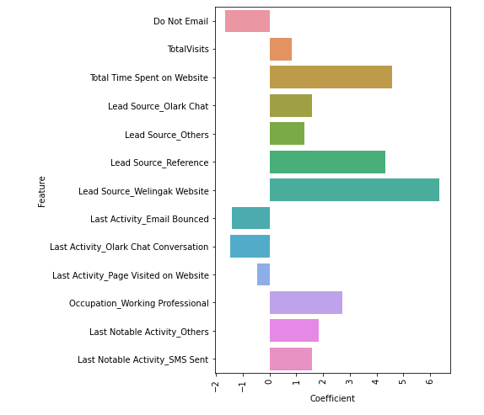

1. **Lead Source:** Lead source by Reference or promotional activity like Welingak Website Olark Chat and others. Leads obtained though references and their referees will both get benefited by offers, cashbacks, alumni support etc. Sales team should focus on this more.
2. **Total Time Spent on Website:** From this variable, the more time spent by the customer on the website, the higher the probability of lead conversion. Lower the time, lesser the chance of lead conversion. Regular follow up from sales should be there.
3. **What is your current occupation:** In this variable, types of leads (e.g. Unemployed, Students, employed etc.) play a major role. Students and Others are not good leads. More convertible leads are Unemployed and Employees looking for career transition. Sales team can focus more on these two occupation categories.

**Question2:** What are the top 3 categorical/dummy variables in the model which should be focused the most on in order to increase the probability of lead conversion?

**Answer:** These three categorical variables

* Lead Source_Reference
* Lead Source_Olark Chat
* Lead Source_Social Media

From the graph plotted in Question 1, we can observe that these Lead Source categories plays an important role with higher chance of conversion among customers.

**Question3:** X Education has a period of 2 months every year during which they hire some interns. The sales team, in particular, has around 10 interns allotted to them. So, during this phase, they wish to make the lead conversion more aggressive. So, they want almost all of the potential leads (i.e. the customers who have been predicted as 1 by the model) to be converted and hence, want to make phone calls to as much of such people as possible. Suggest a good strategy they should employ at this stage.

**Answer:**

We can achieve this by reducing the threshold value for final prediction, e.g., from 0.34 to 0.2 or less.

This increases Sensitivity, although this may also misclassify some of the non-convertible leads as possible conversions. Since we have additional manpower from the interns, we can make the lead conversion more aggressive by making phone calls to as many potential leads as possible.

**Question4:** Similarly, at times, the company reaches its target for a quarter before the deadline. During this time, the company wants the sales team to focus on some new work as well. So, during this time, the company’s aim is to not make phone calls unless it’s extremely necessary, i.e., they want to minimize the rate of useless phone calls. Suggest a strategy they should employ at this stage.

**Answer:**

To reduce the rate of useless phone calls, we need to make sure that calls are only made to those leads who have a very high conversion probability. We can achieve this by increasing the threshold value for final prediction, e.g., from 0.34 to 0.75 or more. This increase specificity and will give us only those leads with very high chances of conversion.