Dr. D. Y. Patil Pratishthan’s

**D. Y. Patil Institute of Master of Computer Applications and Management**

Sector No.29, Behind Akurdi Railway Station, Pradhikaran, Nigdi, Pune – 411044

(Approved by AICTE, Recognized by DTE, Mah.; Affiliated to SPPU)

### **Name: Aparna Likhitkar Roll No.:36 Div A**

**End-Term Practical Examination**

**Subject: IT41L (Python Programming)**

**Class: MCA – II Div: Sem: IV Date: 1-6-21 Time: 09:30 AM Total Marks: 50**

**Q1) Write Python Program to Count the Frequency of Words Appearing in a String Using a Dictionary [10]**

**my_string = input("Enter the string :")**

**my_list=[]**

**my_list=my_string.split()**

**word_freq=[my_list.count(p) for p in my_list]**

**print("The frequency of words is ...")**

**print(dict(zip(my_list,word_freq)))**

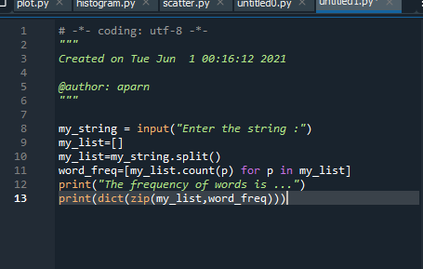

**Output :-**

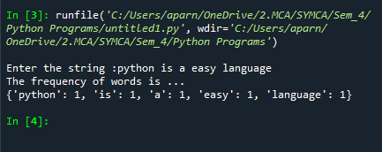

**Q2) [15]**

**Write a NumPy program to check two random arrays are equal or not. Sample Output:  
First array:  
[1 0 1 0 1 1]  
Second array:  
[0 0 1 1 1 0]  
Test above two arrays are equal or not!  
False**

**import numpy as np**

**x = np.random.randint(0,2,6)**

**print("First array:")**

**print(x)**

**y = np.random.randint(0,2,6)**

**print("Second array:")**

**print(y)**

**print("Test above two arrays are equal or not!")**

**array_equal = np.allclose(x, y)**

**print(array_equal)**

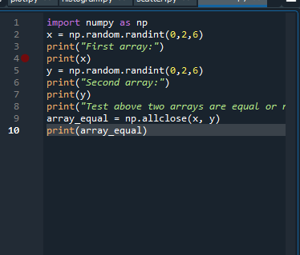

**Ouput :-**

