DS 6040 Bayesian Machine Learning

Prof. Donald E. Brown

December 12th, 2021

Hannah Schmuckler (mmc4cv), Karolina Naranjo-Velasco (kn3cs) , Aparna Marathe (am7ad), Beza Delelegn (bmd5bc)

Readme

File Name: Master_File_FINAL.ipynb

Open with Google Colab.

Dependencies:

Numpy

Pandas

Pymc3

Arviz

Matplotlib.pyplot

Seaborn

Pickle

Sklearn.model_selection

To access data & trace files in pickle format:

Go to this link while logged in to your UVA email:

<https://drive.google.com/drive/folders/1xvfoBilTrcl6mZJQHGT1Ft5EFn__14sL?usp=sharing>

Once there, click on the folder name and click Add shortcut to Drive. 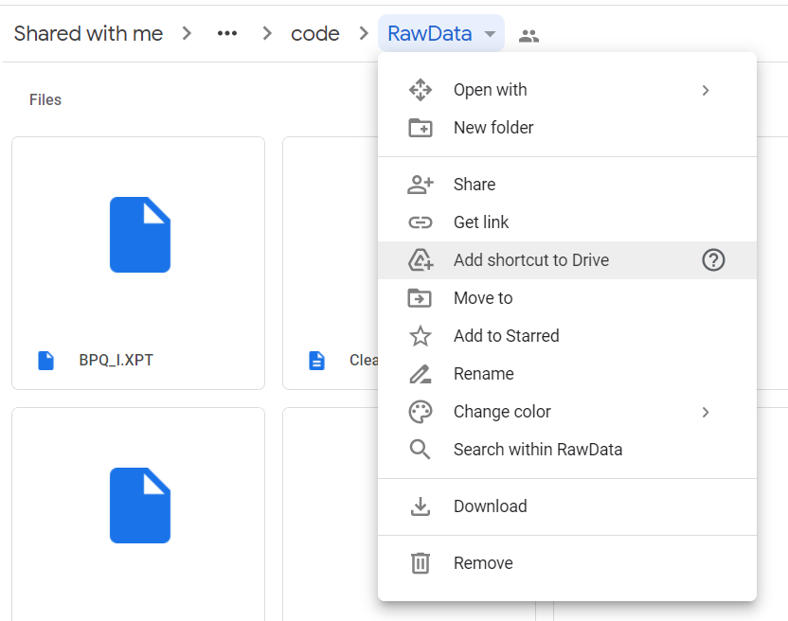

Once you have done that, you should be able to access the files to run this code by running these lines of code (which are in the file):

from google.colab import drive

drive.mount('/content/gdrive')

%cd /content/gdrive/MyDrive/6040 Final Project/deliverables/code/RawData

Alternatively, all files may be downloaded from <https://github.com/hschmuckler/BayesFinalProject>.

Pickle is a way of saving large python objects and retrieving them later. Our file has been built with many pymc3 traces that take a long time to run, the code to run them is commented out by default. Once your working directory is set as above, the code should automatically load the traces and run smoothly. If this does not work, uncomment the trace to run it manually, and comment out the save and load pickle functions.