Selection set2

1.

#include<stdio.h>

int main()

{

float bmi;

printf("Enter the bmi value: ");

scanf("%f",&bmi);

if (bmi<=18.5)

printf("\nUnderweight");

else if (bmi<=24.9)

printf("\nNormal");

else if (bmi<=29.9)

printf("\nOverweight");

else

printf("\nObese");

return 0;

}

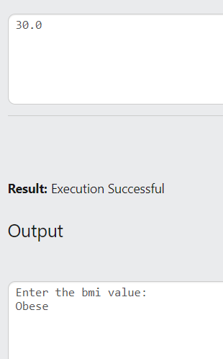

Switch Case I

1)

#include<stdio.h>

int main()

{

int ch;

float r,a;

printf("1. Area of Circle\n2. Area of square\n3.Area of sphere\n");

printf("Enter your choice: ");

scanf("%d",&ch);

switch (ch)

{

case 1:

{

printf("\nEnter the radius: ");

scanf("%f",&r);

a=3.14\*r\*r;

break;

}

case 2:

{

printf("\nEnter side value: ");

scanf("%f",&r);

a=r\*r;

break;

}

case 3:

{

printf("\nEnter the radius: ");

scanf("%f",&r);

a=4\*3.14\*r\*r;

break;

}

default:

printf("\nInvalid choice");

break;

}

printf("\nArea = %.3f",a);

return 0;

}

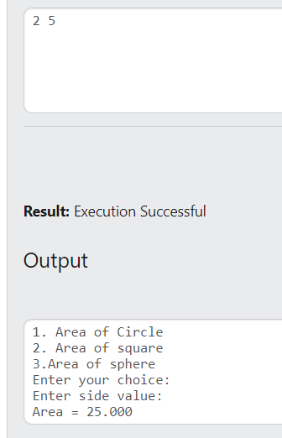

2)

#include<stdio.h>

int main()

{

char a;

printf("Enter the character: ");

scanf("%c",&a);

if (a>=97&&a<=122||a>=65&&a<=90)

{

switch (a)

{

case 'a':

case 'e':

case 'i':

case 'o':

case 'u':

case 'A':

case 'E':

case 'I':

case 'O':

case 'U':

{

printf("\n%c is a vowel",a);

break;

}

default:

{

printf("\n%c is a consonant",a);

break;

}

}

}

else

{

printf("%c is not a alphabet");

}

return 0;

}

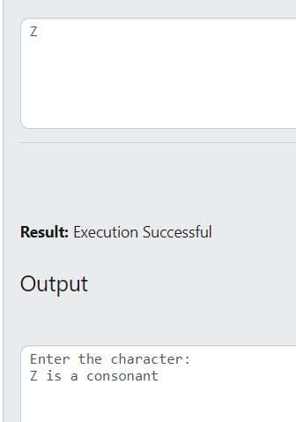

3)

#include<stdio.h>

int main()

{

int a,b;

printf("Enter 1st number: ");

scanf("%d",&a);

printf("\nEnter 2nd number: ");

scanf("%d",&b);

switch (a>b)

{

case 1:

{

printf("\n%d is larger ",a);

break;

}

case 0:

{

switch (a<b)

{

case 1:

{

printf("\n%d is larger ",b);

break;

}

case 0:

{

printf("\n%d and %d are equal ",a,b);

break;

}

}

}

}

return 0;

}

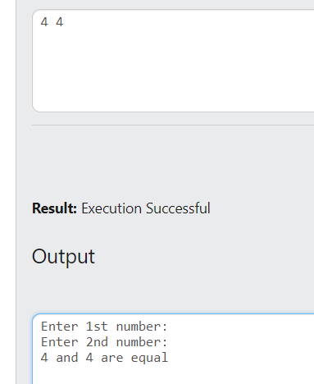

4)

#include<stdio.h>

int main()

{

int a;

printf("Enter a number: ");

scanf("%d",&a);

switch (a>0)

{

case 1:

{

printf("\n%d is a positive integer ",a);

break;

}

case 0:

{

switch (a<0)

{

case 1:

{

printf("\n%d is a negative integer ",a);

break;

}

case 0:

{

printf("\n%d is equal to zero ",a);

break;

}

}

}

}

return 0;

}

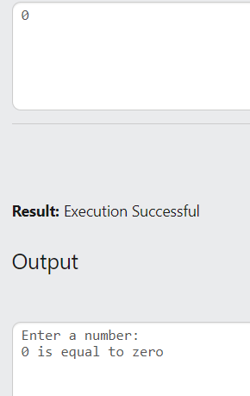

6)

#include<stdio.h>

int main()

{

char ch;

int q;

float p;

printf("B= Burger F= French Fries P= Pizza S= Sandwiches");

printf("\nEnter your choice:");

scanf("%c",&ch);

printf("\nEnter the quantity: ");

scanf("%d",&q);

switch (ch)

{

case 'B':

{

p=200\*q;

printf("\nTotal price= %.2f",p);

break;

}

case 'F':

{

p=50\*q;

printf("\nTotal price= %.2f",p);

break;

}

case 'P':

{

p=500\*q;

printf("\nTotal price= %.2f",p);

break;

}

case 'S':

{

p=150\*q;

printf("\nTotal price= %.2f",p);

break;

}

default:

printf("\nInvalid Choice");

}

return 0;

}

