Array Set 3

1.

#include<stdio.h>

int main()

{

int n,i,j,x;

printf("Enter the number of elements");

scanf("%d",&n);

int a[n];

printf("\nEnter the sum value: ");

scanf("%d",&x);

printf("\nEnter the elements");

for (i=0;i<n;i++)

scanf("%d",&a[i]);

for (i=0;i<n;i++)

{

for (j=i;j<n;j++)

{

if (a[i]+a[j]==x)

printf("\n%d,%d",a[i],a[j]);

}

}

return 0;

}

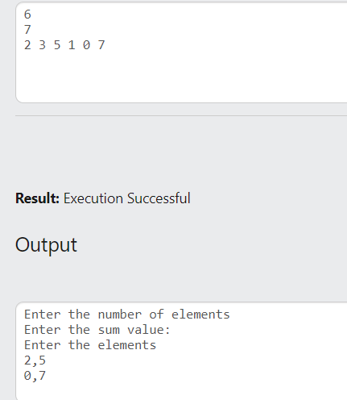

2.

#include<stdio.h>

int main()

{

int n,i,j,min;

printf("Enter the number of elements");

scanf("%d",&n);

int a[n];

printf("\nEnter the elements");

for (i=0;i<n;i++)

scanf("%d",&a[i]);

if (a[0]>a[1])

min=a[0]-a[1];

else

min=a[1]-a[0];

for (i=1;i<n;i++)

{

for (j=0;j<n;j++)

{

if (a[i]>=a[j])

{

if(min>a[i]-a[j]&&i!=j)

min=a[i]-a[j];

}

else

{

if(min>a[j]-a[i]&&i!=j)

min=a[j]-a[i];

}

}

}

printf("\n%d",min);

return 0;

}

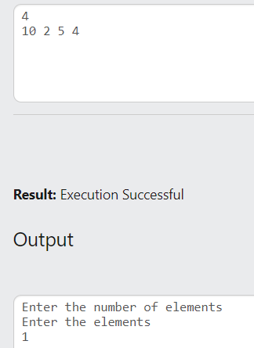

3.

#include<stdio.h>

int main()

{

int n,i,j,x,c=0;

printf("Enter the number of elements");

scanf("%d",&n);

int a[n];

printf("\nEnter the elements");

for (i=0;i<n;i++)

scanf("%d",&a[i]);

printf("\nEnter the difference:");

scanf("%d",&x);

for (i=0;i<n;i++)

{

for (j=i+1;j<n;j++)

{

if (a[i]>=a[j])

{

if(a[i]-a[j]==x)

c++;

}

else

{

if(a[j]-a[i]==x)

c++;

}

}

}

printf("\nCount=%d",c);

return 0;

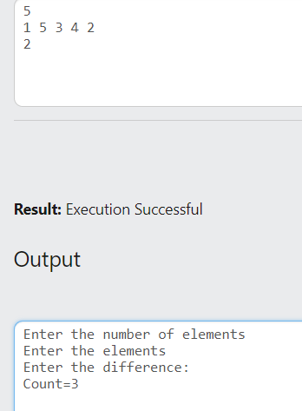}

4.

#include<stdio.h>

int main()

{

int n,i,j,t;

printf("Enter the number of elements");

scanf("%d",&n);

int a[n];

int b[n];

printf("\nEnter the elements");

for (i=0;i<n;i++)

{

scanf("%d",&a[i]);

b[i]=a[i];

}

t=a[0];

for (i=0;i<n;i++)

{

a[i]=a[i+1];\

}

a[n-1]=t;

printf("\nRotate to Right:\n");

for (i=0;i<n;i++)

printf("%d ",a[i]);

t=b[n-1];

for (i=n-1;i>=1;i--)

b[i]=b[i-1];

b[0]=t;

printf("\nRotate to Left:\n");

for (i=0;i<n;i++)

printf("%d ",b[i]);

return 0;

}

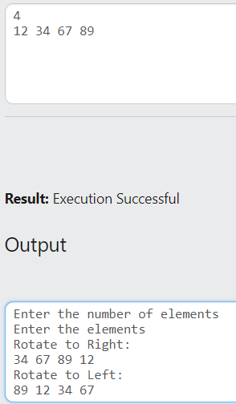

5.

#include<stdio.h>

int main()

{

int n,i,j,sum,s,flag=0,b,e;

printf("Enter the number of elements");

scanf("%d",&n);

int a[n];

printf("\nEnter the elements");

for (i=0;i<n;i++)

scanf("%d",&a[i]);

printf("\nEnter the sum of subarray");

scanf("%d",&s);

for (i=0;i<n;i++)

{

sum=0;

b=i;

for (j=i;j<n;j++)

{

sum=sum+a[j];

if (sum==s)

{

flag=1;

e=j;

break;

}

}

if (flag==1)

{

printf("\nSum found between indexes %d and %d",b,e);

break;

}

}

return 0;

}

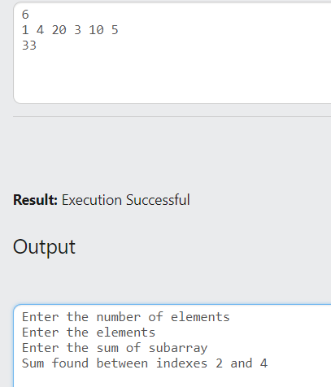

6.

#include<stdio.h>

int main()

{

int n,i,j,flag=0;

printf("Enter the number of elements");

scanf("%d",&n);

int a[n];

int b[n];

printf("\nEnter the elements");

for (i=0;i<n;i++)

scanf("%d",&a[i]);

for (i=0;i<n;i++)

{

flag=0;

for (j=0;j<n;j++)

{

if (i==a[j])

flag=1;

}

if (flag==1)

b[i]=i;

else

b[i]=-1;

}

printf("\n");

for (i=0;i<n;i++)

printf("%d ",b[i]);

return 0;

}

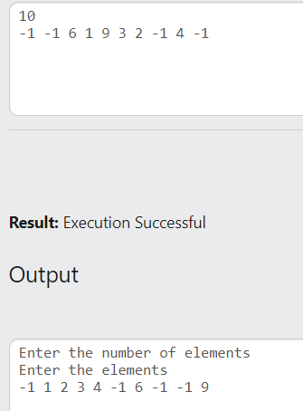

7.

#include<stdio.h>

int main()

{

int n,m,i,j,flag=0;

scanf("%d",&n);

int a[n];

scanf("%d",&m);

for (i=0;i<n;i++)

scanf("%d",&a[i]);

for (i=0;i<m;i++)

{

flag=0;

for (j=0;j<n;j++)

{

if (i==a[j])

flag=1;

}

if (flag==0)

{

printf("%d",i);

break;

}

}

return 0;

}

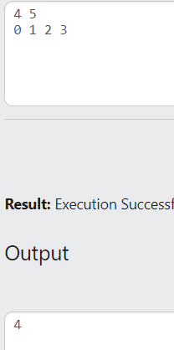

8.

#include<stdio.h>

int main()

{

int n,i,j,sum1,sum2,flag=0;

scanf("%d",&n);

int a[n];

for (i=0;i<n;i++)

scanf("%d",&a[i]);

for (i=0;i<n;i++)

{

sum1=sum2=0;

for (j=i-1;j>=0;j--)

{

sum1+=a[j];

}

for (j=i+1;j<n;j++)

{

sum2+=a[j];

}

if (sum1==sum2)

{

printf("%d",i);

flag=1;

break;

}

}

if (flag==0)

printf("-1");

return 0;

}

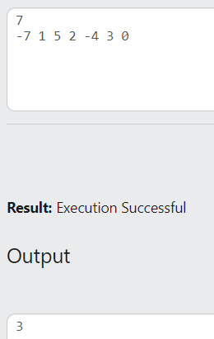

9.

#include<stdio.h>

int main()

{

int n,i,j,t;

scanf("%d",&n);

int a[n];

for (i=0;i<n;i++)

scanf("%d",&a[i]);

for (i=1;i<n;i++)

{

if (i%2!=0)

{

if (a[i]<a[i-1])

{

t=a[i];

a[i]=a[i-1];

a[i-1]=t;

}

if (a[i]<a[i+1])

{

t=a[i];

a[i]=a[i+1];

a[i+1]=t;

}

}

}

for (i=0;i<n;i++)

printf("%d ",a[i]);

return 0;

}

