1 D Array

1.

#include<stdio.h>

int main()

{

int n,i,c=0;

printf("Enter the number of elements");

scanf("%d",&n);

int a[n];

printf("\nEnter the elements");

for (i=0;i<n;i++)

scanf("%d",&a[i]);

for (i=0;i<n;i++)

if (a[i]<0)

c++;

printf("\nTotal number of negative elements=%d",c);

return 0;

}

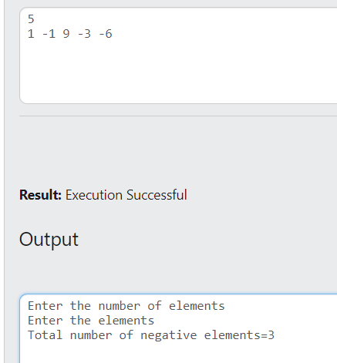

2.

#include<stdio.h>

int main()

{

int n,i,min=0,max=0;

printf("Enter the number of elements");

scanf("%d",&n);

int a[n];

printf("\nEnter the elements");

for (i=0;i<n;i++)

scanf("%d",&a[i]);

for (i=0;i<n;i++)

{

if (a[i]<a[min])

min=i;

if (a[i]>a[max])

max=i;

}

printf("\nMaximum element=%d",a[max]);

printf("\nMinimum element=%d",a[min]);

return 0;

}

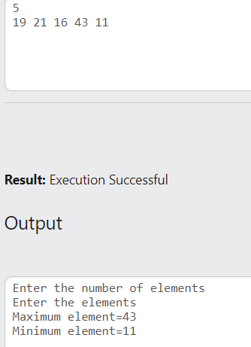

3.

#include<stdio.h>

int main()

{

int n,i,e,p;

printf("Enter the number of elements");

scanf("%d",&n);

int a[n+1];

printf("\nEnter the elements");

for (i=0;i<n;i++)

scanf("%d",&a[i]);

printf("\nEnter the element to be inserted:");

scanf("%d",&e);

printf("\nEnter the position of element to be inserted:");

scanf("%d",&p);

for (i=n;i>=p;i--)

{

a[i]=a[i-1];

}

a[p-1]=e;

printf("\nNew array:");

for (i=0;i<=n;i++)

printf("%d ",a[i]);

return 0;

}

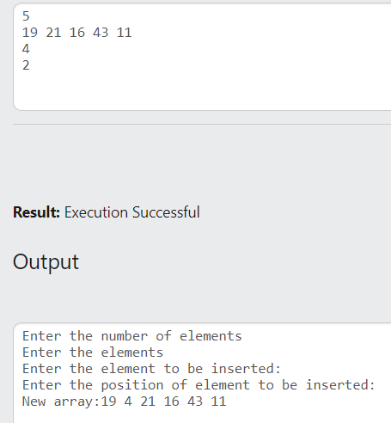

4.

#include<stdio.h>

int main()

{

int n,i,p;

printf("Enter the number of elements");

scanf("%d",&n);

int a[n];

printf("\nEnter the elements");

for (i=0;i<n;i++)

scanf("%d",&a[i]);

printf("\nEnter the position of element to be deleted:");

scanf("%d",&p);

for (i=p-1;i<n;i++)

{

a[i]=a[i+1];

}

printf("\nNew array:");

for (i=0;i<n-1;i++)

printf("%d ",a[i]);

return 0;

}

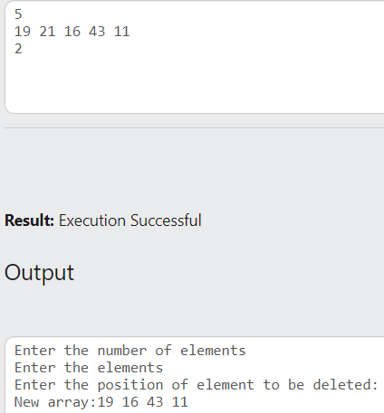

5.

#include<stdio.h>

int main()

{

int n,i,e;

printf("Enter the number of elements");

scanf("%d",&n);

int a[n];

printf("\nEnter the elements");

for (i=0;i<n;i++)

scanf("%d",&a[i]);

printf("\nEnter the element to search:");

scanf("%d",&e);

for (i=0;i<n;i++)

{

if (a[i]==e)

{

printf("\n%d found at position %d",e,i+1);

break;

}

}

if (i==n)

printf("\nElement not found!");

return 0;

}

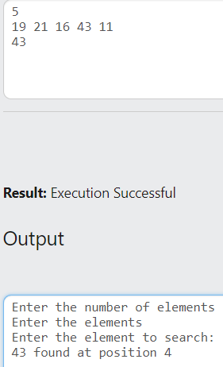

6.

#include<stdio.h>

int main()

{

int n,i,e,mid,f,l,flag=0;

printf("Enter the number of elements");

scanf("%d",&n);

int a[n];

printf("\nEnter the elements");

for (i=0;i<n;i++)

scanf("%d",&a[i]);

printf("\nEnter the element to search:");

scanf("%d",&e);

f=0;

l=n-1;

while (flag==0&&f<=l)

{

mid=(f+l)/2;

if (e<a[mid])

l=mid-1;

else if (e>a[mid])

f=mid+1;

else

{

printf("\n%d found at position %d",e,mid+1);

flag=1;

}

}

if (flag==0)

printf("\n%d not found",e);

return 0;

}

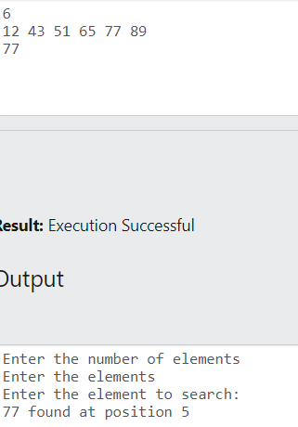

7.

#include<stdio.h>

int main()

{

int n,i,j,c;

printf("Enter the number of elements");

scanf("%d",&n);

int a[n];

printf("\nEnter the elements");

for (i=0;i<n;i++)

scanf("%d",&a[i]);

for (i=0;i<n;i++)

{

c=1;

for (j=i+1;j<n;j++)

{

if (a[j]!=-1)

{

if (a[j]==a[i])

{c++;

a[j]=-1;

}

}

}

if (a[i]!=-1)

printf("\nFrequency of %d = %d",a[i],c);

}

return 0;

}

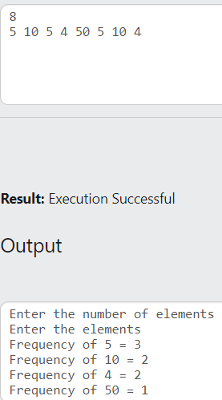

8.

#include<stdio.h>

int main()

{

int n,i,j,c;

printf("Enter the number of elements");

scanf("%d",&n);

int a[n];

printf("\nEnter the elements");

for (i=0;i<n;i++)

scanf("%d",&a[i]);

printf("\nAll unique elements in the array are: ");

for (i=0;i<n;i++)

{

c=1;

for (j=i+1;j<n;j++)

{

if (a[j]!=-1)

{

if (a[j]==a[i])

{c++;

a[j]=-1;

}

}

}

if (a[i]!=-1)

{if (c==1)

printf("%d ",a[i]);

}

}

return 0;

}

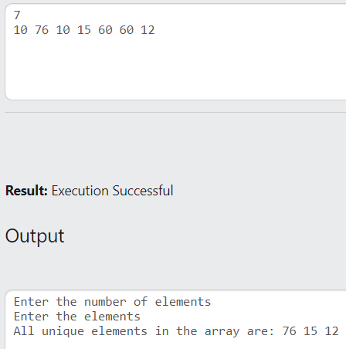

9.

#include<stdio.h>

int main()

{

int n,i,max=0;

printf("Enter the number of elements");

scanf("%d",&n);

int a[n];

printf("\nEnter the elements");

for (i=0;i<n;i++)

scanf("%d",&a[i]);

for (i=0;i<n;i++)

{

if (a[i]>a[max])

max=i;

}

a[max]=-1;

max=0;

for (i=0;i<n;i++)

{

if (a[i]>a[max])

max=i;

}

printf("\nSecond maximum element=%d",a[max]);

return 0;

}

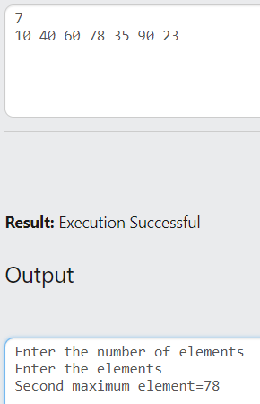

10.

#include<stdio.h>

int main()

{

int n,i,j,t;

printf("Enter the number of elements");

scanf("%d",&n);

int a[n];

printf("\nEnter the elements");

for (i=0;i<n;i++)

scanf("%d",&a[i]);

for (i=0;i<=n-2;i++)

{

for (j=0;j<=n-i-2;j++)

{

if (a[j]>a[j+1])

{

t=a[j];

a[j]=a[j+1];

a[j+1]=t;

}

}

}

printf("\nArray after sorting: ");

for (i=0;i<n;i++)

printf("%d ",a[i]);

return 0;

}

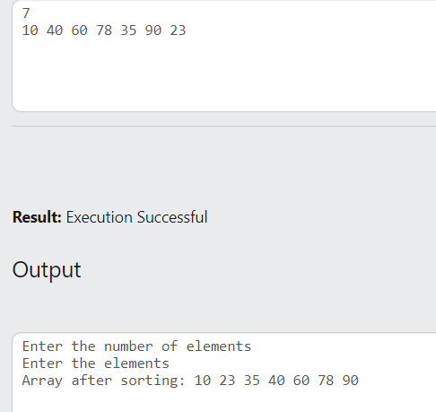

11.

#include<stdio.h>

int main()

{

int n,i,j,t,min;

printf("Enter the number of elements");

scanf("%d",&n);

int a[n];

printf("\nEnter the elements");

for (i=0;i<n;i++)

scanf("%d",&a[i]);

for (i=0;i<=n-1;i++)

{

min=i;

for (j=i+1;j<=n-1;j++)

{

if (a[min]>a[j])

{

min=j;

}

}

if (min!=i)

{

t=a[min];

a[min]=a[i];

a[i]=t;

}

}

printf("\nArray after sorting: ");

for (i=0;i<n;i++)

printf("%d ",a[i]);

return 0;

}

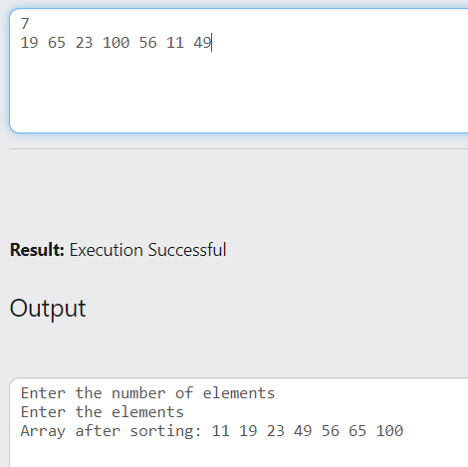

#include<stdio.h>

int main()

{

int i=0,j=0,k=0,n1,n2,n3;

scanf("%d%d%d",&n1,&n2,&n3);

int a[n1],b[n2],c[n3];

for (i=0;i<n1;i++)

scanf("%d",&a[i]);

for (i=0;i<n2;i++)

scanf("%d",&b[i]);

for (i=0;i<n3;i++)

scanf("%d",&c[i]);

i=0;

while (i<n1&&j<n2&&k<n3)

{

if (a[i]==b[j]&&b[j]==c[k])

{

printf("%d ",a[i]);

i++;

j++;

k++;

}

else if (a[i]<b[j])

i++;

else if(b[j]<c[k])

j++;

else

k++;

}

}