1D ARRAY SET 2

1.

#include<stdio.h>

int main()

{

int n,i,j,c=0,t;

printf("Enter the number of elements");

scanf("%d",&n);

int a[n];

printf("\nEnter the elements");

for (i=0;i<n;i++)

scanf("%d",&a[i]);

for (i=0;i<=n-2;i++)

{

for (j=0;j<=n-i-2;j++)

{

if (a[j]==0)

{

a[j]=a[j+1];

a[j+1]=0;

}

}

}

printf("\n");

for (i=0;i<n;i++)

printf("%d ",a[i]);

return 0;

}

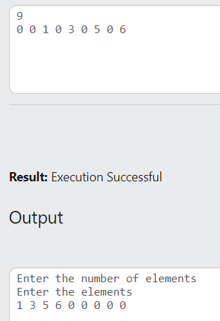

2.

#include<stdio.h>

int main()

{

int n,i,j,sum=0,r;

printf("Enter the number of elements");

scanf("%d",&n);

int a[n];

printf("\nEnter the elements");

for (i=0;i<n;i++)

scanf("%d",&a[i]);

for (i=0;i<n;i++)

{

for (j=0;j<n;j++)

{

r=a[i]%a[j];

sum+=r;

}

}

printf("\nSum = %d",sum);

return 0;

}

