**2D array set 1**

2.

#include<stdio.h>

int main()

{

int m,n,i,j,x,y;

printf("Enter the number of row:");

scanf("%d",&m);

printf("\nEnter the number of column:");

scanf("%d",&n);

int a[m][n];

printf("\nEnter the elements");

for (i=0;i<m;i++)

{

for (j=0;j<n;j++)

scanf("%d",&a[i][j]);

}

printf("\nEnter the row number");

scanf("%d",&x);

printf("\n");

for (i=0;i<n;i++)

printf("%d ",a[x-1][i]);

printf("\nEnter the column number");

scanf("%d",&y);

printf("\n");

for (i=0;i<m;i++)

printf("%d ",a[i][y-1]);

printf("\n%d",a[x-1][y-1]);

return 0;

}

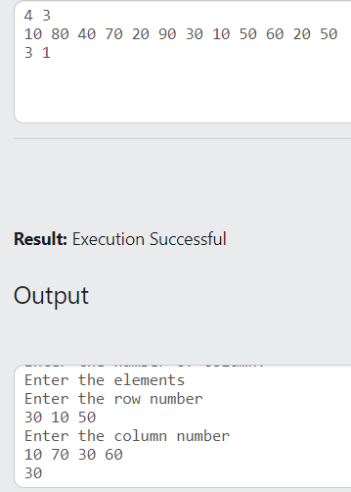

3.

#include<stdio.h>

int main()

{

int m,n,i,j,k;

printf("Enter the number of row:");

scanf("%d",&m);

printf("\nEnter the number of column:");

scanf("%d",&n);

int a[m][n];

int b[m][n];

int sum[m][n];

int sub[m][n];

int mul[m][n];

printf("\nEnter the elements of array 1");

for (i=0;i<m;i++)

{

for (j=0;j<n;j++)

scanf("%d",&a[i][j]);

}

printf("\nEnter the elements of array 2");

for (i=0;i<m;i++)

{

for (j=0;j<n;j++)

scanf("%d",&b[i][j]);

}

printf("\nEnter the scale factor");

scanf("%d",&k);

for (i=0;i<m;i++)

{

for (j=0;j<n;j++)

{

sum[i][j]=a[i][j]+b[i][j];

sub[i][j]=a[i][j]-b[i][j];

mul[i][j]=k*a[i][j];

}

}

printf("\nSum of arrays\n");

for (i=0;i<m;i++)

{

for (j=0;j<n;j++)

printf("%d ",sum[i][j]);

printf("\n");

}

printf("Subtraction of arrays\n");

for (i=0;i<m;i++)

{

for (j=0;j<n;j++)

printf("%d ",sub[i][j]);

printf("\n");

}

printf("Multiplication of arrays\n");

for (i=0;i<m;i++)

{

for (j=0;j<n;j++)

printf("%d ",mul[i][j]);

printf("\n");

}

return 0;

}

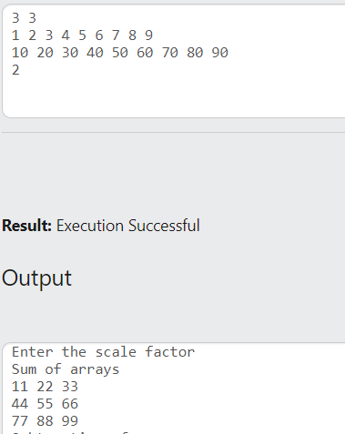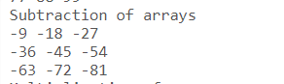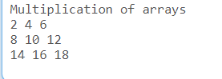

4.

#include<stdio.h>

int main()

{

int m,n,i,j,k;

printf("Enter the number of row");

scanf("%d",&m);

printf("\nEnter the number of column:");

scanf("%d",&n);

int a[m][n],b[n][m];

printf("\nEnter the elements of matrix");

for (i=0;i<m;i++)

{

for (j=0;j<n;j++)

scanf("%d",&a[i][j]);

}

for (i=0;i<m;i++)

{

for (j=0;j<n;j++)

{

b[j][i]=a[i][j];

}

}

printf("\nTranspose of matrix\n");

for (i=0;i<n;i++)

{

for (j=0;j<m;j++)

printf("%d ",b[i][j]);

printf("\n");

}

return 0;

}

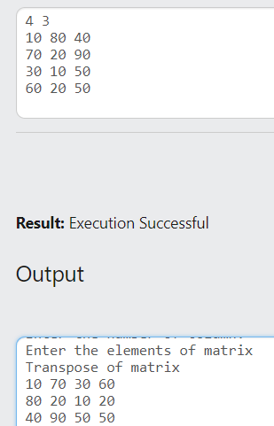

5.

#include<stdio.h>

int main()

{

int m,n,i,j,k;

printf("Enter the order");

scanf("%d",&n);

int a[n][n];

printf("\nEnter the elements of matrix");

for (i=0;i<n;i++)

{

for (j=0;j<n;j++)

scanf("%d",&a[i][j]);

}

printf("\nDiagonal elements are:");

for (i=0;i<n;i++)

{

printf(" %d",a[i][i]);

}

return 0;

}

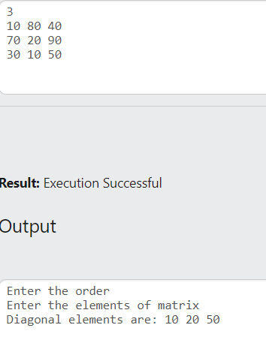

6.

#include<stdio.h>

int main()

{

int m,n,i,j,sum=0;

printf("Enter the order");

scanf("%d",&n);

int a[n][n];

printf("\nEnter the elements of matrix");

for (i=0;i<n;i++)

{

for (j=0;j<n;j++)

scanf("%d",&a[i][j]);

}

for (i=0;i<n;i++)

{

sum+=a[i][i];

}

printf("\nSum of diagonal elements are:%d",sum);

return 0;

}

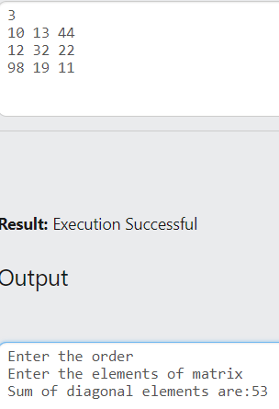

7.

#include<stdio.h>

int main()

{

int m,n,i,j,flag=0;

printf("Enter the order of matrix");

scanf("%d",&n);

int a[n][n],b[n][n];

printf("\nEnter the elements of matrix");

for (i=0;i<n;i++)

{

for (j=0;j<n;j++)

scanf("%d",&a[i][j]);

}

for (i=0;i<n;i++)

{

for (j=0;j<n;j++)

{

b[j][i]=a[i][j];

}

}

for (i=0;i<n;i++)

{

for (j=0;j<n;j++)

{

if (b[i][j]!=a[i][j])

flag=1;

}

if (flag==1)

break;

}

if (flag==0)

printf("\nGiven matrix is a symmetric matrix");

else

printf("\nGiven matrix is not a symmetric matrix");

return 0;

}

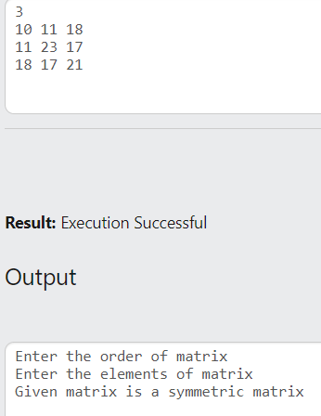

8.

#include<stdio.h>

int main()

{

int m,n,i,j,flag=0;

printf("Enter the order of matrix");

scanf("%d",&n);

int a[n][n],b[n][n];

printf("\nEnter the elements of matrix");

for (i=0;i<n;i++)

{

for (j=0;j<n;j++)

scanf("%d",&a[i][j]);

}

for (i=0;i<n;i++)

{

for (j=0;j<n;j++)

{

b[j][i]=a[i][j];

}

}

for (i=0;i<n;i++)

{

for (j=0;j<n;j++)

{

if (i!=j&&b[i][j]!=-a[i][j])

flag=1;

}

if (flag==1)

break;

}

if (flag==0)

printf("\nGiven matrix is a skew symmetric matrix");

else

printf("\nGiven matrix is not a skew symmetric matrix");

return 0;

}

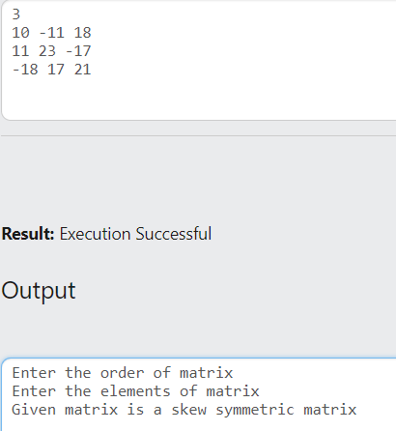

9.

#include<stdio.h>

int main()

{

int m,n,i,j,flag1=0,flag2=0;

printf("Enter the order of matrix");

scanf("%d",&n);

int a[n][n];

printf("\nEnter the elements of matrix");

for (i=0;i<n;i++)

{

for (j=0;j<n;j++)

scanf("%d",&a[i][j]);

}

for (i=0;i<n;i++)

{

for (j=0;j<n;j++)

{

if (i<j&&a[i][j]!=0)

flag1=1;

if (i>=j&&a[i][j]!=0)

flag2=1;

}

if (flag1==1&&flag2==1)

break;

}

if (flag1==0&&flag2==1)

printf("\nGiven matrix is a lower triangular matrix");

else

printf("\nGiven matrix is not a lower triangular matrix");

return 0;

}

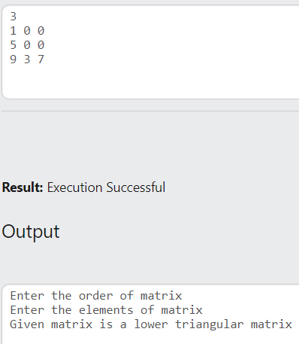

10.

#include<stdio.h>

int main()

{

int m,n,i,j,flag1=0,flag2=0;

printf("Enter the order of matrix");

scanf("%d",&n);

int a[n][n];

printf("\nEnter the elements of matrix");

for (i=0;i<n;i++)

{

for (j=0;j<n;j++)

scanf("%d",&a[i][j]);

}

for (i=0;i<n;i++)

{

for (j=0;j<n;j++)

{

if (i>j&&a[i][j]!=0)

flag1=1;

if (i<=j&&a[i][j]!=0)

flag2=1;

}

if (flag1==1&&flag2==1)

break;

}

if (flag1==0&&flag2==1)

printf("\nGiven matrix is a upper triangular matrix");

else

printf("\nGiven matrix is not a upper triangular matrix");

return 0;

}

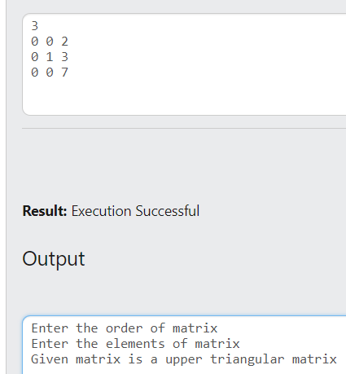

11.

#include<stdio.h>

int main()

{

int m,n,i,j,sr=0,sc=0,sd1=0,sd2=0,sl=0,su=0,s=0;

printf("Enter the order of matrix");

scanf("%d",&n);

int a[n][n];

printf("\nEnter the elements of matrix");

for (i=0;i<n;i++)

{

for (j=0;j<n;j++)

scanf("%d",&a[i][j]);

}

for (i=0;i<n;i++)

{

sr=sc=0;

sd1+=a[i][i];

sd2+=a[i][n-1-i];

for (j=0;j<n;j++)

{

sr+=a[i][j];

sc+=a[j][i];

if (i>j)

su+=a[i][j];

if (i<j)

sl+=a[i][j];

}

printf("\nSum of row %d=%d",i+1,sr);

printf("\nSum of column %d=%d",i+1,sc);

}

printf("\nSum of diagonal 1 = %d",sd1);

printf("\nSum of diagonal 2 = %d",sd2);

printf("\nSum of lower triangle = %d",sl);

printf("\nSum of upper triangle = %d",su);

return 0;

}

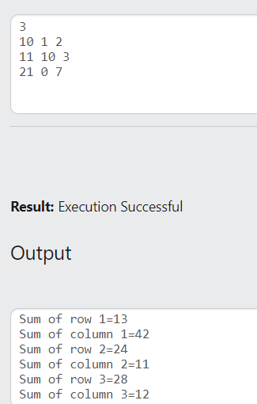

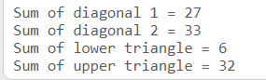

Q:Boolean matrix

#include<stdio.h>

int main()

{

int m,n,i,j,x,y;

scanf("%d%d",&m,&n);

int A[m][n];

for (i=0;i<m;i++)

for(j=0;j<n;j++)

scanf("%d",&A[i][j]);

scanf("%d%d",&x,&y);

if (A[x][y]==1)

{

for (i=0;i<m;i++)

A[i][y]=1;

for (j=0;j<n;j++)

A[x][j]=1;

}

for (i=0;i<m;i++)

{for(j=0;j<n;j++)

printf("%d ",A[i][j]);

printf("\n");}

return 0;

}

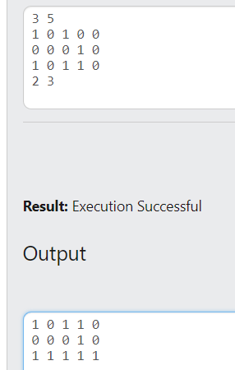

Q:Sum of row and column

#include<stdio.h>

int main()

{

int m,n,i,j,sum=0;

scanf("%d%d",&m,&n);

int A[m][n];

for (i=0;i<m;i++)

for(j=0;j<n;j++)

scanf("%d",&A[i][j]);

for (i=0;i<m;i++)

{

sum=0;

for (j=0;j<n;j++)

{

sum+=A[i][j];

}

printf("Sum of Row%d: %d\n",i+1,sum);

}

for (j=0;j<n;j++)

{

sum=0;

for (i=0;i<m;i++)

{

sum+=A[i][j];

}

printf("Sum of Column%d: %d\n",j+1,sum);

}

return 0;

}