STRING SET-1

1.

#include<stdio.h>

int main()

{

char A[10];

int c=0,i=0;

scanf("%s",A);

/\*while (A[i]!='\0')

{

c++;

i++;

}

printf("%d",c);\*/

for (i=0;A[i]!='\0';i++);

printf("%d",i);

return 0;

}

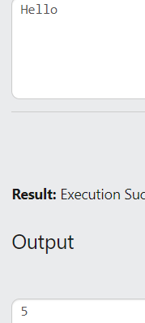

2.

#include<stdio.h>

int main()

{

char A[10];

int i=0;

scanf("%s",A);

while (A[i]!='\0')

{

printf("%c ",A[i]);

i++;

}

return 0;

}

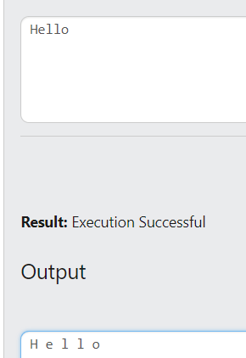

3.

#include<stdio.h>

int main()

{

char A[10];

int i;

scanf("%s",A);

for (i=0;A[i]!='\0';i++);

i=i-1;

while (i>=0)

{

printf("%c ",A[i]);

i--;

}

return 0;

}

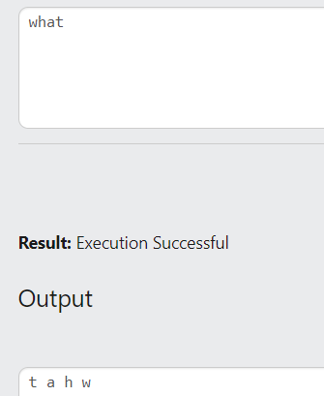

4.

#include<stdio.h>

int main()

{

char A[50],ch;

int i=0,len;

ch=getchar();

while (ch!='\n')

{

A[i]=ch;

ch=getchar();

i++;

}

len=i;

printf("\n");

for (i=0;i<len;i++)

putchar(A[i]);

return 0;

}

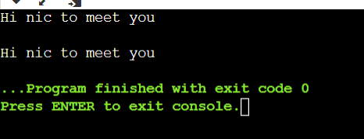

5.

#include<stdio.h>

int main()

{

char A[50];

printf("Enter the name\n");

gets(A);

puts(A);

return 0;

}

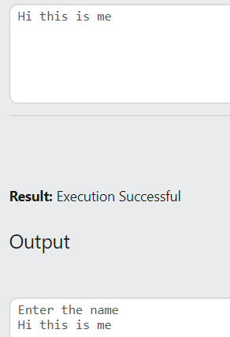

6.

#include<stdio.h>

int main()

{

char A[50];

int i=0,len,c1=0,c2=0;

gets(A);

for (i=0;A[i]!='\0';i++);

len=i;

for (i=0;i<len;i++)

{

if (A[i]>='a'&&A[i]<='z'||A[i]>='A'&&A[i]<='Z')

if (A[i]=='a'||A[i]=='e'||A[i]=='i'||A[i]=='o'||A[i]=='u'||A[i]=='A'||A[i]=='E'||A[i]=='I'||A[i]=='O'||A[i]=='U')

c1++;

else

c2++;

}

printf("Number of vowels=%d",c1);

printf("\nNumber of consonant=%d",c2);

return 0;

}

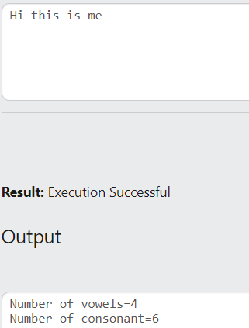

7.

#include<stdio.h>

int main()

{

char A[50];

char ch;

int i=0,len,c=0;

printf("Enter the string");

gets(A);

printf("\nEnter the character");

scanf("%c",&ch);

for (i=0;A[i]!='\0';i++);

len=i;

for (i=0;i<len;i++)

{

if (A[i]==ch)

c++;

}

printf("\nNumber of times %c occured=%d",ch,c);

return 0;

}

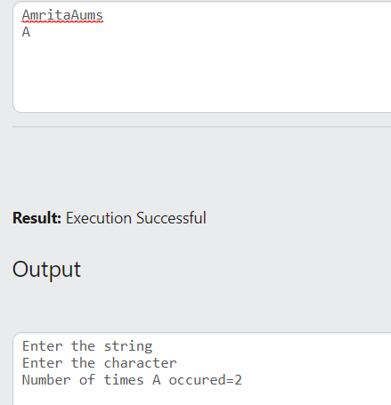

8.

#include<stdio.h>

int main()

{

char A[50];

int i=0,len,c1=0,c2=0;

gets(A);

for (i=0;A[i]!='\0';i++);

len=i;

for (i=0;i<len;i++)

{

if (A[i]>='a'&&A[i]<='z')

c1++;

else if (A[i]>='A'&&A[i]<='Z')

c2++;

}

printf("Number of lower case letters=%d",c1);

printf("\nNumber of upper case letters=%d",c2);

return 0;

}

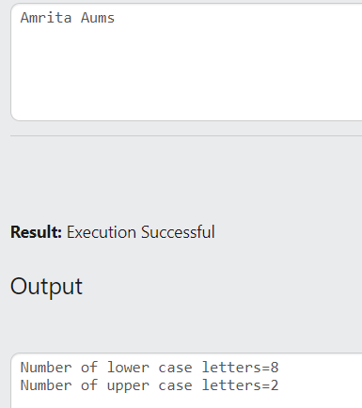

9.

#include<stdio.h>

int main()

{

char A[50];

int i=0,len,c1=0,c2=0,c3=0;

gets(A);

for (i=0;A[i]!='\0';i++);

len=i;

for (i=0;i<len;i++)

{

if (A[i]>='a'&&A[i]<='z'||A[i]>='A'&&A[i]<='Z')

c1++;

else if (A[i]>='0'&&A[i]<='9')

c2++;

else

c3++;

}

printf("Number of aplhabets=%d",c1);

printf("\nNumber of digits=%d",c2);

printf("\nNumber of special charcters=%d",c3);

return 0;

}

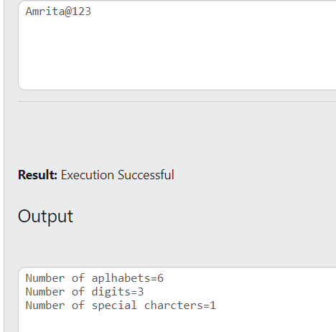

10.

#include<stdio.h>

int main()

{

int i,len;

char s[50];

printf("Enter a string:");

gets(s);

for(i=0;s[i]!='\0';i++);

len=i;

for(i=0;i<len;i++)

{

s[i]=s[i]-32;

}

printf("\nConverted string : ");

puts(s);

return 0;

}

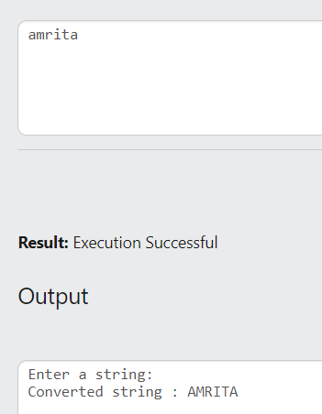

11.

#include<stdio.h>

int main()

{

int i,len;

char s[50];

printf("Enter a string:");

gets(s);

for(i=0;s[i]!='\0';i++);

len=i;

for(i=0;i<len;i++)

{

s[i]=s[i]+32;

}

printf("\nConverted string : ");

puts(s);

return 0;

}

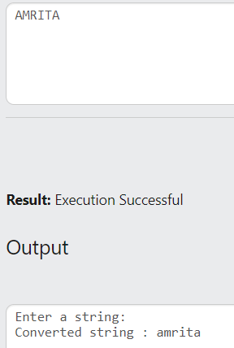

12.

#include<stdio.h>

int main()

{

int i,len;

char s[50],c[50];

printf("Enter a string:");

gets(s);

for(i=0;s[i]!='\0';i++);

len=i;

for(i=0;i<len;i++)

{

c[i]=s[i];

}

printf("\nCopied string : ");

puts(c);

return 0;

}

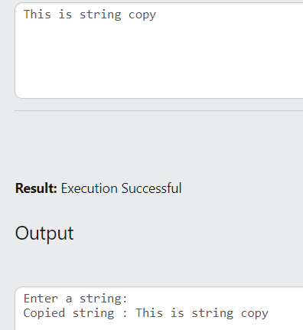

13.

#include<stdio.h>

int main()

{

int i,j,len1,len2,flag=0;

char s[50],c[50];

printf("Enter 1st string:");

scanf("%s ",s);

printf("Enter 2nd string:");

scanf("%s ",c);

for(i=0;s[i]!='\0';i++);

len1=i;

for(i=0;c[i]!='\0';i++);

len2=i;

if (len1==len2)

{

for(i=0;i<len1;i++)

{

if (s[i]!=c[i])

{flag=1;break;}

}

if (flag==0)

printf("\nStrings are equal");

else

printf("\nStrings are not equal");

}

else

printf("\nStrings are not equal");

return 0;

}

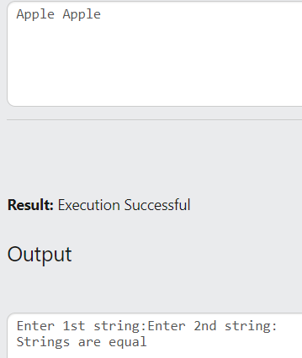

14.

#include<stdio.h>

int main()

{

int i,j,len1,len2,flag=0;

char a[50],b[50],c[50];

printf("Enter 1st string:");

scanf("%s ",a);

puts(a);

printf("\nEnter 2nd string:");

scanf("%s ",b);

puts(b);

for(i=0;a[i]!='\0';i++);

len1=i;

for(i=0;b[i]!='\0';i++);

len2=i;

for(i=0;i<len1;i++)

{

c[i]=a[i];

}

for(i=0;i<len2;i++)

{

c[len1+i]=b[i];

}

printf("\nConcatenated String is:");

puts(c);

return 0;

}

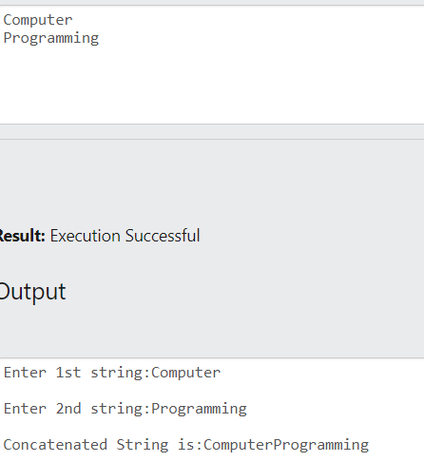

Q: Sort string.

#include<stdio.h>

#include<string.h>

int main()

{

int i,j,min,len;

char temp;

char s1[30];

gets(s1);

len=strlen(s1);

for (i=0;i<len;i++)

{

min=i;

for (j=i+1;j<len;j++)

{

if (s1[min]>s1[j])

min=j;

}

temp=s1[i];

s1[i]=s1[min];

s1[min]=temp;

}

puts(s1);

return 0;

}

