LOOPS_SET 1

1)

#include<stdio.h>

int main()

{

int i,sum=0;

printf("The first 10 natural number is :\n");

for (i=1;i<=10;i++)

{

printf("%d ",i);

sum+=i;

}

printf("\nThe Sum is : %d",sum);

return 0;

}

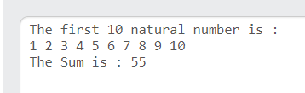

2)

#include<stdio.h>

int main()

{

int i,n;

printf("Input number of terms : ");

scanf("%d",&n);

printf("\n");

for (i=1;i<=n;i++)

{

printf("Number is : %d and cube of the %d is :%d\n",i,i,i*i*i);

}

return 0;

}

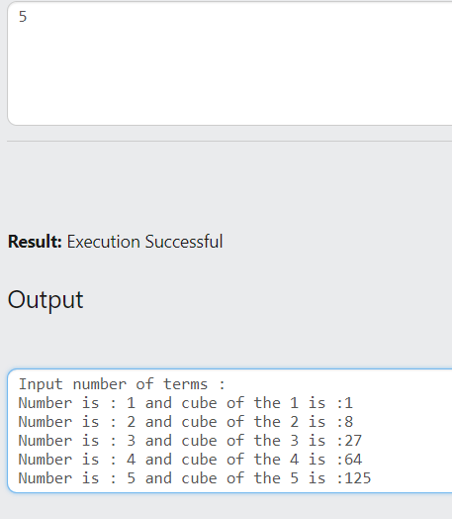

3)

#include<stdio.h>

int main()

{

int i,n,sum=0,c=1;

printf("Input number of terms : ");

scanf("%d",&n);

printf("\nThe odd numbers are :");

for (i=1;c<=n;i+=2)

{

printf("%d ",i);

c++;

sum+=i;

}

printf("\nThe Sum of odd Natural Number upto %d terms : %d",n,sum);

return 0;

}

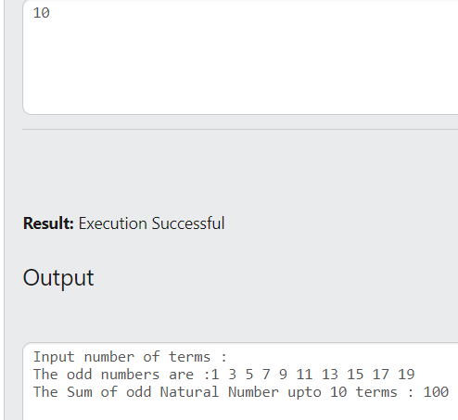

4)

#include<stdio.h>

int main()

{

int i,n,f=1;

printf("Input the number : ");

scanf("%d",&n);

for (i=1;i<=n;i++)

{

f*=i;

}

printf("\nThe Factorial of %d is : %d",n,f);

return 0;

}

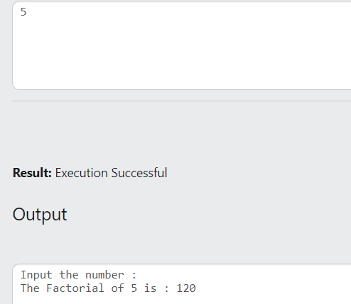

5)

#include<stdio.h>

int main()

{

int i,n,sum=0;

printf("Input the number : ");

scanf("%d",&n);

printf("\nThe positive divisor : ");

for (i=1;i<n;i++)

{

if (n%i==0)

{

printf("%d ",i);

sum+=i;

}

}

printf("\nThe sum of the divisor is : %d",sum);

if (sum==n)

printf("\nSo, the number is perfect.");

else

printf("\nSo, the number is not perfect.");

return 0;

}

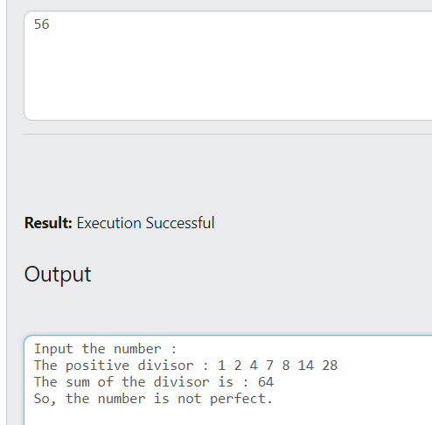

6)

#include<stdio.h>

int main()

{

int i,j,s,e,sum;

printf("Input the starting range of number : ");

scanf("%d",&s);

printf("\nInput the ending range of number : ");

scanf("%d",&e);

printf("\nThe Perfect numbers within the given range : ");

for (j=s;j<=e;j++)

{

sum=0;

for (i=1;i<j;i++)

{

if (j%i==0)

{

sum+=i;

}

}

if (sum==j)

printf("%d ",j);

}

return 0;

}

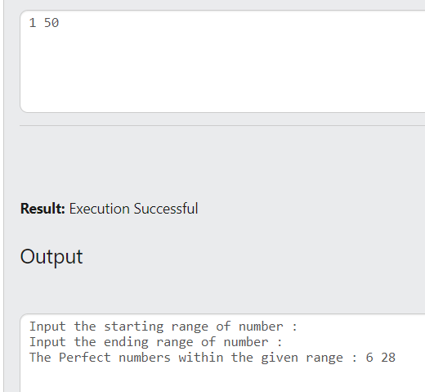

7)

#include<stdio.h>

#include<math.h>

int main()

{

int i,n1,n,sum=0,r;

printf("Input a number: ");

scanf("%d",&n);

n1=n;

while (n1!=0)

{

r=n1%10;

n1=n1/10;

sum+=pow(r,3);

}

if (sum==n)

printf("\n%d is an Armstrong number",n);

else

printf("\n%d is not an Armstrong number",n);

return 0;

}

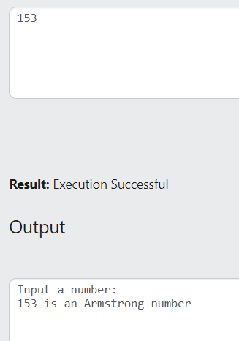

8)

#include<stdio.h>

#include<math.h>

int main()

{

int i,e,s,n1,sum,r;

printf("Input starting number of range: ");

scanf("%d",&s);

printf("\nInput ending number of range: ");

scanf("%d",&e);

printf("\nArmstrong numbers in given range are:");

for (i=s;i<=e;i++)

{

n1=i;

sum=0;

while (n1!=0)

{

r=n1%10;

n1=n1/10;

sum+=(r*r*r);

}

if (sum==i)

printf(" %d",i);

}

return 0;

}

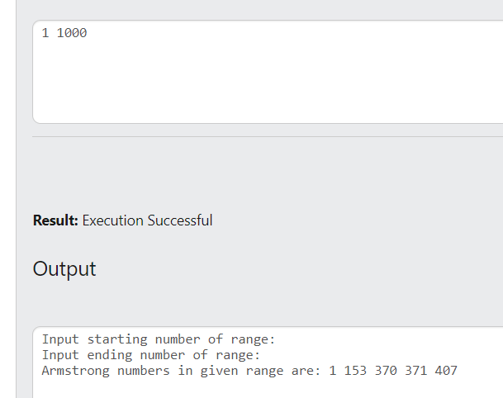

9)

#include<stdio.h>

int main()

{

int i,n,c=0;

printf("Input the number : ");

scanf("%d",&n);

for (i=2;i<n;i++)

{

if (n%i==0)

c=1;

}

if (c==0)

printf("\n%d is a prime number.",n);

else

printf("\n%d is not a prime number.",n);

return 0;

}

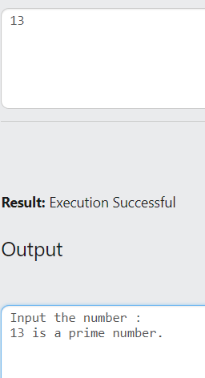

10)

#include<stdio.h>

int main()

{

int i,n,rn=0,r;

printf("Input the number : ");

scanf("%d",&n);

while (n!=0)

{

r=n%10;

n/=10;

rn=rn*10+r;

}

printf("\nThe number in reverse order is : %d",rn);

return 0;

}

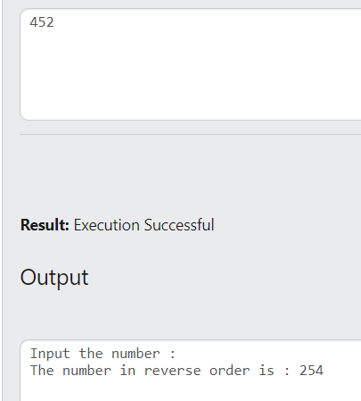

11)

#include<stdio.h>

int main()

{

int n,rn=0,r,x;

printf("Input the number : ");

scanf("%d",&n);

x=n;

while (n!=0)

{

r=n%10;

n/=10;

rn=rn*10+r;

}

if (rn==x)

printf("\n%d is a palindrome number",x);

else

printf("\n%d is not a palindrome number",x);

return 0;

}

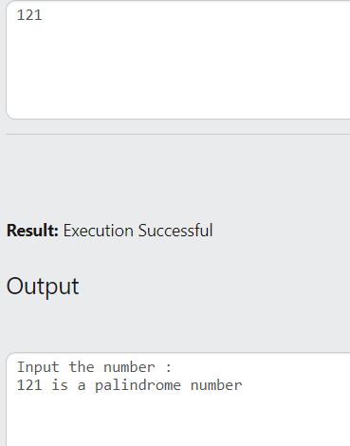

12)

#include<stdio.h>

int main()

{

int i,sum=0;

printf("Numbers between 100 and 200, divisible by 9 :\n");

i=100;

while (i<=200)

{

if (i%9==0)

{

printf("%d ",i);

sum+=i;

}

i++;

}

printf("\nThe sum : %d",sum);

return 0;

}

