1)

#include<stdio.h>

int main()

{

int n;

printf("Enter a number\n");

scanf("%d",&n);

if (n%2==0)

{

printf("\n%d is an even number",n);

}

else

{

printf("\n%d is an odd number",n);

}

return 0;

}

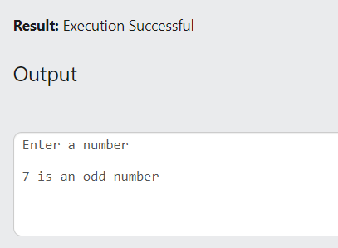

2)

#include<stdio.h>

int main()

{

int n1,n2;

printf("Enter 1st number\n");

scanf("%d",&n1);

printf("Enter 2nd number\n");

scanf("%d",&n2);

if (n2>n1)

{

printf("\n%d is the maximum",n2);

}

else

{

printf("\n%d is the maximum",n1);

}

return 0;

}

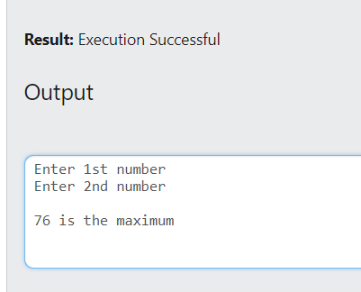

3)

#include<stdio.h>

int main()

{

int n1;

printf("Enter a number\n");

scanf("%d",&n1);

if (n1>0)

{

printf("\n%d is a postive number",n1);

}

else if (n1<0)

{

printf("\n%d is a negative number",n1);

}

else

{

printf("\n%d is zero",n1);

}

return 0;

}

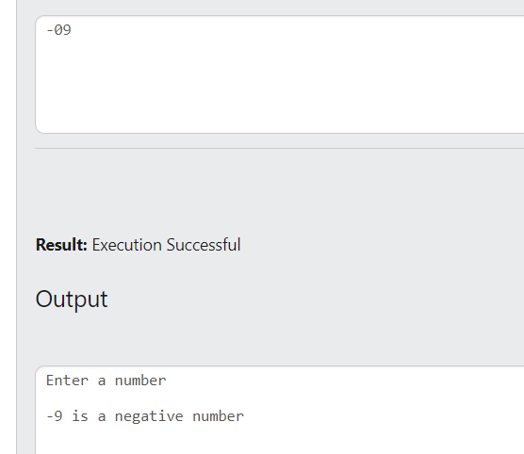

4)

#include<stdio.h>

int main()

{

char ch;

printf("Enter a character\n");

scanf("%c",&ch);

if ((ch>='a'&&ch<='z')||(ch>='A'&&ch<='Z'))

{

printf("\n%c is an alphabet",ch);

}

else

{

printf("\n%c is not an alphabet",ch);

}

return 0;

}

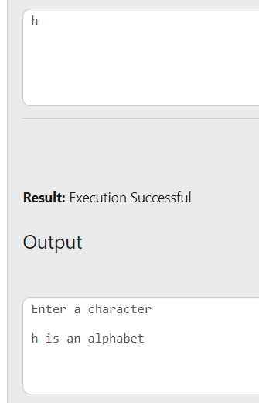

5)

#include<stdio.h>

int main()

{

int n;

printf("Enter a number\n");

scanf("%d",&n);

if ((n%11==0)&&(n%5==0))

{

printf("\n%d is divisible by 5 and 11",n);

}

else

{

printf("\n%d is not divisible by 5 and 11",n);

}

return 0;

}

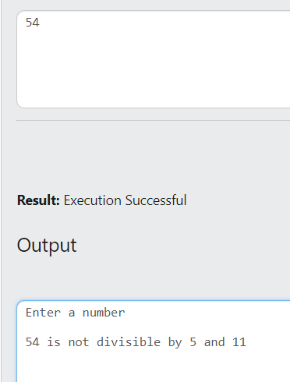

6)

#include<stdio.h>

int main()

{

char ch;

printf("Enter a character\n");

scanf("%c",&ch);

if ((ch=='a'||ch=='e'||ch=='i'||ch=='o'||ch=='u')||(ch=='A'||ch=='E'||ch=='I'||ch=='O'||ch=='U'))

{

printf("\n%c is a vowel",ch);

}

else

{

printf("\n%c is a consonant",ch);

}

return 0;

}

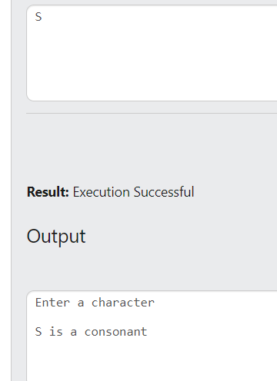

7)

#include<stdio.h>

int main()

{

char ch;

printf("Enter a character\n");

scanf("%c",&ch);

if ((ch>='a'&&ch<='z')||(ch>='A'&&ch<='Z'))

{

printf("\n%c is an alphabet",ch);

}

else if (ch>='0'&&ch<='9')

{

printf("\n%c is a digit",ch);

}

else

{

printf("\n%c is a special character",ch);

}

return 0;

}

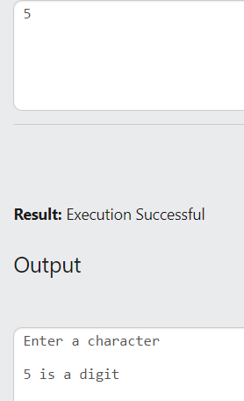

8)

#include<stdio.h>

int main()

{

char ch;

printf("Enter a character\n");

scanf("%c",&ch);

if (ch>='a'&&ch<='z')

{

printf("\n%c is an small letter",ch);

}

else if (ch>='A'&&ch<='Z')

{

printf("\n%c is a capital letter",ch);

}

else

{

printf("\n%c is not an alphabet",ch);

}

return 0;

}

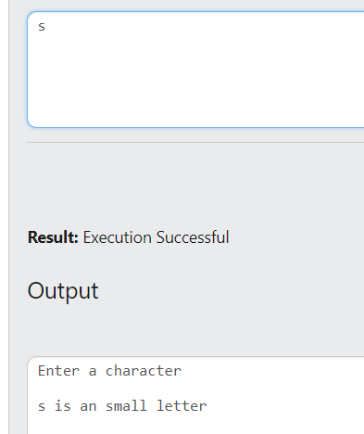

9)

#include<stdio.h>

int main()

{ int n;

printf("Enter a number\n");

scanf("%d",&n);

if (n==0)

{

printf("\n%d is Sunday",n);

}

else if (n==1)

{

printf("\n%d is Monday",n);

}

else if (n==2)

{

printf("\n%d is Tuesday",n);

}

else if (n==3)

{

printf("\n%d is Wednesday",n);

}

else if (n==4)

{

printf("\n%d is Thursday",n);

}

else if (n==5)

{

printf("\n%d is Friday",n);

}

else if (n==6)

{

printf("\n%d is Saturday",n);

}

else

{

printf("\n%d is not a week number",n);

}

return 0;

}

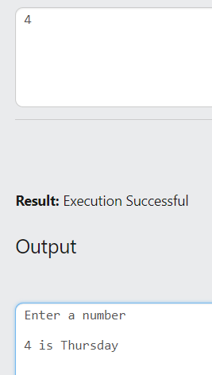

10)

#include<stdio.h>

int main()

{ int n1,n2,n3;

printf("Enter 1st side\n");

scanf("%d",&n1);

printf("Enter 2nd side\n");

scanf("%d",&n2);

printf("Enter 3rd side\n");

scanf("%d",&n3);

if (n1==n2==n3)

{

printf("Given triangle is an equilateral triangle");

}

else if ((n1!=n2)&&(n2!=n3)&&(n1!=n3))

{

printf("Given triangle is a scalene triangle");

}

else

{

printf("Given triangle is an isoceles triangle");

}

return 0;

}

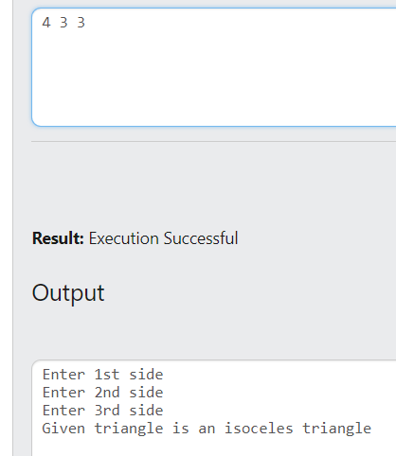

11)

#include<stdio.h>

int main()

{ int n1,n2,n3;

printf("Enter 1st number\n");

scanf("%d",&n1);

printf("Enter 2nd number\n");

scanf("%d",&n2);

printf("Enter 3rd number\n");

scanf("%d",&n3);

if (n1>n2)

{

if (n1>n3)

{

printf("%d is the largest number",n1);

}

}

else if (n2>n3)

{

printf("%d is the largest number",n2);

}

else

{

printf("%d is the largest number",n3);

}

return 0;

}

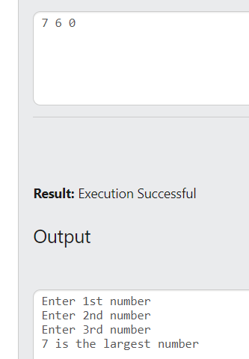

12)

#include<stdio.h>

int main()

{ int n1,n2,n3,n4,n5;

float p;

printf("Enter mark of physics\n");

scanf("%d",&n1);

printf("Enter mark of chemistry\n");

scanf("%d",&n2);

printf("Enter mark of biology\n");

scanf("%d",&n3);

printf("Enter mark of maths\n");

scanf("%d",&n4);

printf("Enter mark of computer\n");

scanf("%d",&n5);

p=(n1+n2+n3+n4+n5)/5;

if (p>=90)

{

printf("Grade A");

}

else if (p>=80)

{

printf("Grade B");

}

else if (p>=70)

{

printf("Grade C");

}

else if (p>=60)

{

printf("Grade D");

}

else if (p>=40)

{

printf("Grade E");

}

else

{

printf("Grade F");

}

return 0;

}

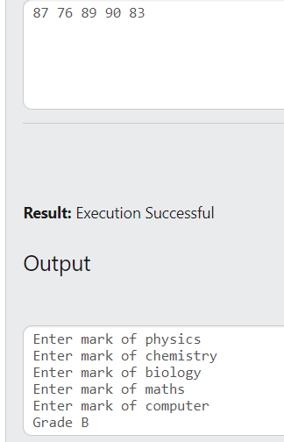

13)

#include<stdio.h>

int main()

{ int bp;

float s;

printf("Enter basic salary\n");

scanf("%d",&bp);

if (bp<=10000)

{

s=bp+(bp\*20/100)+(bp\*80/100);

}

else if (bp<=20000)

{

s=bp+(bp\*25/100)+(bp\*90/100);

}

else

{

s=bp+(bp\*30/100)+(bp\*95/100);

}

printf("Total salary=%.2f",s);

return 0;

}

