2)

#include<stdio.h>

#include<string.h>

struct hotel

{

char name[30];

char address[30];

char grade;

float avgcharge;

int nr;

};

void choice1(struct hotel h[],int n)

{

char g;

int i;

scanf(" %c",&g);

for(i=0;i<n;i++)

{

if (h[i].grade==g)

printf("%s\n",h[i].name);

}

}

void choice2(struct hotel h[],int n)

{

float v;

int i;

scanf("%f",&v);

for(i=0;i<n;i++)

{

if (h[i].avgcharge<v)

printf("%s\n",h[i].name);

}

}

int main()

{

int i,n,ch;

scanf("%d",&n);

struct hotel h[n];

for(i=0;i<n;i++)

{

scanf("%s ",h[i].name);

gets(h[i].address);

scanf(" %c",&h[i].grade);

scanf("%f",&h[i].avgcharge);

scanf("%d",&h[i].nr);

}

scanf("%d",&ch);

printf("\n\nOUTPUT\n");

if (ch==1)

choice1(h,n);

else

choice2(h,n);

}

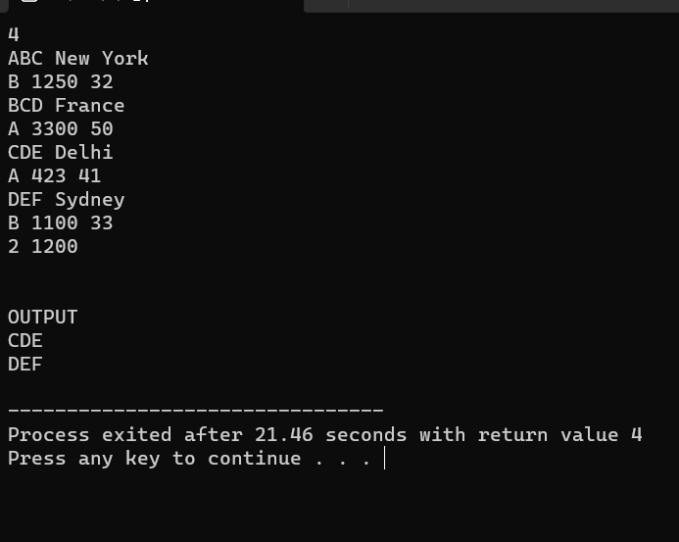

3)

#include<stdio.h>

#include<string.h>

struct address

{

int dno;

char street[30];

char city[30];

int pincode;

};

struct home

{

char name[30];

struct address a;

int unit;

};

int main()

{

int n,i;

scanf("%d",&n);

struct home h[n];

for (i=0;i<n;i++)

{

scanf("%s ",h[i].name);

scanf("%d",&h[i].a.dno);

scanf("%s ",h[i].a.street);

scanf("%s ",h[i].a.city);

scanf("%d",&h[i].a.pincode);

scanf("%d",&h[i].unit);

}

for (i=0;i<n;i++)

{

printf("Bill Home %d=",i+1);

if (h[i].unit<=50)

printf("50\n");

else if(h[i].unit<=200)

printf("%.2f\n",1.25\*h[i].unit);

else

printf("%.2f\n",1.35\*h[i].unit);

}

}

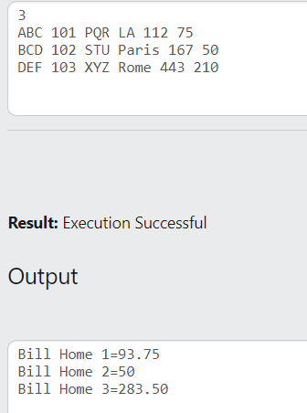

4)

#include<stdio.h>

#include<string.h>

struct details

{

int accno;

char name[30];

float balance;

};

void choice1(int c,struct details b[],int n)

{

int i,k;

float newb;

scanf("%f",&newb);

for (i=0;i<n;i++)

{

if (b[i].accno==c)

{

b[i].balance=newb;

k=i;

break;

}

}

printf("%d ",b[k].accno);

printf("%s ",b[k].name);

printf("%.2f",b[k].balance);

}

void choice2(struct details b[],int n)

{

int k;

for (k=0;k<n;k++)

{

printf("%d ",b[k].accno);

printf("%s ",b[k].name);

printf("%.2f\n",b[k].balance);

}

}

int main()

{

int i,n,ch,c;

scanf("%d",&n);

struct details b[n];

for (i=0;i<n;i++)

{

scanf("%d",&b[i].accno);

scanf("%s ",b[i].name);

scanf("%f",&b[i].balance);

}

scanf("%d",&ch);

if (ch==1)

{

scanf("%d",&c);

choice1(c,b,n);

}

if (ch==2)

{

choice2(b,n);

}

}

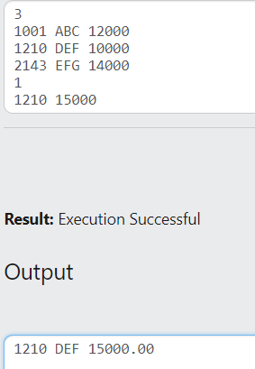

6)

#include<stdio.h>

#include<math.h>

struct point

{

int x;

int y;

};

void checkforequilateral(struct point p[],int n)

{

int d1,d2,d3;

d1=pow((p[1].x-p[0].x),2)+pow((p[1].y-p[0].y),2);

d2=pow((p[2].x-p[1].x),2)+pow((p[2].y-p[1].y),2);

d3=pow((p[0].x-p[2].x),2)+pow((p[0].y-p[2].y),2);

if (d1==d2&&d2==d3)

printf("YES");

else

printf("NO");

}

int main()

{

struct point p[3];

int i;

for (i=0;i<3;i++)

{

scanf("%d",&p[i].x);

scanf("%d",&p[i].y);

}

checkforequilateral(p,3);

}