POINTER SIZE=8

1)Read and display

#include<stdio.h>

int main()

{

int n,i;

int a[50];

int \*ptr=a;

scanf("%d",&n);

for (i=0;i<n;i++)

{

scanf("%d",ptr+i);

}

for (i=0;i<n;i++)

{

printf("%d is stored at %u\n",\*(ptr+i),ptr+i);

}

return 0;

}

2)

#include<stdio.h>

int main()

{

int n,i;

int a[50];

int \*ptr=a;

scanf("%d",&n);

for (i=0;i<n;i++)

{

scanf("%d",ptr);

ptr++;

}

ptr=a;

for (i=0;i<n;i++)

{

printf("%d is stored at %u\n",\*(ptr+i),ptr+i);

}

return 0;

}

3)

#include<stdio.h>

int main()

{

int n,i;

int a[50];

//int \*ptr=a;

scanf("%d",&n);

for (i=0;i<n;i++)

{

scanf("%d",a+i);

//ptr++;

}

//ptr=a;

for (i=0;i<n;i++)

{

printf("%d is stored at %u\n",\*(a+i),a+i);

}

return 0;

}

4) #include<stdio.h>

int main()

{

int n,i;

int a[50];

//int \*ptr=a;

scanf("%d",&n);

for (i=0;i<n;i++)

{

scanf("%d",a);

a++;

}

//ptr=a;

for (i=0;i<n;i++)

{

printf("%d is stored at %u\n",\*(a+i),a+i);

}

return 0;

}

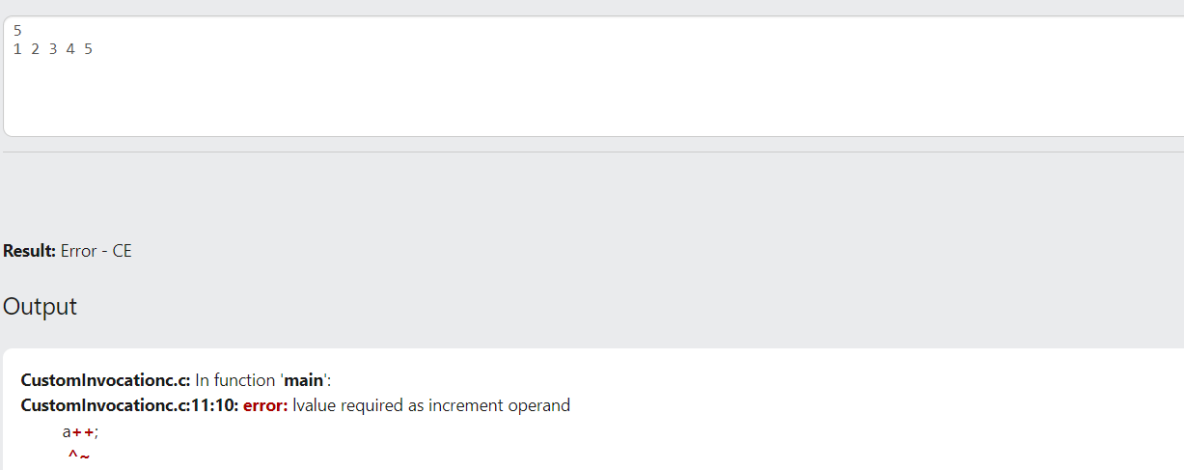

5)

#include<stdio.h>

#include<string.h>

int main()

{

int i;

char \*ch;

char a[50];

gets(a);

ch=a;//ch=&a[0];

for (i=0;i<strlen(a);i++)

{

printf("%c is stored at %u\n",\*(ch+i),ch+i);

}

//ptr=a;

/\*for (i=0;i<n;i++)

{

printf("%d is stored at %u\n",\*(a+i),a+i);

}\*/

return 0;

}

6)

#include<stdio.h>

void swap(int a,int b)

{

int temp;

temp=a;

a=b;

b=temp;

printf("a=%d b=%d\n",a,b);

}

int main()

{

int a=10,b=20;

printf("a=%d b=%d\n",a,b);

swap(a,b);

printf("a=%d b=%d",a,b);

return 0;

}

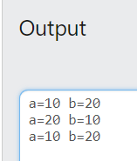

7)

#include<stdio.h>

void swap(int \*p,int \*q)

{

int temp;

temp=\*p;

\*p=\*q;

\*q=temp;

printf("a=%d b=%d\n",\*p,\*q);

}

int main()

{

int a=10,b=20;

printf("a=%d b=%d\n",a,b);

swap(&a,&b);

printf("a=%d b=%d",a,b);

return 0;

}

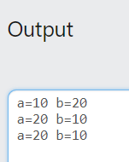

8)

#include<stdio.h>

int main()

{

int z[2]={1,5};

int \*ip=z;

printf("%d\n",\*ip);

printf("%u\n",ip);

printf("%u\n",\*++ip);

printf("%d\n",\*ip);

return 0;

}

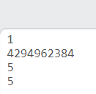

9)

#include<stdio.h>

int main()

{

int z[2]={1,5};

int \*ip=z;

printf("%d\n",++\*ip);

printf("%d\n",\*ip);

return 0;

}

