1)

#include<stdio.h>

#include<string.h>

struct student

{

int roll_no;

char name[20];

float marks;

char gender;

}st2={20,"Suresh",30,'M'};//equivalent to struct student st1; but global

int main()

{

struct student st1,st3;

st1.roll_no=17;

strcpy(st1.name,"Amrita");

st1.marks=36.5;

st1.gender='F';

//,st2={20,"Suresh",30,'M'}, st3={40,"Ramesh",25.5,'M'};

//printf("%d",sizeof(st));

scanf("%d%s %f %c",&st3.roll_no,st3.name,&st3.marks,&st3.gender);//no space->error

printf("%d %s %.2f %c\n",st1.roll_no,st1.name,st1.marks,st1.gender);

printf("%d %s %.2f %c\n",st2.roll_no,st2.name,st2.marks,st2.gender);

printf("%d %s %f %c",st3.roll_no,st3.name,st3.marks,st3.gender);

}

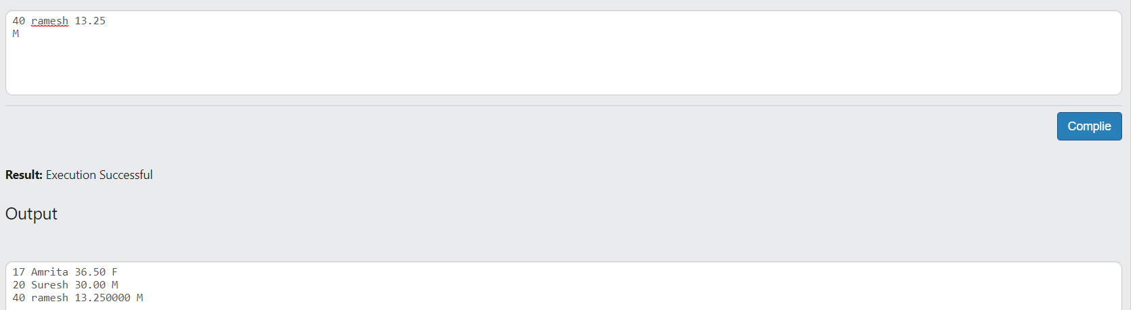

2)WAP to store the details of 2 employee (name, ID, HRA, TA, BP) and print the employee details with highest salary.

CODE:

#include<stdio.h>

struct employee

{

char name[30];

int id;

float hra,ta,bp;

};

int main()

{

struct employee e1,e2;

//printf("Enter the details of employee1\n");

scanf("%s %d%f%f%f",e1.name,&e1.id,&e1.hra,&e1.ta,&e1.bp);

//printf("Enter the details of employee2\n");

scanf("%s %d%f%f%f",e2.name,&e2.id,&e2.hra,&e2.ta,&e2.bp);

float s1=e1.hra+e1.ta+e1.bp,s2=e2.hra+e2.ta+e2.bp;

printf("Salary of employee 1 = %.2f\n",s1);

printf("Salary of employee 2 = %.2f\n",s2);

if (s1>s2)

{

printf("Employee 1 has higher salary");

}

else if (s1<s2)

{

printf("Employee 2 has higher salary");

}

else

{

printf("Employee 1 and Employee 2 have equal salary");

}

}

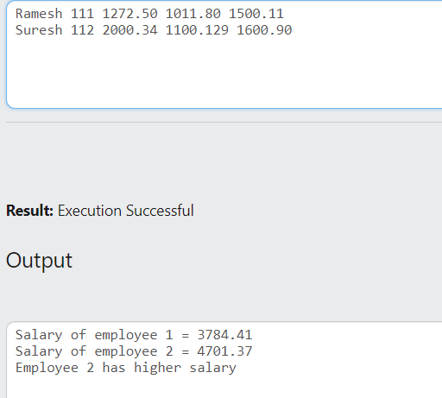

3)Sum of complex number.

#include<stdio.h>

struct complex

{

int real;

int img;

};

int main()

{

struct complex c1,c2,c3;

scanf("%d%d",&c1.real,&c1.img);

scanf("%d%d",&c2.real,&c2.img);

c3.real=c1.real+c2.real;

c3.img=c1.img+c2.img;

printf("(%d+i%d)+(%d+i%d)=%d+i%d",c1.real,c1.img,c2.real,c2.img,c3.real,c3.img);

}

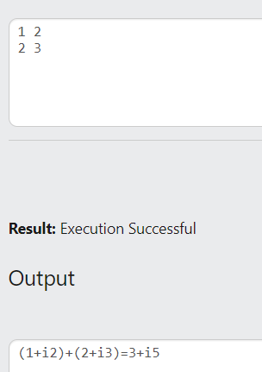

3) Array as member.

#include<stdio.h>

struct student

{

int rno;

char name[30];

int mark[3];

};

int main()

{

int i;

struct student s1={111,"Anna",20,30,35},s2={112,"Aparna Siva",{25,35,30}};

printf("marks of %s: %d %d %d\n",s1.name,s1.mark[0],s1.mark[1],s1.mark[2]);

printf("marks of %s: ",s2.name);

for (i=0;i<3;i++)

{

printf("%d ",s2.mark[i]);

}

}

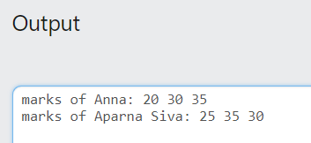

3.Array of structures.

#include<stdio.h>

struct student

{

int rno;

char name[30];

//int mark[3];

};

int main()

{

int n,i;

scanf("%d",&n);

struct student s[n];

for (i=0;i<n;i++)

{

scanf("%d",&s[i].rno);

scanf("%s",s[i].name);

}

for (i=0;i<n;i++)

{

printf("%d ",s[i].rno);

printf("%s\n",s[i].name);

}

//printf("%d",sizeof(s[1]));

}

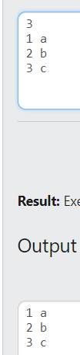

Q:

#include<stdio.h>

struct student

{

int roll;

int mark[3];

char name[30];

};

int main()

{

int i,j;

struct student s1[2];

//printf("%ld",sizeof(s1[1]));

for(j=0;j<2;j++)

{

scanf("%d\n",&s1[j].roll);

for(i=0;i<3;i++)

{

scanf("%d",&s1[j].mark[i]);

}

scanf("%s",s1[j].name);

}

for(i=0;i<2;i++)

{

printf("%d ",s1[i].roll);

for(j=0;j<3;j++)

{

printf("%d ",s1[i].mark[j]);

}

printf("%s \n",s1[i].name);

}

}

Q: NESTED STRUCTURE

#include<stdio.h>

#include<string.h>

struct dob

{

int date;

int month;

char k;

int year;

};

struct student

{

char name[21];

int roll;

struct dob d1;

};

int main()

{

struct student s1;

printf("%d ",sizeof(s1.d1));

printf("%d ",sizeof(s1.name));

printf("%d ",sizeof(s1.roll));

printf("%d ",sizeof(s1.d1.month));

printf("%d ",sizeof(s1));

}

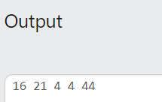

(OR)

#include<stdio.h>

#include<string.h>

struct student

{

char name[21];

int roll;

struct dob

{

int date;

int month;

char k;

int year;

}d1;

};

int main()

{

struct student s1;

printf("%d ",sizeof(s1.d1));

printf("%d ",sizeof(s1.name));

printf("%d ",sizeof(s1.roll));

printf("%d ",sizeof(s1.d1.month));

printf("%d ",sizeof(s1));

}

Q: Passing structure to fn.

#include<stdio.h>

#include<string.h>

struct dob

{

int date;

int month;

//char k;

int year;

};

struct student

{

char name[21];

int roll;

struct dob d1;

};

void display(struct student t)

{

printf("%s ",t.name);

printf("%d ",t.roll);

printf("%d ",t.d1.date);

}

int main()

{

struct student s;

scanf("%s ",s.name);

scanf("%d",&s.roll);

scanf("%d",&s.d1.date);

display(s);

}

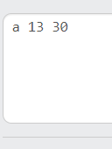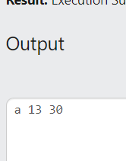

Q:Passing structure array to a function.

#include<stdio.h>

#include<string.h>

struct dob

{

int date;

int month;

//char k;

int year;

};

struct student

{

char name[21];

int roll;

struct dob d1;

};

void display(struct student t[],int n)

{

int i;

for (i=0;i<3;i++)

{

printf("%s ",t[i].name);

printf("%d ",t[i].roll);

printf("%d ",t[i].d1.date);

printf("\n");

}

}

int main()

{

int i;

struct student s[3];

for (i=0;i<3;i++)

{

scanf("%s ",s[i].name);

scanf("%d",&s[i].roll);

scanf("%d",&s[i].d1.date);

}

display(s,3);

}

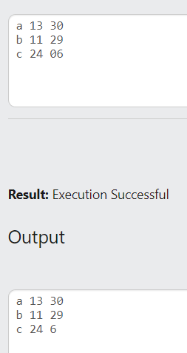

Q: copy structure.

#include<stdio.h>

struct student

{

char name[20];

int id;

float mark;

};

int main()

{

struct student s={"Amrita", 10,44.5};

struct student t=s;

printf("%s ",t.name);

printf("%d ",t.id);

printf("%f ",t.mark);

}

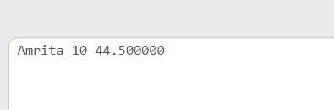

Q:pointer ->

#include<stdio.h>

struct student

{

char name[20];

int id;

float mark;

};

int main()

{

struct student s;

struct student *p=&s;

scanf("%s ",p->name);

scanf("%d",&p->id);

scanf("%f",&p->mark);

printf("%s ",p->name);

printf("%d ",p->id);

printf("%f ",p->mark);

}

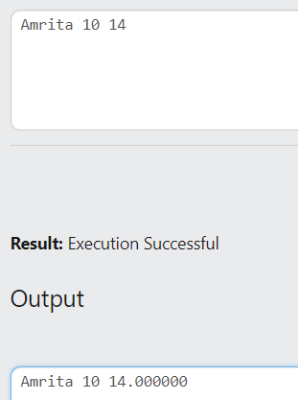

Q: pointer dot operator

#include<stdio.h>

struct student

{

char name[20];

int id;

float mark;

};

int main()

{

struct student s;

struct student *p=&s;

scanf("%s ",(*p).name);

scanf("%d",&(*p).id);

scanf("%f",&(*p).mark);

printf("%s ",(*p).name);

printf("%d ",(*p).id);

printf("%f ",(*p).mark);

}

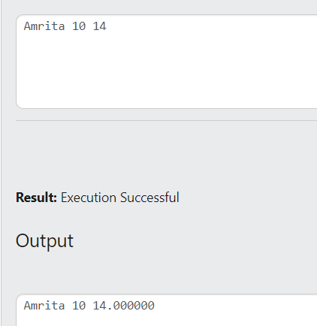

Q: structure array pointer.(ERROR)

#include<stdio.h>

struct student

{

char name[20];

int id;

float mark;

};

int main()

{

struct student s[3];

struct student *p=&s[0];

for (int i=0;i<3;i++)

{

scanf("%s ",(*p+i)->name);

scanf("%d",&(*p+i)->id);

scanf("%f",&*(*p+i)->mark);

}

for (int i=0;i<3;i++)

{

printf("%s ",*(p+i)->name);

printf("%d ",*(p+i)->id);

printf("%f ",*(p+i)->mark);

}

//scanf("%s ",(*p).name);

//scanf("%d",&(*p).id);

//scanf("%f",&(*p).mark);

}

Gcd lacm

#include<stdio.h>

#include<string.h>

struct num

{

int a;

int b;

}

int gcd(n1)

{

int i,g=1;

for (i=1;i<=n1.a&&i<=n1.b;i++)

{

if(n1.a%i==0&&n1.b%i==0)

g=i;

}

return g;

}

int main()

{

struct num n1,g;

scanf("%d%d",&n1.a,&n1.b);

g=gcd(n1);

l=n1.a*n1.b/gcd;

}