# **Analyzing Individual Preparedness for Effective Disaster Response Strategies**

Aparna Nidamanuri

May 4, 2024

**Introduction:**

Imagine waking up to news reports of wildfires raging across California, hurricanes battering the Gulf Coast, and floods inundating towns in the Midwest. These aren't scenes from a disaster movie, but an increasingly common reality in the United States.

The nation has experienced a dramatic rise in the frequency, severity, and cost of climate-related disasters in recent years. From 2020 to 2023 alone, 60 climate disasters caused over 1,400 deaths and nearly 3,000 injuries. These disasters have all been billion-dollar events, highlighting the devastating economic impact alongside the human cost.

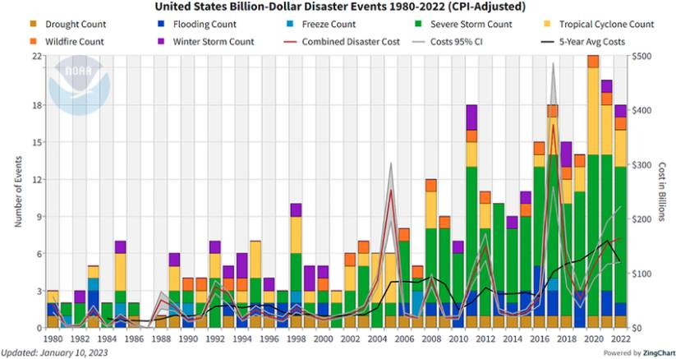

This graph from the National Oceanic and Atmospheric Administration (NOAA) clearly shows the sharp increase in billion-dollar disasters. Just compare the first three years of this decade to previous decades. We're already seeing more billion-dollar disasters than entire decades in the past!

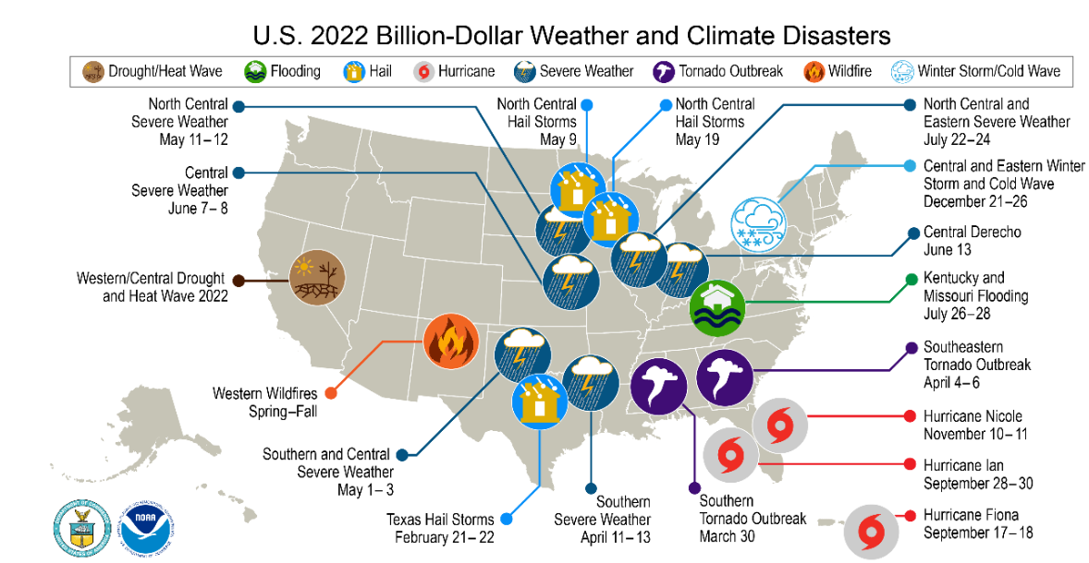

The increased frequency and intensity of disasters is putting a strain on emergency response organizations. These organizations are managing more than twice the number of major disasters compared to just a few years ago, and their daily deployments have doubled.

While these statistics paint a grim picture, they also highlight a critical need for improved preparedness. We can't control the weather, but we can be better prepared to face the challenges it throws our way.

This presentation will explore the factors that influence individual preparedness for disasters. By understanding these factors, we can develop more effective strategies to keep communities safe in the face of a disaster.

**Problem Statement:**

As climate disasters become more frequent and severe, a critical question emerges: Are we ready? The reality is, many individuals remain unprepared for these events. This lack of preparedness can have devastating consequences. Our project delves deeper into this challenge by analyzing the factors that influence how prepared people are for climate disasters. By understanding these factors, we can develop more effective strategies to promote preparedness and ensure safer communities.

**Literature Review:**

As climate disasters become more frequent and complex, effective preparedness is critical. Machine learning (ML) techniques are revolutionizing disaster management by enabling data-driven decision-making. ML algorithms can analyze vast datasets to identify patterns and risk factors associated with different disasters.

This review of existing research highlights several ways ML is enhancing preparedness. For example, in risk assessment, studies like Jaiswal et al. (2021) developed a data-driven model that incorporates big data and AI to assess infrastructure resilience. This approach helps us understand and prepare for disruptive events like natural disasters or cyberattacks.

ML is also being used to develop early warning systems. Jiang et al. (2021) leveraged machine learning to analyze real-time data from various sources and predict potential disasters. This allows for earlier intervention and saves lives.

By incorporating machine learning throughout the preparedness cycle, we can build more resilient communities and mitigate the impact of disasters. Our research takes a unique approach by leveraging the rich data from the 2023 FEMA National Household Survey. By analyzing this data, we aim to identify the factors influencing individual preparedness behaviors and develop more targeted preparedness strategies.

**Data Collection:**

Our research leverages data from the 2023 FEMA National Household Survey (NHS). This annual survey conducted by FEMA gauges the nation's preparedness actions, attitudes, and motivations. The rich data collected in the 2023 survey is particularly valuable for our project because it provides insights into individual preparedness behaviors across the U.S.   
The NHS collects a wide range of data relevant to our research questions, including demographics, information on preparedness actions taken, and individuals' past experiences with disasters. It provides a nationally representative sample, and it includes data from disaster-prone areas.

**Data Preprocessing:**  
We extracted features that are relevant to our problem statement about preparedness. These features include:

* Awareness, Perception, and Experience
* Age
* Employment and Income
* Demographics (Gender, Education, Ethnicity)
* Disability and Care Needs
* Household Composition (Number of adults and children)
* Homeownership
* Geographic Information (State, Geographic Division, County)

**Feature Engineering:**

The original survey did not have a preparedness level variable. To address this, we created a new variable based on the following actions taken by individuals for disaster preparedness:

* Assembled or updated supplies
* Learned evacuation routes
* Made a plan
* Safeguarded documents
* Saved for a rainy day
* Documented and insured property
* Got involved in my community
* Made my home safer
* Planned with neighbors
* Signed up for alerts and warnings
* Practiced emergency drills or habits
* Tested family communication plan

We assigned a preparedness level (1-5) based on the number of actions taken by each respondent.

As we delve deeper into the data, we observed that some classes in our data have significantly more instances than others. Since the initial distribution of preparedness levels exhibited class imbalance, we strategically merged some classes. This approach helps create a more balanced distribution of preparedness levels within our data, ultimately improving the effectiveness of our machine learning models.

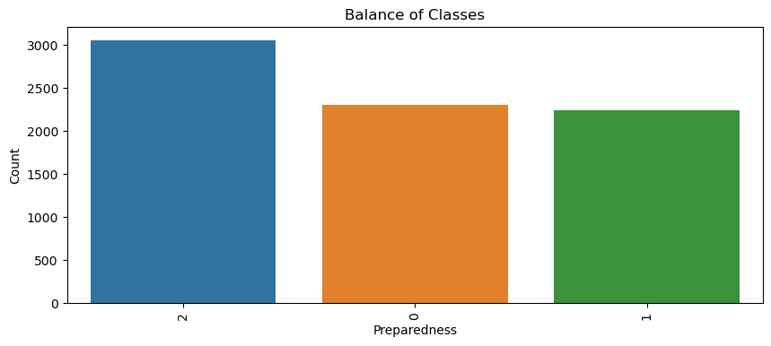

**Research Questions:**

Now that we've explored the evolving landscape of disaster preparedness and the role of machine learning in this area, let's delve deeper into the specific questions guiding our research.

* *Demographic Factors & Preparedness Levels:* How do demographics relate to preparedness in disaster-prone regions?
* *Distribution of Preparedness Levels:* How are preparedness levels distributed across states?
* *Influence of Awareness & Past Experiences:* How awareness and past experiences affect preparedness levels?
* *Contributions to Disaster Management:* How can insights from preparedness behaviors inform disaster management?

**Exploratory Data Analysis:**

Let's delve deeper into the influence of specific demographic factors. Here, we see the distribution of preparedness levels across each demographic factor.

Age:

The graph suggests a positive correlation between age groups and preparedness. As the age increases, there is a general trend of higher counts of individuals with preparedness levels 1 and 2. This implies that older age groups might have higher levels of preparedness. The finding underscores the potential significance of educational outreach programs. By targeting educational efforts toward younger demographics, we can increase their readiness levels.

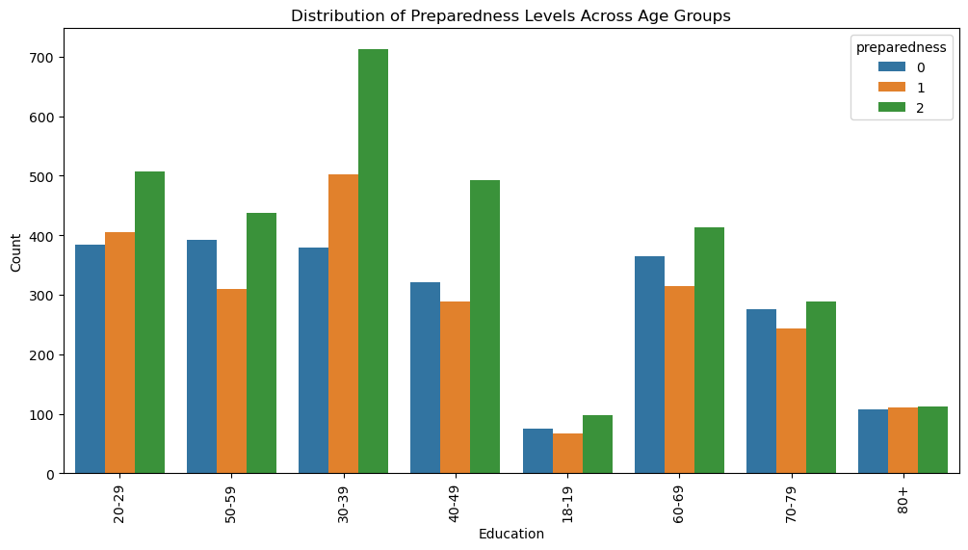

Education:  
The graph suggests a positive correlation, with individuals having higher education levels exhibiting higher preparedness levels.This finding underscores the potential significance of educational outreach programs in promoting earthquake preparedness across diverse communities.

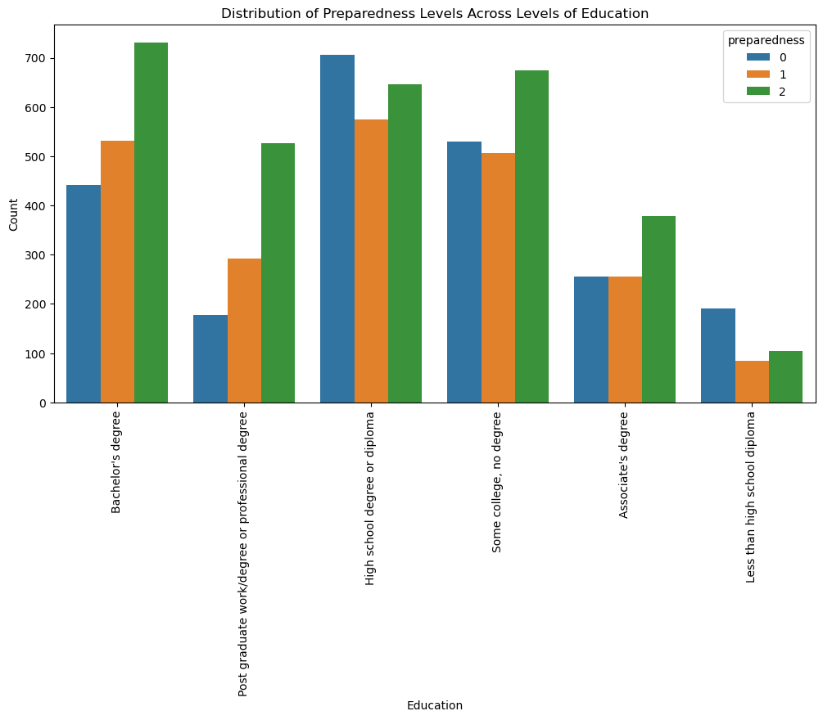

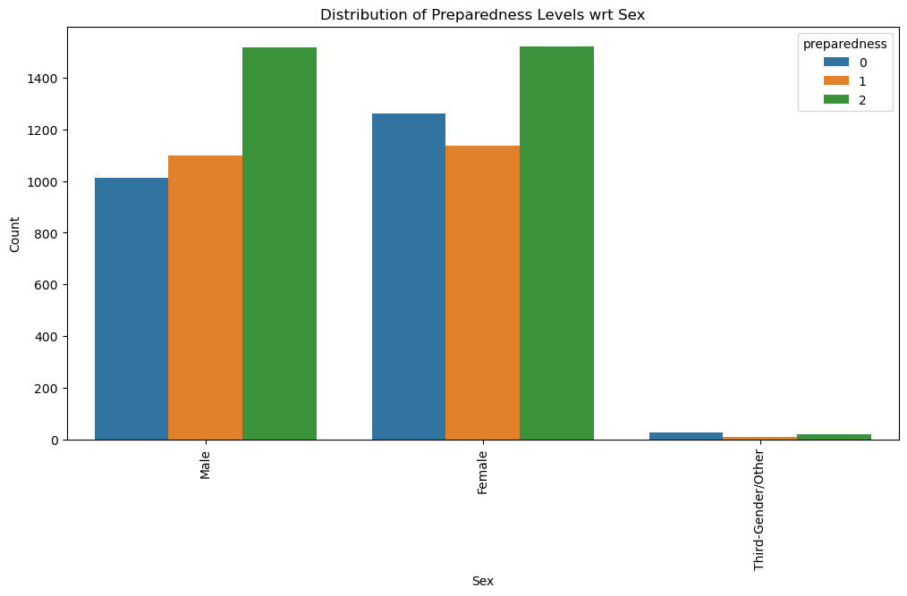

Gender:

Both males and females exhibit even distribution across all three levels, indicating that they might be more spread out in terms of preparedness.

Employment:

The graph suggests a connection between employment and preparedness. Individuals who have never been unemployed for an extended period (12 months or more) exhibit the highest preparedness levels. In contrast, those who have been unemployed for various durations, are not currently in the labor force, or are retired tend to have lower preparedness levels. However, it's interesting to note that retired individuals show a mix across all three preparedness levels. These findings highlight the importance of considering not just current employment status but also unemployment history when designing disaster preparedness programs.

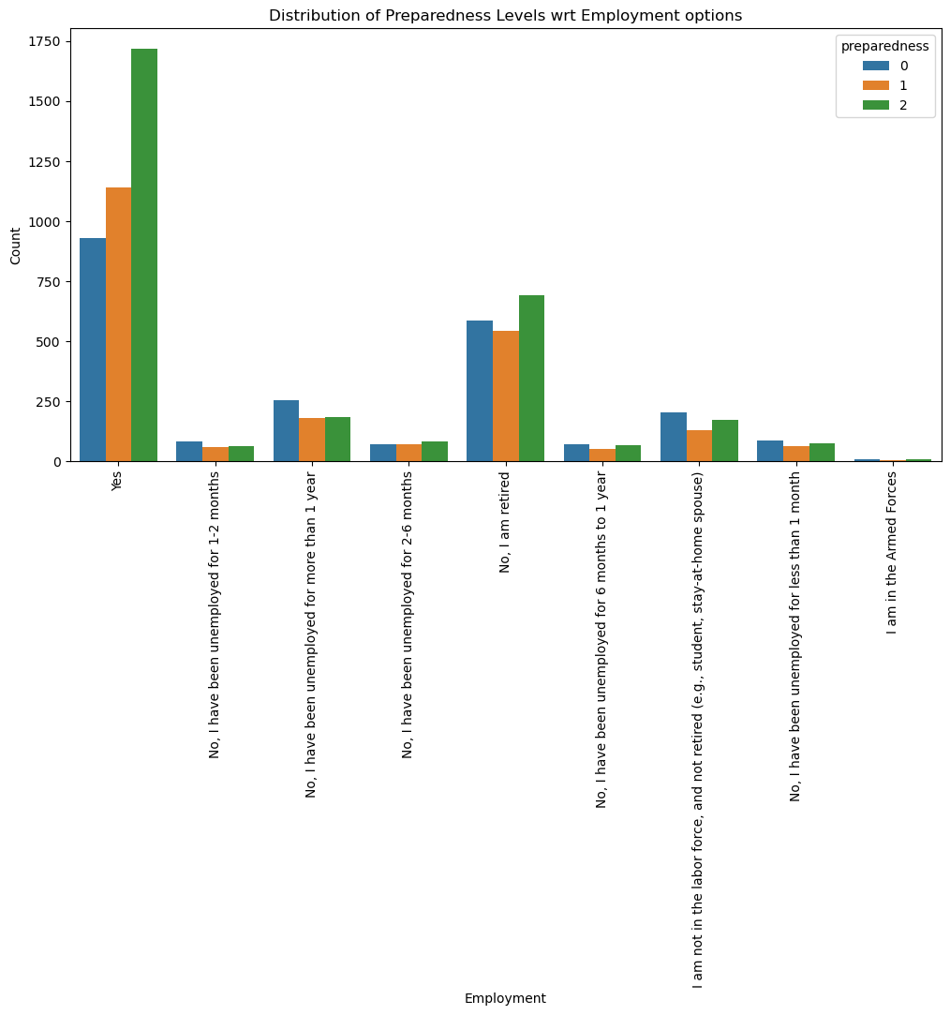

Income Groups:

The graph reveals that individuals in the highest income bracket, those earning between $100,000 and $149,999, exhibit the highest preparedness levels. Conversely, those with income less than $10,000 tend to fall into the lowest preparedness category. Interestingly, the middle-income groups show a wider range of preparedness levels. This suggests a potential link between financial resources and the ability to take preparedness actions. These findings emphasize the importance of considering income disparities when designing disaster preparedness programs.

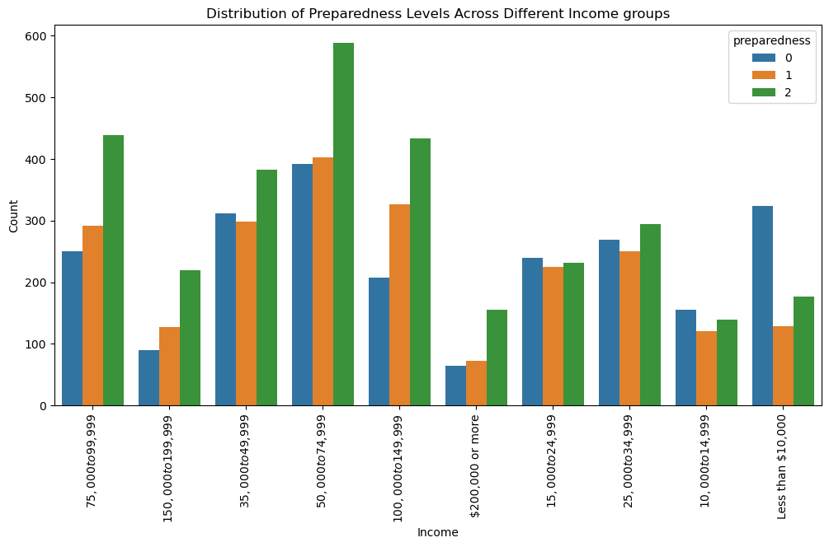

Disability:  
  
The graph reveals that a larger portion of individuals without disabilities falls under preparedness level 2, indicating they have taken some actions to prepare. However, there's also a significant number in other classes. In comparison, individuals with disabilities have lower counts across all preparedness levels. While the majority in this group also fall under level 2, the counts in other classes cannot be neglected. These findings highlight the critical need for inclusive disaster preparedness programs.

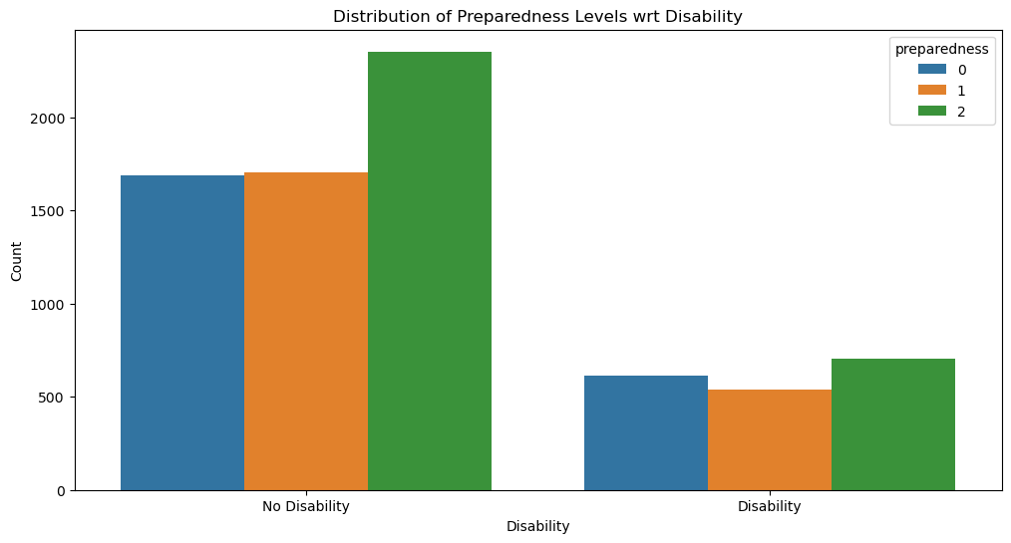

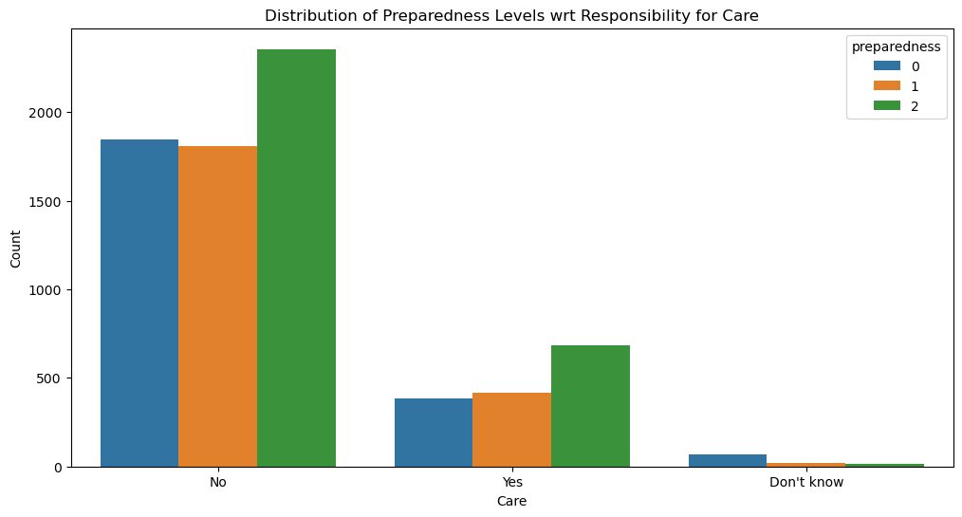

Responsibility for care:  
The graph reveals an interesting trend. Individuals who indicated they are not responsible for caregiving seem to have a wider range of preparedness levels. The majority falls under preparedness level 2, but there's also a significant number at level 1. In contrast, individuals who identified as having caregiving responsibilities tend to have lower preparedness overall. A larger portion of this group falls under preparedness level 0, suggesting they might not have taken many preparedness actions yet. It's also worth noting a considerable number of individuals unsure about their caregiving role also exhibit lower preparedness, similar to the group with caregiving responsibilities, but with slightly fewer individuals in each category. These findings highlight the importance of considering caregiving responsibilities when designing disaster preparedness programs.

Homeownership:

Homeowners tend to have higher preparedness levels overall. A larger portion of homeowners fall under preparedness level 2, indicating they've taken more preparedness actions. Renters, on the other hand, exhibit a more balanced distribution across all three levels.

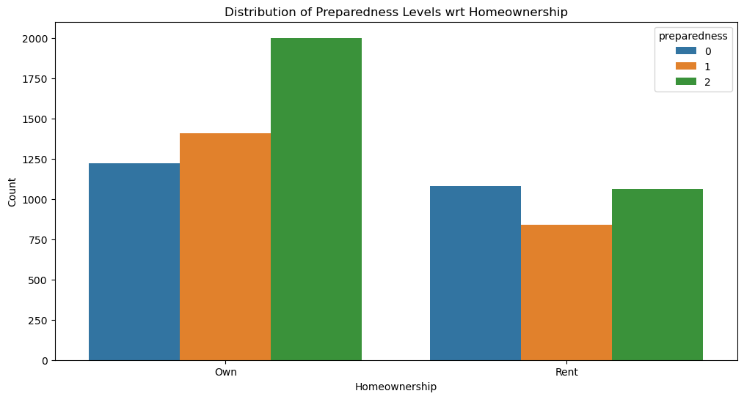

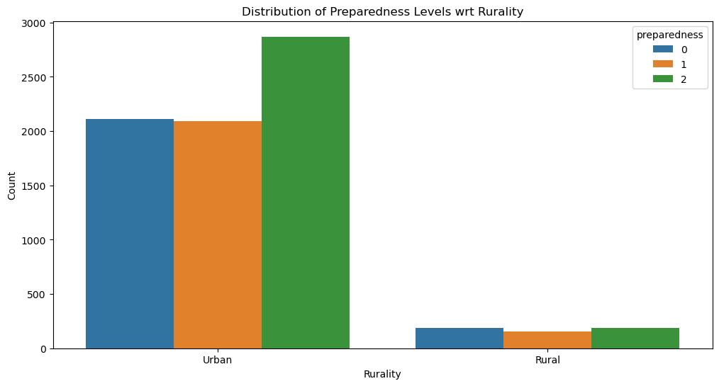

Rurality:

The graph reveals a clear disparity in preparedness between urban and rural areas. Individuals in urban areas tend to exhibit higher preparedness levels. The majority falls under level 2, indicating a more prepared state. Additionally, a significant number of urban residents fall into level 1. In contrast, preparedness levels in rural areas are considerably lower. We see very few residents in either preparedness level 1 or 2. This suggests that a larger portion of the rural population might not have taken many preparedness actions yet.

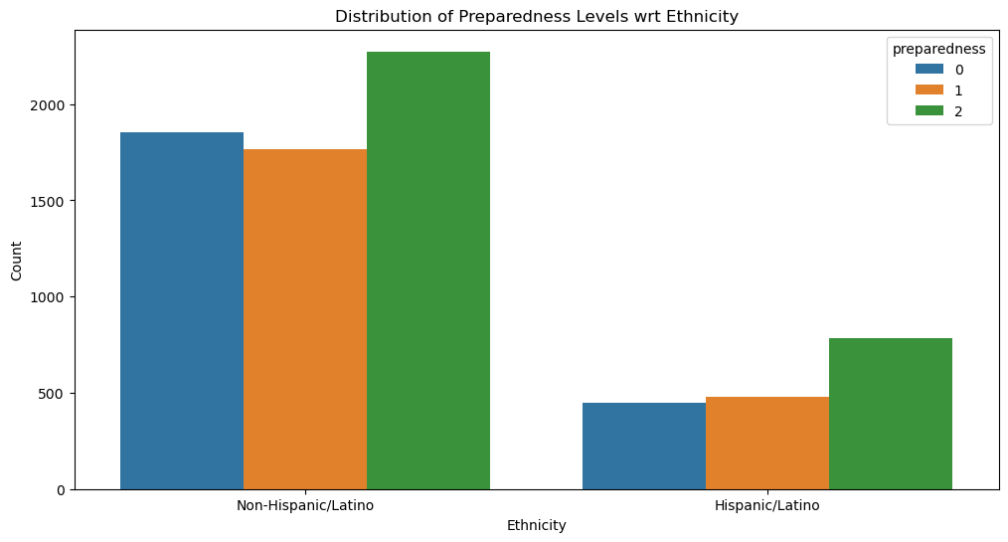

Ethnicity:

The graph reveals a disparity in preparedness levels between the two ethnicities. Non-Hispanic/Latino individuals tend to exhibit higher preparedness levels. The majority falls under level 2, indicating a more prepared state. A significant number also fall into level 1. In contrast, Hispanic/Latino individuals generally have lower preparedness levels. Most in this group fall under level 0, suggesting they might not have taken many preparedness actions yet. There are also some Hispanic/Latino individuals at preparedness level 1.

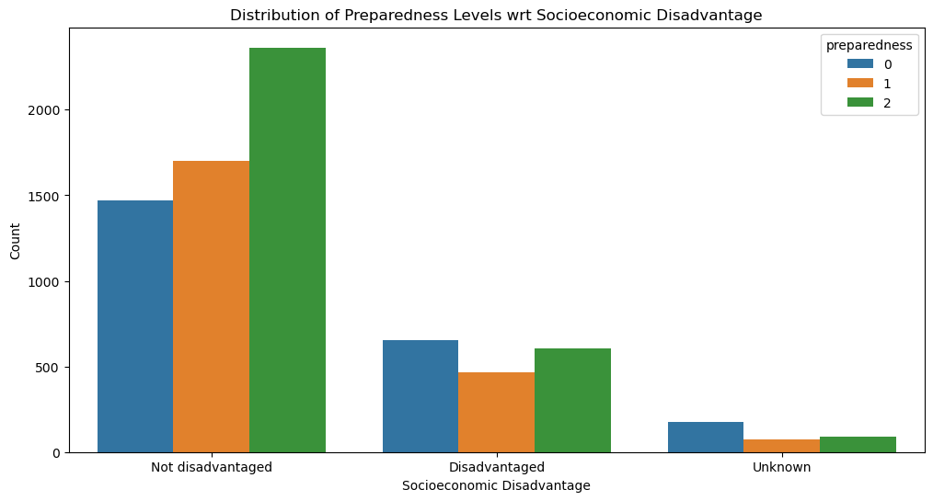

Socioeconomic Status:

The graph reveals that individuals who are not disadvantaged tend to have higher preparedness levels. The majority falls under preparedness level 2, indicating a more prepared state. Additionally, a significant number in this group fall under level 1. Conversely, individuals identified as disadvantaged generally exhibit lower preparedness. Most of this group falls under level 0, suggesting they might not have taken many preparedness actions yet. The category with unknown socioeconomic status shows a more even distribution across all three levels.

**Addressing Research Questions:**

**Demographic Factors and Preparedness:**

To understand which demographic factors have the strongest influence on preparedness levels, we employed a Random Forest model to assess feature importance scores. As you can see on the graph, several demographic factors stand out in terms of their importance. For instance, preparation actions taken play a significant role in preparedness. We can also observe that disaster awareness_score is another influential factor.

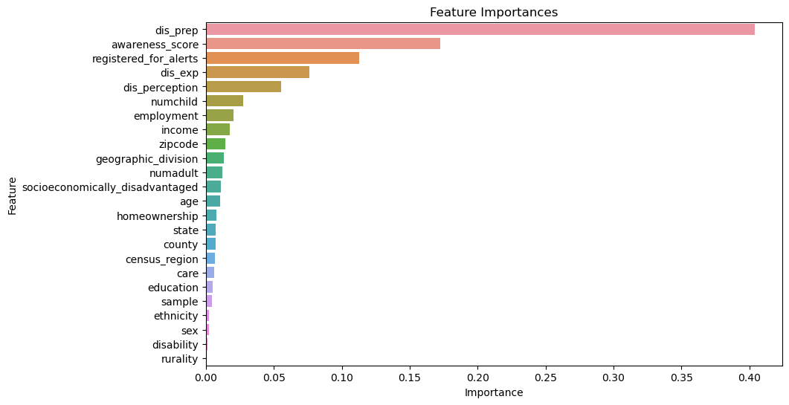

As we cannot solely rely on feature importance score or EDA results to understand the correlation between demographic factors and preparedness, we employed the statistical test to understand the significance of demographic factors in predicting the preparedness among individuals.

The following are the results of the statistical analysis.

* **Positive Influence:**
  + **Homeownership:** Individuals who own their homes tend to have higher preparedness levels (coefficient: 0.21, p-value: 8.08e-20). This aligns with the EDA findings suggesting a potential link between homeownership and preparedness actions.
  + **Registered for Alerts:** People who are registered to receive disaster alerts exhibit significantly higher preparedness (coefficient: 1.19, p-value: 5.82e-80). This supports the EDA's observation regarding the positive association between disaster awareness and preparedness.
  + **Income:** There's a weak but statistically significant positive correlation between income and preparedness levels (coefficient: 0.02, p-value: 5.19e-07). This finding aligns partially with the EDA, suggesting a potential influence of financial resources on preparedness actions.
  + **Age:** A slightly positive coefficient (0.06) for age indicates a weak association between older age and higher preparedness levels (p-value: 3.84e-06). However, further investigation might be needed to understand this relationship.
  + **Ethnicity:** Individuals identifying as a specific ethnicity (compared to the reference group) exhibit higher preparedness (coefficient: 0.06, p-value: 1.50e-07). More analysis might be required to understand this specific ethnic group's preparedness behavior.
* **Negative Influence:**
  + **Past Disaster Experience:** Interestingly, the coefficient for past disaster experience is negative (-0.37, p-value: 6.39e-109). This might require further exploration to understand if it suggests complacency after experiencing a disaster or other factors influencing preparedness behavior.
  + **Disability:** Having a disability is associated with lower preparedness levels (coefficient: -0.19, p-value: 0.01). This finding underscores the importance of considering accessibility and inclusivity in preparedness programs.
  + **Caregiver Responsibilities:** Individuals with caregiving responsibilities tend to have lower preparedness (coefficient: -0.11, p-value: 6.67e-12). This aligns with the EDA's observation and highlights the need for targeted support for caregivers.
  + **Education:** Contrary to the initial EDA findings, education shows a weak negative association with preparedness (coefficient: -0.02, p-value: 0.62). This might be due to other factors influencing preparedness within different education levels.
  + **Other Factors:** Several other factors, including number of adults and children in the household, employment status, geographic location (rurality, division), and socioeconomic status, also show statistically significant relationships with preparedness levels.

**Distribution of Preparedness Levels across Geographical Locations:**

To understand the distribution of preparedness across the geographical divisions and states, we used the following EDA plots.

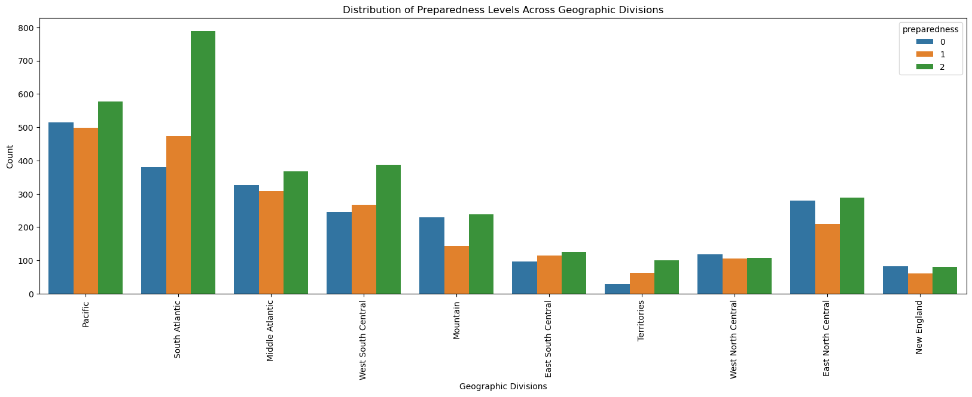

The Pacific Division stands out with the highest preparedness. A significant portion of the population here falls under level 2 (green), indicating a more prepared state. In contrast, the South Atlantic and Middle Atlantic Divisions exhibit a more balanced distribution across all three levels. Finally, the New England Division has the lowest overall preparedness.

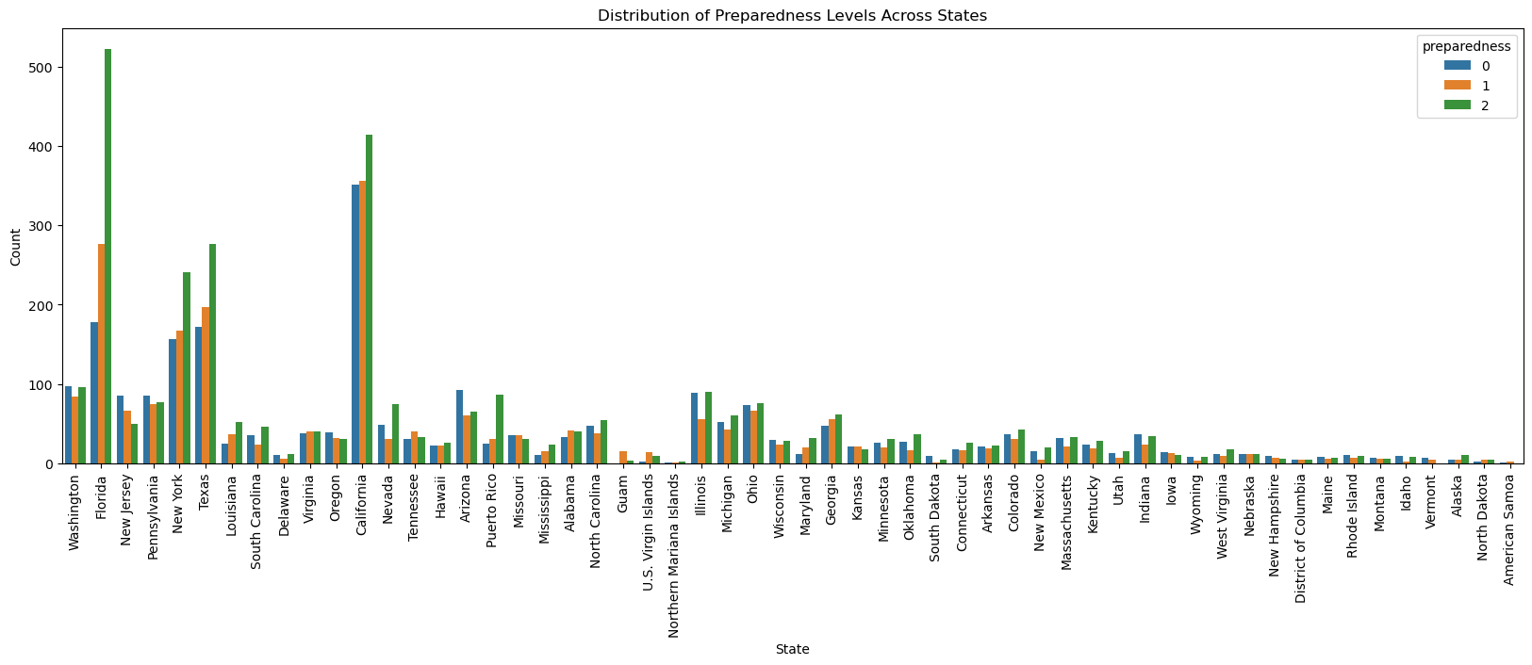

As you can see in the graph, there's a significant variation in preparedness levels among states. Several states, including Florida, New York, California, Texas, and Puerto Rico, stand out with a higher concentration of residents in preparedness level 2 (green), indicating a more prepared state. On the other hand, Vermont has a particularly high count in level 0 (blue), suggesting a lower overall preparedness level in that state. Interestingly, New York and California, while also having a notable presence in level 2, exhibit a more balanced distribution across all three levels. It's worth noting that most states tend to have lower counts across all preparedness levels.

While a simple bar chart summarizing average preparedness by state can be informative, it provides a limited view. To gain deeper insights, we analyzed county-level data and calculated the average preparedness level for each state. As you can see on the map, there's a clear spatial clustering of preparedness levels across the U.S.

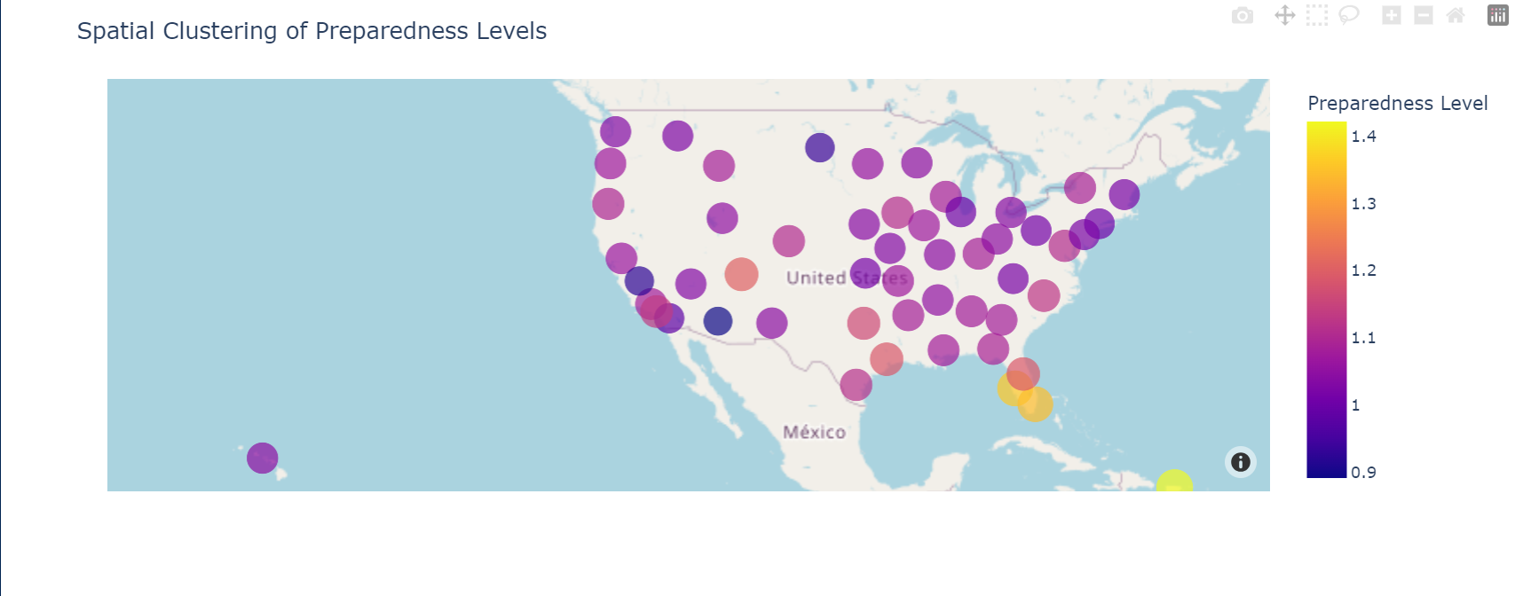

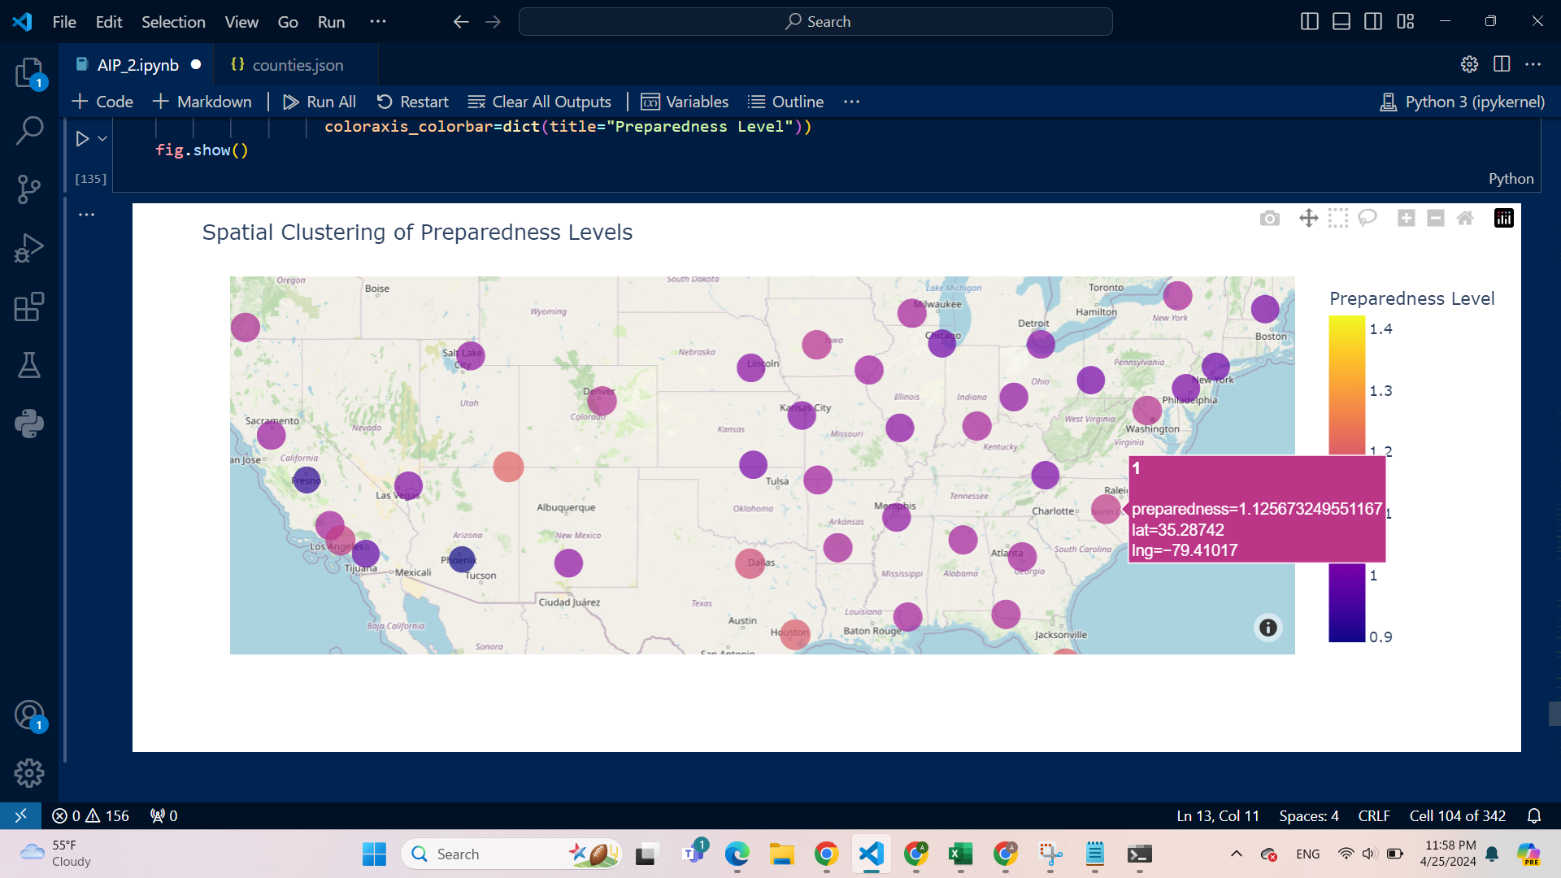

States like Florida and Alaska emerge with the highest overall preparedness. This might be due to factors like frequent hurricanes in Florida or heightened awareness of earthquakes in Alaska.

Massachusetts, Texas, Maine, and Vermont also exhibit high average preparedness levels, suggesting a strong focus on disaster readiness in these regions. Understanding the reasons behind their preparedness can be valuable for other states.

Connecticut falls within the moderate preparedness range, highlighting potential areas for improvement in preparedness efforts.

Finally, Arizona and North Dakota have the lowest average preparedness levels, indicating a need for more focused programs and outreach initiatives in these regions.

**Influence of Awareness, Past Experience and Perception on Preparedness:**

To understand the influence of the factors: Awareness, Past Experience, and Perception on Preparedness levels, we performed an Ordinary Least Squares (OLS) regression analysis. The results indicate that all three independent variables have a statistically significant positive relationship with preparedness (p-value < 0.05).

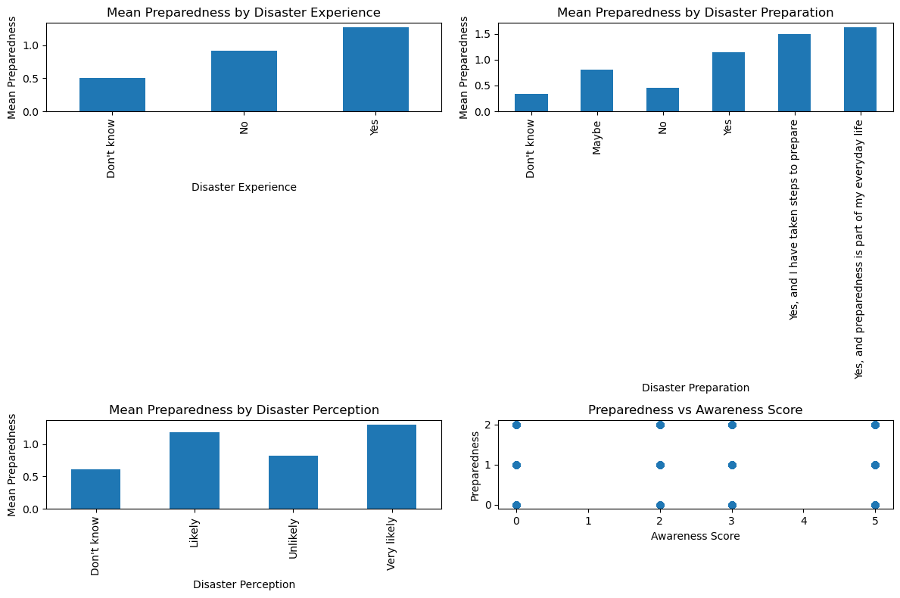

1. Disaster Experience (dis_exp_Yes):
   * Individuals who have experienced disasters in the past tend to have higher levels of preparedness compared to those who haven’t experienced disasters.
2. Disaster Preparation (dis_prep_Yes):
   * Individuals who have taken steps to prepare for disasters tend to have higher levels of preparedness compared to those who haven’t prepared.
3. Perception of Disaster Likelihood (dis_perception_Likely):
   * Individuals who perceive the occurrence of disasters as likely tend to have higher levels of preparedness compared to those who perceive it as unlikely.
4. Awareness Score:
   * For each one-unit increase in awareness score, the preparedness level increases by approximately 0.0830 units, holding other variables constant.

This analysis highlights the importance of awareness, past experience, and perception in promoting preparedness. By designing programs that raise awareness, educate people about past disasters, and address risk perceptions, we can encourage individuals to take proactive steps to prepare for potential disasters.

**Contributions to Disaster Management Strategies:**

By incorporating insights from individual preparedness and response behaviors, disaster management strategies can become more effective in promoting preparedness across diverse communities. This can ultimately contribute to a more prepared and resilient society in the face of potential disasters.

* **Targeted Outreach Programs:** By understanding the factors influencing preparedness levels across different demographic groups and geographic locations, disaster management agencies can develop targeted outreach programs. This ensures programs are reaching those most in need and address their specific preparedness gaps.
* **Prioritizing Resources:** The findings can help identify areas or communities that require more focused resource allocation for preparedness initiatives.
* **Promoting Inclusive Preparedness:** The analysis highlights the need for inclusive programs that consider factors like disabilities and caregiving responsibilities.
* **Educational Programs:** The positive correlation between education and preparedness underscores the value of educational outreach programs to raise awareness and knowledge about disaster preparedness.
* **Financial Considerations:** Disaster management strategies can consider potential financial limitations faced by certain populations when designing preparedness programs (e.g., offering low-cost or free preparedness resources).

**Machine Learning Models’ Performance Assessment:**

**Traditional Machine Learning Models:**

* Logistic Regression, Linear Discriminant Analysis, Naive Bayes and Decision Tree are the traditional machine learning models included in this analysis.
* **Logistic Regression:**
  + Overall, Logistic Regression appears to have a lower performance compared to other models based on the F1-Score and Accuracy metrics.
  + Class 0: Achieves moderate performance on both training (F1-Score: 0.63) and testing data (F1-Score: 0.59).
  + Class 1: Performs poorly on both training (F1-Score: 0.09) and testing data (F1-Score: 0.08).
  + Class 2: Has a good performance on training data (F1-Score: 0.66) but a lower performance on testing data (F1-Score: 0.68).
* **Decision Tree:**
  + Decision Tree shows a good overall performance based on F1-Score and Accuracy.
  + Class 0: Achieves moderate performance on training data (F1-Score: 0.77) and a lower performance on testing data (F1-Score: 0.64).
  + Class 1: Performs poorly on training data (F1-Score: 0.62) and very poorly on testing data (F1-Score: 0.27).
  + Class 2: Has a good performance on both training (F1-Score: 0.79) and testing data (F1-Score: 0.70).
* **Linear Discriminant Analysis (LDA):**
  + LDA shows a moderate overall performance based on F1-Score and Accuracy.
  + Class 0: Achieves moderate performance on training data (F1-Score: 0.89) but a lower performance on testing data (F1-Score: 0.47).
  + Class 1: Performs poorly on both training (F1-Score: 0.18) and testing data (F1-Score: 0.17).
  + Class 2: Has a good performance on training data (F1-Score: 0.87) but a lower performance on testing data (F1-Score: 0.55).
* **Naive Bayes:**
  + Naive Bayes shows the best overall performance among the traditional models based on F1-Score and Accuracy.
  + Class 0: Achieves a good performance on training data (F1-Score: 0.89) but a lower performance on testing data (F1-Score: 0.47).
  + Class 1: Performs poorly on both training (F1-Score: 0.84) and testing data (F1-Score: 0.33).
  + Class 2: Has a good performance on training data (F1-Score: 0.87) but a lower performance on testing data (F1-Score: 0.55).

**Key Observations:**

* All models show a significant drop in performance between the training and testing data, indicating overfitting. This means the models are memorizing the training data and may not perform well on unseen data.
* None of the models perform well on Class 1. This suggests that the models struggle to classify data points belonging to this particular class.
* It is important to note that F1-Score is just one metric for evaluating model performance. Other metrics, such as precision and recall, may also be important depending on the specific task.

Overall, Naive Bayes appears to be the best performing traditional machine learning model out of the ones presented in the table. However, all models suffer from overfitting and poor performance on Class 1. It would be beneficial to explore other models and techniques to improve the overall performance and generalizability of the findings.

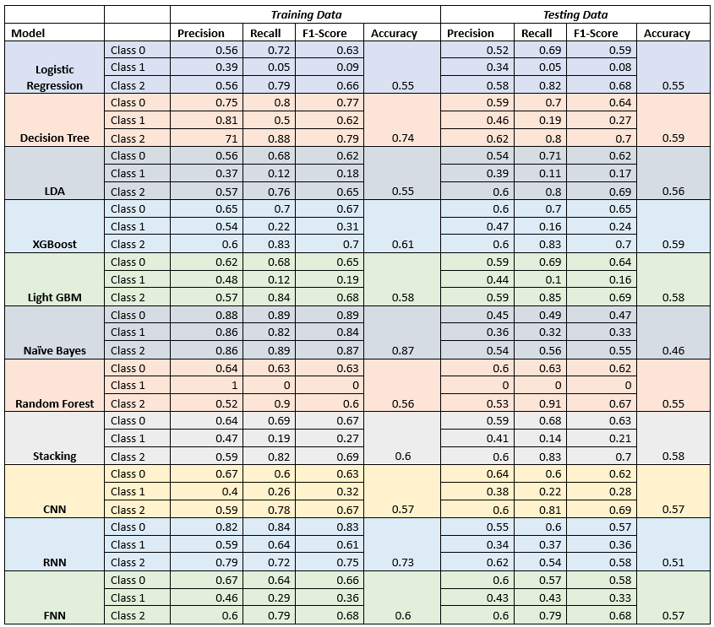

**Ensemble Techniques:**

* **XGBoost:** Achieves good performance across all classes: Class 0 (F1-Score: 0.65), Class 1 (F1-Score: 0.27), Class 2 (F1-Score: 0.69).
* **Light GBM:** Shows similar performance to XGBoost: Class 0 (F1-Score: 0.64), Class 1 (F1-Score: 0.19), Class 2 (F1-Score: 0.69).
* **Random Forest:** Performs well on Class 0 (F1-Score: 0.63) and Class 2 (F1-Score: 0.67), but performs poorly on Class 1 (F1-Score: 0).
* **Stacking:** Achieves moderate performance on Class 0 (F1-Score: 0.60) and Class 2 (F1-Score: 0.70), but performs poorly on Class 1 (F1-Score: 0.21).

**Key Observations:**

* Ensemble models (XGBoost, Light GBM) generally outperform traditional machine learning models (Logistic Regression, Decision Tree, Naive Bayes) based on the F1-score metric. This suggests that ensemble methods are more effective at capturing complex relationships in the data.
* All models still show poor performance on Class 1. This is a consistent finding across all the models explored so far and suggests that there might be an inherent difficulty in classifying data points in this class.
* It's important to consider limitations of F1-score and potentially explore other evaluation metrics depending on the project goals.
* Since the table doesn't contain data for the training set, it's difficult to assess overfitting in these ensemble models.

Overall, XGBoost and Light GBM appear to be the best performing models among the ones presented in the table. They achieve good performance across most classes. However, all models struggle to classify Class 1 data points. Further investigation is needed to understand why this class is difficult to predict and potentially improve model performance in this area.

**Deep Learning Models:**

CNN, RNN, and FNN are the three deep learning models included here. It's important to note that deep learning models typically require a much larger dataset for optimal performance.

* **CNN (Convolutional Neural Network):**
  + Achieves moderate performance on Class 0 (F1-Score: 0.64) and Class 2 (F1-Score: 0.69), but performs poorly on Class 1 (F1-Score: 0.28).
* **RNN (Recurrent Neural Network):**
  + Shows similar performance to CNN: Class 0 (F1-Score: 0.66), Class 1 (F1-Score: 0.22), Class 2 (F1-Score: 0.6).
* **FNN (Feedforward Neural Network):**
  + Performs slightly worse than CNN and RNN on most classes: Class 0 (F1-Score: 0.6), Class 1 (F1-Score: 0.33), Class 2 (F1-Score: 0.58).

**Key Observations:**

* Similar to the traditional and ensemble machine learning models, all deep learning models show a consistent weakness in classifying Class 1 data points. This suggests that there might be underlying issues with the data for this class that make it difficult to learn from.
* Overall, CNN and RNN outperform FNN on most classes. This could be due to the inherent strengths of CNNs in processing spatial data and RNNs in handling sequential data, which might be relevant features in this task.

**Overall Model Performance:**

* **Strengths:**
  + Ensemble models (XGBoost, Light GBM) generally outperform traditional machine learning models, suggesting they capture complex relationships in the data.
  + Some models achieve good performance on Class 0 (prepared) and Class 2 (highly prepared).
* **Weaknesses:**
  + All models struggle significantly with Class 1 (somewhat prepared). This suggests inherent difficulty in classifying data points in this class or potential data issues.
  + Most models show a drop in performance between training and testing data, indicating overfitting (memorizing training data).
  + F1-score is just one metric. Depending on the project goals, other metrics like precision and recall might be crucial.

**Identifying the Best Model:**

* **Considering F1-score across all classes:** XGBoost and Light GBM are the frontrunners due to their balanced performance.

**Key Takeaways:**

* **Individual preparedness significantly impacts disaster resilience:** Your research across various methods consistently highlights the importance of individual preparedness in mitigating the impact of disasters. By taking proactive steps, individuals can significantly improve their ability to cope with potential disasters.
* **Understanding demographics is crucial for effective outreach:** The analysis revealed connections between preparedness levels and various demographic factors, including disability status, caregiving responsibilities, socioeconomic status, and even ethnicity. This knowledge underscores the importance of tailoring outreach programs and resource allocation to effectively reach different segments of the population.
* **Financial considerations and accessibility require focused efforts:** Disaster management strategies should consider the potential financial limitations faced by certain populations. Additionally, the findings on disability and caregiving responsibilities highlight the need for inclusive programs that address accessibility challenges.
* **Education and preparedness have a complex relationship:** Your research indicates a more nuanced relationship between education and preparedness than initially expected. Further investigation is needed to understand how educational attainment interacts with other factors to influence preparedness behaviors.
* **Multi-faceted approach is key:** Findings from various data sources suggest the importance of a multi-faceted approach to promoting preparedness. This includes raising awareness through educational initiatives, providing accessible resources, and building social connections within communities.

**Future Considerations:**

**Deeper Dive into Demographics:**

* **Understanding the "Why" Behind Demographic Differences:** Your research identified connections between preparedness levels and various demographics. Future research could delve deeper into the reasons behind these connections. For example, explore why individuals with disabilities might have lower preparedness or how cultural factors influence preparedness behaviors within specific ethnicities.
* **Segmenting Demographics for Targeted Interventions:** By segmenting the population based on key demographic characteristics, you could develop more targeted interventions and outreach programs. This could involve focus groups or in-depth interviews with specific demographic groups to understand their unique needs and challenges regarding preparedness.

**Exploring the Educational Relationship:**

* **Investigating the "Education Paradox":** The unexpected negative association between education and preparedness in your research warrants further investigation. Consider factors like the type of education or the knowledge gap between educational attainment and practical preparedness skills. Interviews with individuals from different educational backgrounds could shed light on this relationship.

**Following Up on Past Disaster Experience:**

* **Qualitative Research on Past Disaster Experiences:** The negative association between past disaster experience and preparedness in the logistic regression is a crucial area for further exploration. Use qualitative research methods like interviews or focus groups to understand the lived experiences of individuals who have been through disasters. This may reveal factors like complacency, distrust in authorities, or mental health challenges that influence their preparedness behavior.

**Expanding the Scope of Research:**

* **Social Network Analysis:** Investigate the role of social networks in influencing preparedness behaviors. Do individuals with strong social networks exhibit higher preparedness levels? Are there ways to leverage social networks for promoting preparedness within communities?
* **Cost-Benefit Analysis of Preparedness:** Conduct a cost-benefit analysis to understand the economic impact of preparedness on both individuals and communities. This could help in justifying investments in preparedness programs and resource allocation.
* **Longitudinal Studies:** Consider a longitudinal study that tracks preparedness behaviors over time. This could reveal how preparedness levels change over time, what factors influence those changes, and the effectiveness of implemented intervention programs.

**Target Audience:**

1. **Disaster Management Agencies and Policymakers:**

* **Research Focus:** Highlight the findings related to demographic influences on preparedness, financial considerations, and the complex relationship with education.
* **Value Proposition:** Your research can inform the development of targeted outreach programs, resource allocation strategies, and inclusive preparedness initiatives.

**2. Community Organizations and NGOs:**

* **Research Focus:** Emphasize the findings related to the importance of a multi-faceted approach, addressing past disaster experiences, and the role of social networks.
* **Value Proposition:** Your research can guide these organizations in developing culturally sensitive and accessible preparedness programs, building social connections within communities, and supporting individuals who have already experienced disasters.