STRUCTURE_1

1)

#include<stdio.h>

struct student

{

int rno;

char name[30];

int age;

int mark[3];

};

int main()

{

struct student s={1,"Amrita",19,{97,87,91}};

printf("%d ",s.rno);

printf("%s ",s.name);

printf("%d ",s.age);

printf("%d %d %d",s.mark[0],s.mark[1],s.mark[2]);

}

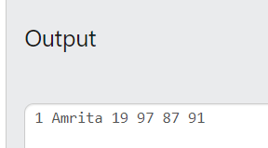

2)

#include<stdio.h>

struct student

{

int rno;

char name[30];

int age;

};

int main()

{

int i;

struct student s[5];

for (i=0;i<5;i++)

{

scanf("%d",&s[i].rno);

scanf("%s ",s[i].name);

scanf("%d",&s[i].age);

}

printf("%d ",s[1].rno);

printf("%s ",s[1].name);

printf("%d ",s[1].age);

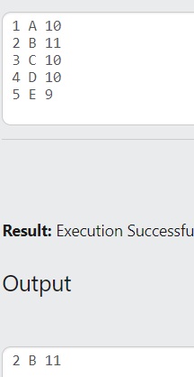}

3)

#include<stdio.h>

struct date

{

int date;

char day[10];

char month[30];

int year;

};

int main()

{

int i;

struct date d={1,"Sunday","January",2024};

printf("%d ",d.date);

printf("%s ",d.day);

printf("%s ",d.month);

printf("%d ",d.year);

}

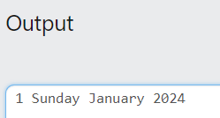

4)

#include<stdio.h>

struct student

{

int rno;

char name[30];

int age;

int mark[3];

};

int main()

{

int n,i;

scanf("%d",&n);

struct student s[n];

for (i=0;i<n;i++)

{

scanf("%d",&s[i].rno);

scanf("%s ",s[i].name);

scanf("%d",&s[i].age);

scanf("%d%d%d",&s[i].mark[0],&s[i].mark[1],&s[i].mark[2]);

}

for (i=0;i<n;i++)

{

printf("%d ",s[i].rno);

printf("%s ",s[i].name);

printf("%d ",s[i].age);

printf("%d,%d,%d\n",s[i].mark[0],s[i].mark[1],s[i].mark[2]);

}

}

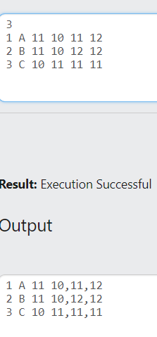

5)

#include<stdio.h>

#include<string.h>

struct book

{

int bno;

char bname[30];

char author[30];

int volume;

int year;

};

int main()

{

struct book b1;

scanf("%d",&b1.bno);

scanf("%s ",b1.bname);

scanf("%s ",b1.author);

scanf("%d",&b1.volume);

scanf("%d",&b1.year);

printf("Book Number-%d\n",b1.bno);

printf("Book Name-%s\n",b1.bname);

printf("Author Name-%s\n",b1.author);

printf("Volume Number-%d\n",b1.volume);

printf("Year of publish-%d",b1.year);

}

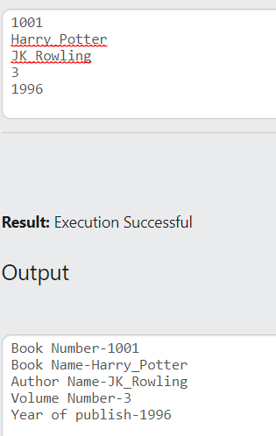

6)

#include<stdio.h>

#include<string.h>

struct operation

{

int a;

int b;

int sum;

int diff;

int pro;

float q;

};

int main()

{

struct operation x;

char ch;

scanf("%d",&x.a);

scanf("%d",&x.b);

scanf(" %c",&ch);

if (ch=='+')

{

x.sum=x.a+x.b;

printf("Sum=%d",x.sum);

}

else if (ch=='-')

{

x.diff=x.a-x.b;

printf("Difference=%d",x.diff);

}

else if(ch=='*')

{

x.pro=x.a*x.b;

printf("Product=%d",x.pro);

}

else if(ch=='/')

{

x.q=x.a/x.b;

printf("Quotient=%.2f",x.q);

}

}

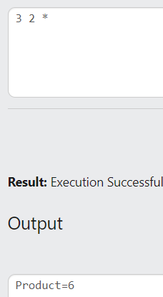

7)

#include<stdio.h>

#include<string.h>

struct state

{

char state_name[30];

int dno;

int population;

};

int main()

{

struct state s[2];

int i;

for(i=0;i<2;i++)

{

scanf("%s ",s[i].state_name);

scanf("%d",&s[i].dno);

scanf("%d",&s[i].population);

}

for(i=0;i<2;i++)

{

printf("%s ",s[i].state_name);

printf("%d ",s[i].dno);

printf("%d\n",s[i].population);

}

}

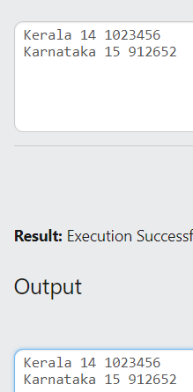

8)

#include<stdio.h>

#include<string.h>

struct time_struct

{

int hour;

int minute;

int second;

};

void display(struct time_struct t)

{

printf("%d:%d:%d",t.hour,t.minute,t.second);

}

int main()

{

struct time_struct t;

scanf("%d",&t.hour);

scanf("%d",&t.minute);

scanf("%d",&t.second);

display(t);

}

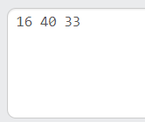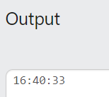

9)

#include<stdio.h>

#include<string.h>

struct time_struct

{

int hour;

int minute;

int second;

};

void difference(struct time_struct t1,struct time_struct t2)

{

struct time_struct t3;

int diff=(t1.hour*3600+t1.minute*60+t1.second)-(t2.hour*3600+t2.minute*60+t2.second);

t3.hour=diff/3600;

diff=diff%3600;

t3.minute=diff/60;

diff=diff%60;

t3.second=diff;printf("Time difference=%d:%d:%d",t3.hour,t3.minute,t3.second);

}

int main()

{

struct time_struct t1,t2;

scanf("%d",&t1.hour);

scanf("%d",&t1.minute);

scanf("%d",&t1.second);

scanf("%d",&t2.hour);

scanf("%d",&t2.minute);

scanf("%d",&t2.second);

difference(t1,t2);

}

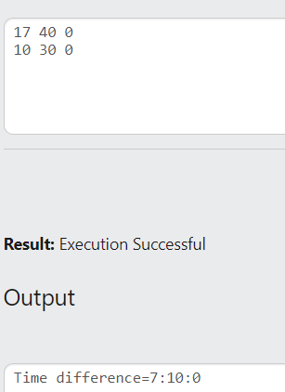

10)

#include<stdio.h>

#include<string.h>

struct distance

{

int feet;

int inch;

};

void add(struct distance d1,struct distance d2)

{

struct distance d3;

d3.inch=(d1.inch+d2.inch)%12;

d3.feet=(d1.feet+d2.feet)+(d1.inch+d2.inch)/12;

printf("Total distance=%dfeet+%dinch",d3.feet,d3.inch);

}

int main()

{

struct distance d1,d2;

scanf("%d",&d1.feet);

scanf("%d",&d1.inch);

scanf("%d",&d2.feet);

scanf("%d",&d2.inch);

add(d1,d2);

}

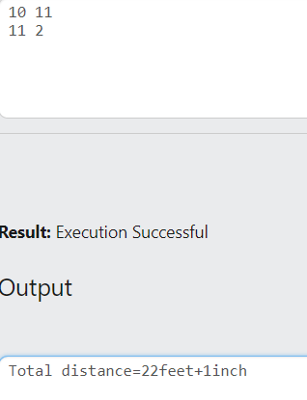

11)

#include<stdio.h>

#include<string.h>

struct datee

{

int date;

char day[10];

char month[10];

int year;

};

void compare(struct datee d1,struct datee d2)

{

if (d1.date==d2.date&&d1.year==d2.year&&strcmp(d1.day,d2.day)==0&&strcmp(d1.month,d2.month)==0)

printf("Dates are equal");

else

printf("Dates are not equal");

}

int main()

{

struct datee d1,d2;

scanf("%d",&d1.date);

scanf("%s ",&d1.day);

scanf("%s ",&d1.month);

scanf("%d",&d1.year);

scanf("%d",&d2.date);

scanf("%s ",&d2.day);

scanf("%s ",&d2.month);

scanf("%d",&d2.year);

compare(d1,d2);

}

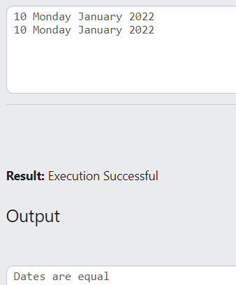

12)

#include<stdio.h>

#include<string.h>

struct student

{

int mark[3];

float avg;

char grade;

};

int main()

{

int i;

struct student s;

for (i=0;i<3;i++)

{

scanf("%d",&s.mark[i]);

}

s.avg=(s.mark[0]+s.mark[1]+s.mark[2])/3;

if (s.avg>=95)

s.grade='O';

else if (s.avg>=85)

s.grade='A';

else if (s.avg>=75)

s.grade='B';

else if (s.avg>=65)

s.grade='C';

else if (s.avg>=55)

s.grade='D';

else

s.grade='F';

printf("Average=%.2f\n",s.avg);

printf("Grade=%c",s.grade);

}

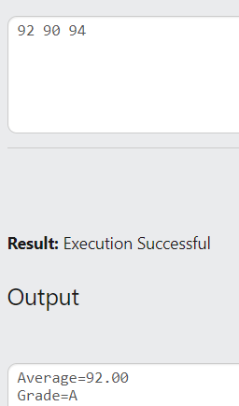

13)

#include<stdio.h>

#include<string.h>

struct complex

{

int real;

int img;

};

void display(struct complex c1,struct complex c2)

{

printf("Complex number 1=%d+%di\n",c1.real,c1.img);

printf("Complex number 2=%d+%di",c2.real,c2.img);

}

void add(struct complex c1,struct complex c2)

{

struct complex c3;

c3.real=c1.real+c2.real;

c3.img=c1.img+c2.img;

printf("Sum=%d+%di",c3.real,c3.img);

}

void sub(struct complex c1,struct complex c2)

{

struct complex c3;

c3.real=c1.real-c2.real;

c3.img=c1.img-c2.img;

printf("Difference=%d+%di",c3.real,c3.img);

}

int main()

{

int ch;

struct complex c1,c2;

scanf("%d%d",&c1.real,&c1.img);

scanf("%d%d",&c2.real,&c2.img);

scanf("%d",&ch);

if (ch==1)

display(c1,c2);

else if (ch==2)

add(c1,c2);

else if (ch==3)

sub(c1,c2);

}

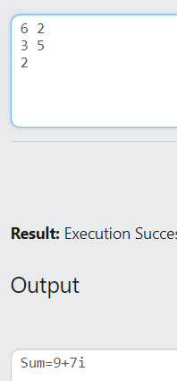

14)

15)

#include<stdio.h>

struct fraction

{

int num;

int deno;

};

int main()

{

struct fraction f1,f2;

scanf("%d",&f1.num);

scanf("%d",&f1.deno);

scanf("%d",&f2.num);

scanf("%d",&f2.deno);

if(f1.num/f1.deno==f2.num/f2.deno)

printf("0");

else if(f1.num/f1.deno<f2.num/f2.deno)

printf("-1");

else

printf("+1");

}

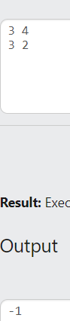

16)

#include<stdio.h>

struct coordinate

{

int x;

int y;

};

int main()

{

struct coordinate p;

scanf("%d",&p.x);

scanf("%d",&p.y);

if(p.x>=0&&p.y>=0)

printf("1");

else if(p.x<0&&p.y>=0)

printf("2");

else if(p.x<0&&p.y<0)

printf("3");

else if(p.x>=0&&p.y<0)

printf("4");

}

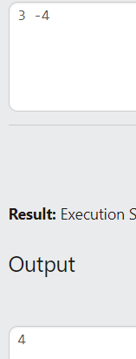

17)

#include<stdio.h>

#include<math.h>

struct coordinate

{

int x;

int y;

};

int main()

{

float d;

struct coordinate p1,p2;

scanf("%d",&p1.x);

scanf("%d",&p1.y);

scanf("%d",&p2.x);

scanf("%d",&p2.y);

d=pow(pow((p2.x-p1.x),2)+pow((p2.y-p1.y),2),0.5);

printf("%.2f",d);

}

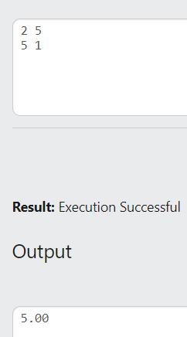

18)

#include<stdio.h>

struct employee

{

int id;

char name[30];

char city[30];

float bp;

float da;

float ded;

float ts;

};

void salary(struct employee e)

{

e.da=20*e.bp/100;

e.ded=5*e.bp/100;

e.ts=e.bp+e.da-e.ded;

printf("%.2f",e.ts);

}

int main()

{

struct employee e;

scanf("%d",&e.id);

scanf("%s ",e.name);

scanf("%s ",e.city);

scanf("%f",&e.bp);

salary(e);

}

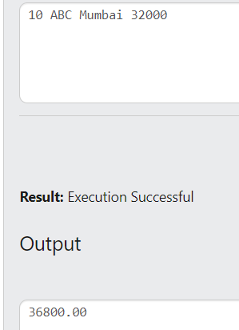

19)

#include<stdio.h>

struct dob

{

int date;

int month;

int year;

};

struct student

{

char name[30];

char rno[30];

struct dob d;

float cgpa;

};

void choice1(struct student s[],int n)

{

int i;

for(i=0;i<n;i++)

{

if (s[i].cgpa>8)

{

printf("%s ",s[i].name);

printf("%s ",s[i].rno);

printf("%d-%d=%d ",s[i].d.date,s[i].d.month,s[i].d.year);

printf("%.2f\n",s[i].cgpa);

}

}

}

void choice2(struct student s[],int n)

{

int i;

for(i=0;i<n;i++)

{

if (s[i].d.year>2000)

{

printf("%s ",s[i].name);

printf("%s ",s[i].rno);

printf("%d-%d=%d ",s[i].d.date,s[i].d.month,s[i].d.year);

printf("%.2f\n",s[i].cgpa);

}

}

}

void choice3(struct student s[],int n)

{

int i,min=s[0].cgpa,k=0;

for (i=1;i<n;i++)

{

if (s[i].cgpa<min)

{

min=s[i].cgpa;

k=i;

}

}

printf("%s",s[k].rno);

}

int main()

{

struct student s[5];

int i,ch;

for (i=0;i<5;i++)

{

scanf("%s ",s[i].name);

scanf("%s ",s[i].rno);

scanf("%d%d%d",&s[i].d.date,&s[i].d.month,&s[i].d.year);

scanf("%f",&s[i].cgpa);

}

scanf("%d",&ch);

if (ch==1)

choice1(s,5);

else if(ch==2)

choice2(s,5);

else if (ch==3)

choice3(s,5);

}

