CB.EN. U4CSE22311

STRINGS – SET 1

Q2) Write a program in C to separate individual characters from a string.

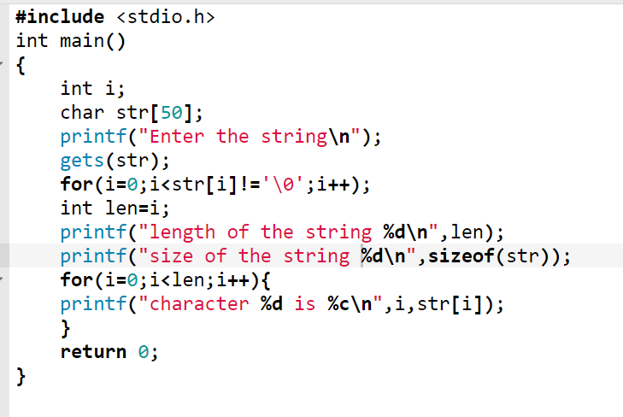

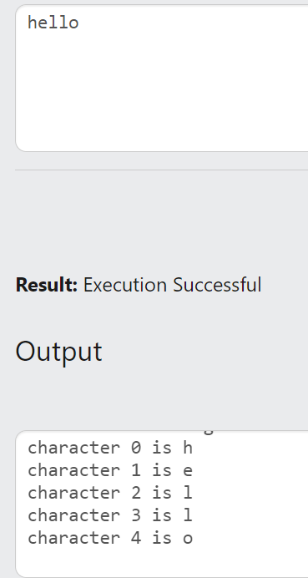

Q3) Write a program in C to print individual characters of a string in reverse order.

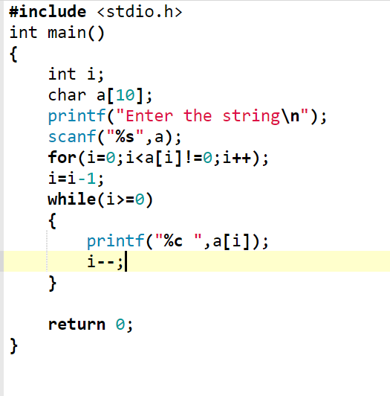

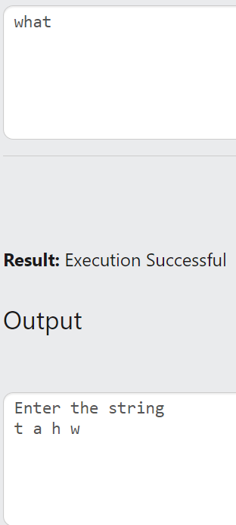

Q4) Write a C program to read and display the string using getchar and putchar function

#include<stdio.h>

int main()

{

char s[30],ch;

int i=0;

printf("enter the string");

while(ch!='\n')

{

ch=getchar();

s[i]=ch;

i++;

}

s[i]='\0';

int len;

for(i=0;s[i]!='\0';i++);

len=i;

for(i=0;i<len;i++)

{

putchar(s[i]);

}

return 0;

}

Q5) Write a C program to read and display the string using gets and puts function.

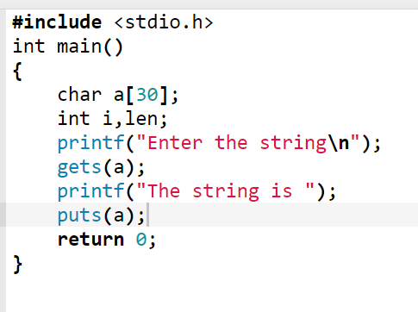

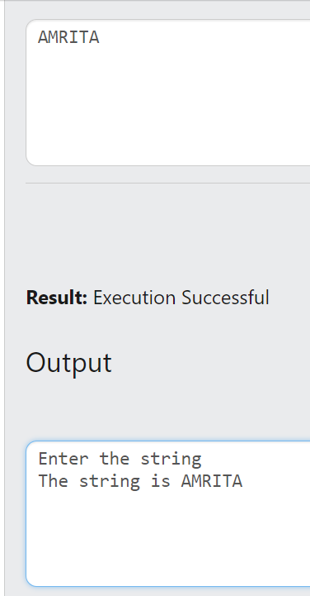

Q6) Write a program in C to count the total number of vowels or consonants in a string.

#include <stdio.h>

int main()

{

int i,c1=0,c2=0,len;

char str[50];

printf("Enter the string\n");

scanf("%s",str);

for(i=0;i<str[i]!='\0';i++);

len=i;

for(i=0;i<len;i++)

{

if((str[i]>='A'&&str[i]<='Z')||(str[i]>='a'&&str[i]<='z'))

{

if(str[i]=='a'||str[i]=='e'||str[i]=='i'||str[i]=='o'||str[i]=='u'||str[i]=='A'||str[i]=='E'||str[i]=='I'||str[i]=='O'||str[i]=='O'||str[i]=='U')

{

c1=c1+1;

}

else

{

c2=c2+1;

}

}

}

printf("The number of vowels is %d \n",c1);

printf("The number of consonants is %d",c2);

return 0;

}

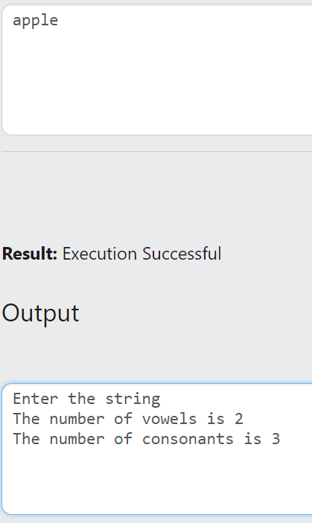

Q7) Write a program in C to find the frequency of a given character in a string.

#include <stdio.h>

int main()

{

int i,c=0,len;

char a[30];

char k;

printf("Enter the string\n");

gets(a);

printf("Enter the character frequency to be found\n");

scanf("%c",&k);

for(i=0;i<a[i]!='\0';i++);

len=i;

for(i=0;i<len;i++)

{

if (a[i]==k)

c=c+1;

}

printf("The frequency of %c is %d",k,c);

return 0;

}

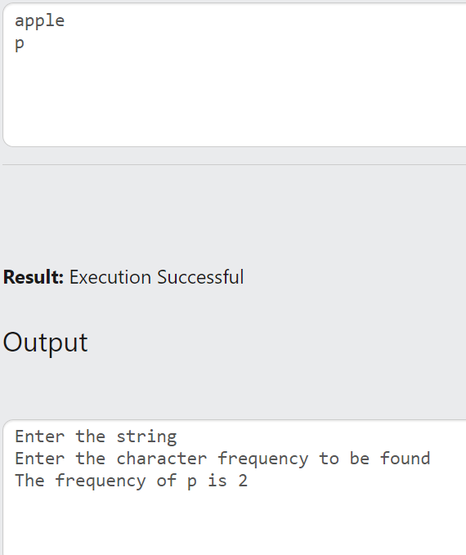

Q8) Write a C program to count the number of upper case and lowercase characters in a string

#include <stdio.h>

int main()

{

char a[30];

int i,len,c=0,b=0;

gets(a);

for(i=0;i<a[i]!='\0';i++);

len=i;

for(i=0;i<len;i++)

{

if(a[i]>='a'&&a[i]<='z')

{

c=c+1;

}

else if(a[i]>='A'&&a[i]<='z')

{

b=b+1;

}

}

printf("no of lowercase characters %d\n",c);

printf("np of uppercase characters %d",b);

return 0;

}

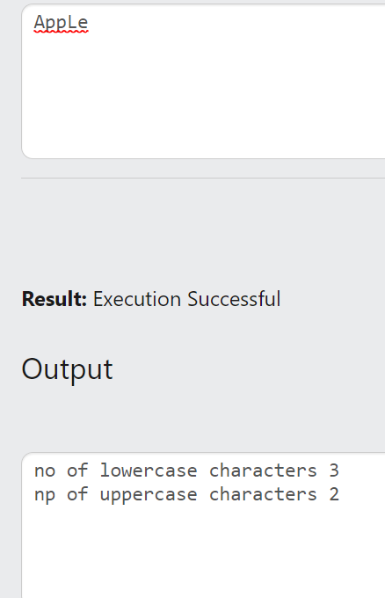

Q9) Write a C program to print the no of characters, digits and other symbols in a string

#include <stdio.h>

int main()

{

char a[30];

int i,len,c=0,b=0,d=0;

gets(a);

for(i=0;i<a[i]!='\0';i++);

len=i;

for(i=0;i<len;i++)

{

if((a[i]>='a'&&a[i]<='z')||(a[i]>='A'&&a[i]<='Z'))

{

c=c+1;

}

else if(a[i]>='0'&&a[i]<='9')

{

b=b+1;

}

else

d=d+1;

}

printf("no of characters %d\n",c);

printf("no of digits %d\n",b);

printf("no of symbols %d",d);

return 0;

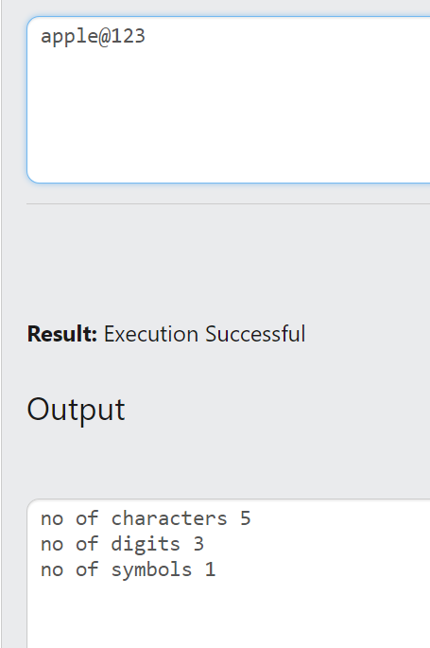

Q10) Input a lowercase string , Write a C program to convert the all the characters to Uppercase

#include <stdio.h>

int main()

{

char a[30];

int i,len;

printf("Enter the lowercase character\n");

gets(a);

for(i=0;i<a[i]!='\0';i++);

len=i;

for(i=0;i<len;i++)

{

if((a[i]>='a'&&a[i]<='z')||(a[i]>='A'&&a[i]<='Z'))

a[i]=a[i]-32;

}

printf("String is ");

puts(a);

return 0;

}

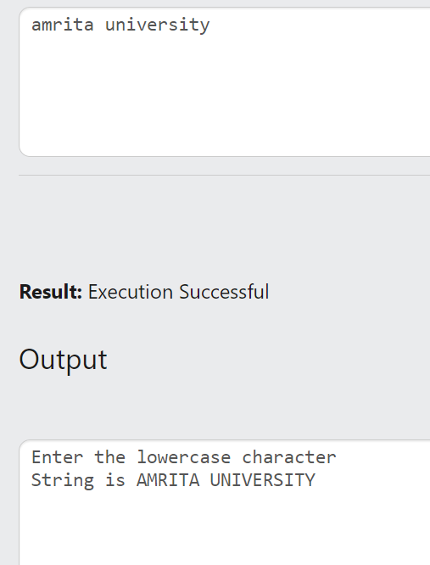

Q11) Input a uppercase string , Write a C program to convert the all the characters to lowercase

#include <stdio.h>

int main()

{

char a[30];

int i,len;

printf("Enter the uppercase character\n");

gets(a);

for(i=0;i<a[i]!='\0';i++);

len=i;

for(i=0;i<len;i++)

{

if((a[i]>='a'&&a[i]<='z')||(a[i]>='A'&&a[i]<='Z'))

a[i]=a[i]+32;

}

printf("String is ");

puts(a);

return 0;

}

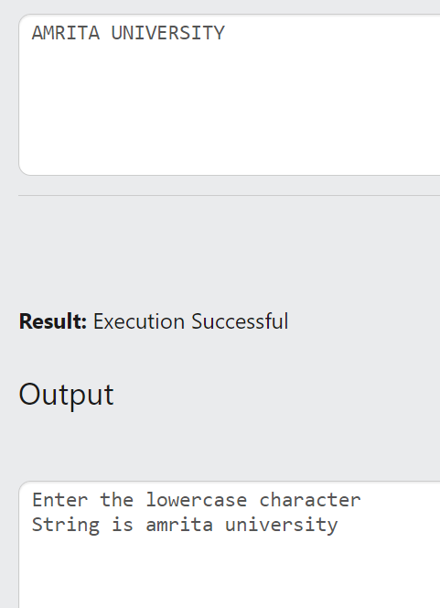

Q12) Write a program in C to copy one string to another string.

#include <stdio.h>

int main()

{

char a[30],str[30];

int i,len;

printf("Enter the string\n");

gets(a);

for(i=0;i<a[i]!='\0';i++);

len=i;

for(i=0;i<len;i++)

{

str[i]=a[i];

}

printf("String is ");

puts(str);

return 0;

}

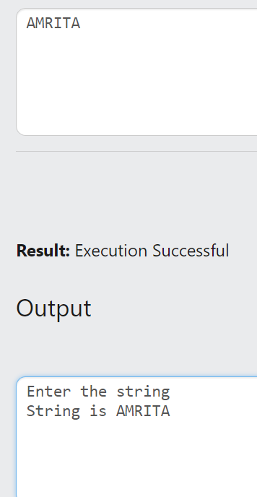

Q13) Check whether two strings are same or not.

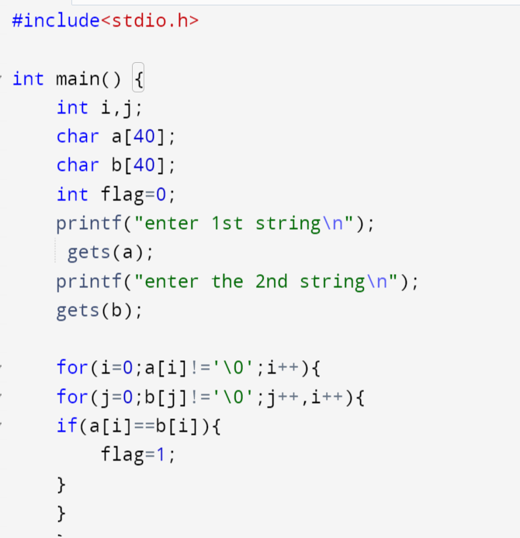

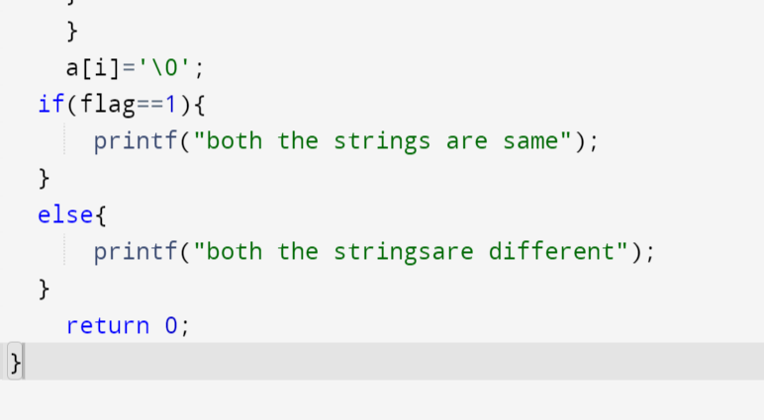

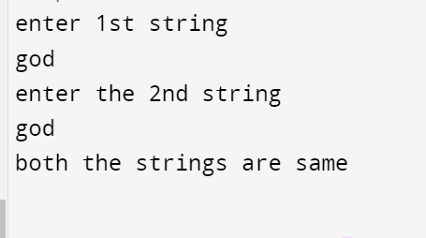

Q14) Concatenate two strings

