DDL of output table
create table if not exists tags(lookup_url_num longint, html_node varchar(500), html_tag varchar(100), html_left_sibling varchar(100), html_right_sibling varchar(100),html_parent varchar(100));
create table if not exists webpage(lookup_url_num longint, url varchar(100), source_url varchar(100), source_offset longint,source_length longint);
create table if not exists full_crawl_data(lookup_url_num longint, url varchar(100), source_url varchar(100), source_offset longint,source_length longint,html_node varchar(500), html_tag varchar(100), html_left_sibling varchar(100), html_right_sibling varchar(100),html_parent varchar(100));

DDL of input lookup table
create table if not exists news_manual_edit(url varchar(100), source_url varchar(100), source_offset longint, source_length longint,collected_by varchar(50));

Output tables and its details:

1.Tags:
Schema of table:
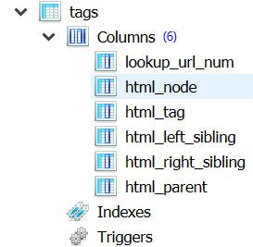

Count of table:
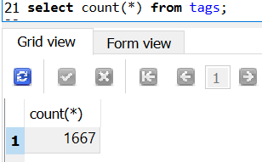

Data glimpse
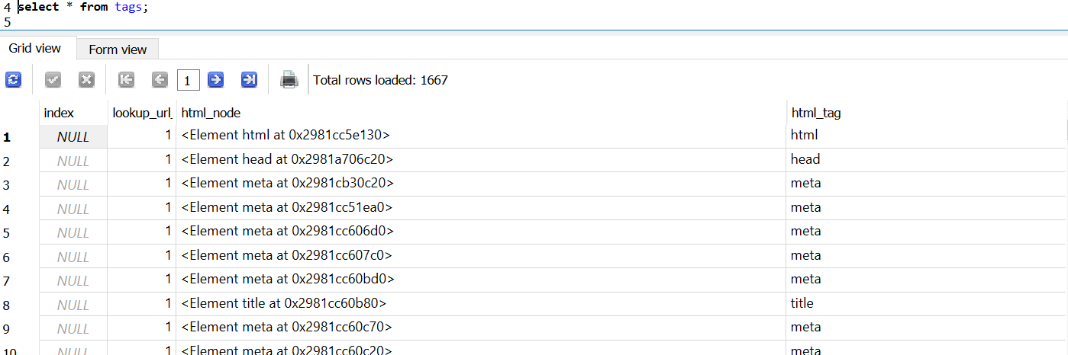

2.Webpage
Schema of table:

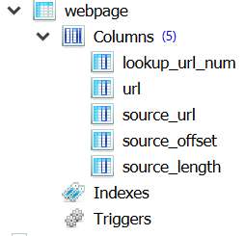

Count of table:
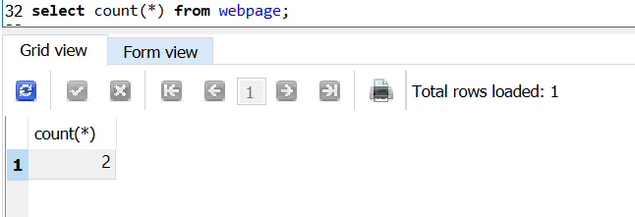

Data glimpse
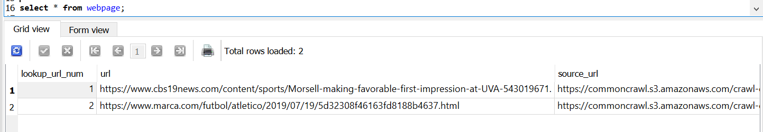

3. Crawl Full Data
Schema of table:

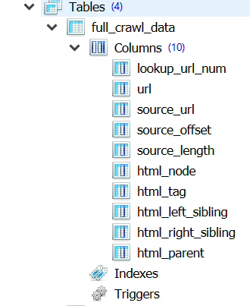

Count of table:
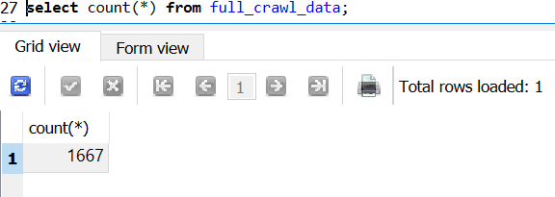
Data glimpse
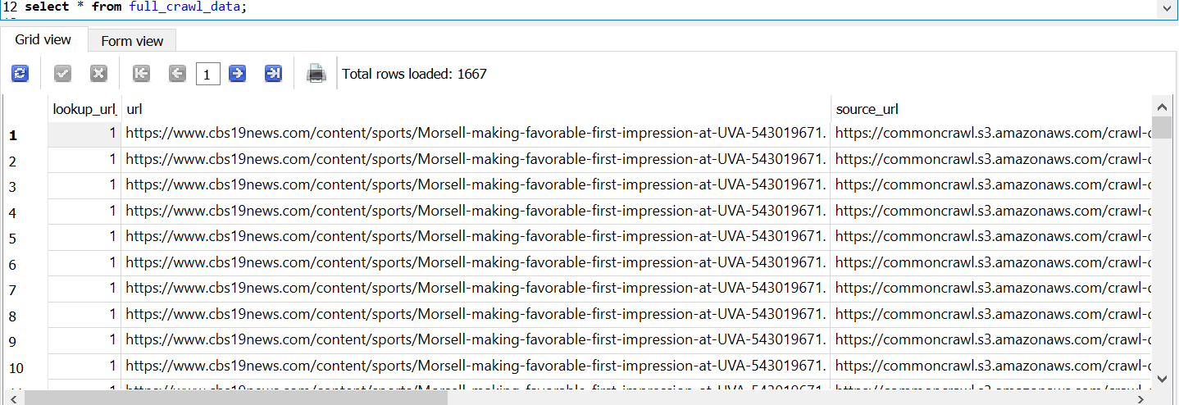

Output Full CSV Datasets:
The datasets are uploaded in GIT location as well if this do not open

