**Annexure 3**

**Software Requirements Specification**

**For Minor Project**

**Travelogue**



|  |  |
| --- | --- |
| **Prepared by:**  **Pooja Sharma(PCE15IT031)**  **Aparna Tyagi(PCE15IT007)** | **Guide:**  **Mrs.Sita Gupta**  **Asst. Professor, PCE** |
| **Department of Information Technology,**  **Poornima College of Engineering**  **October, Session – 2018-19**  **Table of Contents** | |

|  |  |
| --- | --- |
| Table of Contents | Page No. |
| 1. Introduction | 3 |
| 1.1 Purpose | 3 |
| 1.2 Feasibility | 4 |
| 2. Functional /Nonfunctional Requirements | 5 |
| 2.1 Functional Requirement | 5 |
| 2.2 Nonfunctional Requirements | 6 |
| 2.3 Technical Requirments ( Hardware /Software) | 7 |
| 3. System Features | 8 |
| 3.1 Module 1 | 8 |
| 3.1 Module 2 | 8 |
| 3.1 Module 3 | 8 |
| 4. Analysis Diagrams | 10 – 13 |
| 4.1 Use Case Diagram  4.2 Sequence Diagram  4.3 Activity Diagram  4.4 Project Schedule Diagram | 10  11  12  13 |
| 5. Other Requirements | 14 |
| 7. Appendices | 14 |
| 8. References | 14 |
| 9. Guide’s Comments | 14 |

|  |
| --- |
|  |
|  |

# 

# **Introduction**

## 

## **1.1 Purpose**

The purpose of this project is to create a web-based application that provides recommendations in regard to holiday destination best suited to customers based on analysis of travel data. The analysis takes into consideration customer’s physiological, psychological, demographic data.

The proposed system is a web-based application and maintains a centralized repository of all related information.

The system allows one to easily access the relevant information and make necessary travel arrangements

* 1. **Feasibility**

The main objective of the feasibility study is to test the Technical, Operational and Economical

feasibility for adding new modules and debugging old running system.

* **TECHNICAL FEASIBILITY:**

The technical issue usually raised during the feasibility stage of the investigation includes the following:

Does the necessary technology exist to do what is suggested?

Do the proposed equipment’s have the technical capacity to hold the data required to use the new system?

Will the proposed system provide adequate response to inquiries, regardless of the number or location of users?

Can the system be upgraded if developed?

* **ECONOMIC FEASIBILITY:**

A system can be developed technically and that will be used if installed must still be a good investment for the organization. In the economical feasibility, the development cost in creating the system is evaluated against the ultimate benefit derived from the new systems. Financial benefits must equal or exceed the costs. The system is economically feasible. It does not require any additional hardware or software.

The well-planned design would ensure the optimal utilization of the computer resources and would help in the improvement of performance status.

## **Functional /Non-Functional Requirements**

## **2.1 Functional Requirements**

After careful analysis the system has been identified to have the following modules:

* Administrator module
* Recommendation module
* Routes module
* Reservations module
* Testimonials module

1**. ADMINISTRATOR MODULE:**

This module provides administrator related functionality. Administrator manages all information and has access rights to add, delete, edit and view the data related to places, travels, routes, bookings, restaurants etc.

**2. RECOMMENDATION MODULE:**

This module provides the details of various travel destinations recommended to the users by our system. A user can select the appropriate destination depending on convenience and accessibility.

3**. ROUTES MODULE:**

This module provides information related to various routes connecting sources and destinations. For each route, information such as source, destination, fare, reservation details, pick up points etc are provides. Only administrator can add, delete, edit and manage the data. Users can only view the information.

**4. RESERVATIONS MODULE:**

This module provides functionalities that allow a user to book tickets or cancel previously booked tickets. The module maintains the details of all reservations made so far and allows administrator to either confirm or reject the bookings.

**5. TESTIMONIALS MODULE:**

Users of this application can post their opinions, complaints and suggestions regarding this portal and services to the administrator. Accordingly, the administrator can take various steps to act on the complaints and suggestions.

## **2.2 Non-functional Requirements**

## **Performance Requirements**

Performance is measured in terms of the output provided by the application. Requirement specification plays an important part in the analysis of a system. Only when the requirement specifications are properly given, it is possible to design a system, which will fit into required environment.

The requirement specification for any system can be broadly stated as given below:

* The system should be able to interface with the existing system
* The system should be accurate
* The system should be better than the existing system
* The existing system is completely dependent on the user to perform all the duties.

## **Safety Requirements:**

All the data is maintained using MySQL

## **Security Requirements**

The user will be required to login using a password authentication.

## **Software Quality Attributes**

The web-based application that is developed should be easy to use and should have an interactive interface. It must work on all web browsers with the same ease and performance. The web-site must be reliable.

As developers, it is ensured that web-site is adaptable, flexible, easy to maintain, portable and robust.

## **2.3 Technical Requirements (Hardware /Software)**

## **Operating Environment**

Frontend: Windows

Analysis and computing of large amount of data will require at least 8GB RAM.

## **Hardware Interfaces**

Computer/Laptop having Windows OS

RAM: 8GB

## **Software Interfaces**

Web Technologies: PHP, AJAX

Other Technologies: MySQL database

Web Server: Apache HTTPD

## **Communications Interfaces**

Web interface to control and interact with the system.

Mails will be sent to the user after payment is confirmed.

# 

# **System Features**

## **Module 1: Developer**

Developer is the person responsible for all the database handling and developing of the system any problem occurring in the system will be resolved by the developer. Developer is of high priority as developer is the person who listens to the problems of the user and resolves them.

* 1. **Module 2: Local Administrator**

Local Administrator is the person who has all the permissions and handles the travel booking and payment part. Admin will reply to comments and feedbacks of the users.

He will generate weekly and monthly reports of the system and also look after everything going on in the system.

**3.3 Module 3: End User**

End users are the people who will login to our website and make travel bookings according to the destination best suited to them.

# 

# **Analysis Diagrams**

4.1 Use Case Diagram

4.2 Sequence Diagram

4.3 Activity Diagram

4.4 Project Schedule Diagram

**Use Case Diagram**

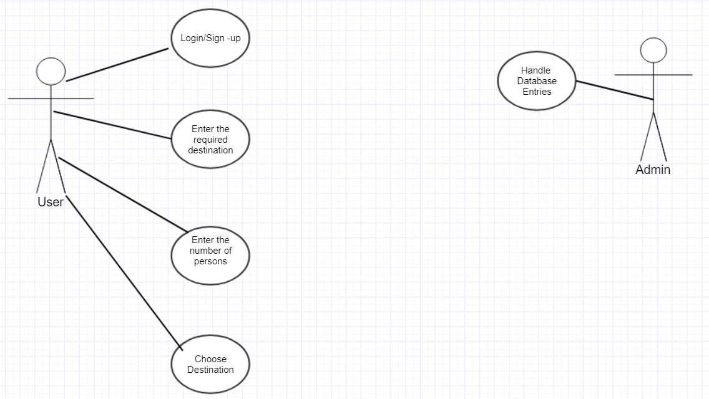

Figure No. 1

**Sequence Diagram**

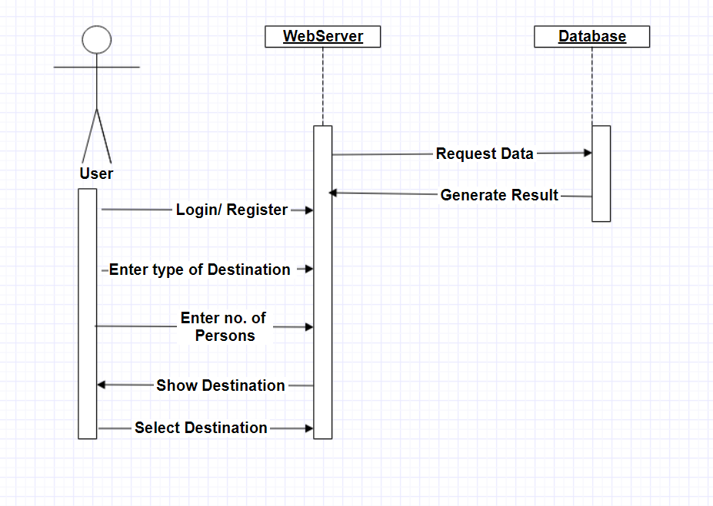

Figure No.2

**Activity Diagram**

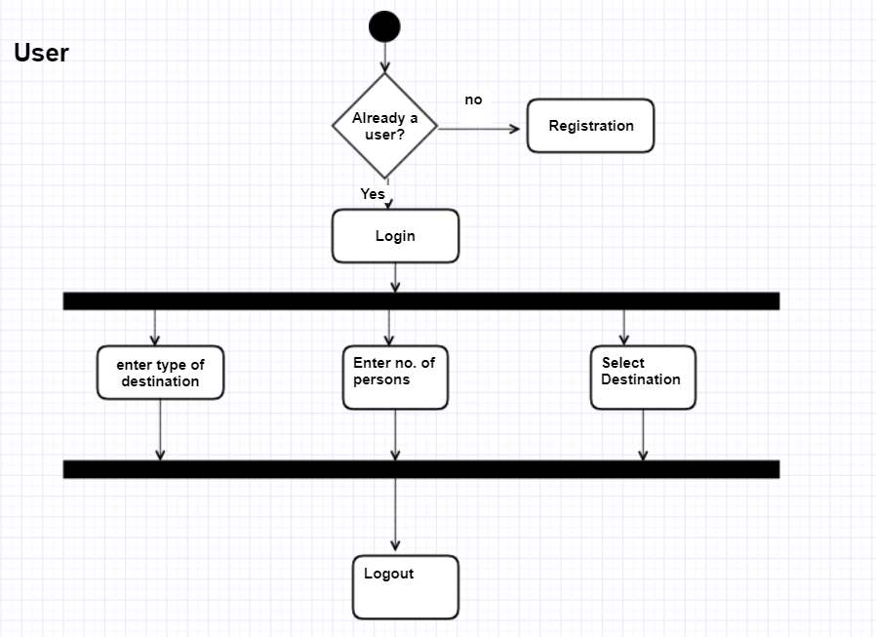

Figure No. 3

**Project Schedule Diagram**

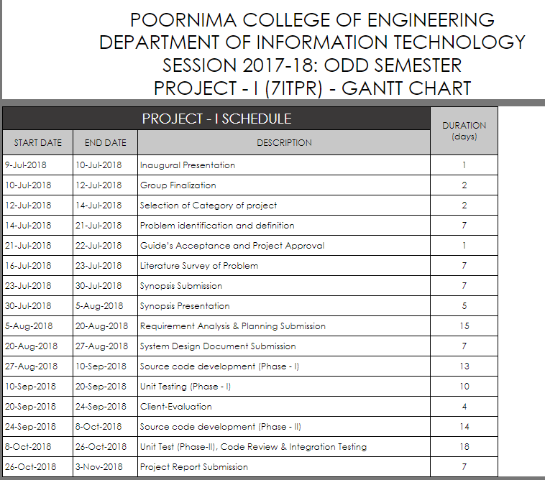

Figure No. 4

# **Other Requirements**

Database Requirement: Database Mysql

# **Appendices**

Use Case Diagram: Figure 1

Sequence Diagram: Figure 2

Activity Diagram: Figure 3

Project Schedule Diagram: Figure 4

# **References**

W3school.com

Tutorialspoint.com

# **Guide’s Comments**