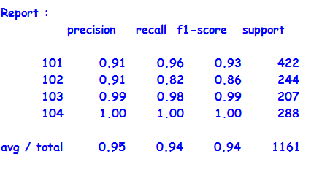

Figure 14: Classification Report

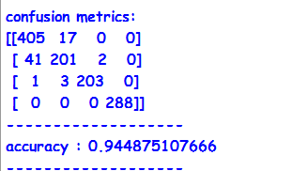

Figure 15: Confusion Metrics and Accuracy

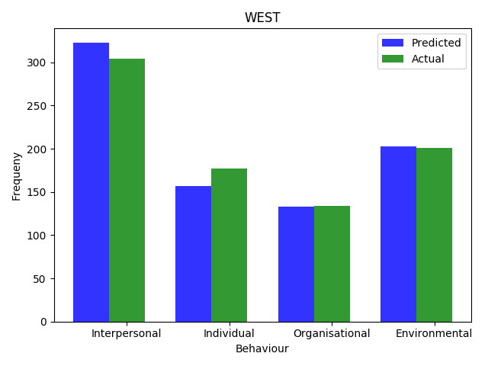

Figure 16 : Bar graph depicting behaviour of the western regions.

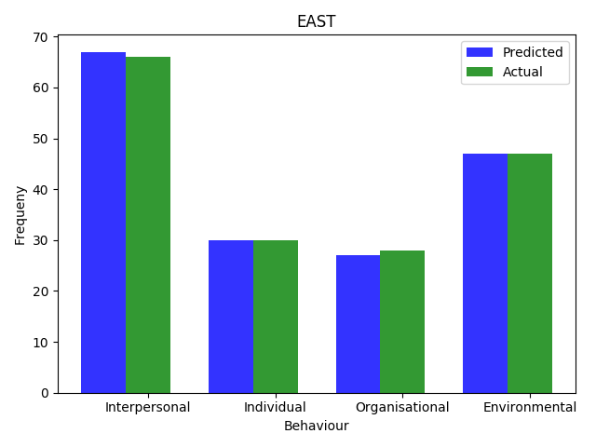

Figure 17 : Bar graph depicting behaviour of the eastern region

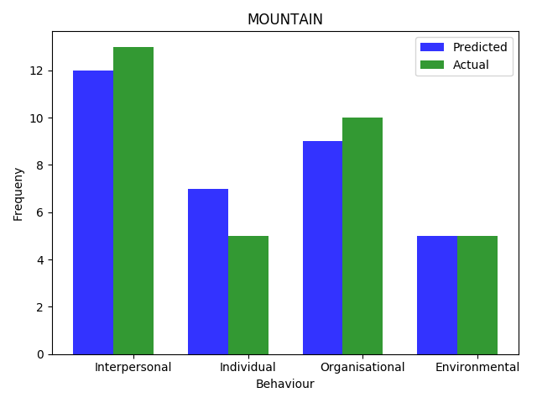

Figure 18: Bar graph depicting behaviour of the people in mountain regions

