**Activity 1 – UML Class Diagram**

**Class Diagram for Activity 2:**

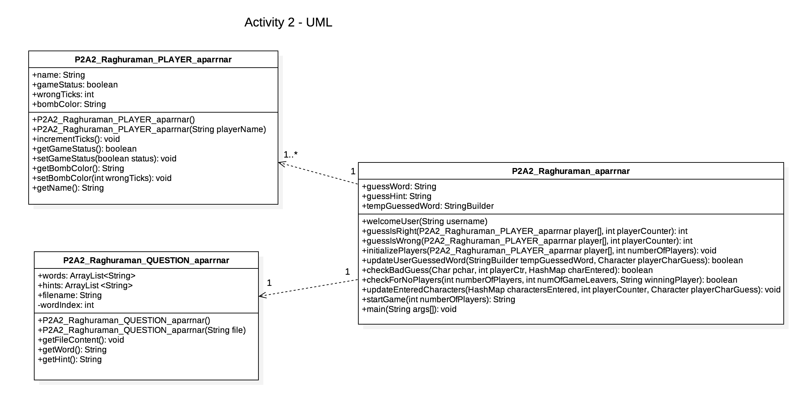

(images are also attached separately for reference)

**Explanation:**

As part of Activity 2, three classes, the PLAYER, QUESTION and main class are defined. The main class uses the objects of the PLAYER and the QUESTION class. Hence, these are modelled as a “dependency” relation, that is, there is a USES relationship between main class and PLAYER and main class and QUESTION.

**Class Diagram for Activity 3:**

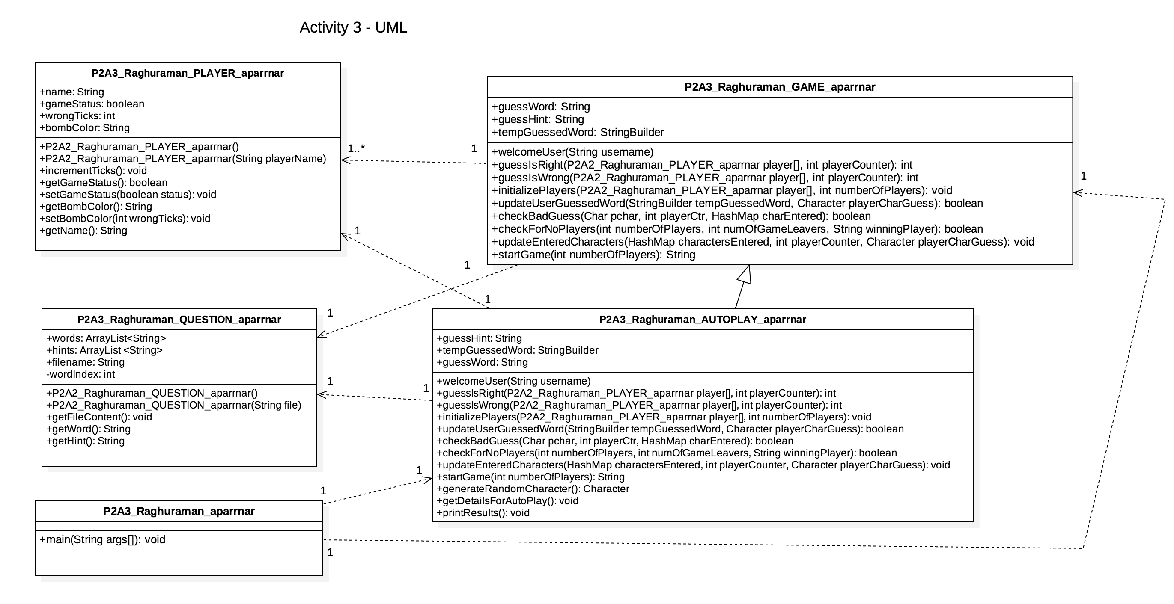

(images are also attached separately for reference)

**Explanation:**

As part of Activity 3, we have created the GAME class and the AUTOPLAY class has been extended from it. Here, the inheritance between AUTOPLAY and GAME has been modelled as a line with an open arrow pointing towards the base class. The dependency relationship indicates that the class with the outward arrow uses or accesses an object of the class with an inward arrow.