**Activity 1 – Flowcharts**

**Flowcharts for the Activity 2 program:**

The main flow of the activity 2 is described below. Some processes are abstracted and represented as separate diagrams for better readability.

**Main flow: welcome() detectEnterPress()**

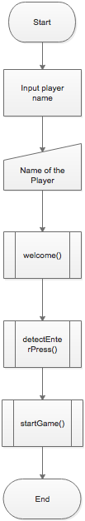 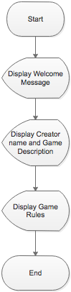 

**startGame():**

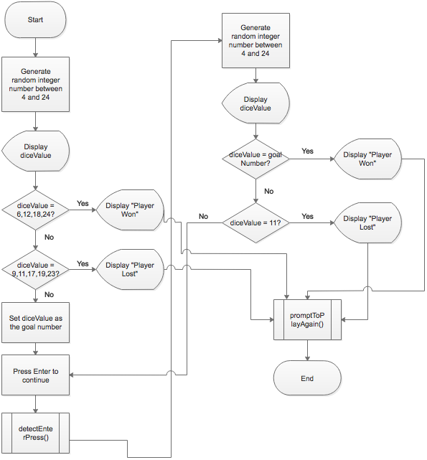

**promptToPlayAgain()**

