**CURRICULUM – VITAE**

[**aparsinghchaudhary@gmail.com**](mailto:aparsinghchaudhary@gmail.com)

Mobile No: 9822993113/9849158389

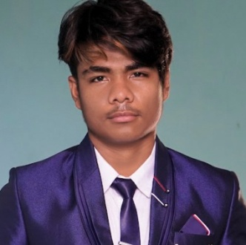**Name :-** Apar Singh Chaudhary

**Fathers Name :-** Ramesh Chaudhary

**Sex :-** Male

**Date of Birth :-** 2059/01/07

**Nationality :-** Nepali

**Religion :-** Hindu

**Marital Status :-** Single

**Permanent Address :-** Lamahi 3, Banguan

**CAREER OBJECTIVES**

*To work with full strength in dynamic organization which provides new challenge that help to add value to the organizations and the individuals, seeking challenging career to value on the preference, where I can enhance my working skills, strength and experience which helps achieving target.*

**Language:-**

|  |  |  |  |  |
| --- | --- | --- | --- | --- |
| **Language** | **Ability to read** | **Ability to Write** | **Ability to Speak** | **Remark** |
| Nepali | Very good | Very good | Very good |  |
| Tharu | Very good | Very good | Very good | Mother Tongue |
| English | Very good | Very good | Very good |  |
| Hindi | Good | Good | Very good |  |

**Educational and Professional Qualifications:**

|  |  |  |  |  |  |  |
| --- | --- | --- | --- | --- | --- | --- |
| **SN** | **Level** | **Institute** | **Board** | **Passed Year** | **Main Subject** | **Remark** |
| 1 | BCA | Ambikeshwari Campus, Ghorahi Dang | Running |  | Software,  Engineer |  |
| 2 | +2 | Rosy Buds Bal Batika Secondary Boarding School, Lamahi Dang | NEB | 2076 | Computer,Math,  Account,  English |  |
| 3 | SEE | Rosy Buds Bal Batika Secondary Boarding School, Lamahi Dang |  | 2073 | Computer And Account |  |

**Trainings:**

|  |  |  |  |  |
| --- | --- | --- | --- | --- |
| **SN** | **Name of training** | **Institute** | **Duration** | **Remark** |
| 1 | Basic Computer, Advance course of Ms word, Excel, Power point, Photo Shop, HTML, Basic hardware Email, Internet Paint and Free Hands, Tally ,Point Page Maker | KOC | 10 Month | 4Sept ToMarch2018 |

**Reference**

**Chandra Parkash Khanal**

Campus Chief

Ambikeshwari Campus

9851211935

**Certification :**

I hereby state that information given above are true and correct to the best of my knowledge and belief , this CV correctly describe me , my qualification and my experience, the other documents will be submitted during interview.

……………..

Signature:

Apar Singh Chaudhary