Cyber Threat Intelligence Data Collection and Visualisation Platform for Incident Response

  - First Deliverable
  - P2414312 – Kieran Edmonds
  - CTEC3451 – Development Project
  - Supervisor: Sarah De’Ath
Table of Contents

Literature Review 3
Introduction 3
Key Features of a TIP 3
Integrating CTI into IR 4
Visualising CTI 5
Conclusion 6
References 7
System Design Documentation 8
System Architecture 8
Database Architecture 9
UI Design 9
Functional Requirements 11
Indicative Test Plan 12
Implementation Report 17
References 18

Literature Review

Introduction
As cyber-attacks increase in frequency and magnitude, organisations have established incident response (IR) teams. A product of IR is cyber threat intelligence (CTI) which is contextualised to a specific threat actor. CTI can be fed back into the IR cycle to improve future responses against that actor. Additionally, CTI can be shared across multiple organisations to collaboratively improve response.
To achieve this, IR teams must have real-time access to CTI during a live incident. Threat intelligence platforms (TIPs) provide this access, but currently available TIPs vary greatly in the services they provide. This literature review will seek to analyse three key areas of TIPs; what are the key features, what intelligence can be derived from IR and applied to IR use cases, and how can CTI be visualised within the platform?

Key Features of a TIP
Dandurand and Serrano (2013) first defined the key requirements of a TIP as: “facilitate information sharing”, “enable automation”, and “facilitate the generation, refinement, and vetting of data through burden-sharing collaboration or outsourcing”. Brown et al. (2015) define the aim of a TIP as managing CTI data and converting it into “actionable information” delivered to tools and stakeholders.
According to Sauerwein et al. (2017), most TIPs involve a primary element of intelligence sharing. However, this study identifies that there is no common definition for ‘intelligence sharing’, meaning that the types, quality, and sources of intelligence being exchanged varies greatly from platform to platform. For example, some focus solely on “sharing of threat intelligence between organisations”, while others share only “automatically aggregated” data from both proprietary and open sources. One “hybrid” platform combines data from multiple sources with threat intelligence from participating users.
Brown et al. (2016) highlights an issue of compatibility between various CTI sources and formats. It is unlikely that a single standard will reach universal adoption, therefore platforms must “ingest and manage as many different standards as possible”. Additionally, the “loss of metadata”, occurring when information is exchanged between systems, means platforms that aggregate CTI from many sources must add marking information to “determine and disseminate provenance and confidence information from different perspectives” (Brown et al., 2016).
A platform’s “consolidating, linking together and normalising” of CTI from feeds is highly important to generate insights (Brown et al. 2016). Consolidating data involves finding “common entities” in the intelligence, such as IP addresses, domain names and actor names. TIPs should “link newly collected data to existing data automatically” and facilitate complex relationships such as “aggregation, composition, generalisation or realisation”. Platforms should also provide de-duplication by identifying and merging matching records.
Intelligence enrichment integrates additional external data to original intelligence, enhancing the “context surrounding data during analysis” (Brown et al. 2016). Enrichment can be performed both during and post-analysis, adding “confidence scores, ratings, and/or prioritisations”. By identifying indicators of relevance, platforms can also determine the relevancy of the data not only to the organisation, but also “larger communities” including industry verticals.
Another important feature of TIPs discussed by Brown et al. (2016) is a “robust search capability” to find and filter information based on content, relationships, similarity, and overlap. Automatic tagging and classification are critical to the effectiveness of search capabilities. As an output, platforms must produce and deliver intelligence to organisational stakeholders by generating reports, wrapping raw data with human analysis.
While Brown et al. (2016) concludes positively that TIPs being developed are more interoperable and freely available, they also detail gaps. Future TIPs “should include standard interfaces (APIs) that enable direct integration with threat analytics capabilities”, allowing users to easily integrate external solutions into their environment. This project will address this gap by including API integration with external tools.
Brown et al. (2016) highlight the importance of trend identification through “statistics, advanced data analytics, and visualisation”, which are currently used externally from platforms. TIPs “should provide capabilities to explore data”. Similarly, Sauerwein et al. (2017) find that “most platforms primarily focus on data collection instead of analysis”. This neglects the remainder of the intelligence lifecycle, meaning entries resemble raw data more than intelligence. Currently, TIPs “provide limited analysis and visualisation features”, few “provide interfaces for third party tools”, and a fraction implement “pivot functionalities” that visualise relationships between intelligence. As such, this project will place more focus on data analytics and visualisation and less on data collection methods outside of standard data entry.
Another gap that Sauerwein et al. (2017) highlights is the overbearing number of manual tasks required for sharing and acquiring intelligence. Most platforms lack automated “intelligence gathering” and “sanitisation of sensitive information”. As a result, the use of the TIP is limited by the organisation’s resources and motivation of participating users. Therefore, this project will aim to automate these processes.

Integrating CTI into IR
Integrating contextualised CTI in real-time can improve the efficiency of a response (Shackleford, 2018). However, it must first be determined how intelligence can be derived from IR and what intelligence is most relevant to effectively resolve a live incident.
The concept of ‘intelligence-driven incident response’ is defined by Roberts and Brown (2017) as utilising CTI as an “integral part of the intrusion-detection and incident response process”. There exists a mutually beneficial relationship, where CTI can “support and augment” IR, whilst IR generates rich, contextualised CTI from many areas. For example, Root cause analysis can identify the “weaknesses in network defences” that attackers are targeting, and malware analysis can identify the evasion tactics and capabilities of attackers. Analysis of lateral movement can be used to focus monitoring efforts, and actions on objectives are indicative of attackers’ “motivations and goals”, which can “guide overall security efforts”.
Skopik (2017) details numerous internal sources of CTI that can be extracted during IR. This includes intrusion detection systems, antivirus and malware scanners, log data from hosts, servers and firewalls among others, incident analysis tools such as “network diagnostics, forensic toolkits, vulnerability scanners”, and security management systems including SIEM and ticketing systems. Skopik also includes personnel, specifically those who report “suspicious behaviour” or “social engineering attempts”.
Meanwhile, Bautista (2018) discusses a limited involvement of IR processes in CTI collection. “Malware processing” and “honeypots” can be classified as IR, however the other sources of CTI listed include “open source”, “human intelligence”, “scanning”, and “crawling”. The author states the type of CTI these activities mostly produce is indicators of compromise (IoCs), which can include IP addresses, bad domains, malware hashes, file sizes, and operating system information.
However, Skopik (2017) discusses additional types; tactics, techniques, and procedures (TTPs), threat actors, vulnerabilities, cybersecurity best practices, courses of action (CoAs), and tools and analysis techniques. Cybersecurity best practices and CoAs are particularly relevant, as they both dictate effective response measures. While best practices address entire classes of threats, CoAs are shaped to a particular threat and “span the whole incident response cycle”. Skopik also gives examples of IoCs, adding process names, service names and altered configuration parameters.
Bautista (2018) does highlight the value in identifying attacker TTPs, as defenders can “attribute specific actions or behaviours to threats”. This idea is expanded upon in the concept of active defence, where a focus on attribution of threats allows defenders to “validate the reality of threats”, “map specific actions to threats”, and tailor monitoring solutions accordingly.
Skopik (2017) identifies an issue with the current state of intelligence integration into IR; there exists no “standard framework that defines how to get to the root cause of an incident by utilising all data feeds available”. Despite many recognising this need, tools have been underemployed or are not yet mature enough. This issue will not be directly addressed in the project; however, the platform will integrate with external incident data correlation tools to support this use case.
Additionally, Schlette et al (2021) identifies that current CTI perspectives are focused on “threat reporting, including informative description of CTI artifacts extended by attacker behaviour”, such as IoCs. Therefore, IR perspectives have received considerably less research attention, despite giving the advantage of outlining “how to apply threat intelligence effectively”. This project addresses this gap by highlighting the IR perspectives of CTI.

Visualising CTI
As Balakrishnan (2014) discusses, security data can be visualised to communicate value and identify anomalies. Data visualisation can be of use to many areas of information security: “security metrics, security monitoring, anomaly detection, forensics, and malware analysis”.
Visualisation has several different threat intelligence applications, particularly within threat reports. Previously, as explained by Yamasaki (2020), there have been “general graph layouts for STIX” to support “a wide variety of use cases”. These include statistics, such as “geographically mapped targets of attacks”, “line charts of scan activities”, and “pie charts of infected malware families”.
There are also visualisations that help to “illustrate the structure of threat intelligence” and can improve IR. Malware behaviours such as “component relationships, file structures, and call flow graphs” can assist malware analysis. C2 infrastructure explains relationships between domains and IP addresses for attribution analysis. Finally, attack flows detail the “series of events such as infection chains and cyber kill chains”, allowing responders to see the bigger picture in an incident or a larger campaign. Yamasaki presents a visualisation method designed to “represent attack flows, emphasise relationships between IoCs and other entities, and focus on differences from existing intelligence.”
Alternatively, some visualisation methods are more purpose specific. Balakrishnan (2014) uses two examples to illustrate this: botnet visualisation and reverse engineering. The Microsoft Digital Crimes Unit and the Office for Creative Research developed a prototype tool called ‘Specimen Box’ which provides live visualisation of botnet activity for analysis. Meanwhile, visualisation can be used to perform pattern recognition and reverse engineering to analyse a malware sample.
CTI can be visualised using different techniques. Cambridge Intelligence (no date) toolkits use two visualisation methods: graph and timeline. Graph visualisation represents “complex connected data as interactive node-link diagrams”, which is helpful for understanding the relationships between data objects. Timeline visualisation displays “sequences of events, how they unfold and how they link together”, giving analysts a chronological representation.
Cambridge Intelligence (no date) also recommends using the numerous frameworks that have been developed for CTI in visualisation. In one example, CTI collected from the Emotet trojan is used to create an attack flow using the MITRE ATT&CK framework, making it “easier to interpret and communicate” and giving analysts “a clear view more quickly and deeply than interrogating the data alone”.
In their study of diagrams in threat reports, Yamasaki (2020) identifies three key observations crucial to effective visualisation. Firstly, most threat diagrams are illustrated as a DAG-network (directed acyclic graph). Secondly, “threat diagrams usually focus on relationships between IoCs”, as opposed to details of each indicator. Finally, diagrams often emphasize differences in a threat structure. This can include a new exploit, a frequently observed IP address, or a new attack pattern.
Yamasaki (2020) discusses the “limitations on the current capabilities” of TIPs, where “the value of threat intelligence depends on analysts’ abilities to handle it”. If TIPs integrated more advanced visualisation, then analysts could extract more value, and would spend less time interpreting data manually. This project will include advanced visualisation to address this.
Yamasaki (2020) also discusses creating “rich STIX data” to improve visualisation, such as kill-chain phrases that describe the context of nodes in terms of their application in a campaign and are required to plot nodes on threat diagrams according to their context. However, threat intelligence feeds often lack these additional details. This project will look to incorporate rich contextual data into the data entry process.

Conclusion
To summarise, TIPs can play a vital role in improving the IR processes. While most vary greatly in features, functionality and the data held, this literature review has attempted to isolate what core features must be included in a TIP and what data would be most relevant for the specific IR use cases. Additionally, this literature review has attempted to identify how best the developing area of data visualisation can be integrated into a TIP to improve its capabilities.

Word Count: 1981

References
Dandurand, L. and Serrano, O.S. (2013) ‘Towards Improved Cyber Security Information Sharing’. Cyber Conflict (CyCon), 5th International Conference on. 1 – 16 June. Available at: https://www.researchgate.net/publication/261449535_Towards_improved_cyber_security_information_sharing (Accessed: 9 December 2021)
Sauerwein, C. et al. (2017) ‘Threat Intelligence Sharing Platforms: An Exploratory Study of Software Vendors and Research Perspectives’ 13th International Conference on Wirtschaftsinformatik. St. Gallen, Switzerland, 12–15 February. Available at: https://aisel.aisnet.org/cgi/viewcontent.cgi?article=1091&context=wi2017 (Accessed: 22 December 2021)
Brown, S. Gommers, J. and Serrano, O. (2015) ‘From Cyber Security Information Sharing to Threat Management’, in Proceedings of the 2nd ACM Workshop on Information Sharing and Collaborative Security. CCS’15: The 22nd ACM Conference on Computer and Communications Security, Denver Colorado USA: ACM, pp. 43–49. doi:10.1145/2808128.2808133.
Shackleford, D. (2018) CTI in Security Operations: SANS 2018 Cyber Threat Intelligence Survey. Available at: https://threatconnect.com/wp-content/uploads/20180122_Survey_CTI-2018_ThreatConnect_Final.pdf (Accessed: 14 January 2022)
Roberts, S.J. and Brown, R. (2017) Intelligence-Driven Incident Response: Outwitting the Adversary. Sebastopol: O'Reilly Media, Incorporated.
Bautista, W. (2018) Practical Cyber Intelligence. Birmingham: Packt Publishing Ltd.
Skopik, F. (2017) Collaborative Cyber Threat Intelligence: Detecting and Responding to Advanced Cyber Attacks at the National Level. Milton, UNITED KINGDOM: Auerbach Publishers, Incorporated. Available at: http://ebookcentral.proquest.com/lib/dmu/detail.action?docID=5107691 (Accessed: 31 December 2021).
Schlette, D. Caselli, M. and Pernul, G. (2021) ‘A Comparative Study on Cyber Threat Intelligence: The Security Incident Response Perspective’, IEEE Communications Surveys Tutorials, 23(4), pp. 2525–2556. doi:10.1109/COMST.2021.3117338.
Balakrishnan, B. (2014) Security Data Visualisation. Available at: https://sansorg.egnyte.com/dl/Im1ZUFrXoV (Accessed: 5 January 2022)
Cambridge Intelligence (no date) Visualising Cyber Threats. Available at: https://info.cambridge-intelligence.com/graph-visualization-for-cyber-security (Accessed: 7 January 2022)
Yamasaki, M. (2020) Rethinking the Graph Visualisation for Threat Reports. Available at: https://www.semanticscholar.org/paper/Rethinking-the-Graph-Visualization-for-Threat-Yamasaki/a81751a6d299a522bce77a4f979ea25ae33d0331 (Accessed: 6 January 2022)

System Design Documentation

System Architecture
The CTI platform consists of a web application running the Python programming language and the Flask framework. Flask is a “lightweight WSGI web application framework” (The Pallets Project, no date). The main python script uses flask module functions to respond to user requests and serves the different pages in the web app using the HTML pages in the templates folder. Each HTML page also uses the ‘Bootstrap’ CSS library for formatting and in future cases JavaScript will be used for additional front-end functionality such as dynamic web forms.
Rather than running a separate Database server, the web application uses SQLite to run the database from the same server in a limited environment. If the web application were to require additional scaling to support more users, the database could be move to a separate server running an implementation of SQL to improve performance. The current instance of the CTI platform uses a python script to connect to the database and execute the prewritten table creation commands held in an SQL file.
In future versions, the CTI platform will integrate with different application programming interfaces (APIs), in order to provide interoperability with external tools. The following diagram illustrates the different elements that form the architecture of the CTI platform web application.

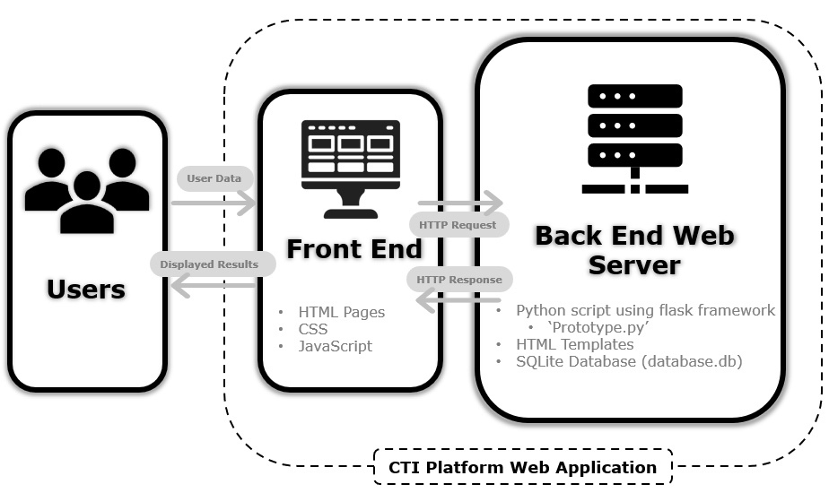
Figure 1: System Architecture Diagram

Database Architecture
The CTI platform depends on an SQLite database that will store a multitude of data. For the administration of the platform, the database will store a ‘Profiles’ table, where each entry represents a different organisation with access to the platform. Each organisation will have a set of entries in the ‘Members’ table, which represents the individual users at the organisation, all with their own credentials and roles.
Meanwhile, for storing intelligence the database has an ‘entries’ table, which will be used to hold verbose intelligence data. Currently, it stores an ‘entryID’ primary key, and a ‘threatActor’ value, however this can be expanded greatly in future following further research. For the purposes of the entity relationship diagram (ERD), it has been given additional fields that represent potential data that could be held in the table in future. Each entry corresponds to an entry in the ‘metadata’ table, which stores contextual information about the entry for searching, filtering, and tracking purposes.
The structure of the intelligence database is detailed below in an ERD.
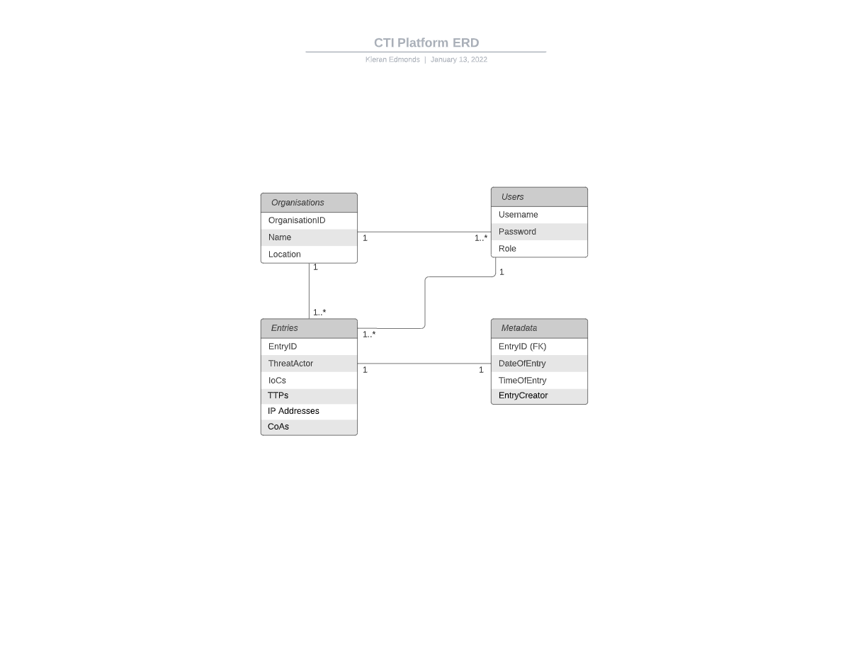
Figure 2: Entity Relationship Diagram

UI Design
Implementing a practical user interface (UI) for the web application requires a stylistically consistent set of web pages. To do so, most of the HTML pages inherit CSS and certain page elements from a parent object, ‘layout.html’. One example of elements inherited from this page is the sidebar. If a page does not require the elements from the layout page, for example the authentication page that is shown to a user upon visiting the website, then this page can have the code that links the two pages together omitted.
As seen in figure 3, each of the main pages feature a limited sidebar on the left-hand side of the screen used for navigation, with all the pages accessible through the displayed icons. This allows for more space on the page to prioritise the entries, forms and visualisations that will form the primary functions of the web application. This also allows for easy navigation, as the user can quickly and easily get to the required page from anywhere in the web application.

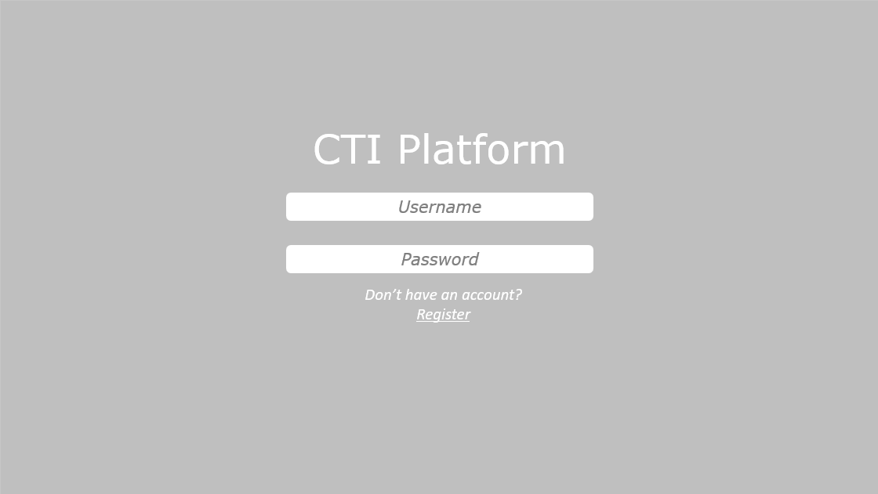 | 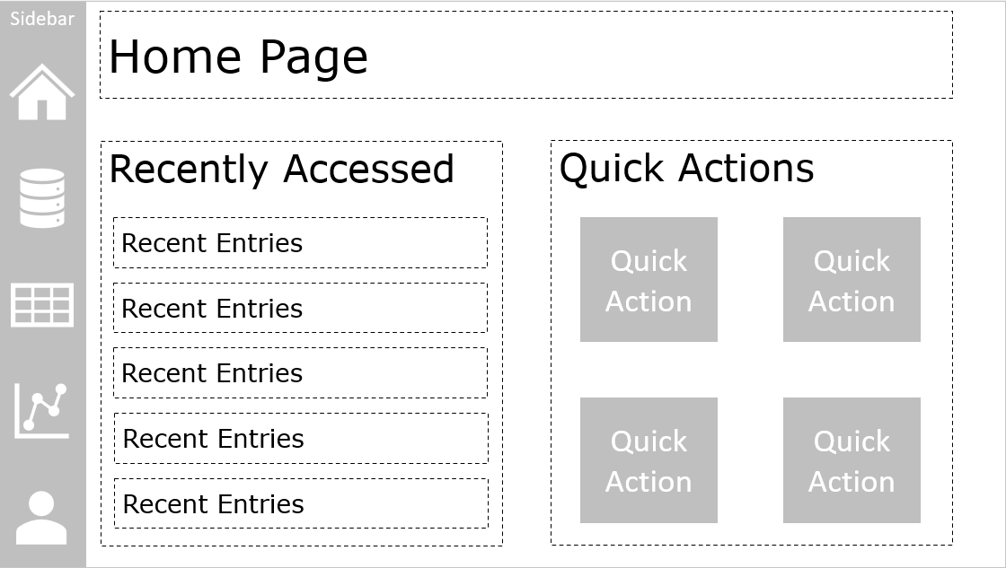
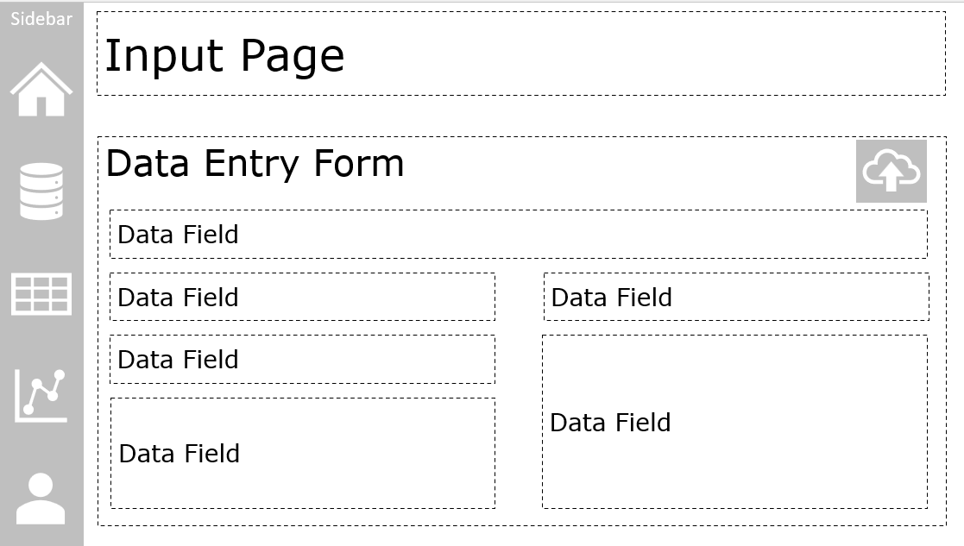 | 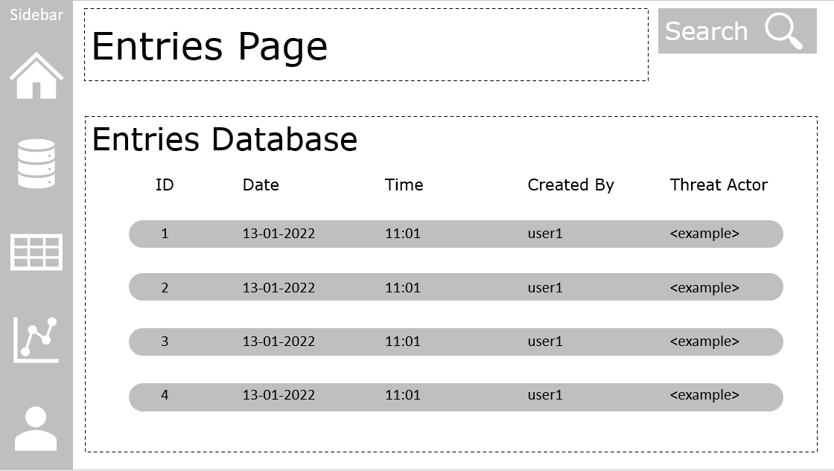
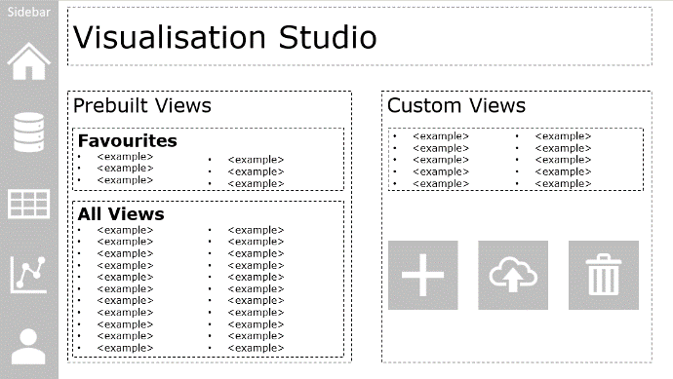

Figure 3: User Interface Diagrams
For ease of access the home page includes recently accessed areas of the web page, allowing users to quickly get back to areas/data entries they last visited. The home page can also have customisable quick actions, where if a user finds they are frequently performing the same action they can add this to the home screen to decrease the time spent navigating through menus to get to the page required.
Focus has also been placed on having clearly visible actions on each page, such as the search button on the entries page, the upload button on the input page, and the add, upload, and delete button for custom views in the visualisation studio. Establishing a consistent iconography in the web application means the users build familiarity and can intuitively understand actions on the page.

Functional Requirements
To accurately understand the necessary functions and capabilities of the platform, it is necessary to detail the users of the web application, what they will aim to use the platform for and how they will go about doing so.

User | Description
Visitor | A user who has not yet logged into an organisational account or has not registered
Team Member | A base-level user belonging to a registered organisational profile
Admin/Team Owner | A superuser within the organisational profile with higher level privileges
Figure 4: Users Table
With the users identified, a use case diagram can be developed to identify the actions each of these users must be able to carry out using the system. Use case diagrams are beneficial to visualising the platform from the user’s perspective, and understanding the relationships between use cases, users, and systems (Visual Paradigm, no date). The use case diagram developed has been simplified to only include the core functionality of the app. This will help to guide the development process and highlight important areas for upcoming sprints.
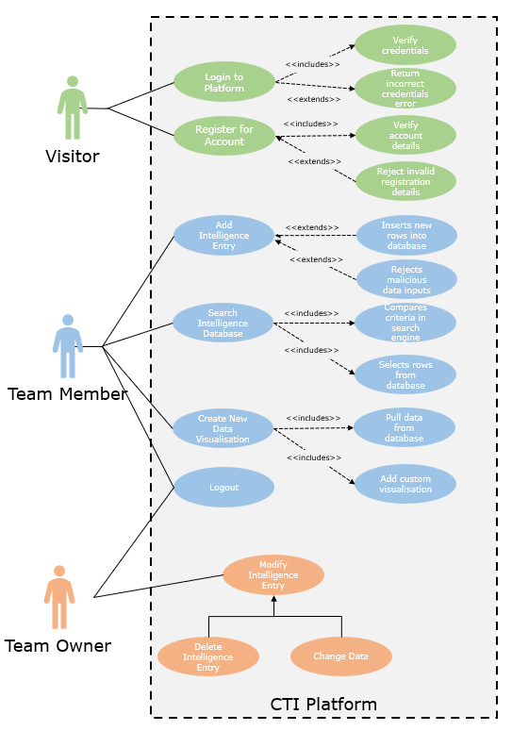
Figure 5: Use Case Diagram

Indicative Test Plan
This web application is being developed with an agile methodology, whereby the user expectations and functional requirements of the web application have been divided up into sprints over the development period. Each sprint iterates through the software development lifecycle (SDLC), designing, developing, testing, deploying, and reviewing the selected feature. After the development period, tests to observe the desired result of the feature that is the subject of the iteration and tests on interactions with other areas of the web application can be performed to ensure the implementation was successful. In contrast, a traditional waterfall methodology will complete the entirety of the implementation phase before moving to testing.
The main advantage of the agile approach is that tests occur earlier, and at this stage code is significantly less complex than at the end of development, making it much easier not only to identify the cause of test failures but also to modify code to correct issues. Additionally, testers are involved in the project from the beginning, allowing more time for better quality test case planning, writing, and implementation (Potter, 2019).
However, there are also disadvantages to this strategy that must be considered. Firstly, as each iteration goes through a separate development phase, development may overlap unnecessarily (Art of Testing, 2021). The same is true for testing; each iteration is tested in isolation and in combination with previous iterations, meaning the likelihood of repetitively carrying out the same tests for each iteration is much higher than testing being performed on the platform at the end of development. However, this disadvantage can be mitigated suitably by ensuring that a clear process for developing a quality end product is managed, as opposed to an “uncertain route determined along the way” (Lynn, no date).
Furthermore, as requirements are not fixed in agile methodologies and the project continues to evolve throughout the entire SDLC, there may be test cases that need to be performed that have not been planned out ahead of time. This leads to much weaker documentation than that which a traditional methodology would produce (Lynn, no date). However, other sources agree that less documentation is actually an advantage of agile testing. ‘Working software over comprehensive documentation’ is one of the core values of the agile manifesto (Agile Alliance, 2019). Dusolle (2021) argues that this allows testers to rely on “exploratory testing based on their experience, creativity and expertise”.
An important area of testing will be the security of the data held in the database. As the platform is intended to be used for organisations to store CTI, which can often include highly sensitive or otherwise confidential information, it is critical to ensure the confidentiality and integrity of the data. As such, the web application and database will need to be subject to multiple in-depth security tests, particularly with the view of preventing SQL injection attacks. It is also necessary to test for cross-site scripting due to the various areas of the web application that involve user input and uploaded files.
In conclusion, the agile testing strategy that will be adopted for this project. After each functional requirement has been implemented, the applicable tests detailed in the test cases table (see Figure 6) will run to ensure the software is in a working state and is of high quality. It may also be necessary to write additional test cases after development that have not been covered in the test cases table, or for features that will be included in the end product that are not derived from the functional requirements. This decision has assessed both the advantages that agile presents as well as it’s disadvantages, whereby it is believed that the disadvantages can be suitably mitigated enough to ensure a successful development project.

Test ID | Test Name | Test Details | Expected Result | Observed Result | Success/Failure | Notes
1 | Application Start-up | Run the main python script in the application and connect to 127.0.0.1:5000 using a web browser | Application is available on 127.0.01:5000 (localhost port 5000)
2 | Application Starts-up at the right page | Connect to 127.0.0.1:5000 using a web browser | The authentication page should be loaded
3 | Authentication page lock | Connect to ‘127.0.0.1:5000/home’ using a web browser | The user should be sent to the authentication page and unable to access any other pages through the URL
4 | Valid Authentication | Input valid credentials into the authentication system | The user should authenticate and load the account associated with the credentials
5 | Invalid Authentication | Input invalid credentials into the authentication system | The user should not authenticate and be presented with an error message
6 | Register Link | Click on the ‘register’ link on the authentication page | The user should be taken to the ‘registration’ page
7 | Registration web form | Enter data into the registration fields and press submit | The user should be taken to a page that informs them of their registration status
8 | Registration web form connected to database | Enter credentials into the registration fields and press submit, then use the same credentials to log in | The user should successfully authenticate to the platform
9 | Home page | Authenticate to the platform with valid credentials | The user should be taken to the home page upon successful validation
10 | Home page - Input page button | Click on the input page button from the home page | The user should be taken to the input page
11 | Home page - Entries page button | Click on the entries page button from the home page | The user should be taken to the entries page
12 | Home page - Visualisation page button | Click on the visualisation page button from the home page | The user should be taken to the visualization page
13 | Home page – Profile drop down | Click on the user profile icon in the bottom of the sidebar | The user should open a pop-up box that has several profile options
14 | Home page - Log Out | Click on the log out button | The user should be taken back to the authentication page and lock from the account until submitting valid credentials
15 | Input page - Home page button | Click on the home page button from the input page | The user should be taken to the home page
16 | Input page - Entries page button | Click on the entries page button from the Input page | The user should be taken to the entries page
17 | Input page - Visualisation page button | Click on the visualisation page button from the Input page | The user should be taken to the visualization page
18 | Input page – Profile drop down | Click on the user profile icon in the bottom of the sidebar | The user should open a pop-up box that has several profile options
19 | Input page - Log Out | Click on the log out button | The user should be taken back to the authentication page and lock from the account until submitting valid credentials
20 | Entries page - Input page button | Click on the input page button from the Entries page | The user should be taken to the Input page
21 | Entries page -Home page button | Click on the home page button from the Entries page | The user should be taken to the home page
22 | Entries page - Visualisation page button | Click on the visualisation page button from the Entries page | The user should be taken to the visualization page
23 | Entries page – Profile drop down | Click on the user profile icon in the bottom of the sidebar | The user should open a pop-up box that has several profile options
24 | Entries page - Log Out | Click on the log out button | The user should be taken back to the authentication page and lock from the account until submitting valid credentials
25 | Visualisation page - Input page button | Click on the input page button from the Visualisation page | The user should be taken to the Input page
26 | Visualisation page -Home page button | Click on the home page button from the Visualisation page | The user should be taken to the home page
27 | Visualisation page - entries page button | Click on the entries page button from the Visualisation page | The user should be taken to the entries page
28 | Visualisation page – Profile drop down | Click on the user profile icon in the bottom of the sidebar | The user should open a pop-up box that has several profile options
29 | Visualisation page - Log Out | Click on the log out button | The user should be taken back to the authentication page and lock from the account until submitting valid credentials
30 | Database.py | Run the database.py script | The terminal should output ‘Database connected successfully’
31 | Input page – Web form | Fill out the fields on the input page and press submit | The user should be taken to a page that outputs the success/failure of the data input
32 | Input page – Web form connected to Database | Fill out the fields on the input page and press submit | The output page should read ‘Records added successfully’
33 | Input page – Web form input validation | Fill out the fields on the input page and input improper data formats to what the form asks for | The web app should return an error notifying the user of data being in an incorrect format
34 | Input page – Web form input sanitisation | Fill out the fields on the input page and use illegal characters (e.g. ‘,=) | The web app should return an error notifying the user of their attempted use of illegal characters
35 | Input page – file upload | Upload a CSV file with the appropriate data formats included | The output page should read ‘Records added successfully’
36 | Input page – incorrect file upload | Upload a file that does not include the appropriate data formats | The output page should inform the user that the file upload failed as it did not match the expected inputs
37 | Entries page – database connected | Navigate to the entries page | The page should be showing, in date order, all of the current entries in the database
38 | Entries page – search feature | Search for a specific entry by one of its criteria | The page should show that entry, as well as other matching criteria, in a results page
39 | Entries page – sorting columns ascending order | Sort by each of the columns on the entries page using ascending order | Each sort should order the table by the ascending order of the column selected
40 | Entries page – sorting columns descending order | Sort by each of the columns on the entries page using descending order | Each sort should order the table by the descending order of the column selected
41 | Entries page – detailed entry view | Click on an entry in the entries page | The user should be taken to a detailed view of the intelligence entry
42 | Visualisation page – database connected | Click on a prebuilt view | The user should be presented a visualisation of the data stored in the database using the view commands
43 | Visualisation – prebuilt views | Click on all prebuilt views | The views should each present the user with visualisations that match their description
44 | Visualisation - favourites | Add a prebuilt or custom view to favourites | The view selected should appear and be accessible from the favourites menu
45 | Visualisation – Add custom view | Add a custom view by using the add view button and entering the commands required | The visualisation should be available, accessible, and in working order from the custom views tab
46 | Visualisation – Delete custom view button | Delete a custom view by dragging it and dropping it onto the bin icon | The custom view should be deleted from the platform
Figure 6: Test Case Table

Implementation Report

This prototype web application includes the core data storage and retrieval functionality of the CTI platform. On the front end, the user has access to four HTML pages: the home page, the data input page, the entries overview page, and the result page. From the home page, the user can read some text about the purpose of the web application. The user can use the sidebar on the left of the screen to navigate to each of the pages. The input page is used to add data entries to the database, which is currently running limited fields as further research will dictate the content and format of the intelligence. The results page is where the user is automatically directed following data input, to validate if the data was inputted successfully. The entries page outputs the entries currently stored in the back-end database. Each of the HTML pages uses ‘layout.html’ as a template, which itself uses two CSS sheets ‘bootstrap.min.css’ and ‘sidebars.css’.
From the back end, the main python script, ‘prototype.py’ uses the prebuilt flask ‘app’ methods to serve the HTML pages stored in the templates on localhost port 5000 (127.0.0.1:5000). This script also pulls the user input that is collected from the ‘input’ page and connects to the database to populate the tables. The database is initialised using the ‘db.py’ script, which must be run before the prototype script. This script executes the prewritten code stored in ‘schema.sql’ to create the tables ‘entries’ and ‘metadata’. Entries represents the actual CTI that will be stored on the platform, whilst metadata will store various contextual information for tracking purposes.

References

The Pallets Project (no date) Flask. Available at: https://palletsprojects.com/p/flask/ (Accessed: 11 January 2022).

Visual Paradigm (no date) What is Use Case Diagram? Available at: https://www.visual-paradigm.com/guide/uml-unified-modeling-language/what-is-use-case-diagram/ (Accessed: 13 January 2022)

Potter, J. (2019) The 6 Key Benefits of Agile Testing. Missing Link Technologies. Available at: https://www.mlt.ca/post/the-6-key-benefits-of-agile-testing (Accessed: 13 January 2022)

Art of Testing (2021) Agile Testing. Available at: https://artoftesting.com/agile-testing#Disadvantages_of_Agile_Testing (Accessed: 13 January 2022)

Lynn, R. (no date) Disadvantages of Agile. Planview. Available at: https://www.planview.com/resources/articles/disadvantages-agile/ (Accessed: 13 January 2022)

Agile Alliance (2019) Agile Manifesto. Available at: https://www.agilealliance.org/wp-content/uploads/2019/09/agile-manifesto-download-2019.pdf (Accessed: 13 January 2022)

Dusolle, S. (2021) The Advantages of Agile Testing. Jahia Techblog. Available at: https://medium.com/jahia-techblog/the-advantages-of-agile-testing-6292b73e3233 (Accessed: 13 January 2022)

