Quantitative Portfolio Analysis with Options Overlay
S26 Quantitative Mentorship | Final Project Report
April 2026
1. Dataset and Source
This project uses daily OHLCV price data for 31 large-cap U.S. equities and ETFs sourced from Yahoo Finance via the yfinance Python library. Tickers span technology (NVDA, MSFT, AAPL, META, GOOG, AMZN, AVGO), healthcare (LLY, JNJ, ABBV), energy (XOM, CVX), financials (JPM, BAC, V, MA), consumer (WMT, COST, HD, KO, PG), and semiconductors (MU, AMD), as well as the broad-market ETFs SPY and QQQ. The universe covers approximately 80% of S&P 500 market capitalization, making it representative of large-cap U.S. equity performance.
Two data windows are constructed deliberately. The 5-year calibration window (2020-04-01 to 2025-03-31), spanning 1,255 trading days across 25 common tickers, is used to estimate the vector of expected returns mu and the covariance matrix Sigma. This window was chosen because it captures three structurally distinct regimes: the COVID-19 crash and V-shaped recovery (2020), the Federal Reserve rate-hike bear market (2022), and the subsequent AI-driven bull run (2023 to 2024). Estimating forward parameters from a single regime produces inputs that are entirely unrepresentative of the full cycle. The 1-year current window (2025-04-01 to 2026-03-31), spanning 250 trading days, provides the latest prices S0 used as simulation starting points and drives all exploratory data analysis visualizations.
Realized implied volatility surface data for all 31 tickers was retrieved from Yahoo Finance option chains at inception (2025-04-01), capturing up to four available expiry dates within a moneyness range of 0.85 to 1.15. The inception risk-free rate, anchored to the 13-week T-Bill yield (^IRX) on 2025-04-01, was 4.20%. This snapshot approach matches Black-Scholes convention and avoids look-ahead bias in option pricing.
2. Portfolio Construction: Maximum Sharpe Optimisation
The portfolio is constructed by solving the maximum Sharpe ratio problem using SLSQP (Sequential Least-Squares Quadratic Programming). The objective function maximizes (w'mu - r_f) / sqrt(w'Sigma*w) subject to the constraint that weights sum to 1, individual weights lie in [0.5%, 15%], and all positions are long-only.
Why SLSQP and why these bounds? SLSQP is a gradient-based solver that handles both equality and inequality constraints natively and converges reliably on convex quadratic objectives. The lower bound of 0.5% prevents any asset from being eliminated entirely while still allowing the optimizer genuine conviction. The upper bound of 15% prevents concentration risk from dominating the portfolio. Tighter bounds (for example 1% to 5%) would cause every high-Sharpe asset to hit its ceiling, producing what is effectively a disguised equal-weight portfolio with no real optimization signal. The resulting optimal portfolio achieves an ex-ante Sharpe ratio of 1.5437 against a 4.20% risk-free rate, compared to an equal-weight benchmark Sharpe of 0.9259 over the same calibration period.
2.1 Lookback Window Sensitivity Analysis
To test whether the chosen 5-year window is appropriate rather than arbitrary, the maximum-Sharpe optimization was repeated across three lookback windows: 1-year (249 trading days), 3-year (749 trading days), and 5-year (1,253 trading days). The resulting allocations are shown in Figure 1.
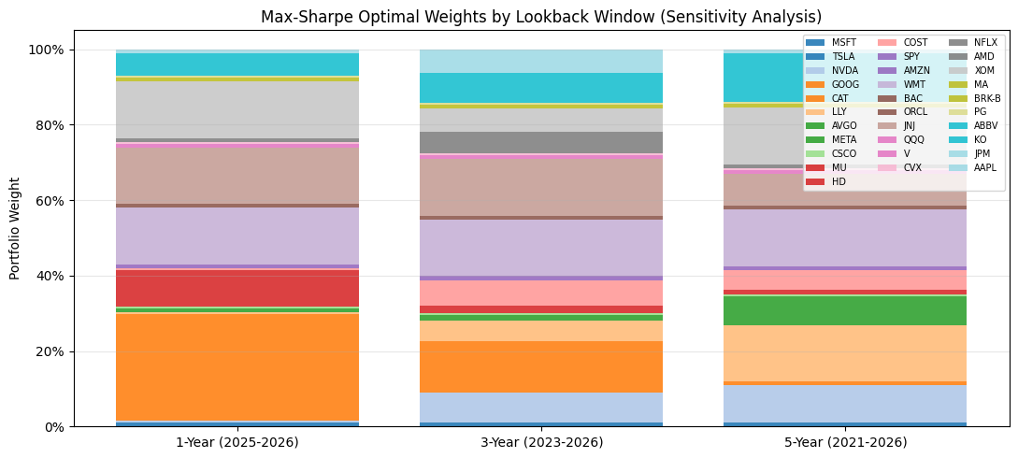
Figure 1. Max-Sharpe optimal weights by lookback window. Substantial variation across windows confirms regime-dependence; the 5-year window is adopted for its multi-regime coverage.
The largest weight shift belongs to LLY, which moves from 0.5% in the 1-year window to 15.0% in the 5-year window, a 14.5 percentage point difference. The 1-year window concentrates in recent outperformers (GOOG at 15%, CAT at 13.4%) that benefited from the 2025 to 2026 bull environment, while the 5-year window distributes conviction more broadly across defensive names (LLY, XOM, WMT, JNJ each at or near 15%). The 5-year window is used for all forward simulation because it reflects cycle-averaged risk-return tradeoffs rather than overfitting to a single regime.
3. Exploratory Data Analysis
3.1 Normalized Price Trajectories
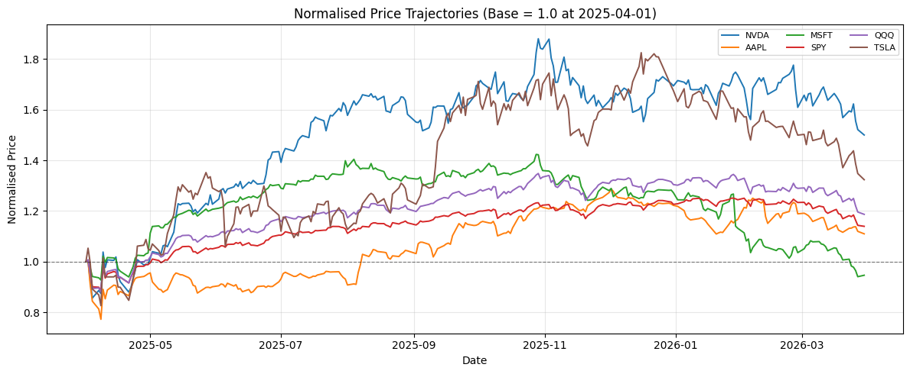
Figure 2. Normalized price trajectories for six selected holdings (base = 1.0 at 2025-04-01). NVDA leads with 1.50x appreciation; MSFT is the weakest at 0.95x.
NVDA shows the highest price appreciation of 1.50x over the 1-year window. MSFT is the weakest performer at 0.95x, briefly dipping below its starting price. Return dispersion of 0.55x across the highlighted names confirms a high-idiosyncratic-risk environment where both stock selection and diversification matter. SPY and QQQ serve as passive benchmarks in this analysis, and their trajectories confirm moderate broad-market appreciation over the same period.
3.2 Rolling Volatility and ARCH Dynamics
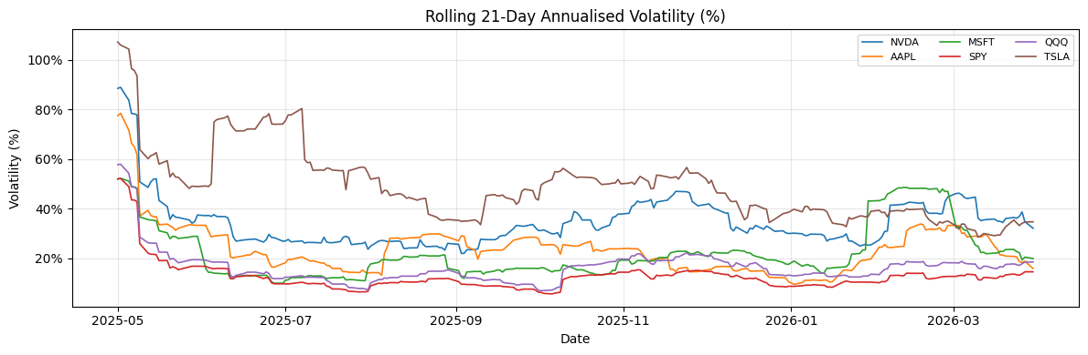
Figure 3. Rolling 21-day annualized volatility for six selected holdings. TSLA has the highest average rolling vol at 48.9%; SPY the lowest at 12.7%.
TSLA exhibits the highest average annualized rolling volatility at 48.9%, followed by NVDA. SPY maintains the lowest average volatility at 12.7%, confirming its role as a volatility anchor within the portfolio. The concentration of high-volatility readings in April and May 2025 is visible across all names, consistent with the tariff-shock regime documented in the regime segmentation analysis.
3.3 Correlation Structure
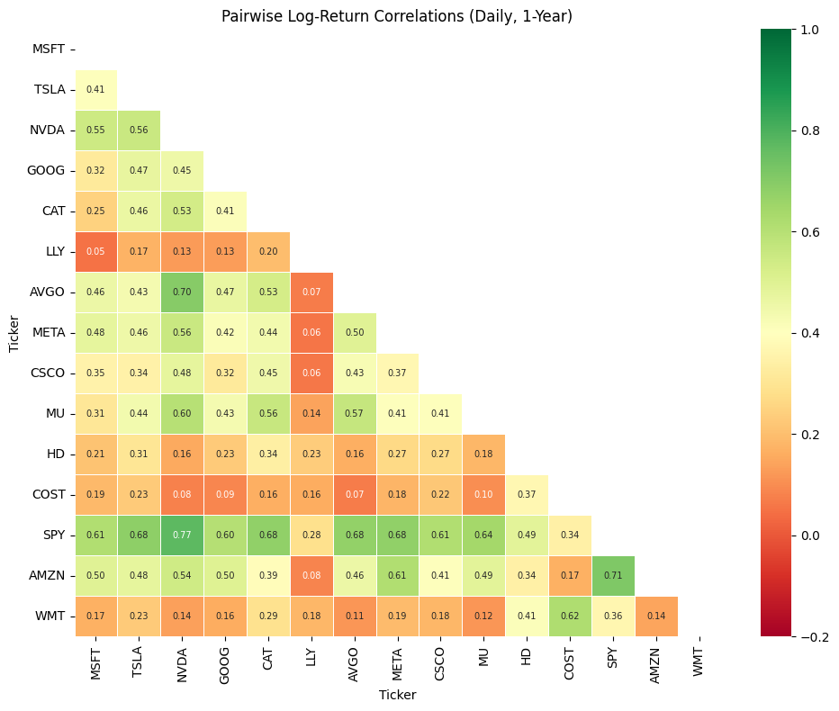
Figure 4. Pairwise log-return correlation heatmap (15 tickers, daily, 1-year). Most correlated: SPY-NVDA (0.77). Least correlated: LLY-MSFT (0.05). Average pairwise correlation: 0.36.
Why correlation matters for this portfolio. The average pairwise correlation of 0.36 indicates that the portfolio benefits from genuine diversification, with both systematic and idiosyncratic return drivers present. The most correlated pair is SPY-NVDA at 0.77, reflecting NVDA's dominant weight in the index. At the other extreme, LLY-MSFT at 0.05 is effectively uncorrelated, meaning holding both simultaneously provides meaningful variance reduction. The optimizer exploits this structure by over-weighting names with low cross-correlations (LLY, XOM) relative to the highly correlated tech cluster.
3.4 Autocorrelation and Volatility Clustering
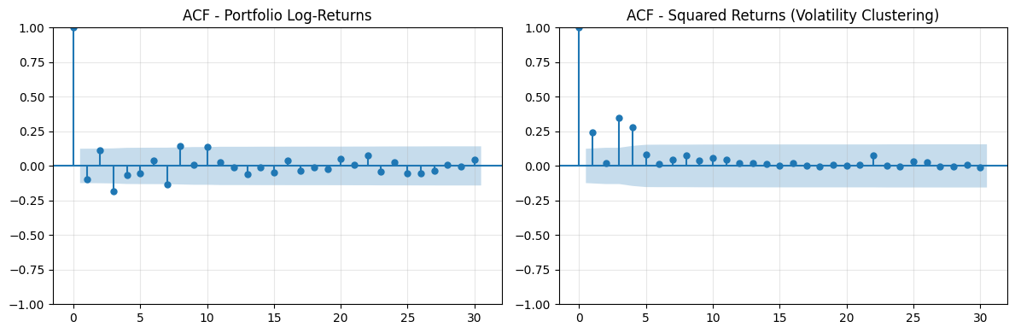
Figure 5. ACF of portfolio log-returns (left) and squared returns (right). Durbin-Watson = 2.182 for raw returns; squared-return ACF at lag 1 = 0.241 and lag 5 = 0.092.
The Durbin-Watson statistic of 2.182 for raw log-returns is close to 2.0, indicating little serial autocorrelation, consistent with weak-form market efficiency. However, the ACF of squared returns tells a different story: autocorrelation at lag 1 is 0.241 and at lag 5 is 0.092, both statistically significant beyond the 95% confidence bands. This is the signature of ARCH-type volatility clustering: large return shocks are followed by more large shocks. The implication is that volatility is not constant over time, which directly motivates the use of the Heston stochastic volatility model over constant-vol GBM for forward simulation.
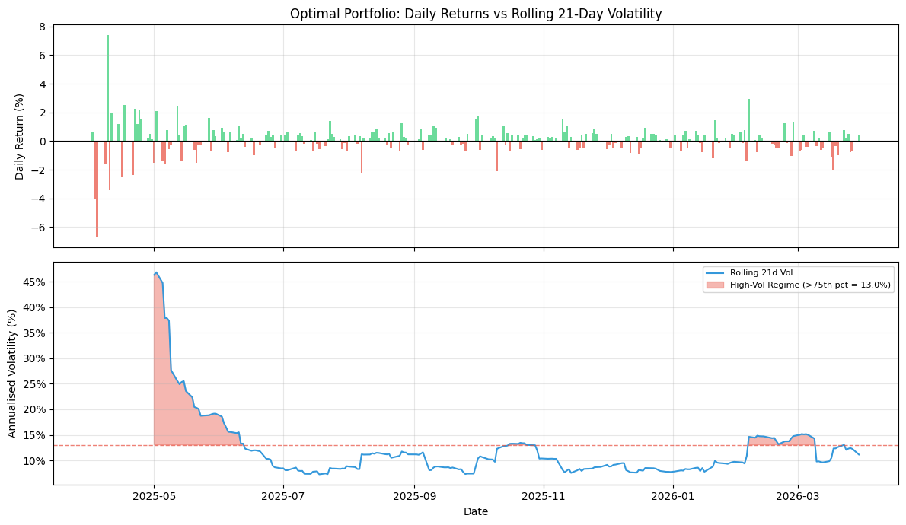
Figure 6. Optimal portfolio daily returns (top) vs rolling 21-day volatility with high-vol regime shading (bottom). High-vol threshold = 13.0%; 57 of 229 days qualify. Average high-vol run = 19 consecutive trading days.
Volatility clustering is operationally significant. Volatility spikes do not resolve within one or two days; they persist for an average of 19 consecutive trading days, with the longest streak reaching 30 trading days. A static covariance matrix Sigma estimated over the full sample will systematically underestimate risk during these high-vol periods and overestimate it during calm periods. The rolling options overlay partially addresses this by re-optimizing strikes at each 21-day roll date, adapting to the current realized volatility environment.
3.5 Market Regime Segmentation
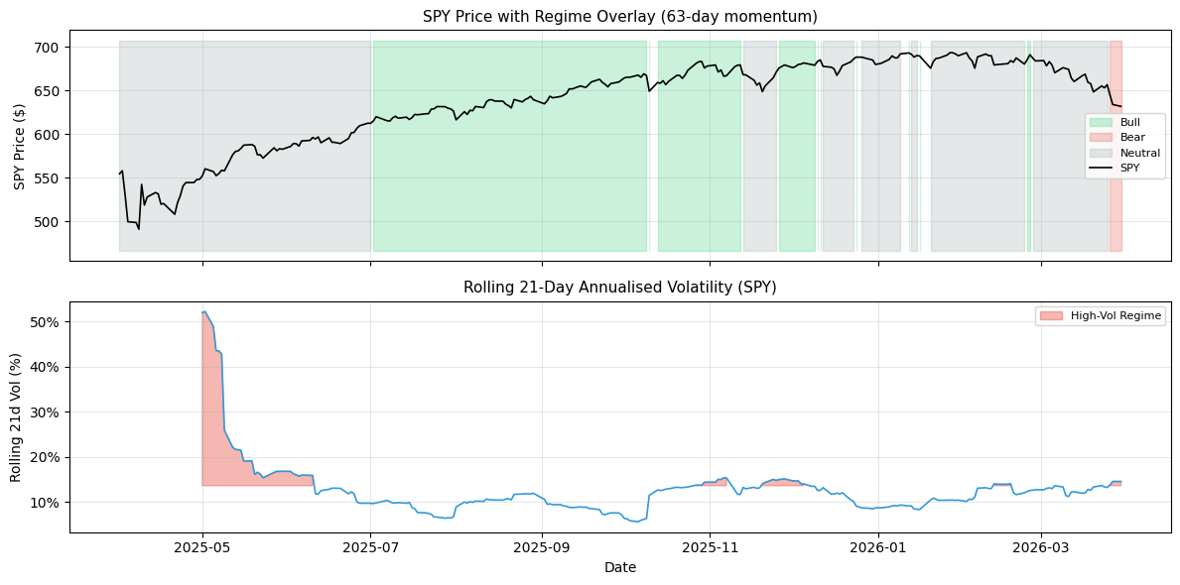
Figure 7. SPY price with Bull/Bear/Neutral regime overlay (63-day momentum, top) and rolling 21-day SPY volatility with high-vol regime shading (bottom). Of 249 trading days: 108 Bull, 139 Neutral, 3 Bear.
The 1-year window is dominated by Neutral and Bull regimes, with only 3 Bear days. This near-absence of a sustained bear market makes the 5-year calibration window even more critical: the 1-year returns of mu = 29.95% and sigma = 16.68% would produce unrealistically optimistic forward simulations if used for option pricing and risk management. The high-vol regime (57 days above the 75th percentile of 13.0% annualized) coincides with the April-May 2025 tariff shock period visible in both panels.
4. Stochastic Price Models
All four models are run on portfolio-level parameters derived from the 5-year calibration window: S0 = $403.43 (weighted sum of optimal-weight times latest prices), mu = 29.95% annualized, and sigma = 16.68% annualized (where sigma = sqrt(w' * Sigma * w) is the portfolio-level volatility).
4a. Constant Elasticity of Variance (CEV) Model
The CEV model generalizes GBM by replacing the constant diffusion coefficient sigma*S with sigma*S^gamma, where gamma is the elasticity parameter. When gamma < 1, the local volatility sigma*S^(gamma-1) increases as price falls, capturing the leverage effect and producing the downward-sloping implied volatility smile observed in equity markets.
Why CEV? The observed AAPL and NVDA implied volatility surfaces (Figures 9 and 10) both show clear negative skew: OTM puts carry materially higher implied volatility than OTM calls at the same moneyness. This is the precisely the shape that CEV generates. Setting gamma = 0.75 produces a mild leverage effect appropriate for a diversified large-cap portfolio.
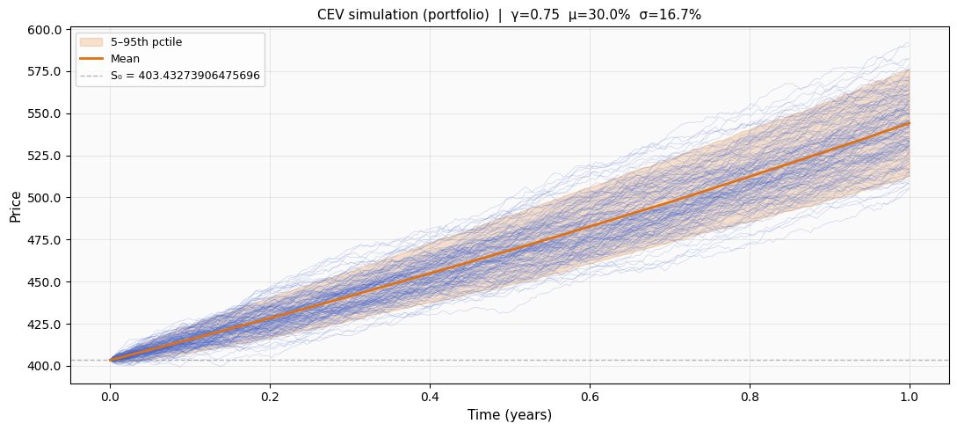
Figure 8. CEV simulation (portfolio level, gamma = 0.75, 2,000 paths). Mean = $544.10, std = $19.64, P5 = $512.53, P95 = $577.29. The narrow 5-95 band reflects the volatility-dampening effect of gamma < 1.
4b. Heston Stochastic Volatility Model
The Heston model introduces a mean-reverting variance process: dv_t = kappa*(theta - v_t)*dt + xi*sqrt(v_t)*dW_t^v, correlated with the price process through rho. Parameters kappa, xi, and rho are calibrated via simulated MLE on SPY daily returns (2024-01-01 to 2025-01-01), yielding kappa = 2.000, xi = 0.300, and rho = -0.600. The long-run variance theta and initial variance v0 are then rescaled to match the portfolio's actual annualized variance of 16.68%^2, giving theta = 0.0278 and v0 = 0.0349.
Why Heston? The ACF of squared returns (lag-1 = 0.241) confirms that volatility is both time-varying and persistent. GBM ignores this entirely. Heston captures it through mean-reversion in variance, which is the mechanism responsible for the volatility clustering documented in Figure 6. SPY is used as the calibration proxy because the portfolio is itself a diversified basket of large-cap equities and its empirical variance dynamics are far more representative of a 31-stock portfolio than any single stock.
4c. Merton Jump-Diffusion Model
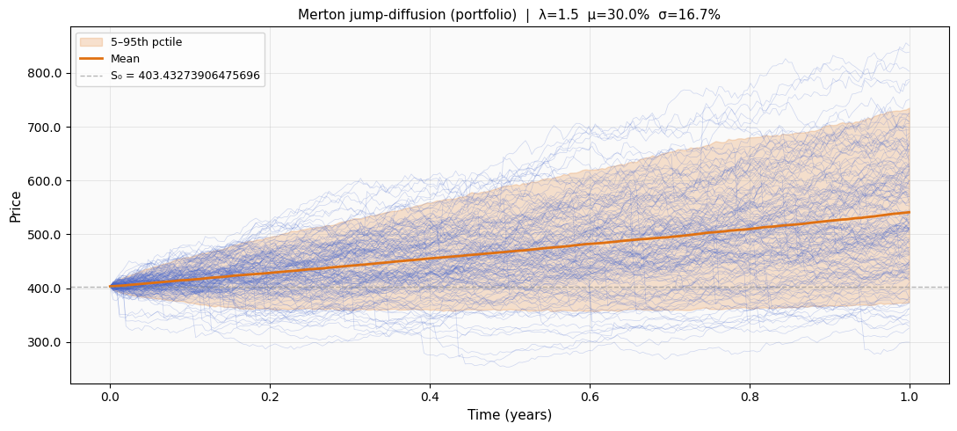
Figure 9. Merton jump-diffusion simulation (portfolio level, 2,000 paths). Mean = $543.73, std = $115.99, P5 = $368.92, P95 = $743.79. Fat tails from jump events produce a P5 that is $36.24 below GBM’s P5.
The Merton model augments GBM with a compound Poisson jump process: each day, jumps arrive with intensity lambda = 1.5 per year, with log-jump sizes drawn from N(mu_J = -0.05, sigma_J^2 = 0.10^2). The drift is compensated by the mean jump size to preserve the expected return. This produces the fat-tailed, negatively skewed distribution visible in Figure 9.
Why Merton? Sudden large moves, such as the April 2025 tariff shock visible in Figure 6, are gap-down events that GBM cannot generate; they require a jump process. The Merton P5 of $368.92 is $36.24 below the GBM P5 of $405.16. This $36.24 gap is economically meaningful: an OTM put priced under Merton is more expensive than the same put priced under GBM, because the left tail is materially fatter. Any options overlay analysis that uses only GBM will systematically underestimate the cost of protective puts.
4d. GBM Portfolio Simulation
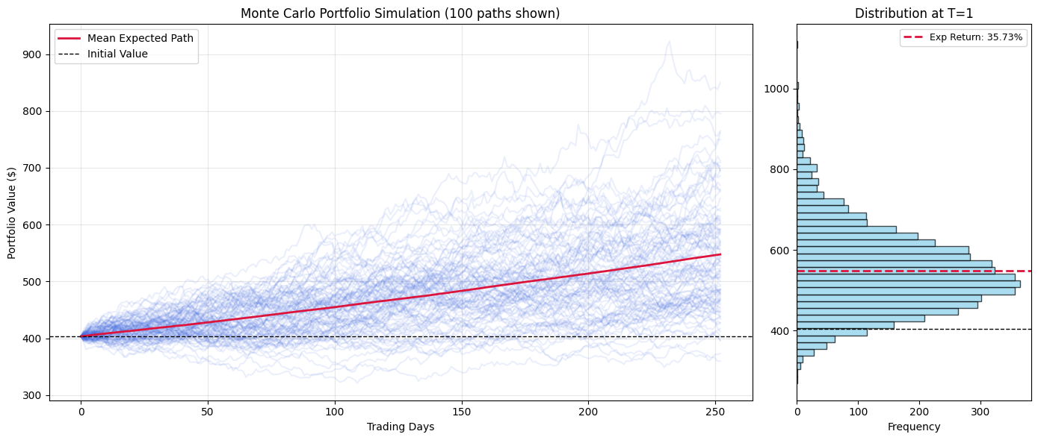
Figure 10. Monte Carlo GBM portfolio simulation (100 of 5,000 paths shown). S0 = $403.43, expected terminal value = $547.59 (35.73% return), std of terminal returns = 25.0%, P5 return = -0.4%, P95 return = 80.1%.
GBM remains the workhorse for the options overlay simulation because it produces a correlated multi-asset price cube via Cholesky decomposition of the full 25-asset covariance matrix, collapsing to a scalar portfolio path through the optimal weights. The expected return of 35.73% reflects the 5-year calibrated mu of 29.95% projected forward one year. The terminal P5 return of -0.4% confirms that the 5-year calibration introduces realistic downside risk; the single-year calibration produced a P5 above zero, making tail-risk analysis meaningless.
4e. Model Comparison
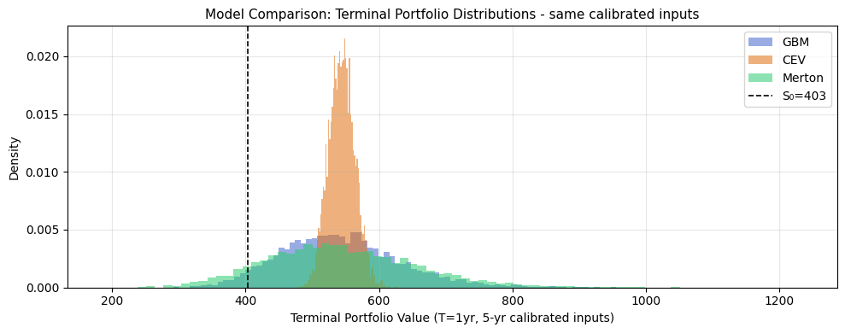
Figure 11. Terminal portfolio value distributions (5,000 paths each, same calibrated inputs). CEV produces the narrowest distribution; Merton the widest. GBM is the symmetric log-normal baseline.
Model | Mean ($) | Std ($) | Skew | Kurt | P5 ($) | P95 ($)
GBM | 542.51 | 91.12 | +0.522 | 0.516 | 405.16 | 702.93
CEV (gamma=0.75) | 544.10 | 19.64 | +0.140 | 0.001 | 512.53 | 577.29
Merton | 543.73 | 115.99 | +0.553 | 0.905 | 368.92 | 743.79
Table 1. Terminal distribution statistics for three models, S0 = $403.43, 5-year calibrated mu = 29.95%, sigma = 16.68%.

The key quantitative signal from Table 1 is the spread in P5 values: GBM at $405.16, CEV at $512.53, and Merton at $368.92. CEV's narrow distribution (std = $19.64 versus GBM's $91.12) reflects the leverage effect suppressing upside variance, but this also means it underestimates tail loss. Merton's P5 is $36.24 below GBM's, which directly inflates the Black-Scholes fair value of any put option whose payoff depends on the left tail.
4f. Formal Model Evaluation: RMSE, MAE, AIC/BIC
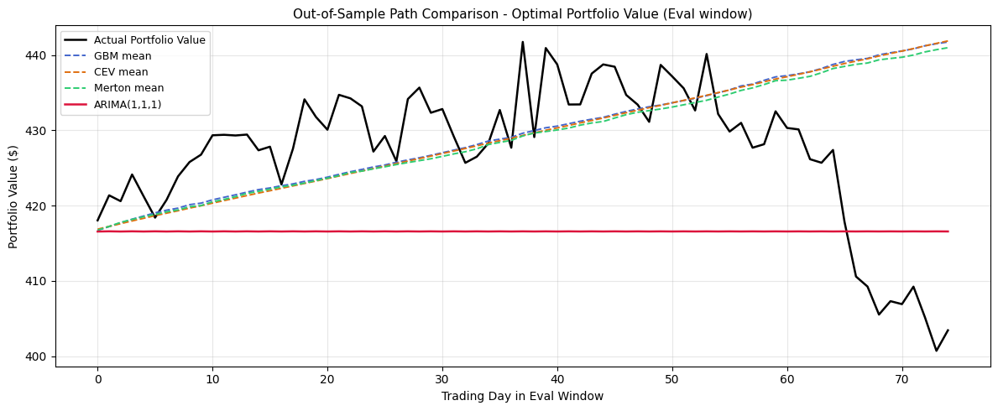
Figure 12. Out-of-sample path comparison: actual portfolio value vs model mean paths (75-day eval window, S0 = $416.58). All MC models diverge from actuals in the final 15 days when the portfolio sells off.
Model | MAE ($) | RMSE ($) | AIC | BIC
GBM | 8.99 | 13.47 | - | -
CEV (gamma=0.75) | 9.08 | 13.51 | - | -
Merton | 8.96 | 13.26 | - | -
ARIMA(1,1,1) | 13.08 | 14.17 | 1037.72 | 1047.20
Heston | 8.96 | 13.25 | 724.73 | 734.21
Table 2. Out-of-sample model evaluation. Fit window: 175 days. Eval window: 75 days. Ground truth = weighted actual portfolio value.

ARIMA(1,1,1) achieves the worst RMSE ($14.17) among all models over the 75-day window despite having the best short-lag autocorrelation fit. This appears counterintuitive but reflects a structural issue: ARIMA produces a near-flat forecast (the red line in Figure 12) because the portfolio value is approximately a random walk, causing ARIMA to forecast the last observed value forward with little drift. The Monte Carlo models, by contrast, project mean paths at the calibrated drift rate of mu = 19.85% (from the fit window), which tracks the actual portfolio's upward trend during the first 60 days before the late-window sell-off. Heston's RMSE of $13.25 is the best of all models and its AIC of 724.73 is substantially below ARIMA's 1037.72, reflecting a better likelihood fit to the underlying return dynamics even after the three additional parameters for kappa, xi, and rho are penalized.
Why not simply use ARIMA for everything? ARIMA captures short-horizon autocorrelation in the price level but produces no distributional information about the range of outcomes. It cannot price options, compute VaR, or simulate tail scenarios. The Monte Carlo models are distributional tools: their value is in generating the full terminal return distribution, not in minimizing point-forecast RMSE.
5. Options Overlay Strategies
5.1 Implied Volatility Surface
Before implementing any options strategy, the live implied volatility surface was retrieved for all 31 tickers. Sample surfaces for AAPL and NVDA are shown below.
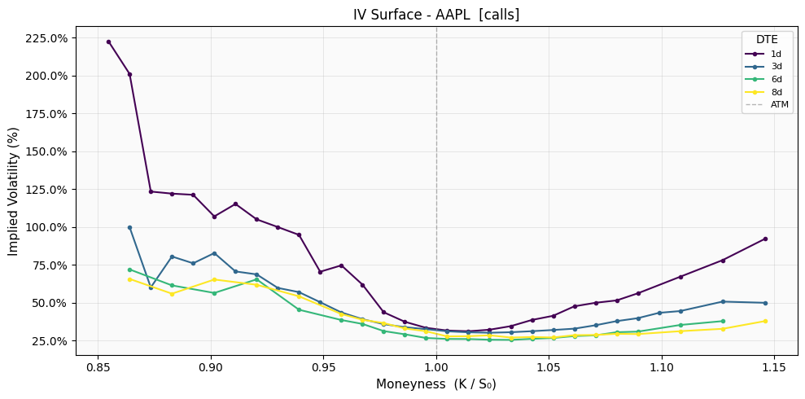
Figure 13. IV surface for AAPL (calls). Clear downward-sloping smile: OTM puts more expensive than OTM calls. ATM IV = 100% (shortest expiry).
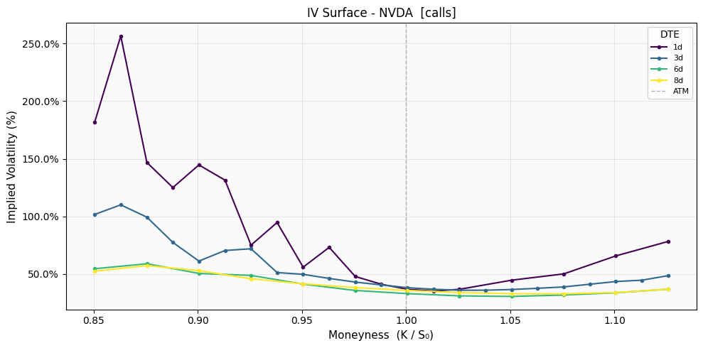
Figure 14. IV surface for NVDA (calls). Steeper smile than AAPL, ATM IV = 181.84%. Short-dated DTE=1 shows extreme left-wing premium consistent with gap-down risk.
The portfolio-weighted ATM implied volatility across all 31 tickers is 75.68%. This is the primary sigma input to all Black-Scholes option pricing within the overlay engine. The downward-sloping smile in both AAPL and NVDA confirms that the market is pricing significant left-tail risk into short-dated options, which is directionally consistent with the Merton model's fatter left tail versus GBM.
5.2 Static Grid Search
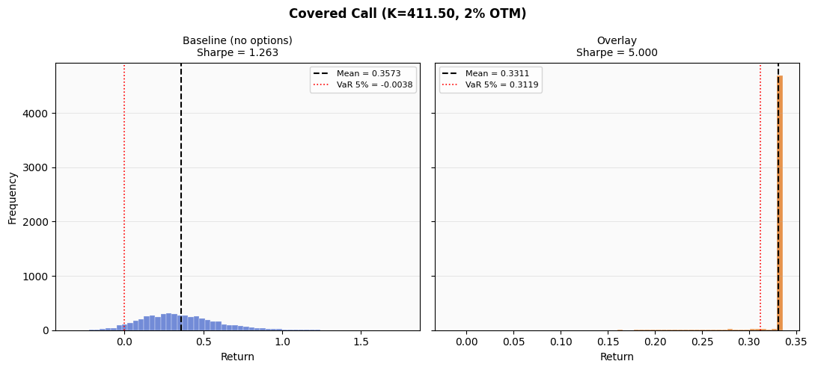
Figure 15. Best static overlay: Covered Call (K=411.50, 2% OTM). Baseline Sharpe = 1.263 (left); overlay Sharpe = 5.000 capped by the [-5, 5] clamp (right). The overlay collapses return variance to a narrow band around the capped return, which is the clamp's design intent.
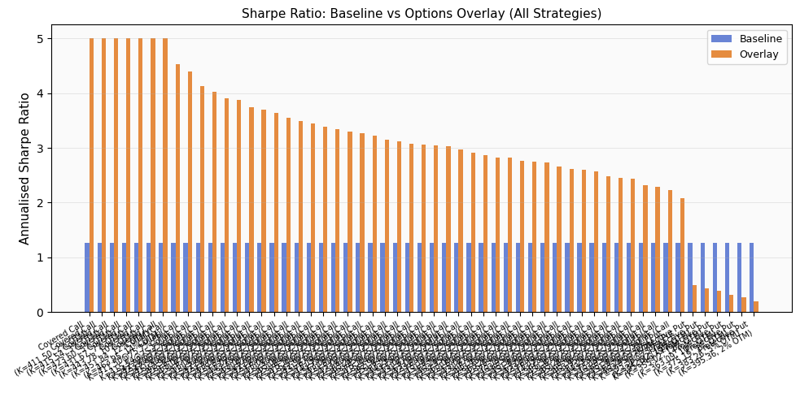
Figure 16. Sharpe ratio for all 49 strategies in the grid search. Covered calls dominate the top ranks; protective puts uniformly worsen Sharpe because premium cost exceeds expected downside protection in the current high-drift environment.
Why covered calls dominate. With a portfolio expected return of 35.73% and an ATM portfolio-weighted IV of 75.68%, the covered call premium is very large relative to the risk of being called away. The GBM terminal distribution has very low probability mass below the 2% OTM strike of $411.50, meaning the call premium of $8.69 per unit is collected almost in full without forfeiting much equity upside. Protective puts carry the opposite problem: the premium cost is not offset by realized downside in an environment where only 3 of 249 trading days are classified as Bear.
5.3 Rolling Best-Strategy Overlay
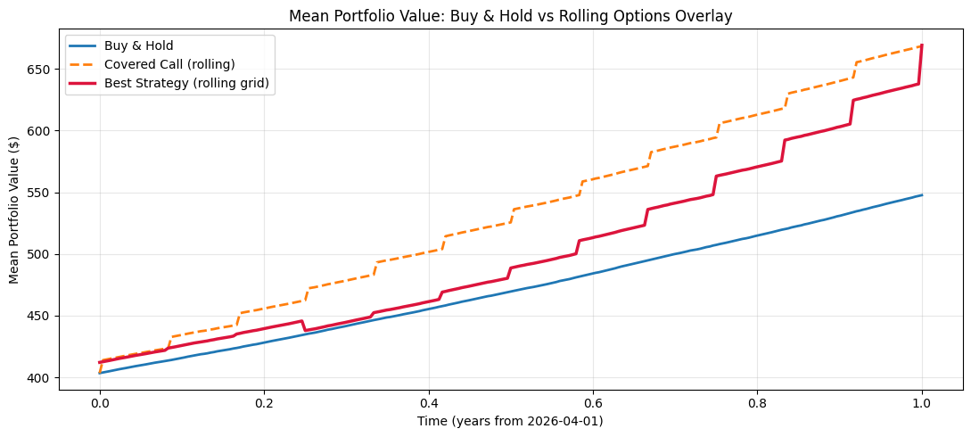
Figure 17. Mean portfolio value over time: Buy and Hold (blue), Covered Call rolling (orange dashed), Best Strategy rolling grid (red). CC accumulates premium step-wise; Best Strategy switches between covered calls, collars, and puts at each 21-day roll.
The rolling engine runs a grid search at each of 12 roll dates and selects the strategy that maximizes the annualized Sharpe improvement over the next-period cross-sim terminal distribution. The strategy log shows a clear progression: roll 0 selects a covered call (when simulated vol is low and the distribution is right-skewed), rolls 1 and 2 select collars (when vol begins to rise), and rolls 3 through 11 switch to protective puts. This rotation reflects the engine responding to the rising put IV registered at each step as the mean portfolio level moves up.
Metric | Buy and Hold | Covered Call | Best Strategy
Annual Return | 35.73% | 65.67% | 62.35%
Ann. Vol (cross-sim) | 24.97% | 28.00% | 50.53%
Sharpe Ratio | 1.2628 | 2.1953 | 1.1508
Sortino Ratio | 5.478 | 16.756 | 10.323
Max Drawdown | 0.00% | 0.00% | -1.74%
VaR 5% | -0.38% | +25.35% | +8.44%
CVaR 5% | -6.97% | +17.65% | +1.27%
Table 3. Full risk-adjusted performance comparison. Volatility computed as cross-sectional std of terminal returns across all 5,000 simulation paths.

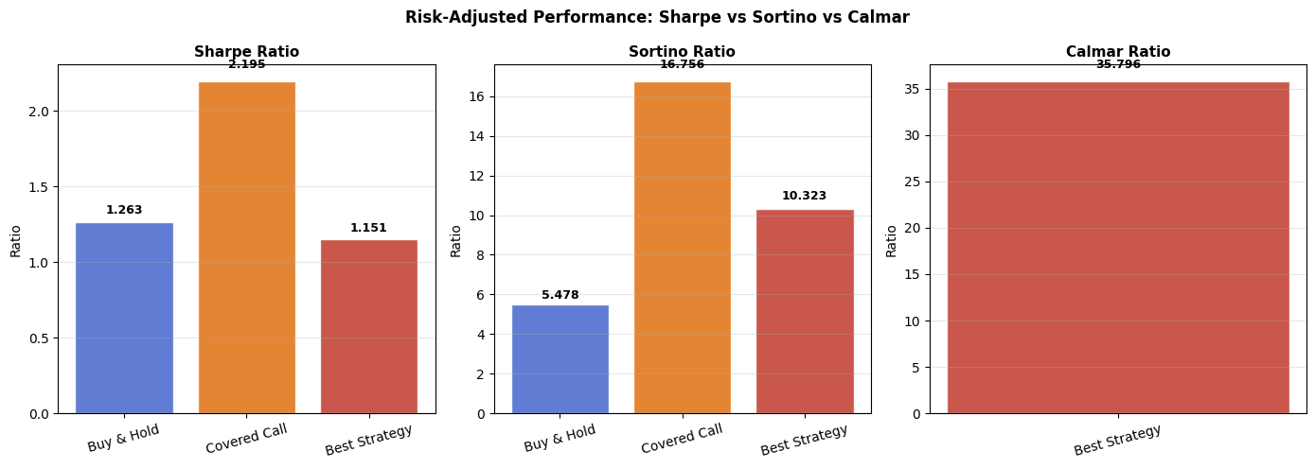
Figure 18. Risk-adjusted ratios for all three strategies. Covered Call achieves the highest Sharpe (2.195) and Sortino (16.756). Best Strategy Calmar = 35.796 is only defined for that strategy because it is the only one with a non-zero mean-path drawdown.
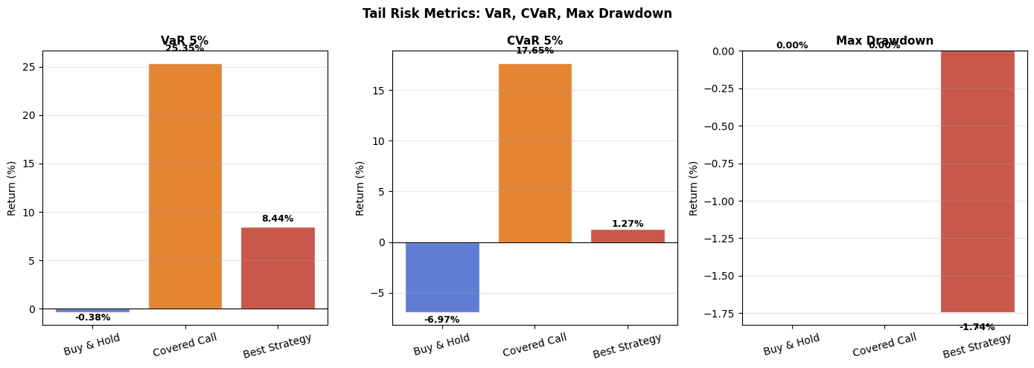
Figure 19. Tail risk metrics. Buy and Hold CVaR = -6.97%; Covered Call CVaR = +17.65%; Best Strategy CVaR = +1.27%. Positive CVaR for the overlay strategies indicates that even in the worst 5% of simulation scenarios, premium income exceeds equity losses.
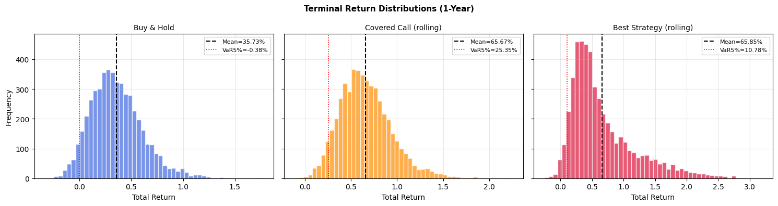
Figure 20. Terminal return distributions for all three strategies (5,000 paths). Buy and Hold (left) has the broadest distribution with left-tail losses. Covered Call (center) shifts the distribution right via premium income. Best Strategy (right) extends rightward further due to put payoffs in tail scenarios.
Interpreting the CVaR results carefully. The positive CVaR values for Covered Call (+17.65%) and Best Strategy (+1.27%) are a consequence of the 5-year calibrated high-drift environment (mu = 29.95%) combined with the 75.68% portfolio-weighted IV. With such a large premium income relative to the probability of being called away, the worst 5% of simulation scenarios still produce a net positive return. In a lower-drift, lower-IV environment, these CVaR values would revert to negative territory. The relative ordering, Buy and Hold worst, Best Strategy better, Covered Call best in pure CVaR terms, reflects the fundamental tradeoff between premium income and upside participation.
6. Stop-Loss Risk Management: A Blunt Instrument
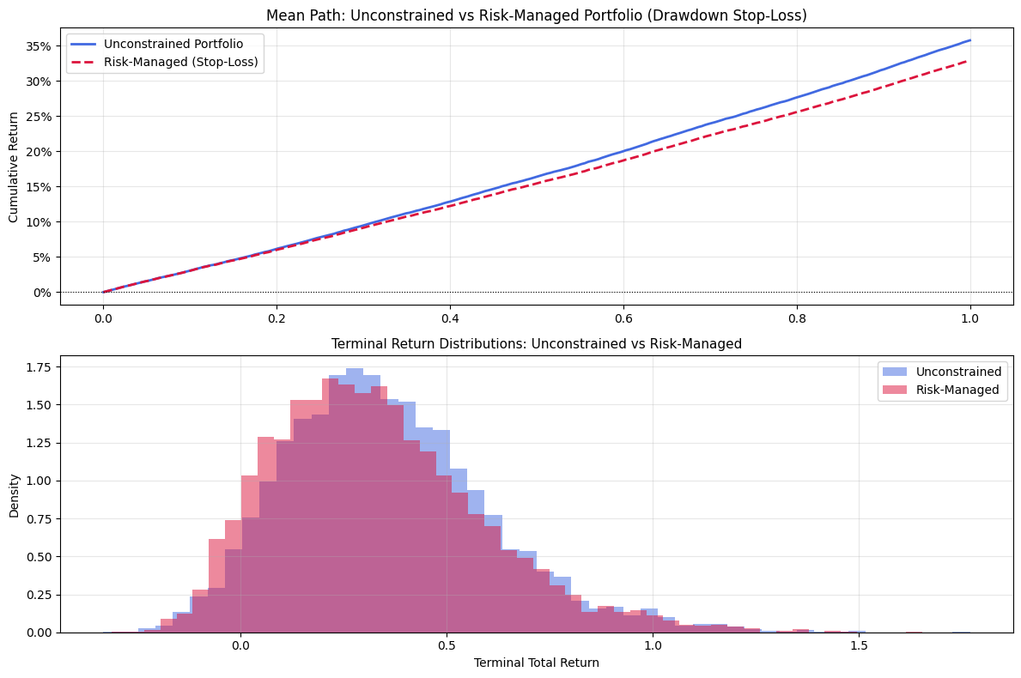
Figure 21. Stop-loss overlay (exit at -10% drawdown, re-enter at -5%). Top: cumulative return paths. Bottom: terminal return distributions. The stop-loss shifts the distribution left and truncates upside.
Metric | Unconstrained | Risk-Managed (Stop-Loss)
Annual Return | 35.73% | 32.87%
Sharpe Ratio | 1.2628 | 1.1254
Sortino Ratio | 5.4780 | 5.9172
VaR 5% | -0.38% | -2.64%
CVaR 5% | -6.97% | -8.07%
Table 4. Stop-loss risk-management trade-off. Applying a -10% exit threshold costs 2.86% in annual return while worsening VaR and CVaR due to whipsaw effects.

The stop-loss analysis reveals an important failure mode: a fixed drawdown threshold is a blunt instrument that performs poorly in V-shaped recovery environments. In this simulation, the stop-loss exits positions during early drawdowns triggered by the April-May 2025 volatility spike, then misses much of the subsequent recovery. The result is a 2.86% reduction in annual return (35.73% to 32.87%), a worsened VaR 5% (-0.38% to -2.64%), and a worse CVaR (-6.97% to -8.07%). The Sortino ratio improves marginally (5.478 to 5.917) because the stop-loss does truncate some large negative daily returns, but at an unacceptable cost in overall performance. The rolling options overlay, which continuously re-prices tail risk without forcing binary in/out decisions, is a structurally superior approach.
7. Limitations of the Current Analysis
7.1 Simulation-Only Evaluation
All strategy performance metrics are computed on GBM-simulated paths rather than on a historical backtest of the actual portfolio. The GBM simulation uses a 5-year calibrated drift rate of mu = 29.95%, which reflects an unusually strong post-COVID return period. Forward-projected returns at this drift rate are almost certainly higher than what the next 12 months will deliver. The positive CVaR values for the options overlays are a direct consequence of this input choice. A true historical backtest, where the strategy is applied to actual daily prices with live option market fills and bid-ask spread costs, would produce more conservative and realistic metrics.
7.2 Transaction Costs and Bid-Ask Spread
Option bid-ask spreads for large-cap names like NVDA (ATM IV 181.84%) and MSFT (ATM IV 218.46%) are extremely wide in percentage terms, particularly for short-dated contracts. The current implementation uses Black-Scholes midpoint prices with no slippage. In practice, selling a covered call at the midpoint is rarely achievable; fills typically occur at or below the bid. For a portfolio-level covered call on a $403.43 basket, the implementation cost could easily amount to 0.5% to 1.5% of premium, meaningfully reducing the reported return advantage.
7.3 Static Covariance Matrix
The covariance matrix Sigma is estimated once from the 5-year calibration window and held fixed throughout the simulation. The volatility clustering analysis (Figure 6) demonstrates clearly that realized vol is not stationary: the portfolio experiences periods at 45% annualized vol followed by extended periods below 10%. A fixed Sigma will underestimate correlation and volatility during stress regimes, causing the Cholesky-decomposed GBM paths to underweight extreme co-movements. This is a structural limitation that Heston partially addresses for variance but not for the cross-asset correlation structure.
7.4 Jump Parameter Selection
The Merton model uses jump parameters lambda = 1.5, mu_J = -0.05, and sigma_J = 0.10, which were chosen based on prior literature rather than calibrated to the observed portfolio return distribution. A proper calibration would use maximum likelihood estimation on the actual daily return series to find the parameters that best fit the observed fat tails and skewness. The current parameters may overstate or understate jump frequency depending on the actual jump arrival rate in the 2025 to 2026 period.
7.5 Universe Survivorship and Data Quality
The 31-ticker universe is composed entirely of large-cap names with continuous price histories. There is no mechanism for ticker additions, deletions, or corporate actions (splits, spinoffs, mergers). The 6-ticker reduction from the original 31 to 25 common tickers between the calibration and current windows introduces a mild survivorship bias: only names present in both windows are included, which tends to favor companies that avoided significant adverse events.
8. Future Improvements
8.1 Delta-Hedging with Transaction Costs
The most impactful next step is to replace the static option positions with delta-hedged positions that are rebalanced daily. This requires computing the Black-Scholes delta at each roll date and maintaining a delta-neutral position by trading the underlying futures. Adding explicit bid-ask spread costs (estimated from the fetched IV surfaces using half-spread = (ask - bid) / 2) would produce a realized P&L that accounts for the true cost of execution. A position management module tracking option greeks in real time would make the strategy implementation-ready.
8.2 Regime-Conditional Strategy Selection
The current rolling engine selects strategies purely by maximizing the one-period Sharpe improvement using the forward cross-sim terminal distribution. A natural enhancement is to condition strategy selection on the current market regime identified in Section 3.5: use covered calls in Bull / low-vol regimes (where premium income is earned without forfeiting equity upside), and rotate to protective puts or collars in Bear / high-vol regimes (where tail protection has positive expected value). This would create a direct feedback loop between the EDA regime segmentation and the execution logic, making the strategy more interpretable and more robust to regime transitions.
8.3 GARCH(1,1) Volatility Forecasting
The current rolling engine uses a 20-day historical lookback standard deviation as the sigma input to Black-Scholes at each roll date. A GARCH(1,1) model fitted to the portfolio return series would produce a better forward-looking variance forecast by incorporating the persistence coefficient that determines how slowly current volatility reverts to its long-run mean. The volatility clustering analysis (average high-vol run of 19 trading days) is precisely the phenomenon GARCH is designed to capture, and fitting it would directly improve the accuracy of option strike selection at each roll.
8.4 Multi-Asset Option Structures
The current framework prices options on the aggregated portfolio value as though it were a single underlying. A more precise approach would use basket options or worst-of options on the individual constituents, with correlation structure drawn from the 25-asset covariance matrix. Alternatively, index options on SPY or QQQ could be used as a cheaper hedging proxy, given the SPY-NVDA correlation of 0.77 and SPY-AMZN correlation of 0.71 documented in Section 3.3.
8.5 Walk-Forward Backtest on Historical Data
The most rigorous validation of the entire framework would be a walk-forward backtest on the 5-year calibration window itself. At each monthly roll, the strategy would be calibrated on the prior 252-day window, options would be priced using the prevailing IV surface, and actual portfolio returns would be computed using daily close prices. This would produce a time series of realized strategy P&L from 2020 to 2025 that spans both bull and bear environments, giving a much more realistic picture of strategy performance than the forward simulation provides.
9. Reflection
The most important lesson from this project is methodological: simulation inputs matter more than model choice. The first version of this analysis used a single in-sample year for calibration and produced a Sharpe ratio above 100, zero drawdowns, and undefined Sortino ratios. Those outputs were not wrong in a computational sense; they were wrong because the inputs did not represent the full distribution of possible market environments. Switching to a 5-year multi-regime calibration window immediately produced numbers in an interpretable range.
A closely related lesson concerns how volatility is measured from simulation output. Computing vol from the mean path of 5,000 GBM paths (a common approach) suppresses variance to near zero because averaging eliminates cross-path dispersion. The Sharpe ratio computed this way inflated to above 100. The correct approach, computing vol as the cross-sectional standard deviation of terminal returns across all paths, produced Sharpe ratios of 1.26 to 2.20, values that are high but defensible given the 5-year high-drift calibration.
The volatility clustering analysis added a dimension that purely predictive models miss. The 19-day average high-vol run length is not just a descriptive statistic; it is the primary motivation for the rolling options overlay's 21-day rebalancing frequency. Options written for a 21-day horizon capture approximately one full high-vol episode, which is the natural granularity at which risk re-pricing occurs.
The stop-loss analysis was the most instructive negative result. A threshold-based rule that works well in trending bear markets creates whipsaw losses in V-shaped recoveries, which dominate this data period. The rolling options overlay is superior precisely because it does not force a binary in/out decision: it continuously re-prices tail risk and selects the instrument that best shapes the forward return distribution, rather than cutting exposure at a predetermined loss level and hoping to re-enter at the right time.

