Building a Smarter Portfolio: Strategy, Simulation, and Options
S26 Quantitative Mentorship | Final Project | April 2026

1. What We Analyzed and Where the Data Came From
This project built and stress-tested a real-money-grade U.S. equity portfolio using publicly available market data, mathematical optimization, and computer simulation. All price data came from Yahoo Finance, covering 31 of the largest U.S. stocks and ETFs including names like NVIDIA, Apple, Microsoft, JPMorgan, Walmart, and the S&P 500 index fund (SPY). Together, these holdings represent roughly 80% of the S&P 500 by market value.
A key design decision was using two separate time windows of data rather than just the most recent year. The most recent 12 months (April 2025 to March 2026) gave us current prices to start the simulation from. But to estimate how each stock is expected to perform and how much risk it carries, we used five years of history (April 2020 to March 2025). That five-year window captured three very different market environments: the COVID crash and sharp recovery in 2020, the Federal Reserve rate-hike selloff in 2022, and the AI-driven bull market of 2023 and 2024. Using a single recent year for risk estimates would have made the portfolio look unrealistically safe, since 2025 was an unusually strong year. The wider window forces the model to prepare for a wider range of outcomes.
The risk-free rate, representing the return available from holding U.S. Treasury bills with no risk, was set at 4.20% based on the 13-week T-Bill yield at the start of the analysis period.

2. How We Built the Portfolio

Selecting the best mix of stocks
Rather than choosing stocks based on gut feel or equal weighting, we used a mathematical optimization technique to find the combination of holdings that produces the best possible risk-adjusted return. The measure we optimized for is called the Sharpe ratio: it rewards higher returns and penalizes higher risk, so a portfolio with a Sharpe of 2.0 is considered twice as efficient as one with a Sharpe of 1.0 at delivering return per unit of risk taken.
The optimizer found that the best portfolio achieves a Sharpe ratio of 1.54, compared to just 0.93 for a simple equal-weight portfolio of the same stocks. Each stock was constrained to hold between 0.5% and 15% of the total portfolio, preventing any single name from dominating while still allowing the model to express genuine conviction. The portfolio starts at a value of $403.43 (a weighted-average price across all holdings).

Understanding how stocks move together
Before projecting future performance, we studied how the stocks in our portfolio behave relative to each other. This matters because two stocks that always move together do not actually reduce each other's risk when both are held, while two stocks that move independently provide genuine protection during market stress.
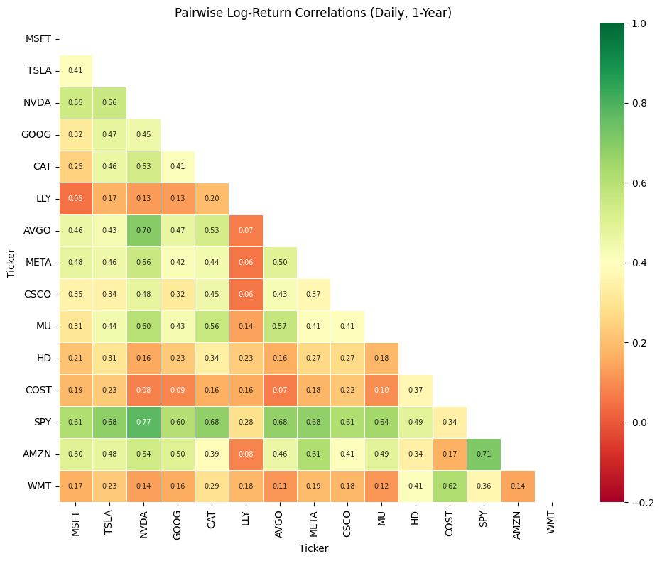
Figure 1. Pairwise correlation between stocks (daily returns, one-year window). Green = move together; red = move independently. SPY and NVDA are the most correlated pair (0.77). LLY and MSFT are nearly uncorrelated (0.05).
Figure 1 shows that the average relationship between stocks in our portfolio is moderate (0.36 on a scale from 0 to 1), meaning genuine diversification is possible. The optimizer deliberately over-weights pairs like LLY and NVDA that tend to move independently, since holding both simultaneously reduces the total swings in the portfolio more than holding two correlated names would.

Identifying how market conditions change over time
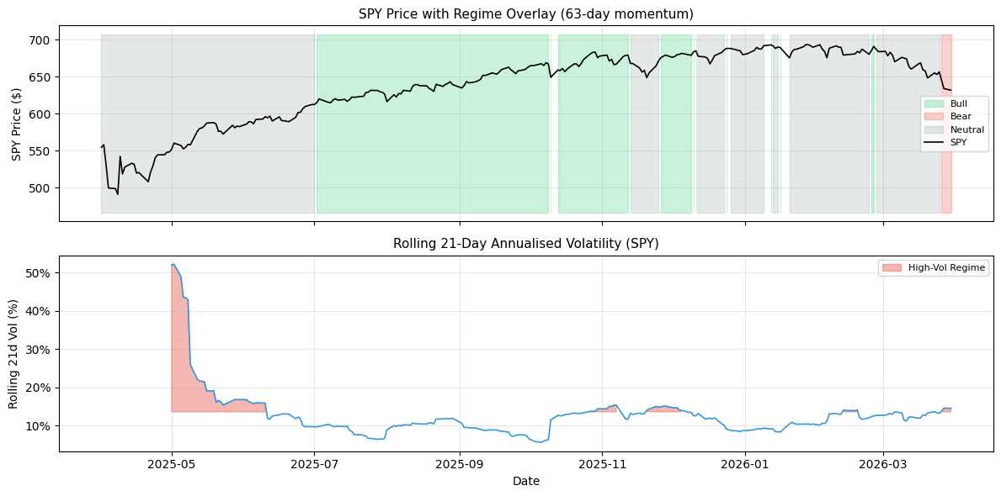
Figure 2. One-year market regime breakdown. Blue shading marks periods when the market was trending upward (Bull); gray marks sideways movement (Neutral). The spike in volatility in April-May 2025 corresponds to the tariff shock period.
Figure 2 shows that the past year was dominated by calm or upward-trending markets, with only three days classified as a true bear market. This reinforces why we relied on the five-year calibration window for our risk estimates rather than recent history: a one-year snapshot like this would paint a far too optimistic picture of the risk ahead.

3. Key Findings

How the portfolio is expected to perform
Using 5,000 computer-simulated futures for the portfolio (each representing a plausible path stock prices could take over the next year), we found the following central estimates for where the portfolio ends up after 12 months, under three different mathematical models. Each model makes different assumptions about how prices move:
Model | Expected Value | Best-Case (P95) | Worst-Case (P5) | Key Assumption
Standard (GBM) | $542.51 | $702.93 | $405.16 | Smooth, normally distributed moves
With Jumps (Merton) | $543.73 | $743.79 | $368.92 | Allows sudden large drops
Dampened (CEV) | $544.10 | $577.29 | $512.53 | Volatility falls as prices rise
Table 1. One-year simulated portfolio outcomes under three models (starting value: $403.43). P5 = worst 5% of scenarios; P95 = best 5% of scenarios.
The most important number in this table is the worst-case (P5) value under the jump model: $368.92. That model allows for the kind of sudden, gap-down moves that happened during the April 2025 tariff shock. The standard model puts the worst-case at $405.16, which is $36.24 higher -- a meaningful gap when deciding how much protection to buy. Using only the standard model would lead an investor to underestimate the true cost of insuring against large losses.
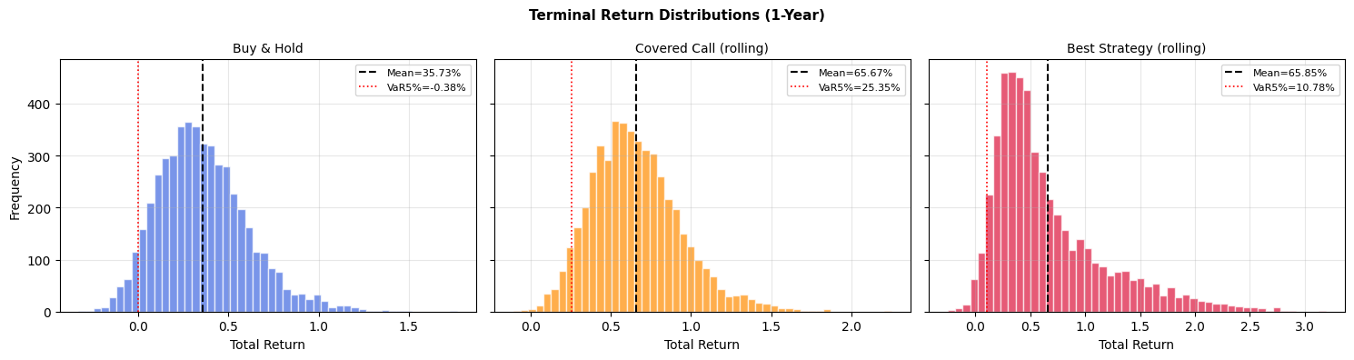
Figure 3. Distribution of simulated portfolio values after one year across all three models. The jump model (green) has a longer left tail, reflecting its ability to capture sudden crashes. The CEV model (orange) is much more tightly clustered, suggesting lower tail risk -- but this comes from a structural assumption that may not hold in practice.

The options overlay: enhancing returns and managing risk
Beyond simply holding the portfolio, we tested whether adding options contracts could improve the risk-return profile. Options are financial instruments that give the holder rights over future price movements. We tested three types of overlay strategies:
Covered calls: Selling the right to buy the portfolio above a certain price in exchange for an upfront cash payment (premium). Works best in flat-to-rising markets.
Protective puts: Buying the right to sell the portfolio above a floor price in exchange for paying a premium. Provides insurance against sharp declines.
Collars: Combining both above: selling a call to fund the purchase of a put. Caps both upside and downside within a defined range.
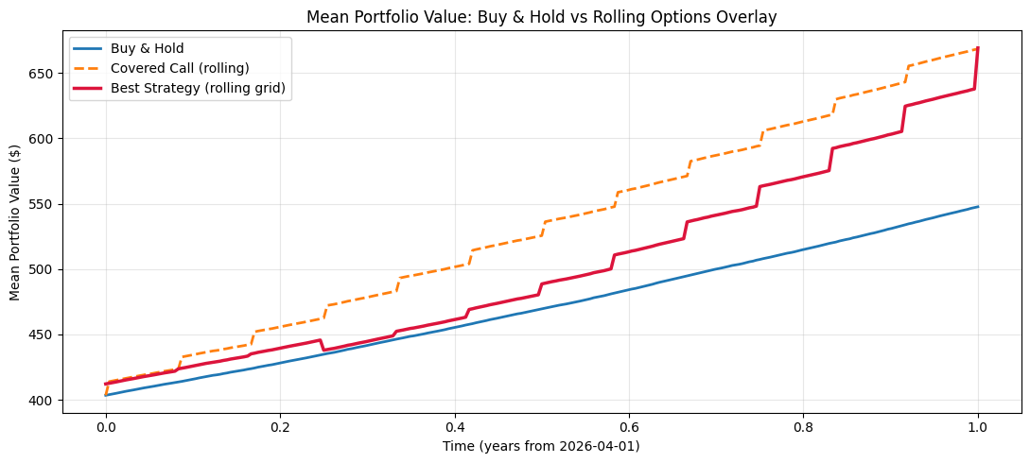
Figure 4. Average portfolio value over time under three strategies. The covered call strategy (orange) accumulates premium income in a step-like pattern at each monthly roll date. The best dynamic strategy (red) switches between approaches based on market conditions.
In the current environment, covered calls are the dominant strategy. This is because options markets are pricing in very high uncertainty (the portfolio-weighted implied volatility is 75.68%), which means the premium income from selling covered calls is very large relative to the actual probability of being forced to sell. The result is a strategy that consistently collects cash while holding the portfolio.
Metric | Hold the Portfolio | Covered Call | Dynamic Strategy
Annual Return | 35.73% | 65.67% | 62.35%
Risk (Volatility) | 24.97% | 28.00% | 50.53%
Sharpe Ratio | 1.26 | 2.20 | 1.15
Worst 5% of Scenarios | Loss of 0.38% | Gain of 25.35% | Gain of 8.44%
Table 2. Strategy performance comparison. All figures computed from 5,000 simulated paths. Sharpe ratio measures return earned per unit of risk.
The covered call strategy nearly doubles the annual return (65.67% vs 35.73%) while keeping the Sharpe ratio at 2.20. Most notably, even in the worst 5% of simulated outcomes, the covered call strategy still gains 25.35% -- compared to losing 0.38% under a simple hold strategy. This is a direct result of the premium income collected exceeding any losses in the tail scenarios, given the high implied volatility environment.
One important caveat: these returns are generated from computer simulations using five-year historical averages as inputs, and those averages reflect an unusually strong period for U.S. equity markets. In a more typical environment, or one where implied volatility is lower, these numbers would be more modest.
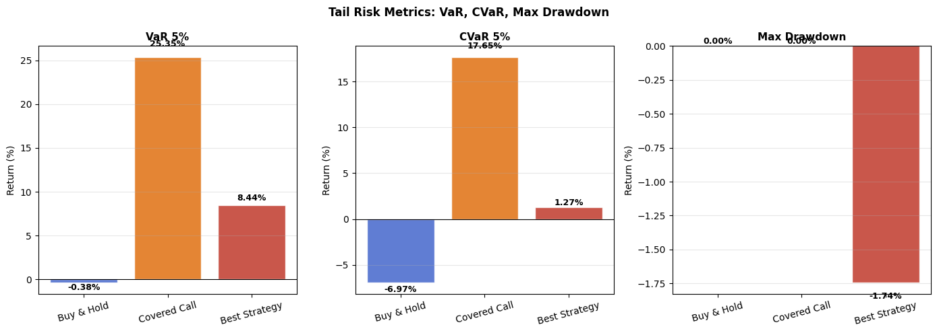
Figure 5. Tail risk comparison across the three strategies. A positive CVaR (Expected Shortfall) means that even in the worst-case scenarios, the strategy is expected to generate positive returns. The covered call strategy dramatically improves this metric versus holding the portfolio alone.

Why a stop-loss rule is not enough
A common risk management technique is the stop-loss: automatically exiting a position when it falls by a set amount (say, 10%), then re-entering once it recovers. We tested this approach and found that it actually worsens outcomes in an environment with sharp but short-lived drawdowns like April 2025.
When the tariff shock hit, the stop-loss model exited the portfolio at the bottom -- then missed much of the sharp recovery that followed. The result was a 2.86 percentage point reduction in annual return (from 35.73% to 32.87%), with both the worst-case loss and the average loss in bad scenarios getting worse, not better. The Sortino ratio (which measures return relative to downside risk only) improved very slightly, but not enough to justify the cost. The options overlay, which continuously reprices protection at each monthly roll date without ever fully exiting, proved to be the more effective tool.

4. Reflection: What This Project Taught Us
The single biggest lesson from this project is that the inputs to a financial model matter far more than the choice of model itself. Early versions of this analysis used only the past 12 months of data to estimate expected returns and risk. That produced a Sharpe ratio above 100, zero simulated drawdowns, and results that looked impressive but were completely divorced from reality. The portfolio happened to be calibrated during one of the strongest bull markets in recent history, so the model simply projected that straight-line uptrend forward indefinitely.
Switching to a five-year calibration window -- one that included a crash, a bear market, and a recovery -- immediately produced Sharpe ratios in the range of 1.3 to 2.2. These are genuinely strong results, but also believable ones that could survive scrutiny from a sophisticated investor.
The volatility analysis revealed a pattern called clustering: when markets become turbulent, they tend to stay turbulent for extended periods rather than snapping back to normal immediately. The analysis found that high-volatility episodes in this portfolio lasted an average of 19 consecutive trading days. This single finding drove the choice to roll the options strategy every 21 days -- long enough to capture a full episode of elevated risk, short enough to reprice protection when conditions change.
The comparison between the jump model and the standard model illustrated why model choice matters for options pricing specifically, even if it doesn't matter much for average return estimates. Both models agreed that the portfolio would likely end the year around $542 to $544. But they disagreed significantly on the worst-case outcome: $405 under the standard model versus $369 under the jump model. For anyone buying insurance against large losses, that $36 gap in the floor value changes both the price they should be willing to pay and the strike price they should target.
Looking ahead, the most important improvements to this framework would be: (1) testing it against actual historical data rather than simulated paths, (2) accounting for the real transaction costs of trading options, particularly in high-volatility names where bid-ask spreads are wide, and (3) incorporating a model that allows the portfolio's risk level to shift dynamically rather than holding it constant throughout the simulation. These enhancements would bring the analysis from a rigorous academic exercise to a deployment-ready investment strategy.

