DAY - 1
Deploying and Scaling the Application

Please note that due to intermittent latency issues, all the steps are performed on PCF Dev (local).
- Starting PCF Dev – Type the following command to start PCF Dev. This step may take few minutes.

Cf dev start

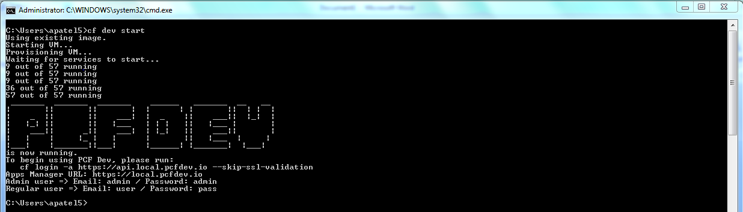

- Now, we will push a .war file into the local cloud setup. First navigate to the folder where the .war is kept. Then type the following command to push the file

cf push <user-defined-app-name> -p <package-or-file-name> -n <host-name-must-be-unique> -m <memory-in-mbs-suffixed-with-m> -i <no.-of-instances>

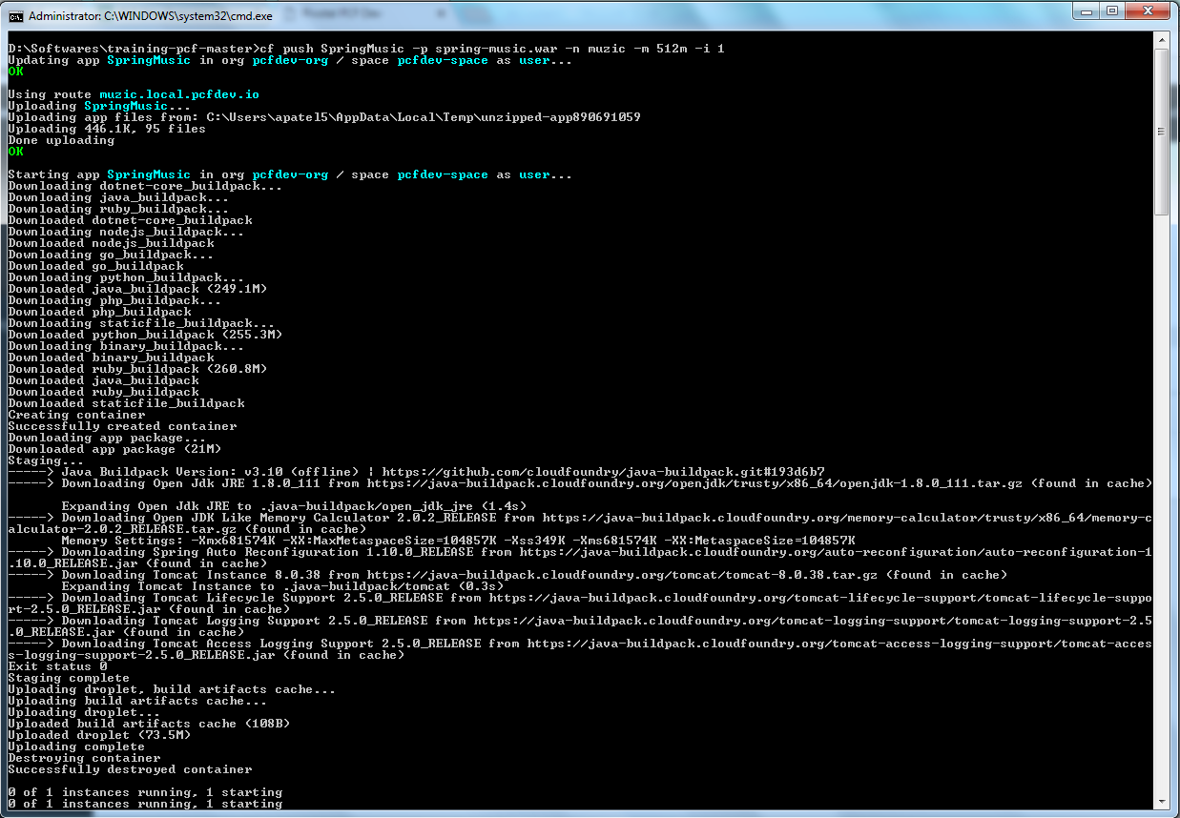

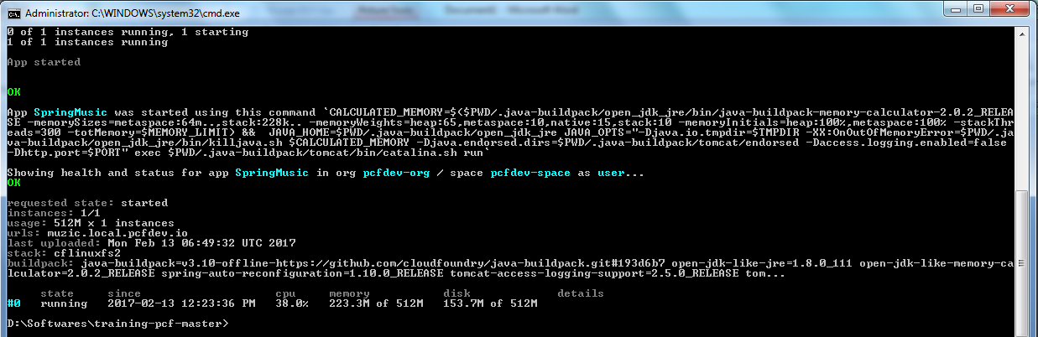

From the logs, we can figure out the different stages of the process –
- Upload the file
- Download all the buildpacks, like for Java, Go, Python, DotNet etc.
- Create Container
- Start staging – Identify the buildpack required, use the buildpack to stage the file, exit staging.
- Create and upload the droplet
- Start the number of instances defined in the command
- Navigate to the URL which is in form - <host-name-specified>.local.pcfdev.io
- See the logs of the application by typing following command

cf logs <app-name>

- Make some changes in data from browser. In my case, I added a new album and found following logs –

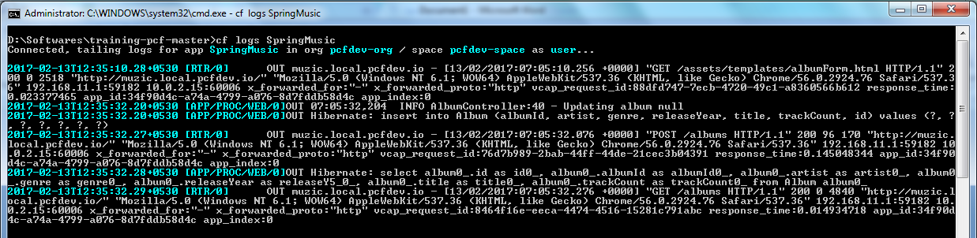

- Now, lets try to scale our application from browser web interface for PCF. Go https://local.pcfdev.io
Login with the credentials.
Navigate to the detailed page of the application

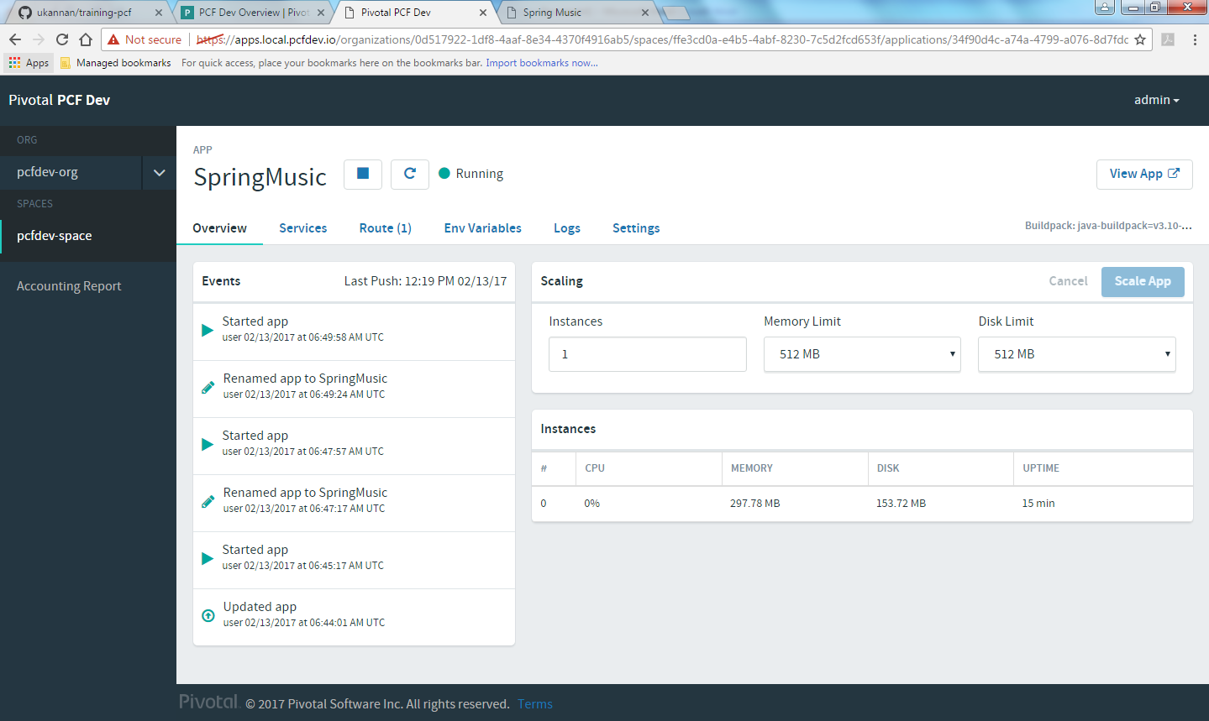

- Now make changes in the Instances field. Earlier, this value was 1, change it to 4.
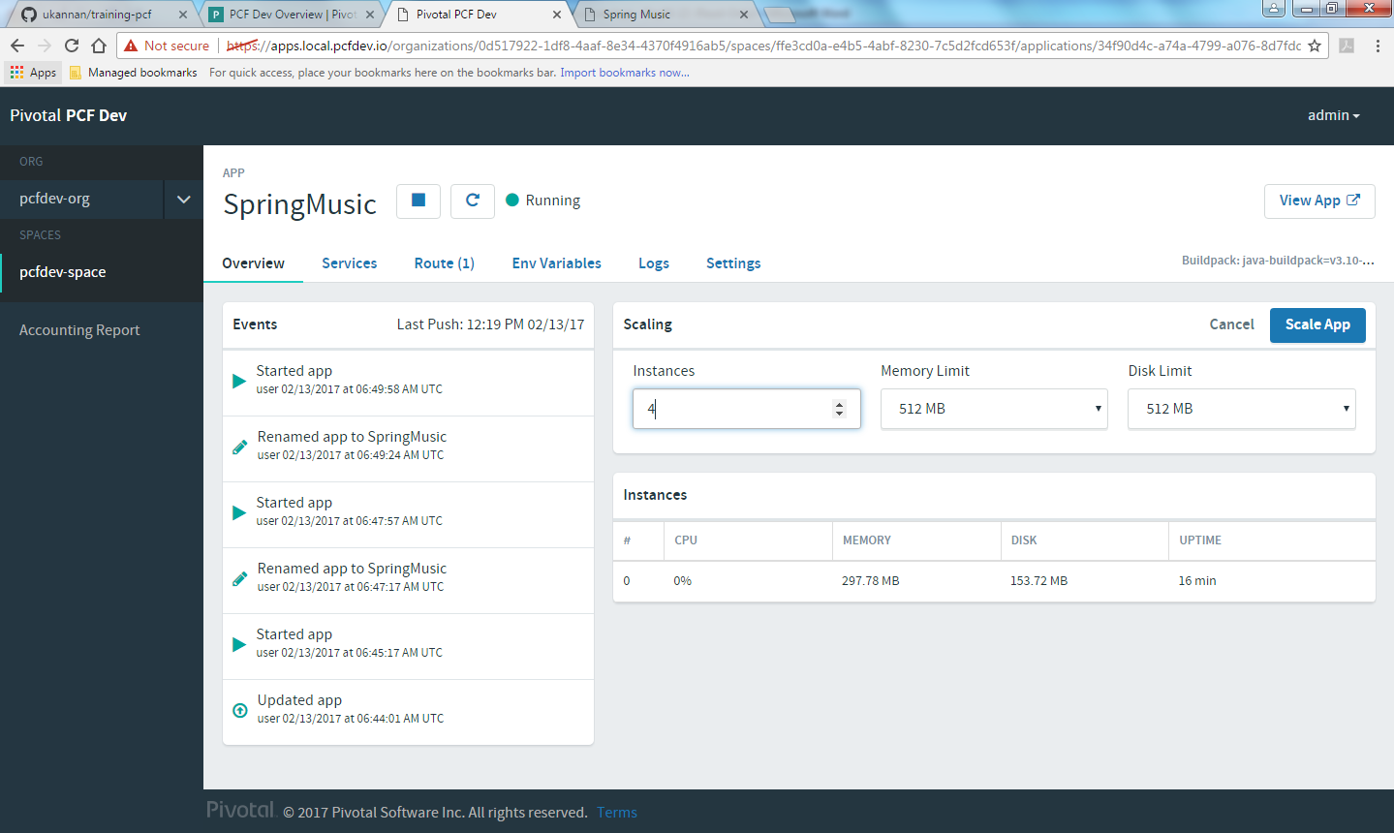

Click on Scale App button and let the process complete.

- Once done, app is successfully scaled.

