DAY - 2
Services

Please note that due to intermittent latency issues, all the steps are performed on PCF Dev (local).
- Getting a list of all the services –

cf marketplace

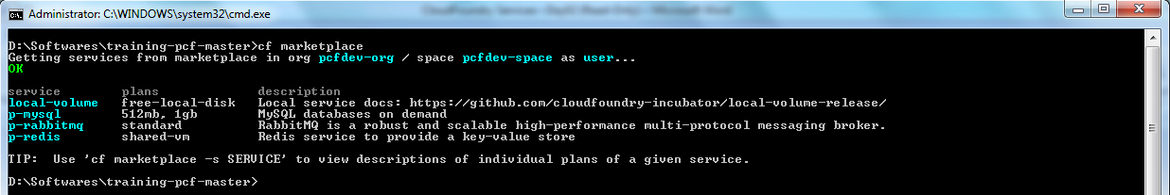

- Now, let us create a new service for MySQL. The command to do so is

cf create-service <service-name> <plan-name> <instance-name>

- Bind the previously pushed Spring Music App with the database service instance with command

cf bind-service <app-name> <service-name>

After running the bind service command, restart the app with following command

cf restart <service-name>

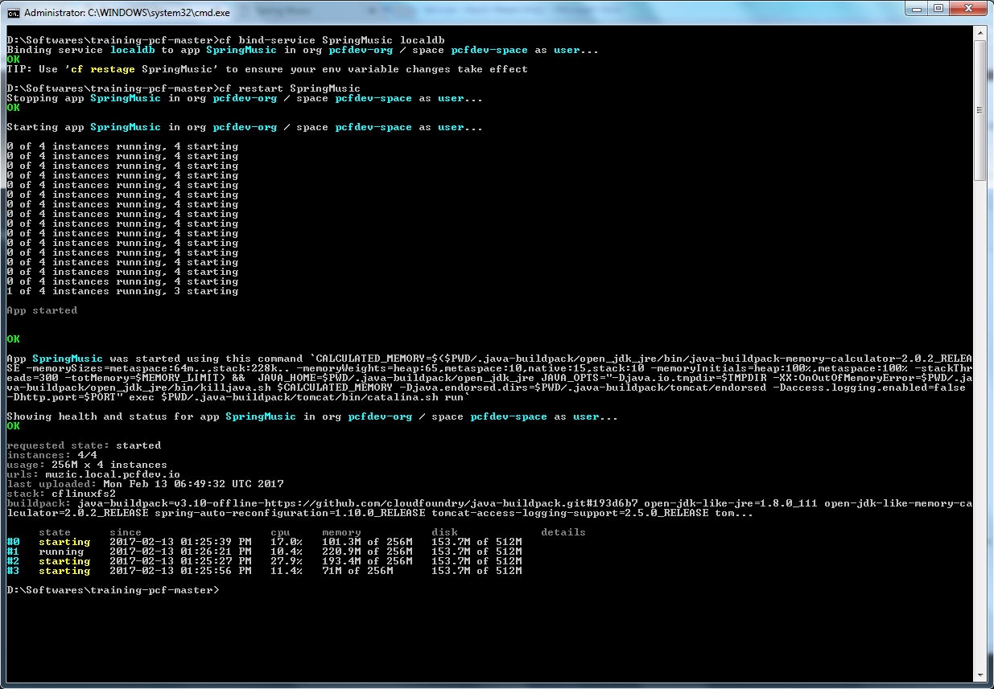

- Go to the application bound services page and click on credentials to obtain the credentials for MySQL instance. Now, use your SQL tool, in my case MySQL Workbench, to connect to the MySQL instance. Querry the data from the table and try adding record directly in table. The record should reflect on browser.

