DAY - 3
Configurations

Please note that due to intermittent latency issues, all the steps are performed on PCF Dev (local).
- In the project cf-spring-mvc-demo, open the manifest.yml file and make following changes –

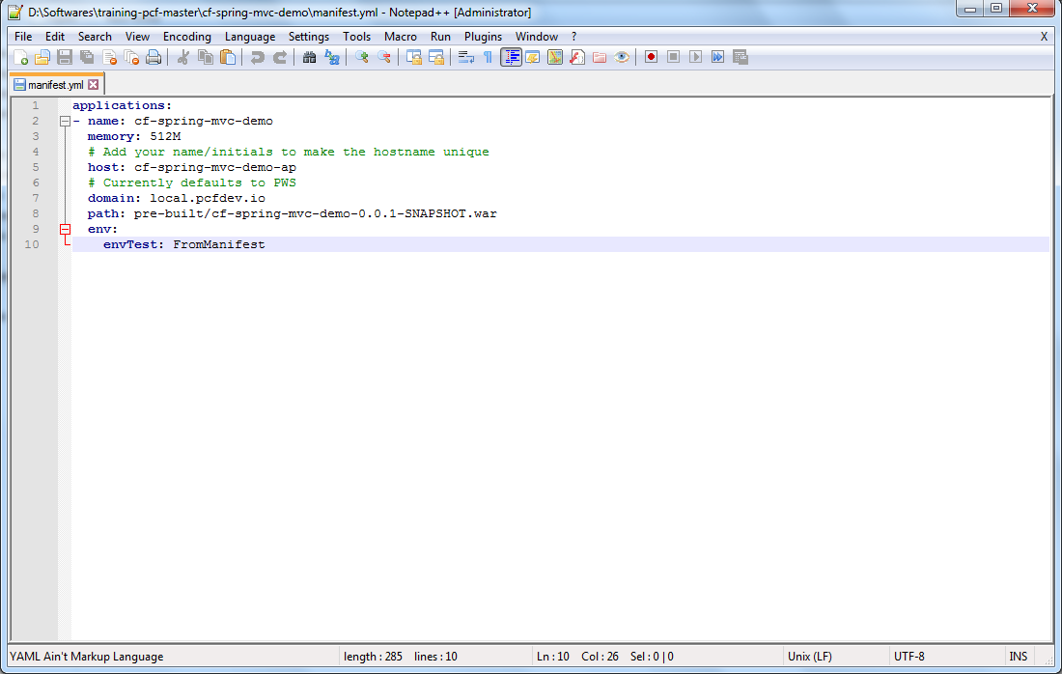

- Now push the application war file cf-spring-mvc-demo-0.0.1-SNAPSHOT.war using –

cf push <app-name> -p <war-file-name>

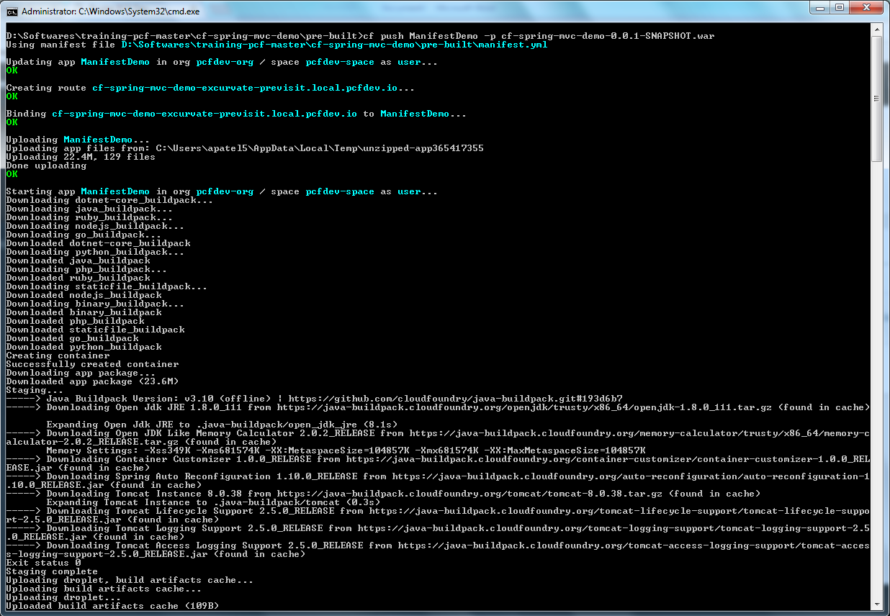

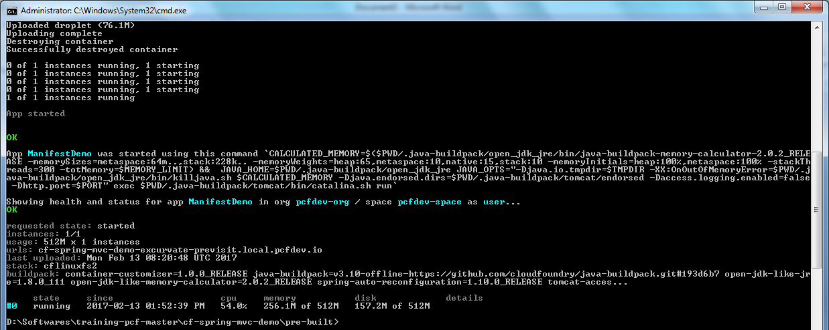

- Now go to the application detail page on browser and click on Env Variables tab. The variable envTest will appear with its value –

