DAY - 4
Blue Green Deployments

Please note that due to intermittent latency issues, all the steps are performed on PCF Dev (local).
- Use Maven command line or STS to build the project cf_bluegreen.
- After building the project, push the .war file in PCF dev with following command –

cf push Blue –p bluegreen-0.0.1-SNAPSHOT.war –m 256M –n blue

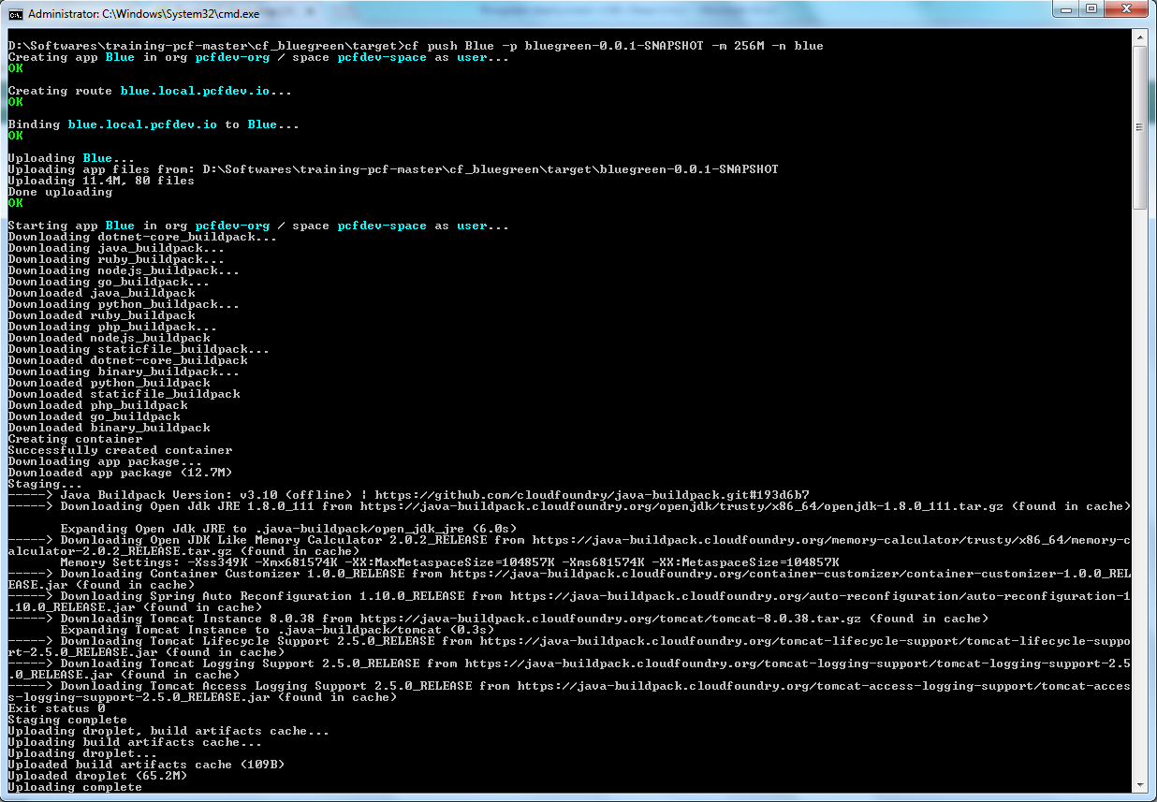

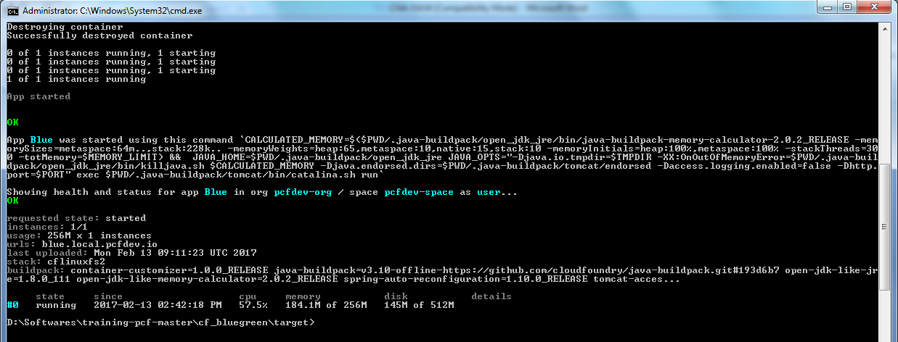

- When deployment is complete, go to the URL in browser and confirm successful deployment of Blue app.

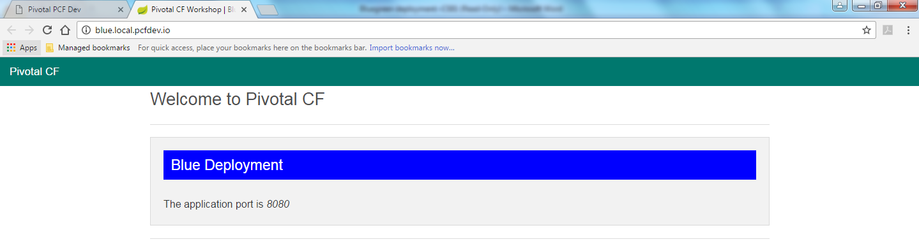

- Add a new route to the blue app deployment with following command

cf map-route <app-name> <domain> <hostname>

In my case, I used following command -

cf map-route Blue local.pcfdev.io newroute-hotdeploy

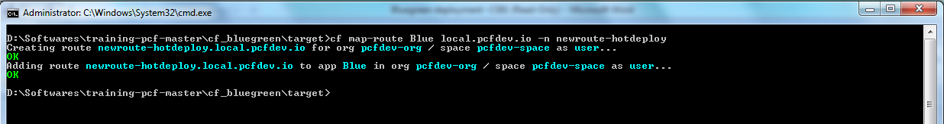

- Check the new route in browser. The exact same app should appear – (look into the URL)

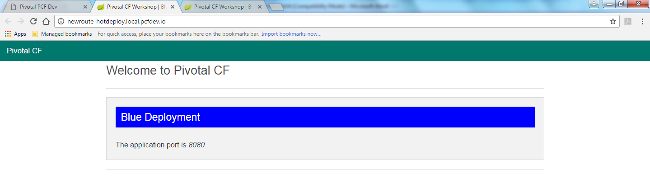

- Change the index.html file in cf_bluegreen\src\main\resources\templates folder. Comment the line with Blue Deployment and uncomment line with Green Deployment. Again run Maven install.
- Push the new .war with new app name and hostname as follows –

cf push Green –p bluegreen-0.0.1-SNAPSHOT.war –m 256M –n green

- Check the URL for green deployment –

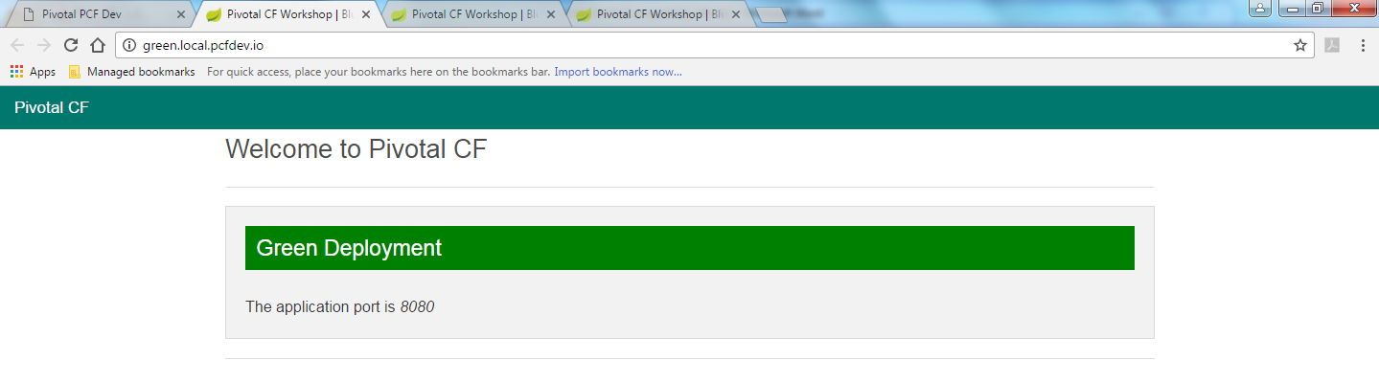

- Now, let’s bind the new route created in step 4 with the green deployment. Use command –

cf map-route Green local.pcfdev.io –n newroute-hotdeploy

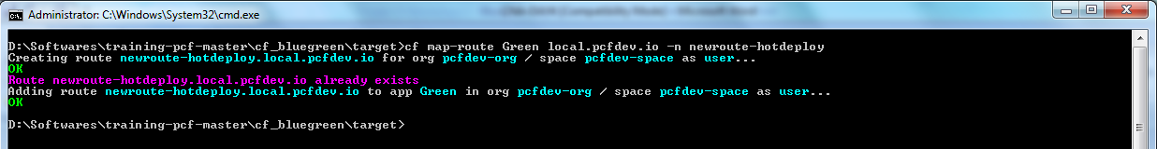

- Unmap new route from blue app.

cf unmap-route Blue local.pcfdev.io –n newroute-hotdeploy

- Go to browser and check the new URL. It should give you the Green Deployment page.

