DAY - 4
Deploying with External Buildpack

- Login to PWS as following –

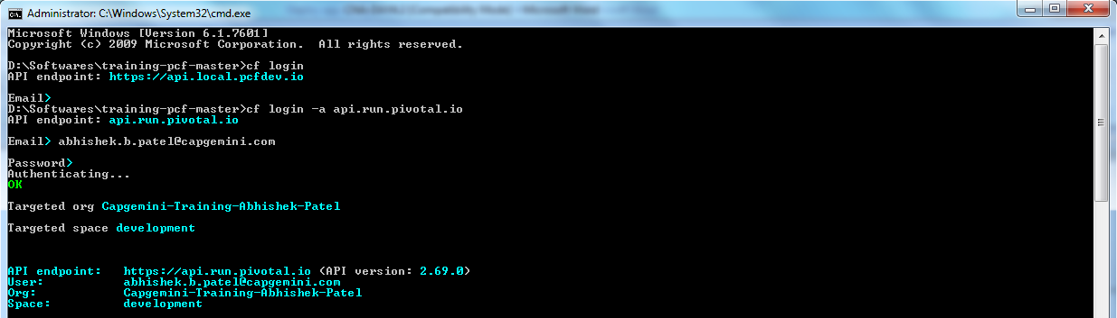

- Push the same Spring Music war file using following command –

cf push SpringMusicCB –p spring-music.war –n custombuildpack –b https://github.com/cloudfoundry/java-buildpack.git

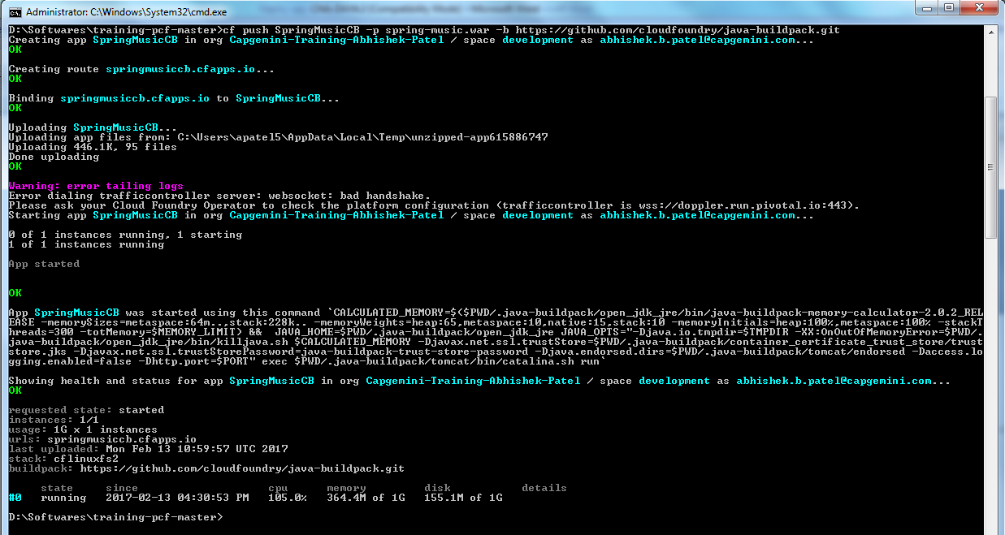

In above screenshot, notice the buildpack is the URL passed in the –b argument.

