Using STS to Deploy and Manage and Applications

To deploy and manage your Cloud Native Applications, you must first configure the Server in your IDE. Due to intermittent latency issues, we will be using PCF Dev. To setup Server in STS, follow the steps –
- In the Servers view (if you don’t have Servers view, go to Window -> Show View -> Servers), add new server.

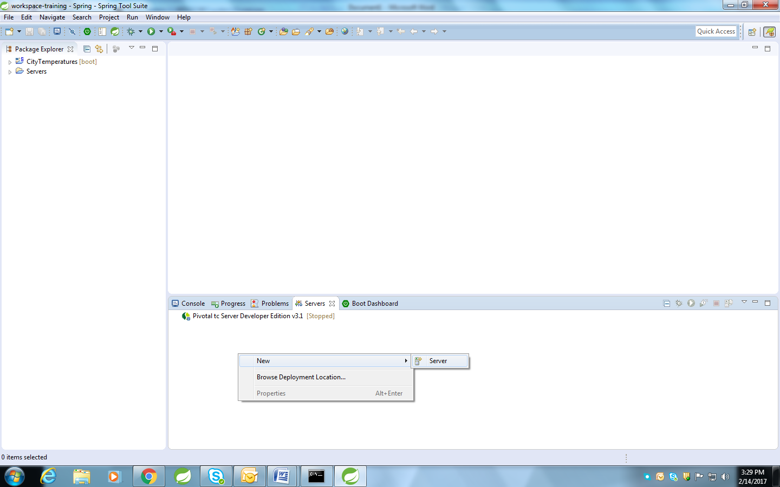

- Select Cloud Foundry and give any name. In my case, I used PCF Dev name. Click Next.

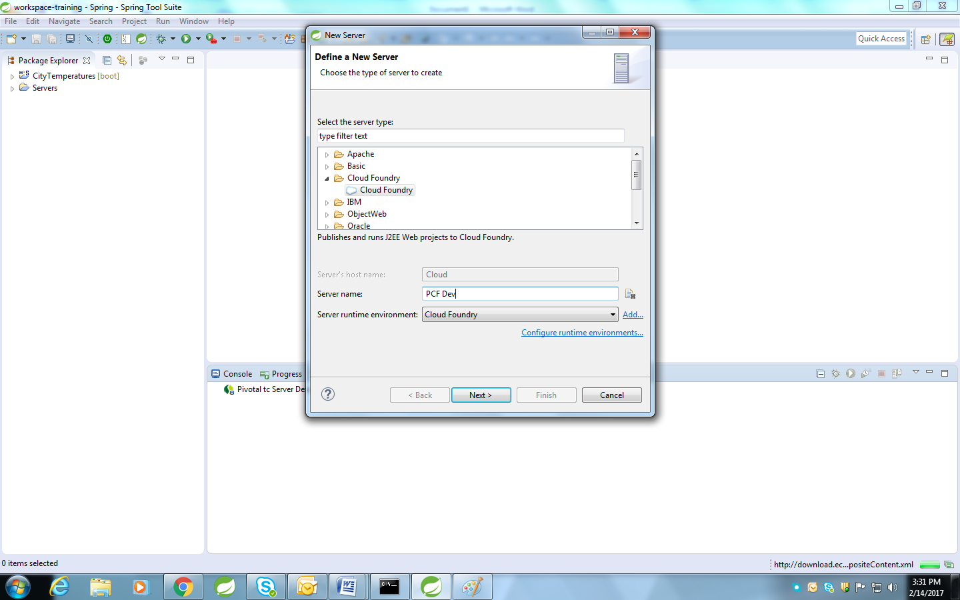

- On next screen, click on Manage Cloud… (do this step if you are using PCF Dev and doing this setup for the very first time). Then click Add.
- In this form we will give a name to the local PCF Dev setup and will provide the api end-point. For PCF Dev, we will use https://api.local.pcfdev.io as api end-point.
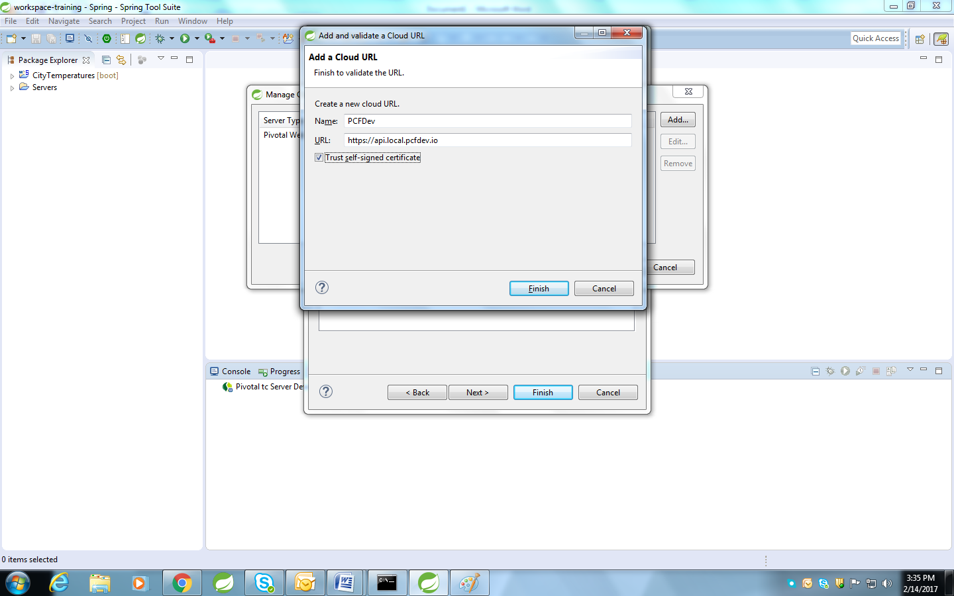

- Click Finish. On Manage Cloud window, now select the newly configured PCFDev cloud and click OK.
- Provide the credentials and click on Validate. Click on Next once verified. Select the organization and space. Click Next. On next screen, just click Finish.
- Right click on project and go to Run As - > Run on Server -> Select Cloud Foundry. Click Finish.

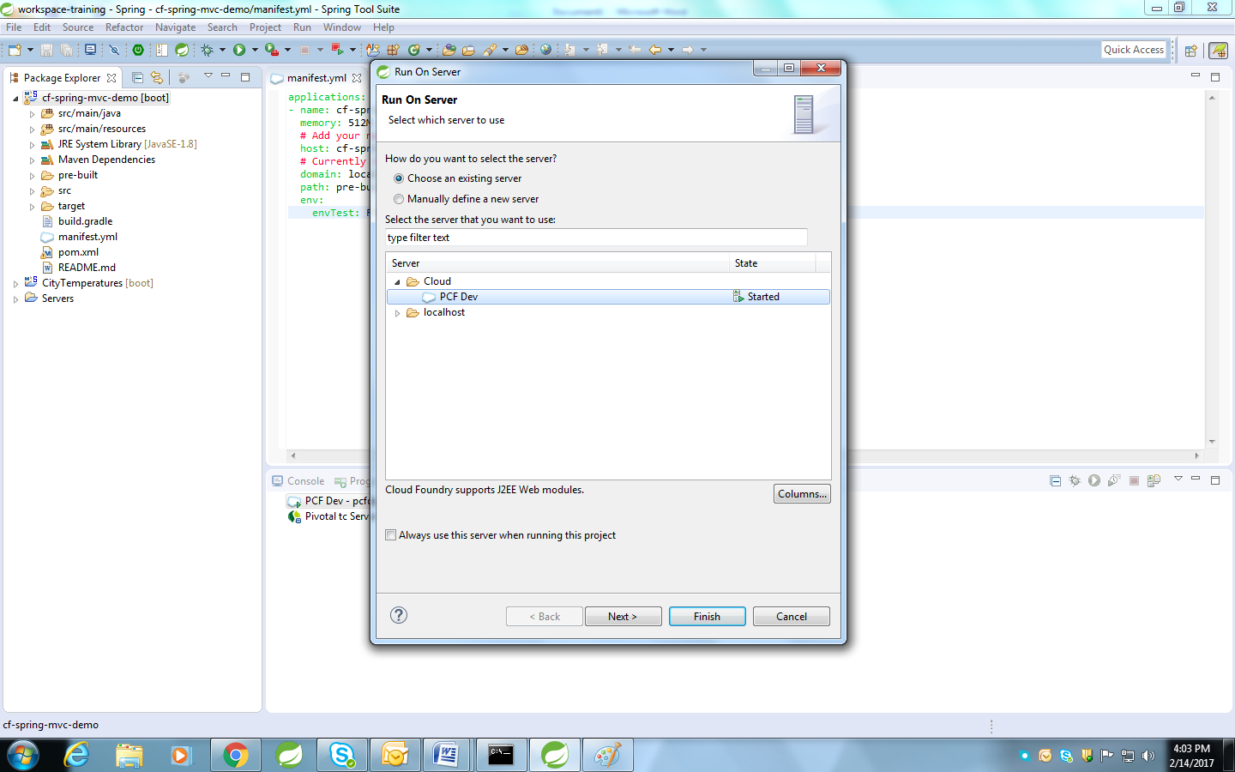

- Now, we will configure our app. In this window leave buildpack config blank as of now. Click next.
- Configure the name of the app, domain and subdomain for app and memory limit. Check the tick box to Start application on deployment. Click Next.

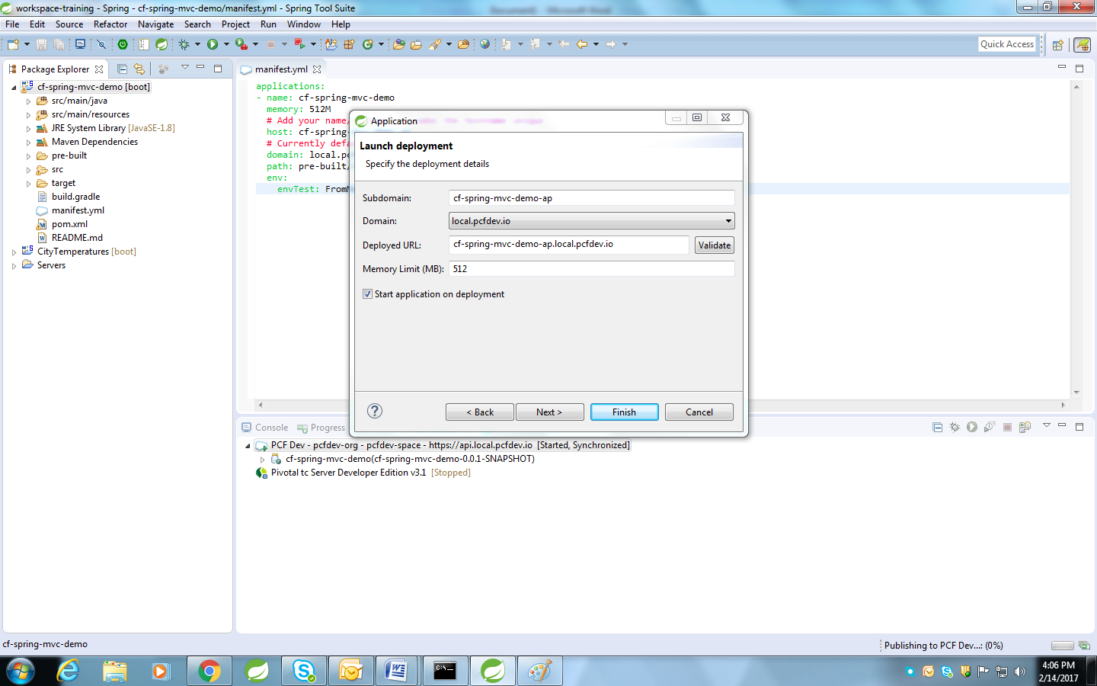

- If there are any services present in your cloud, you will see a list of the instances of these services. You can bind the instances with your application from this wondow. Just check the square for service instance and click Next.

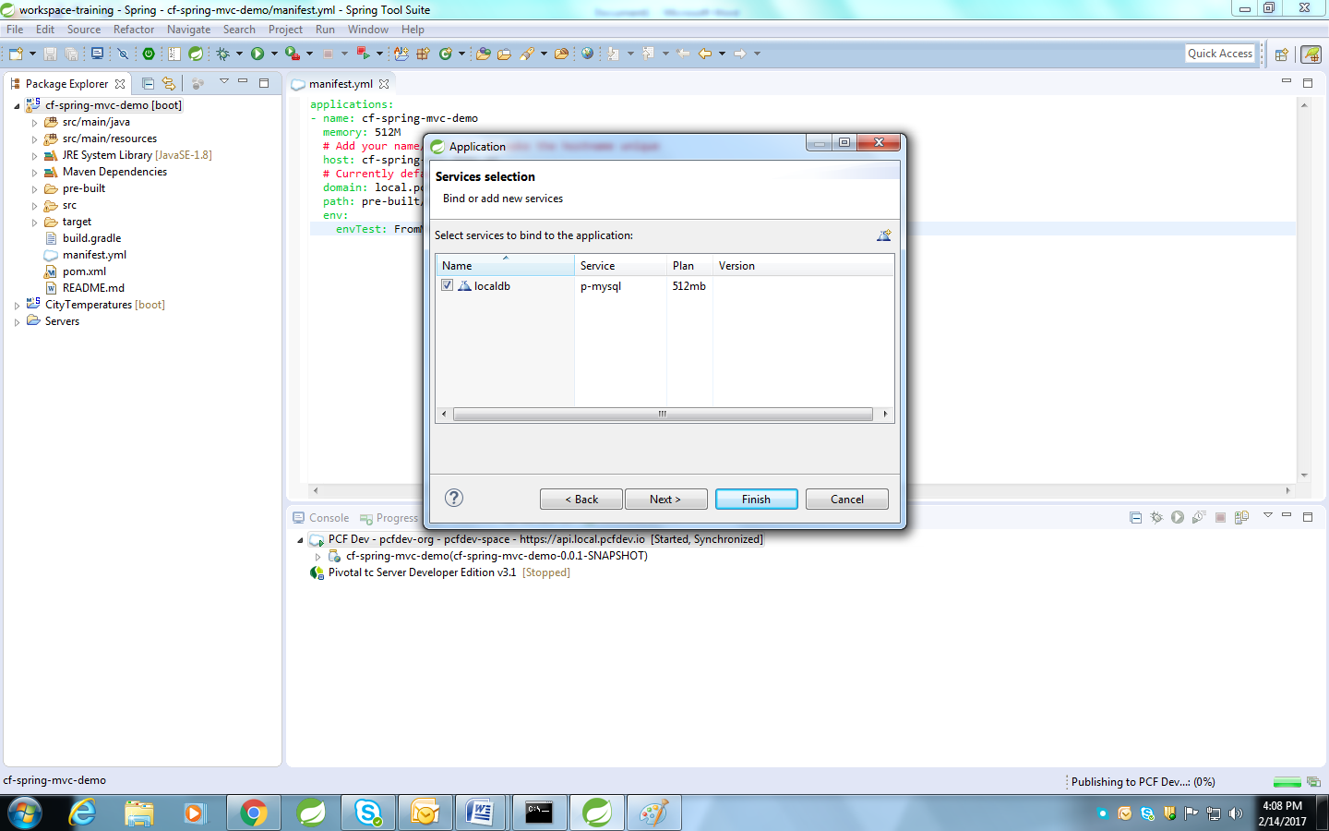

- On next screen, you can configure the User Defined Environment Variables. Initially, manifest.xml is scanned and if there are any variables present there, they will appear on this screen. Click Finish.

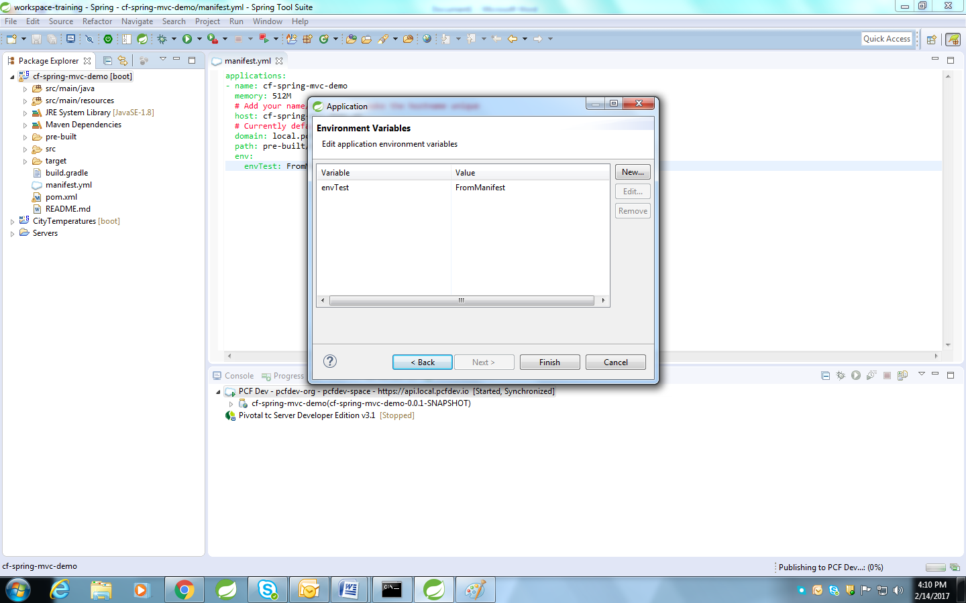

- See the logs for the deployment process in STS Console.

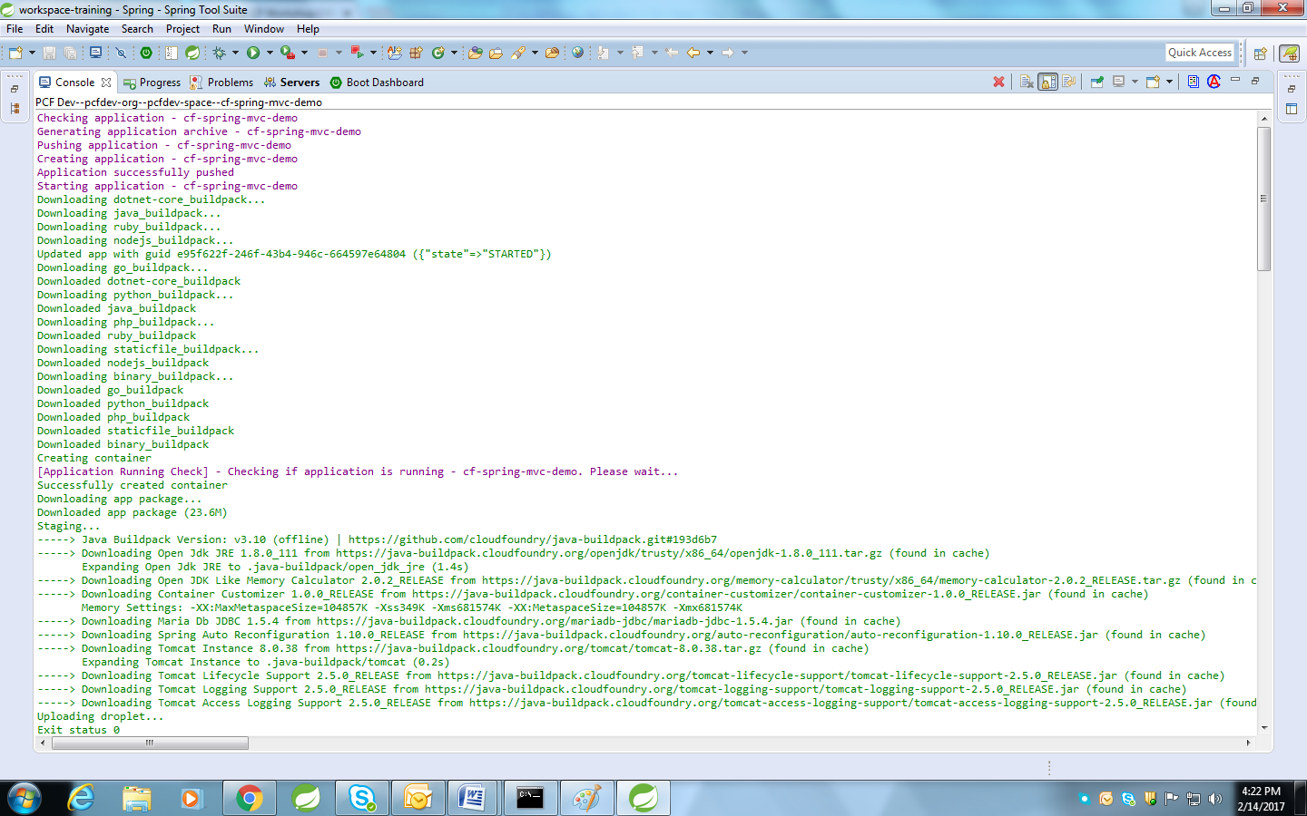

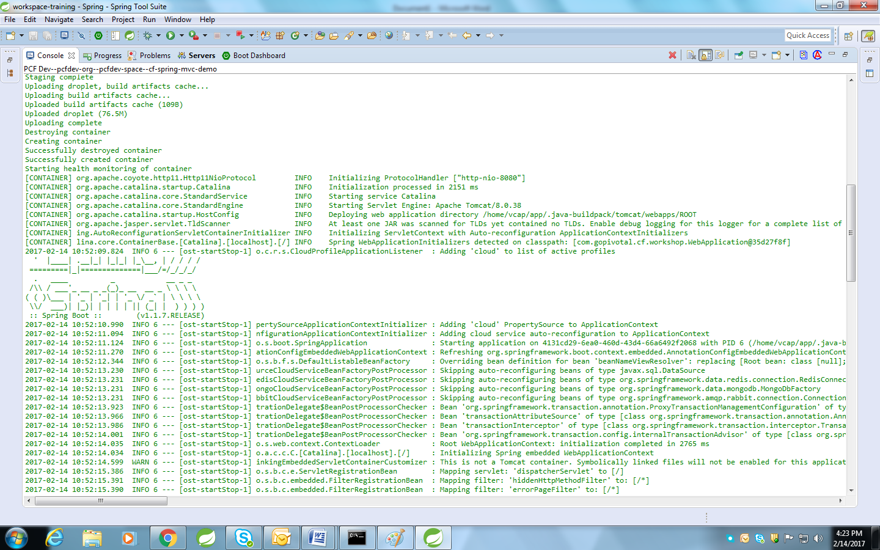

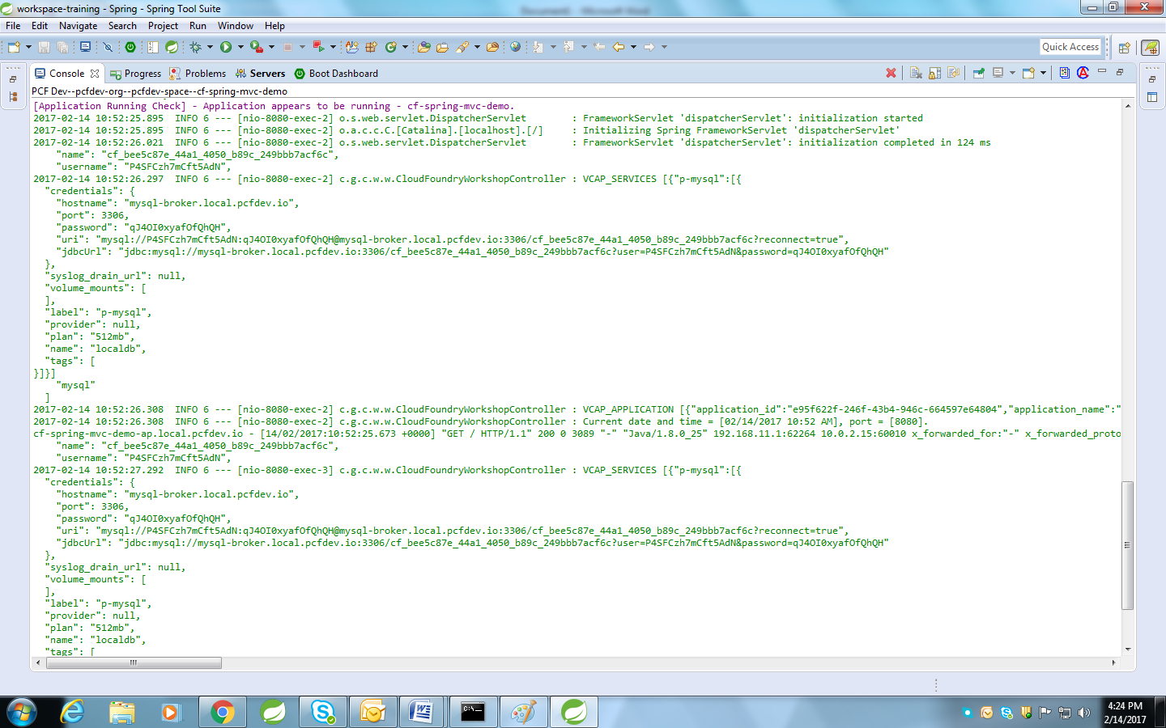

- Go to the application URL. Application must be running.
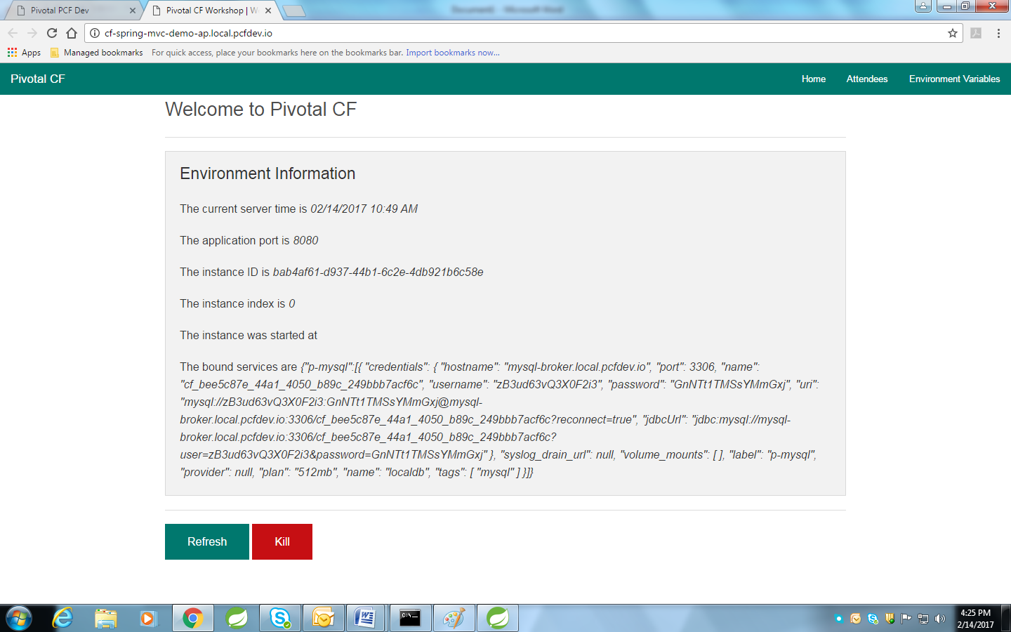

- Alternatively you can manage the application and service from the STS by double clicking on the server in server list.
- Click on the Applications and Services tab.

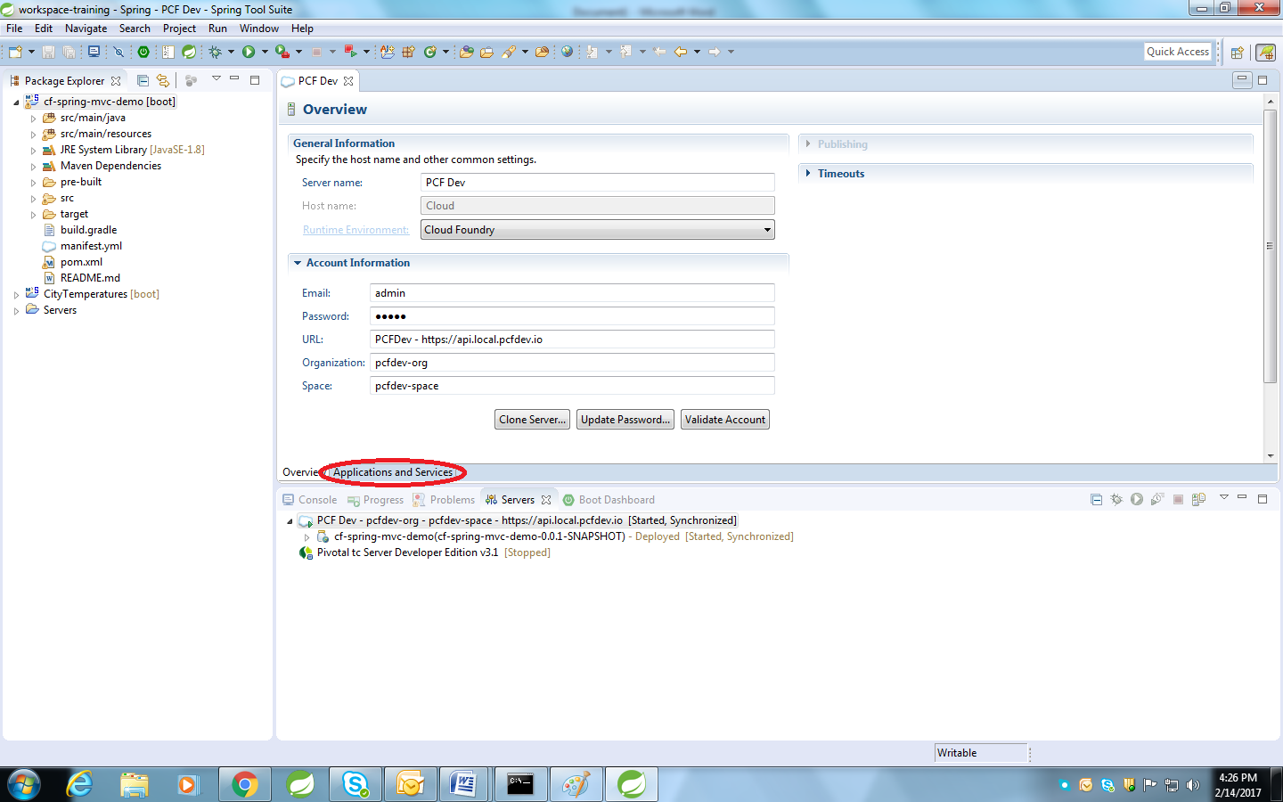

- Click on the application and lets try to change some properties and settings. Lets try to scale our application. Change the number of instances from 1 to 2 and click on Restart.
- Instances section will now show two instances.

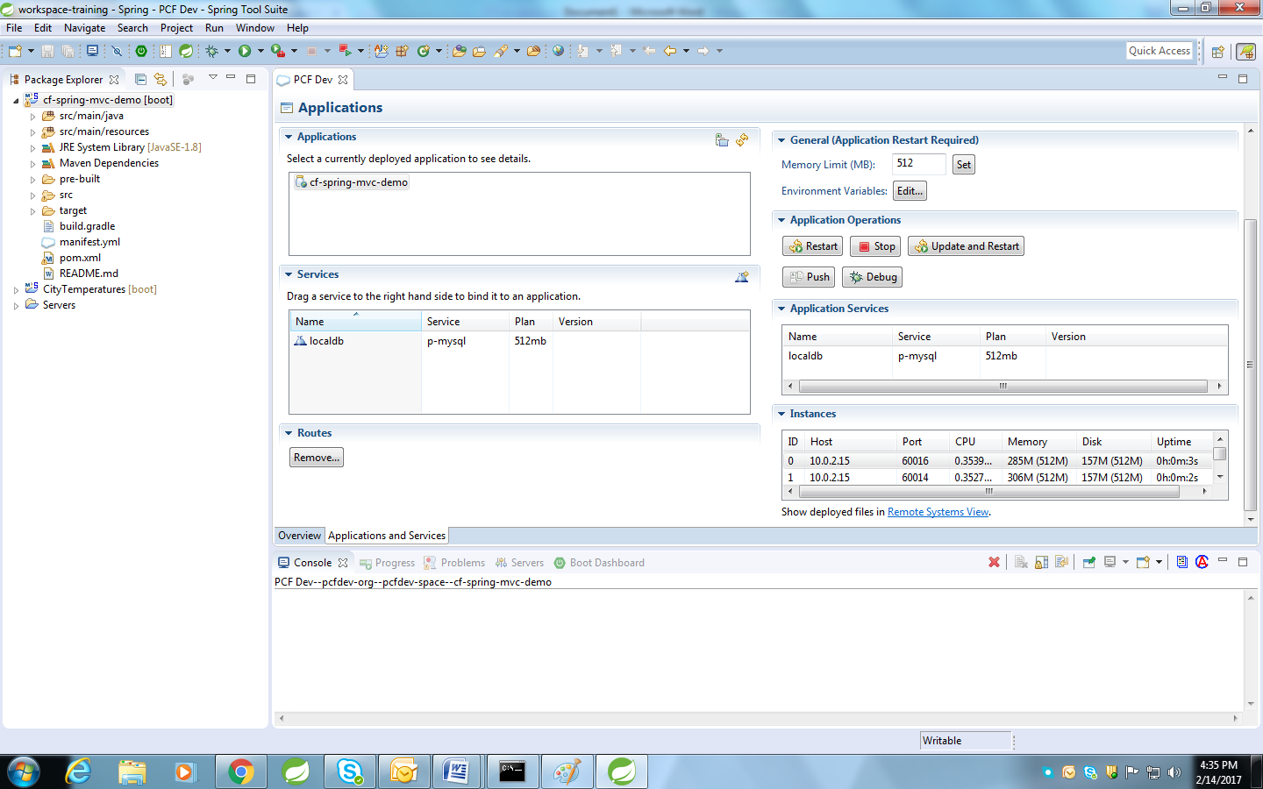

- Now lets update memory setting to 128 MB. Click restart after changing setting. See logs.

