**Question#1:**

Use the question#1.html to generate the below output.

**Output:**

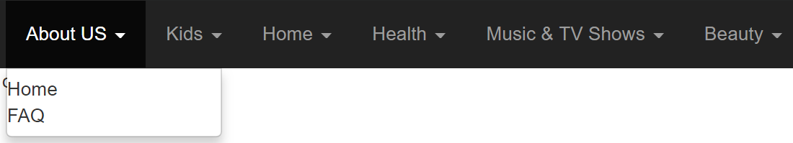

**Question#2**

Use the question#2.html to generate the below output:

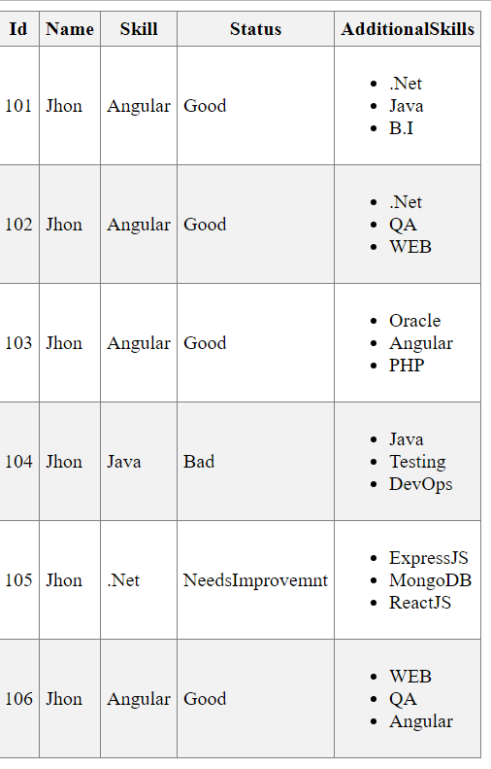

**Question#3:**

User Question3.html to filter based on the selected value.

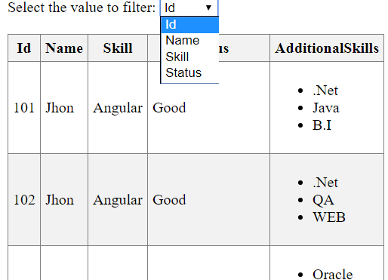

**Question#4:**

Create a custom filter to search based on price in between min and max price.

