# Client Side changes

**Folder Structure:**

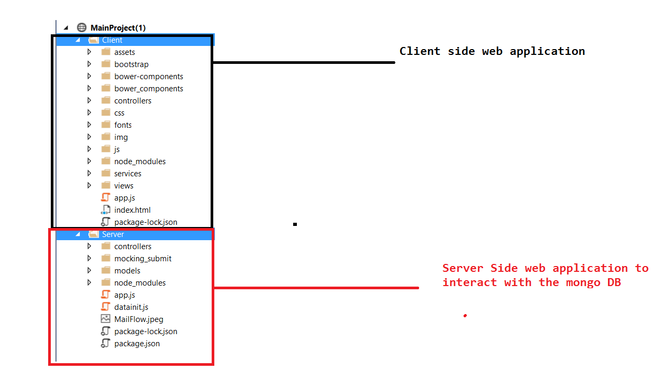

You can notice ng-app = “RealEstateApp” was defined in index.html

**In app.js :** define a module and routing as mentioned below

|  |
| --- |
| var app = angular.module('RealEstateApp', ['ngRoute']);  app.config(['$routeProvider', function ($routeProvider) {    $routeProvider  .when('/home', {  templateUrl: '../views/Home.html',  controller: 'homeController'  })  .when('/trendingProp', {  templateUrl: '../views/TrendingProp.html',  controller: 'trendingPropController'  })  .otherwise({  redirectTo : '/home'  })  }]) |

**In Home.html :** Add a ng-href as mentioned below to route to trendingProp.html when user clicks the trending Prop from home page.

|  |
| --- |
| <li><a ng-href="#trendingProp" >Trendng Properties</a></li> |

**In Services/trendingPropServices.js :** Issue a http call to the end point <http://localhost:3000/api/buy> to get the available properties from mongo DB

|  |
| --- |
| service.getTrendingProp = function () {  var defer = $q.defer();  $http.get('http://localhost:3000/api/buy').then(  function success(response)  {  if (response.status == 200 && response.data.length > 0) {  defer.resolve(response.data);  console.log(response.data);  }  }, function failure(error) {  console.log("There is some error");  defer.reject("Some error!")  })  return defer.promise;  } |

Last class due to time constraints we stopped it from here. We will continue in next class.

# Server Side Changes

**Server Side web application folder structure:**

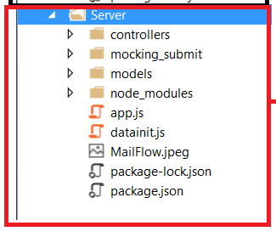

1. Make sure mongod and mongo.exe are running and open a compass
2. Open a command window at server folder and type **node datainit.js**
3. Wait for some 30 seconds to go to compass and refresh the highlighted below.

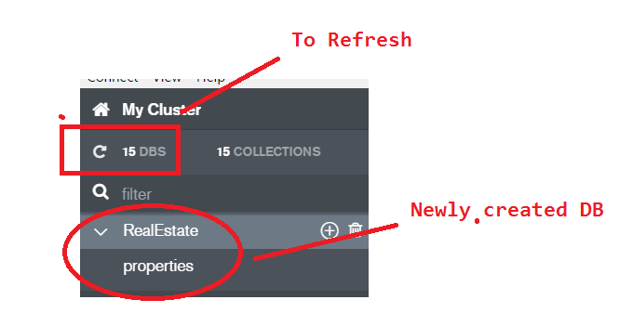

1. Start the **node app.js :** you will see the below window

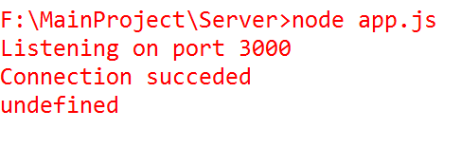

1. Go to browser boomerang and type <http://localhost:3000/api/buy> - We will see the below output.

