Receiver :

RxDataOK

RxAckOK

RxDataErr

RxErr

Subsystem:

TxDataFail

TxDataDone

TxDataOn

TxAckOn

In the simulation setup, the data packets are sending among the nodes in a round-robin fashion:

* Node1 -> Node3 -> Node2 -> Node1.

The ACK packets go in reversed direction:

* Node1 -> Node2 -> Node3 -> Node1.

50 ms = 0.05 seconds

|  |  |  |  |
| --- | --- | --- | --- |
| **CSMA Sim time: 50 ms** | Node 1 | Node 2 | Node 3 |
| RxDataOK | 72 | 82 | 100 |
| RxAckOK | 99 | 71 | 82 |
| RxDataErr | 0 | 3 | 1 |
| RxErr | 57 | 55 | 62 |
| TxDataFail | 1 | 1 | 1 |
| TxDataDone | 99 | 71 | 82 |
| TxDataOn | 11147 | 8648 | 9752 |
| TxAckOn | 1800 | 2050 | 2500 |

Having troubles with MATLAB running 1,000 ms simulation. Keeps crashing after simulation is over.

In Progress -> Terminated

1,000 ms = 1 second

|  |  |  |  |
| --- | --- | --- | --- |
| **CSMA Sim time: 1,000 ms** | Node 1 | Node 2 | Node 3 |
| RxDataOK |  |  |  |
| RxAckOK |  |  |  |
| RxDataErr |  |  |  |
| RxErr |  |  |  |
| TxDataFail |  |  |  |
| TxDataDone |  |  |  |
| TxDataOn |  |  |  |
| TxAckOn |  |  |  |

Half Time

500 ms = 0.5 seconds

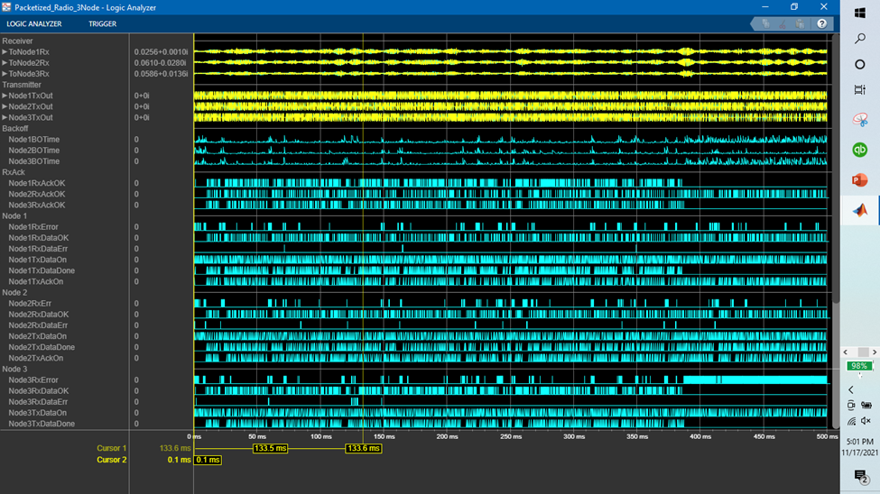

In the simulation setup, the data packets are sending among the nodes in a round-robin fashion:

* Node1 -> Node3 -> Node2 -> Node1.

The ACK packets go in reversed direction:

* Node1 -> Node2 -> Node3 -> Node1.

|  |  |  |  |
| --- | --- | --- | --- |
| **CSMA Sim time: 500 ms** | Node 1 | Node 2 | Node 3 |
| RxDataOK | 843 | 839 | 893 |
| RxAckOK | 884 | 820 | 718 |
| RxDataErr | 3 | 14 | 14 |
| RxErr | 230 | 237 | 967 |
| TxDataFail | 13 | 1 | 11 |
| TxDataDone | 883 | 820 | 717 |
| TxDataOn | 104604 | 87676 | 86940 |
| TxAckOn | 21050 | 20900 | 22325 |

**ALOHA Protocol Simulation Run**

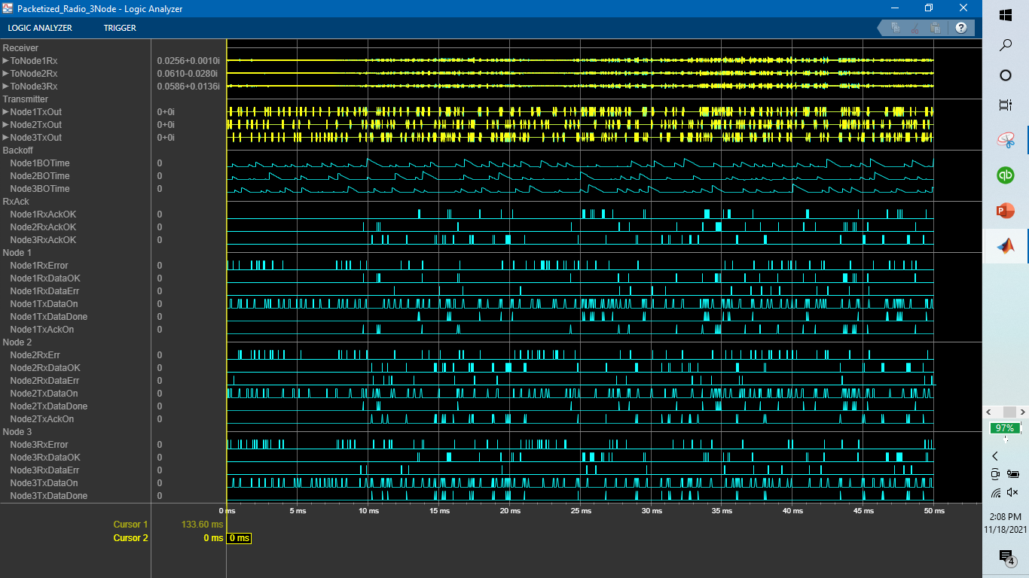

50 ms = 0.05 seconds

|  |  |  |  |
| --- | --- | --- | --- |
| **ALOHA Sim time: 50 ms** | Node 1 | Node 2 | Node 3 |
| RxDataOK | 29 | 45 | 41 |
| RxAckOK | 36 | 27 | 44 |
| RxDataErr | 17 | 19 | 17 |
| RxErr | 80 | 88 | 84 |
| TxDataFail | 20 | 19 | 15 |
| TxDataDone | 36 | 27 | 44 |
| TxDataOn | 11132 | 9476 | 10948 |
| TxAckOn | 725 | 1125 | 1025 |
|  |  |  |  |

|  |  |  |  |
| --- | --- | --- | --- |
| **CSMA Sim time: 50 ms** | Node 1 | Node 2 | Node 3 |
| RxDataOK | 72 | 82 | 100 |
| RxAckOK | 99 | 71 | 82 |
| RxDataErr | 0 | 3 | 1 |
| RxErr | 57 | 55 | 62 |
| TxDataFail | 1 | 1 | 1 |
| TxDataDone | 99 | 71 | 82 |
| TxDataOn | 11147 | 8648 | 9752 |
| TxAckOn | 1800 | 2050 | 2500 |

500 ms = 0.5 seconds

* Encountering an issue where ALOHA- based protocol simulation run at 500 ms run time only executes in half time (240 ms) and terminates the simulation
* Simulation terminates when node 2 and node 3 have prolonged periods of error

Data: 1 – 3 – 2 – 1

Ack: 1 – 2 – 3 - 1

|  |  |  |  |
| --- | --- | --- | --- |
| **ALOHA Sim time: 500 ms** | Node 1 | Node 2 | Node 3 |
| RxDataOK |  |  |  |
| RxAckOK |  |  |  |
| RxDataErr |  |  |  |
| RxErr |  |  |  |
| TxDataFail |  |  |  |
| TxDataDone |  |  |  |
| TxDataOn |  |  |  |
| TxAckOn |  |  |  |

* Under 240 ms

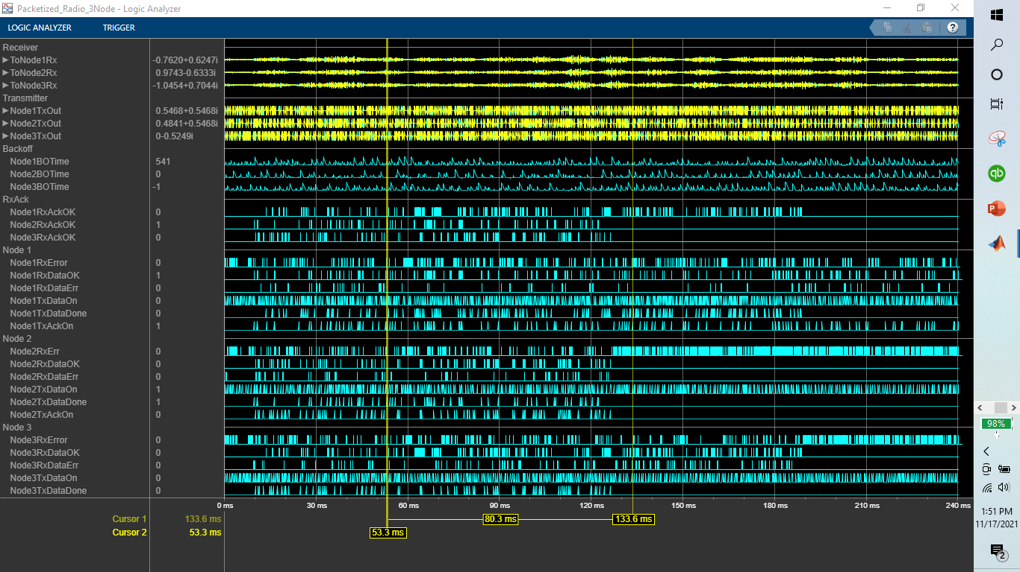

240 ms = 0.24 seconds

Data: 1 – 3 – 2 – 1

Ack: 1 – 2 – 3 - 1

|  |  |  |  |
| --- | --- | --- | --- |
| **ALOHA Sim time: 240 ms** | Node 1 | Node 2 | Node 3 |
| RxDataOK | 161 | 129 | 244 |
| RxAckOK | 225 | 90 | 125 |
| RxDataErr | 62 | 46 | 89 |
| RxErr | 270 | 710 | 391 |
| TxDataFail | 84 | 100 | 95 |
| TxDataDone | 225 | 90 | 125 |
| TxDataOn | 56304 | 40020 | 43976 |
| TxAckOn | 4000 | 3225 | 6075 |

Changed Node order:

* Data: 1 – 2 – 3 – 1
* Ack: 1 – 3 – 2 – 1

After changing node order, attempted to run a 500 ms simulation, but ALOHA protocol extended simulation time this time to a longer duration of 290 ms. Still stops too early.

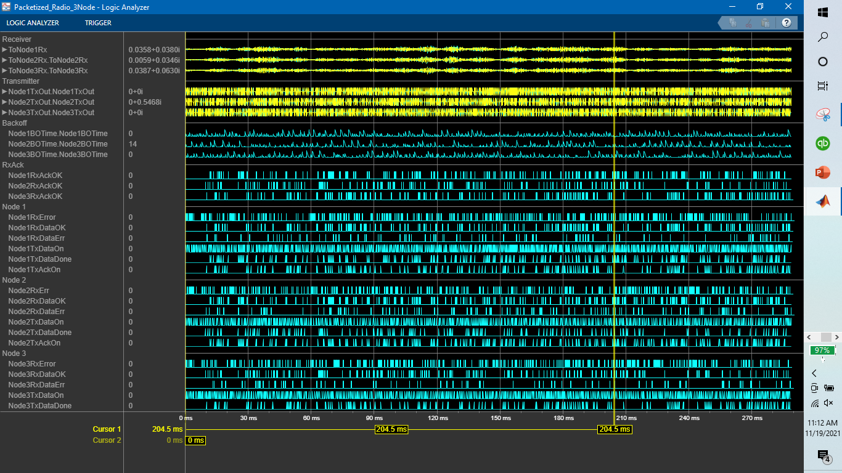

|  |  |  |  |
| --- | --- | --- | --- |
| **ALOHA Sim time: 290 ms** | Node 1 | Node 2 | Node 3 |
| RxDataOK | 268 | 331 | 234 |
| RxAckOK | 302 | 210 | 257 |
| RxDataErr | 92 | 117 | 78 |
| RxErr | 338 | 336 | 341 |
| TxDataFail | 100 | 79 | 79 |
| TxDataDone | 302 | 210 | 257 |
| TxDataOn | 70196 | 52624 | 59156 |
| TxAckOn | 6650 | 8175 | 5825 |

CSMA/CA Under Changed Node Order:

* Data: 1 – 2 – 3 – 1
* Ack: 1 – 3 – 2 – 1
* Under 500 ms

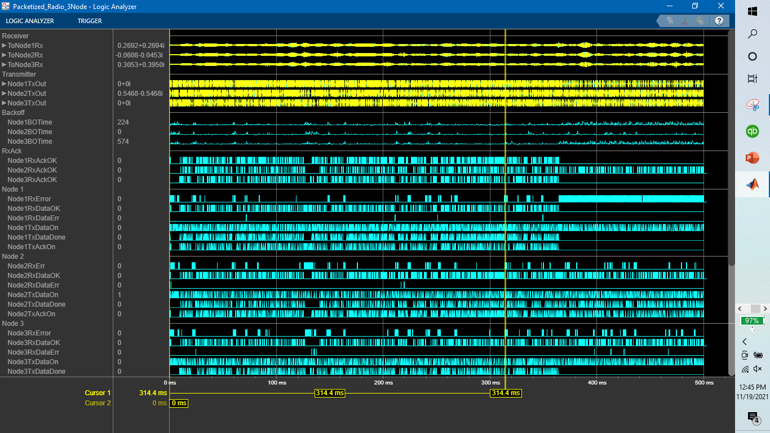

|  |  |  |  |
| --- | --- | --- | --- |
| **CSMA Sim time: 500 ms** | Node 1 | Node 2 | Node 3 |
| RxDataOK | 700 | 992 | 834 |
| RxAckOK | 841 | 822 | 679 |
| RxDataErr | 5 | 4 | 11 |
| RxErr | 1043 | 237 | 252 |
| TxDataFail | 15 | 1 | 15 |
| TxDataDone | 841 | 821 | 679 |
| TxDataOn | 101384 | 87308 | 86296 |
| TxAckOn | 17500 | 24775 | 20825 |
|  |  |  |  |

* Random seed Variable

1. Random Seed Values

Node 1: 500 -> 2000

Node 2: 800 -> 2500

Node 3: 2000 -> 2000

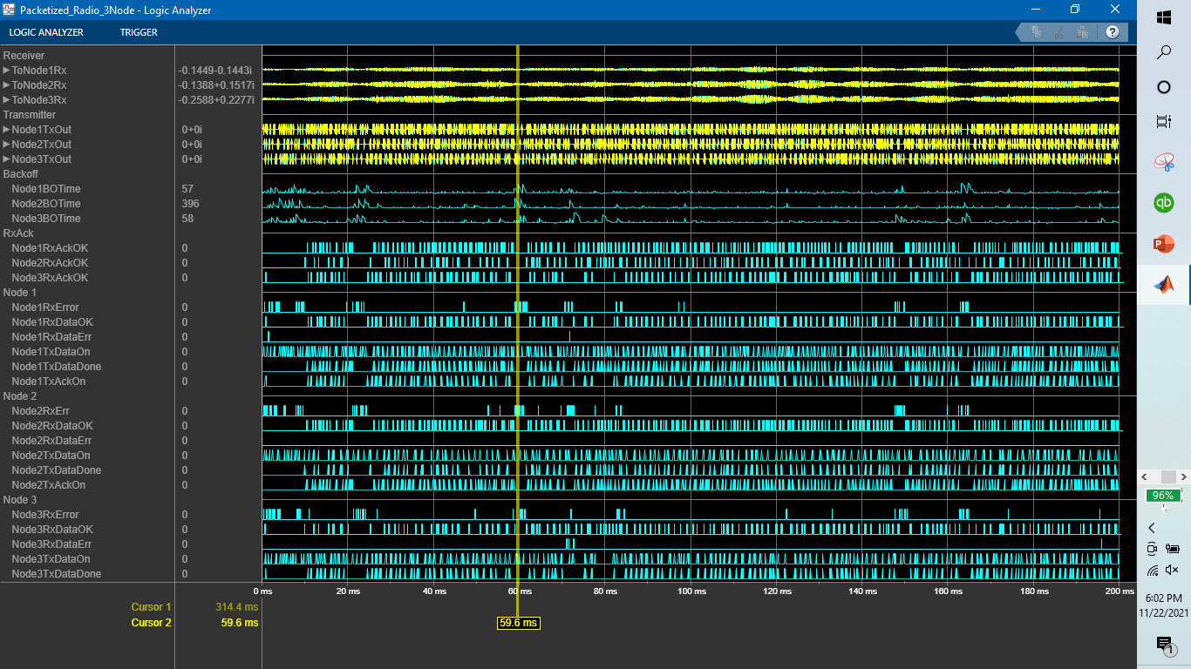

|  |  |  |  |
| --- | --- | --- | --- |
| **CSMA Sim time: 200 ms** | Node 1 | Node 2 | Node 3 |
| RxDataOK | 380 | 492 | 322 |
| RxAckOK | 490 | 317 | 375 |
| RxDataErr | 2 | 0 | 4 |
| RxErr | 88 | 92 | 88 |
| TxDataFail | 1 | 1 | 1 |
| TxDataDone | 490 | 316 | 375 |
| TxDataOn | 49588 | 33028 | 38916 |
| TxAckOn | 9500 | 12275 | 8050 |
|  |  |  |  |

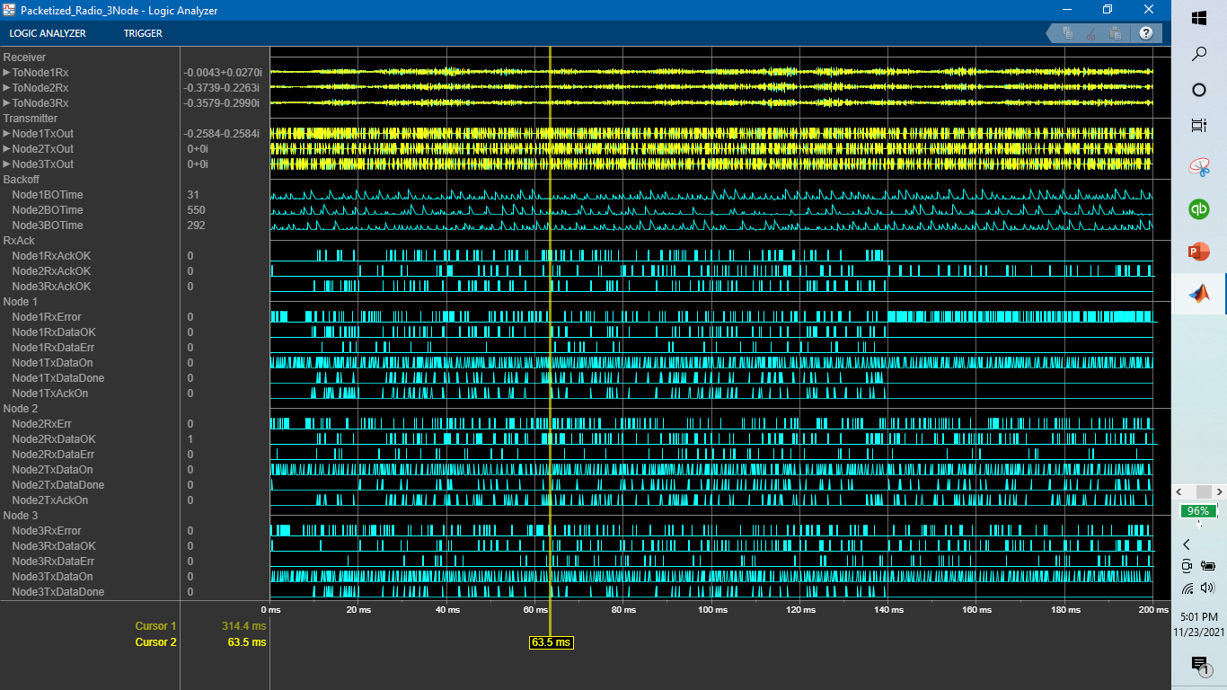

|  |  |  |  |
| --- | --- | --- | --- |
| **ALOHA Sim time: 200 ms** | Node 1 | Node 2 | Node 3 |
| RxDataOK | 145 | 227 | 169 |
| RxAckOK | 158 | 152 | 136 |
| RxDataErr | 41 | 55 | 70 |
| RxErr | 455 | 239 | 221 |
| TxDataFail | 82 | 51 | 72 |
| TxDataDone | 158 | 152 | 136 |
| TxDataOn | 44252 | 36340 | 39008 |
| TxAckOn | 3600 | 5575 | 4225 |

1. Random seed Values:

Node 1: 1846

Node 2: 141

Node 3: 2123

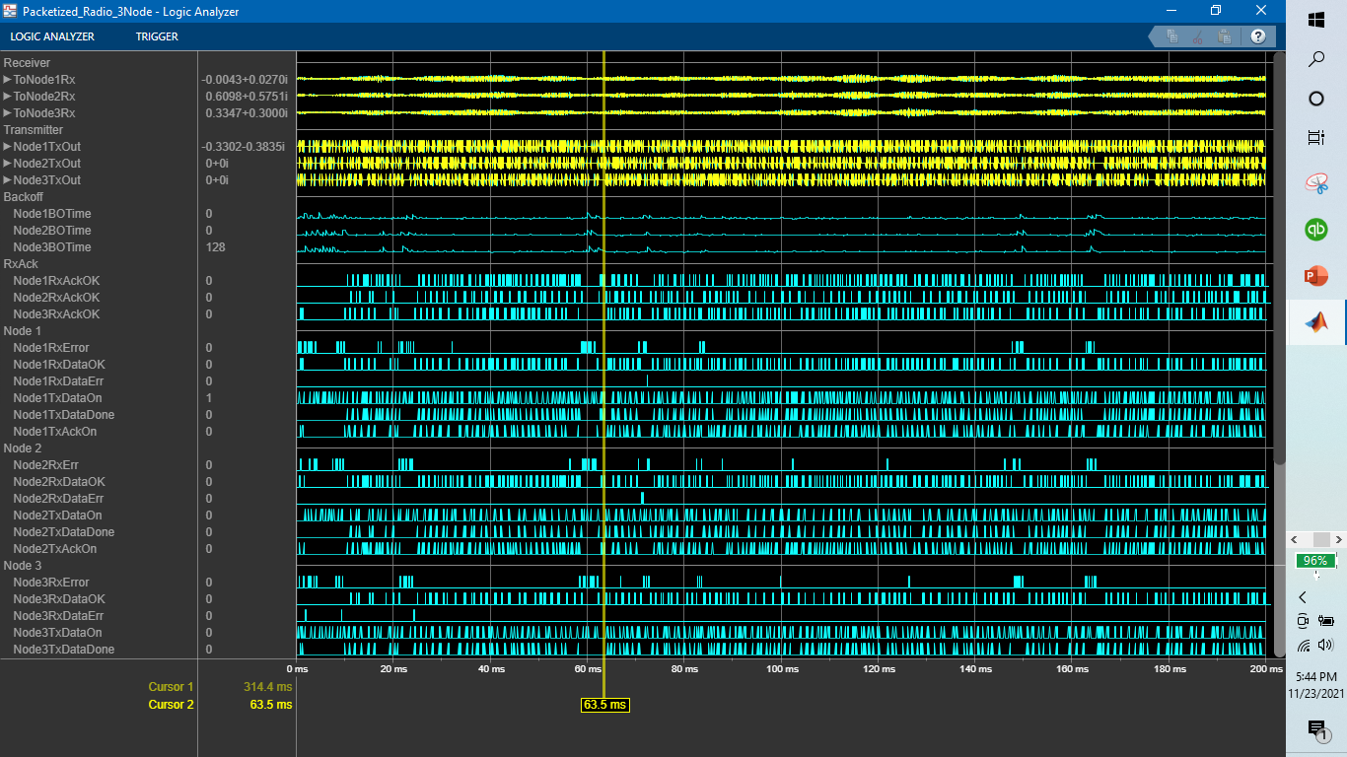

|  |  |  |  |
| --- | --- | --- | --- |
| **CSMA Sim time: 200 ms** | Node 1 | Node 2 | Node 3 |
| RxDataOK | 410 | 447 | 345 |
| RxAckOK | 442 | 341 | 405 |
| RxDataErr | 1 | 2 | 3 |
| RxErr | 79 | 80 | 83 |
| TxDataFail | 1 | 1 | 1 |
| TxDataDone | 442 | 341 | 405 |
| TxDataOn | 44988 | 35144 | 41124 |
| TxAckOn | 10250 | 11150 | 8625 |
|  |  |  |  |

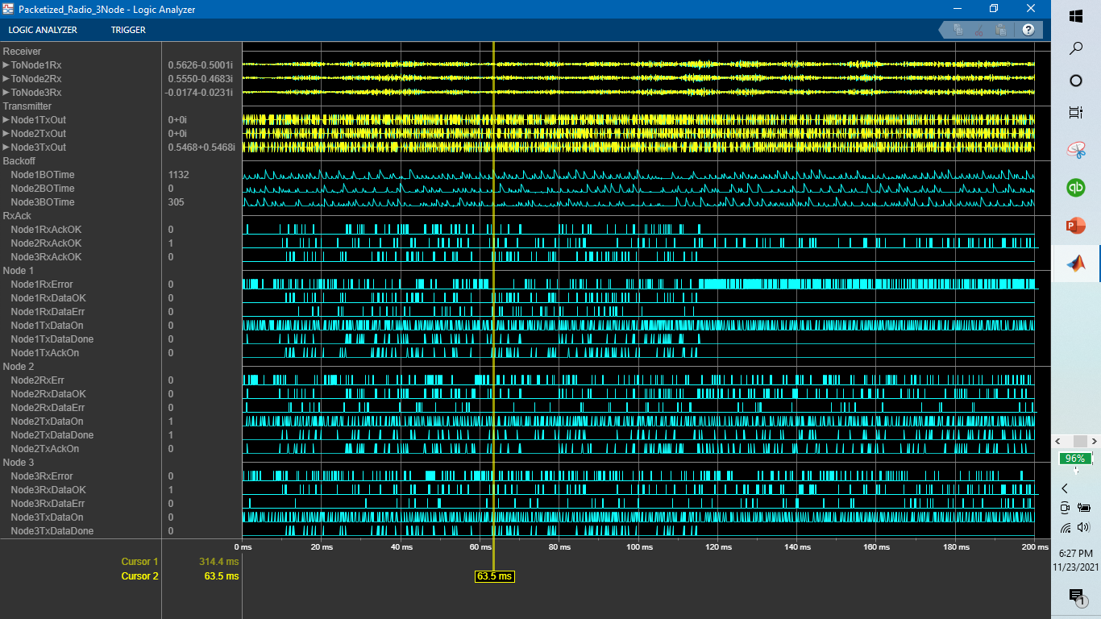

|  |  |  |  |
| --- | --- | --- | --- |
| **ALOHA Sim time: 200 ms** | Node 1 | Node 2 | Node 3 |
| RxDataOK | 120 | 181 | 178 |
| RxAckOK | 107 | 163 | 114 |
| RxDataErr | 50 | 59 | 60 |
| RxErr | 587 | 229 | 250 |
| TxDataFail | 96 | 53 | 82 |
| TxDataDone | 107 | 162 | 114 |
| TxDataOn | 42527 | 38272 | 38569 |
| TxAckOn | 3000 | 4500 | 4375 |

1. Random Seed Values

Node 1: 7031

Node 2: 6248

Node 3: 8464

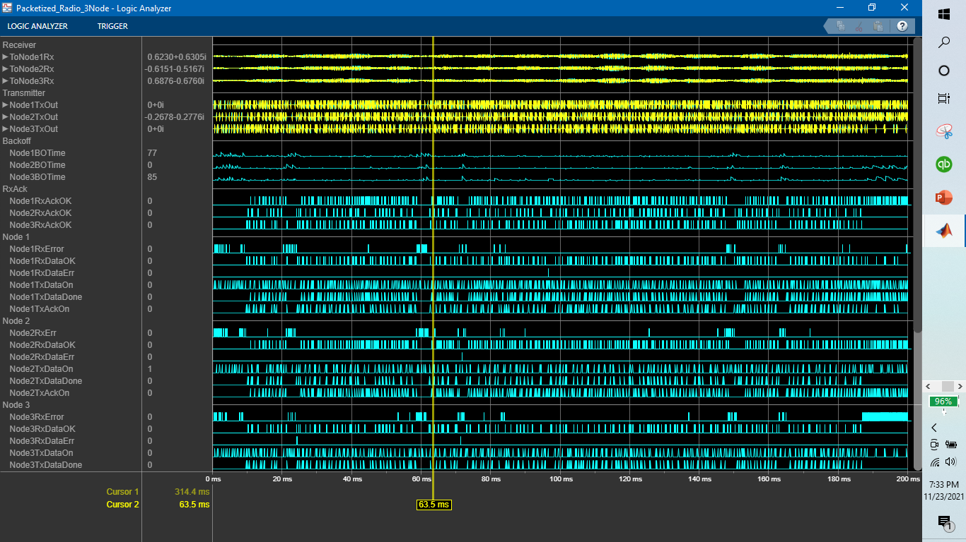

|  |  |  |  |
| --- | --- | --- | --- |
| **CSMA Sim time: 200 ms** | Node 1 | Node 2 | Node 3 |
| RxDataOK | 378 | 505 | 268 |
| RxAckOK | 502 | 265 | 364 |
| RxDataErr | 1 | 1 | 2 |
| RxErr | 109 | 100 | 216 |
| TxDataFail | 1 | 2 | 1 |
| TxDataDone | 502 | 264 | 364 |
| TxDataOn | 50878 | 29256 | 39100 |
| TxAckOn | 10250 | 12625 | 6675 |
|  |  |  |  |

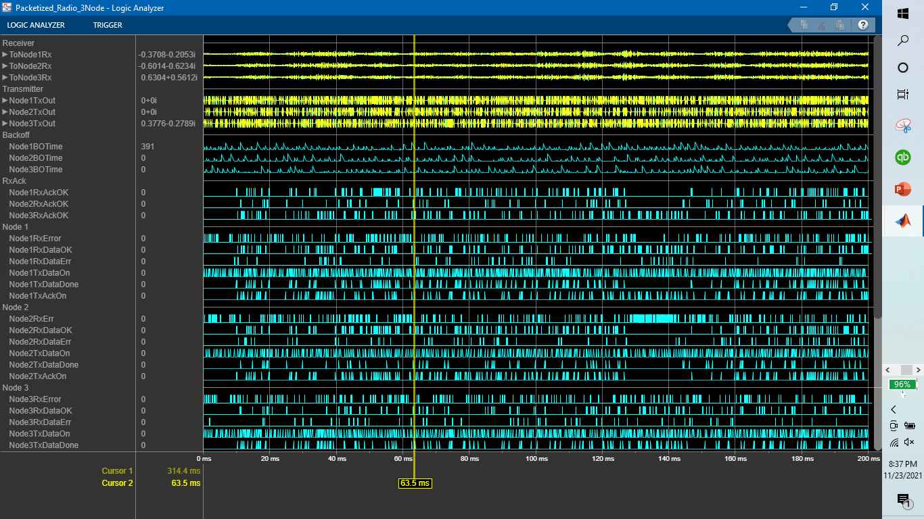

|  |  |  |  |
| --- | --- | --- | --- |
| **ALOHA Sim time: 200 ms** | Node 1 | Node 2 | Node 3 |
| RxDataOK | 231 | 239 | 124 |
| RxAckOK | 218 | 98 | 215 |
| RxDataErr | 64 | 73 | 57 |
| RxErr | 220 | 332 | 232 |
| TxDataFail | 65 | 63 | 61 |
| TxDataDone | 217 | 98 | 215 |
| TxDataOn | 49956 | 32568 | 45724 |
| TxAckOn | 5775 | 5950 | 3025 |

1. Random Seed Values

Node 1: 4672

Node 2: 64116

Node 3: 6518

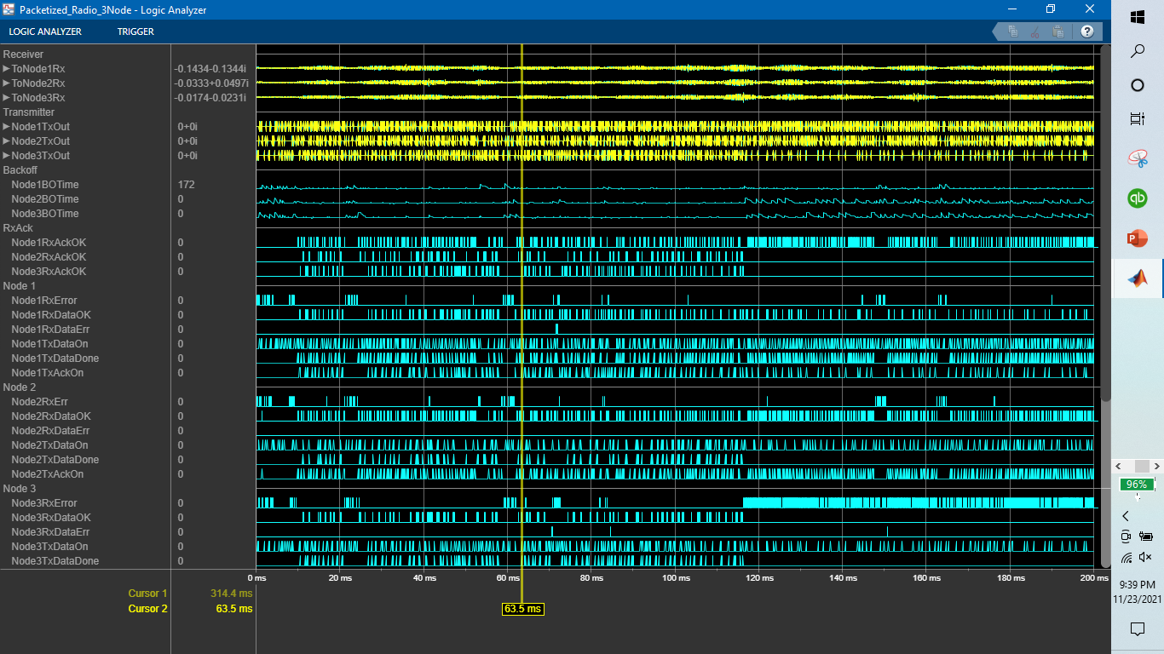

|  |  |  |  |
| --- | --- | --- | --- |
| **CSMA Sim time: 200 ms** | Node 1 | Node 2 | Node 3 |
| RxDataOK | 264 | 583 | 164 |
| RxAckOK | 580 | 163 | 206 |
| RxDataErr | 2 | 0 | 3 |
| RxErr | 105 | 100 | 819 |
| TxDataFail | 1 | 8 | 6 |
| TxDataDone | 580 | 163 | 206 |
| TxDataOn | 57960 | 25392 | 28428 |
| TxAckOn | 6600 | 14575 | 4100 |
|  |  |  |  |

Node 1 sending to Node 2 and Node 2 has a large RxDataOK value. The seed value of Node 2 is noticeably larger.

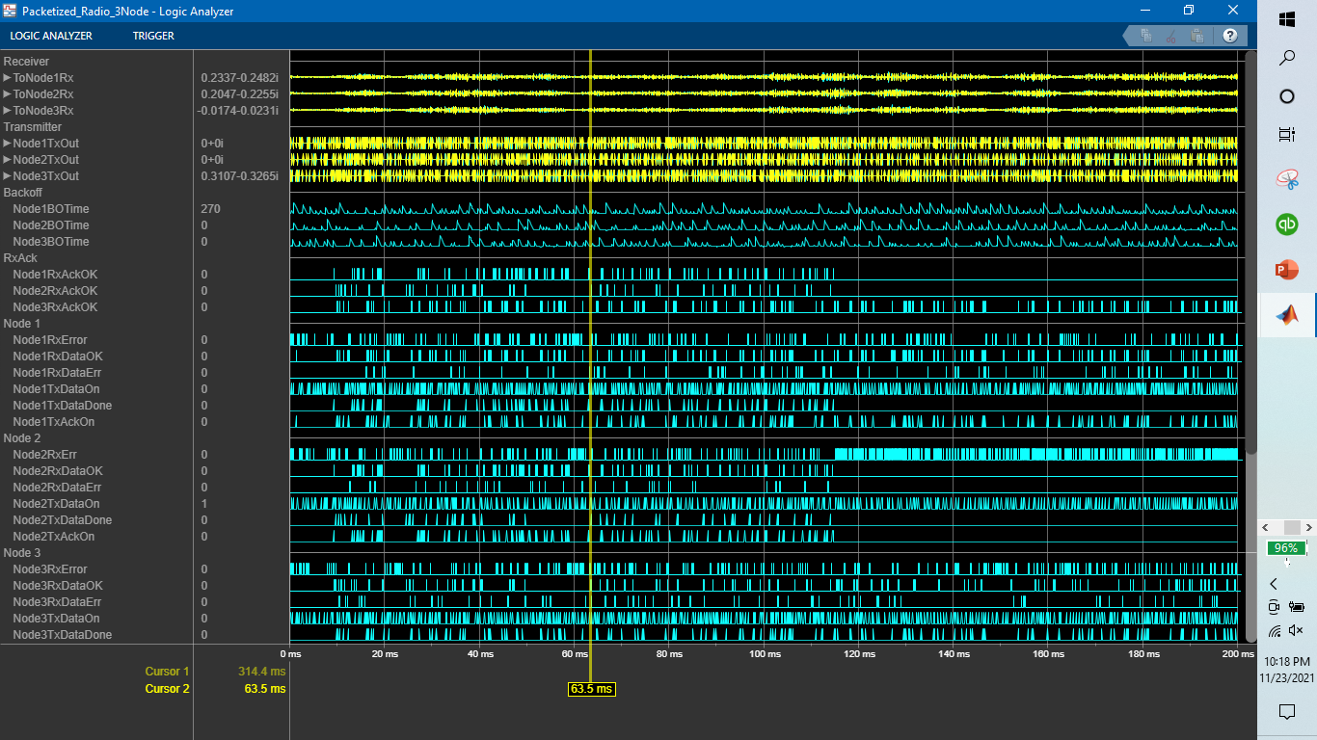

|  |  |  |  |
| --- | --- | --- | --- |
| **ALOHA Sim time: 200 ms** | Node 1 | Node 2 | Node 3 |
| RxDataOK | 218 | 132 | 122 |
| RxAckOK | 124 | 72 | 201 |
| RxDataErr | 79 | 36 | 66 |
| RxErr | 197 | 605 | 232 |
| TxDataFail | 92 | 77 | 59 |
| TxDataDone | 124 | 72 | 201 |
| TxDataOn | 43332 | 32476 | 44179 |
| TxAckOn | 5450 | 3300 | 3025 |

1. Random Seed Value

Node 1: 14677

Node 2: 94897

Node 3: 47385

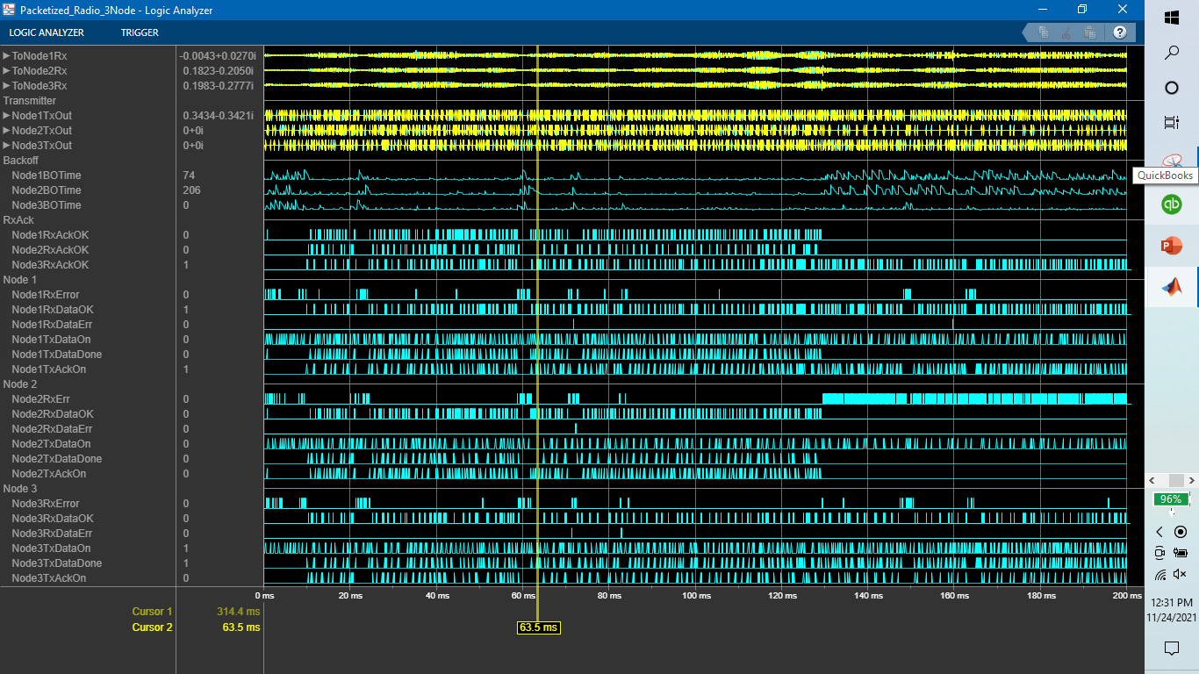

|  |  |  |  |
| --- | --- | --- | --- |
| **CSMA Sim time: 200 ms** | Node 1 | Node 2 | Node 3 |
| RxDataOK | 450 | 307 | 243 |
| RxAckOK | 307 | 187 | 446 |
| RxDataErr | 2 | 1 | 2 |
| RxErr | 100 | 610 | 97 |
| TxDataFail | 8 | 6 | 1 |
| TxDataDone | 307 | 186 | 446 |
| TxDataOn | 38916 | 26128 | 45183 |
| TxAckOn | 11250 | 7675 | 6075 |
|  |  |  |  |

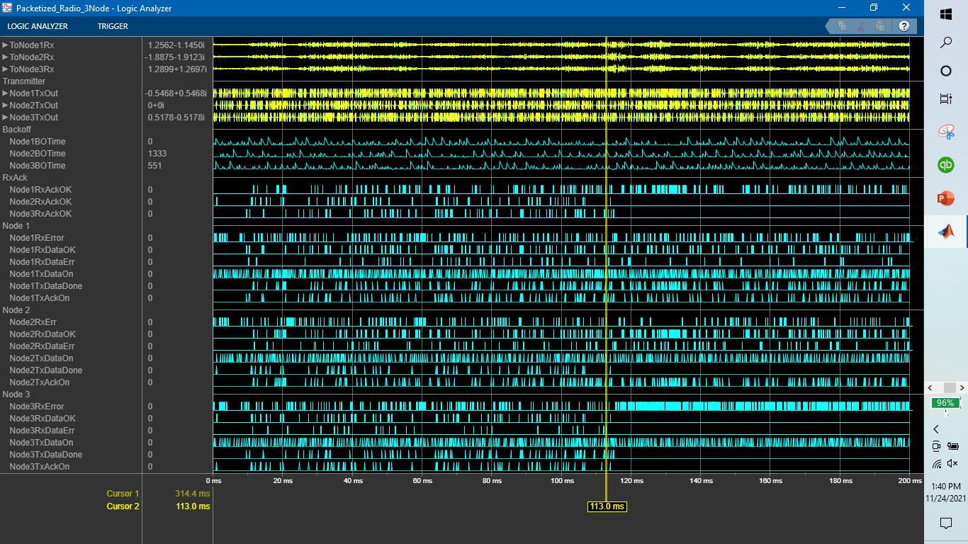

|  |  |  |  |
| --- | --- | --- | --- |
| **ALOHA Sim time: 200 ms** | Node 1 | Node 2 | Node 3 |
| RxDataOK | 170 | 273 | 94 |
| RxAckOK | 251 | 82 | 98 |
| RxDataErr | 58 | 90 | 30 |
| RxErr | 244 | 216 | 691 |
| TxDataFail | 60 | 75 | 89 |
| TxDataDone | 251 | 82 | 98 |
| TxDataOn | 52270 | 32292 | 39192 |
| TxAckOn | 4175 | 6825 | 2350 |

Simulation Run AVERAGES:

|  |  |  |  |
| --- | --- | --- | --- |
| **CSMA Sim time: 200 ms** | Node 1 | Node 2 | Node 3 |
| RxDataOK | 376.4 | 466.8 | 268.4 |
| RxAckOK | 464.2 | 254.6 | 359.2 |
| RxDataErr | 1.6 | 0.8 | 2.8 |
| RxErr | 96.2 | 196.4 | 260.6 |
| TxDataFail | 2.4 | 3.6 | 2 |
| TxDataDone | 464.2 | 254 | 359.2 |
| TxDataOn | 48466 | 29789.6 | 38550.2 |
| TxAckOn | 9570 | 11660 | 6705 |
|  |  |  |  |

|  |  |  |  |
| --- | --- | --- | --- |
| **ALOHA Sim time: 200 ms** | Node 1 | Node 2 | Node 3 |
| RxDataOK | 176.8 | 210.4 | 137.4 |
| RxAckOK | 171.6 | 102.8 | 152.8 |
| RxDataErr | 58.4 | 62.6 | 56.6 |
| RxErr | 340.6 | 324.2 | 325.2 |
| TxDataFail | 79 | 63.8 | 72.6 |
| TxDataDone | 171.4 | 113.2 | 152.8 |
| TxDataOn | 46467.4 | 34389.6 | 41334.4 |
| TxAckOn | 4400 | 5230 | 3400 |