Name: Amit Patil ID : 801077053

**Project Description:** This project modifies the given Visual Analytics System for Urban Trajectory Dataset where all the route information is given in the form of JSON file(trips.json). This data has been used to modify the data exploration with interactive visual interfaces. I use Word Cloud, Sankey Diagram and Scatter Plot to understand the data better in a visual way.

The Project can be run on a web server as it needs to have its files in the same session server hence it needs to be loaded on a local web server like Web Server from Chrome. Once loaded the index.html is displayed on the browser whish displays a map with a small square button at the bottom to select a rectangle area on the map.

Once this is done a query is generated which gives a call back a function which retrieves the data from the area draw and displays its taxi trip trajectories. You can then choose from three visualizations which will be displayed at the righthand side.

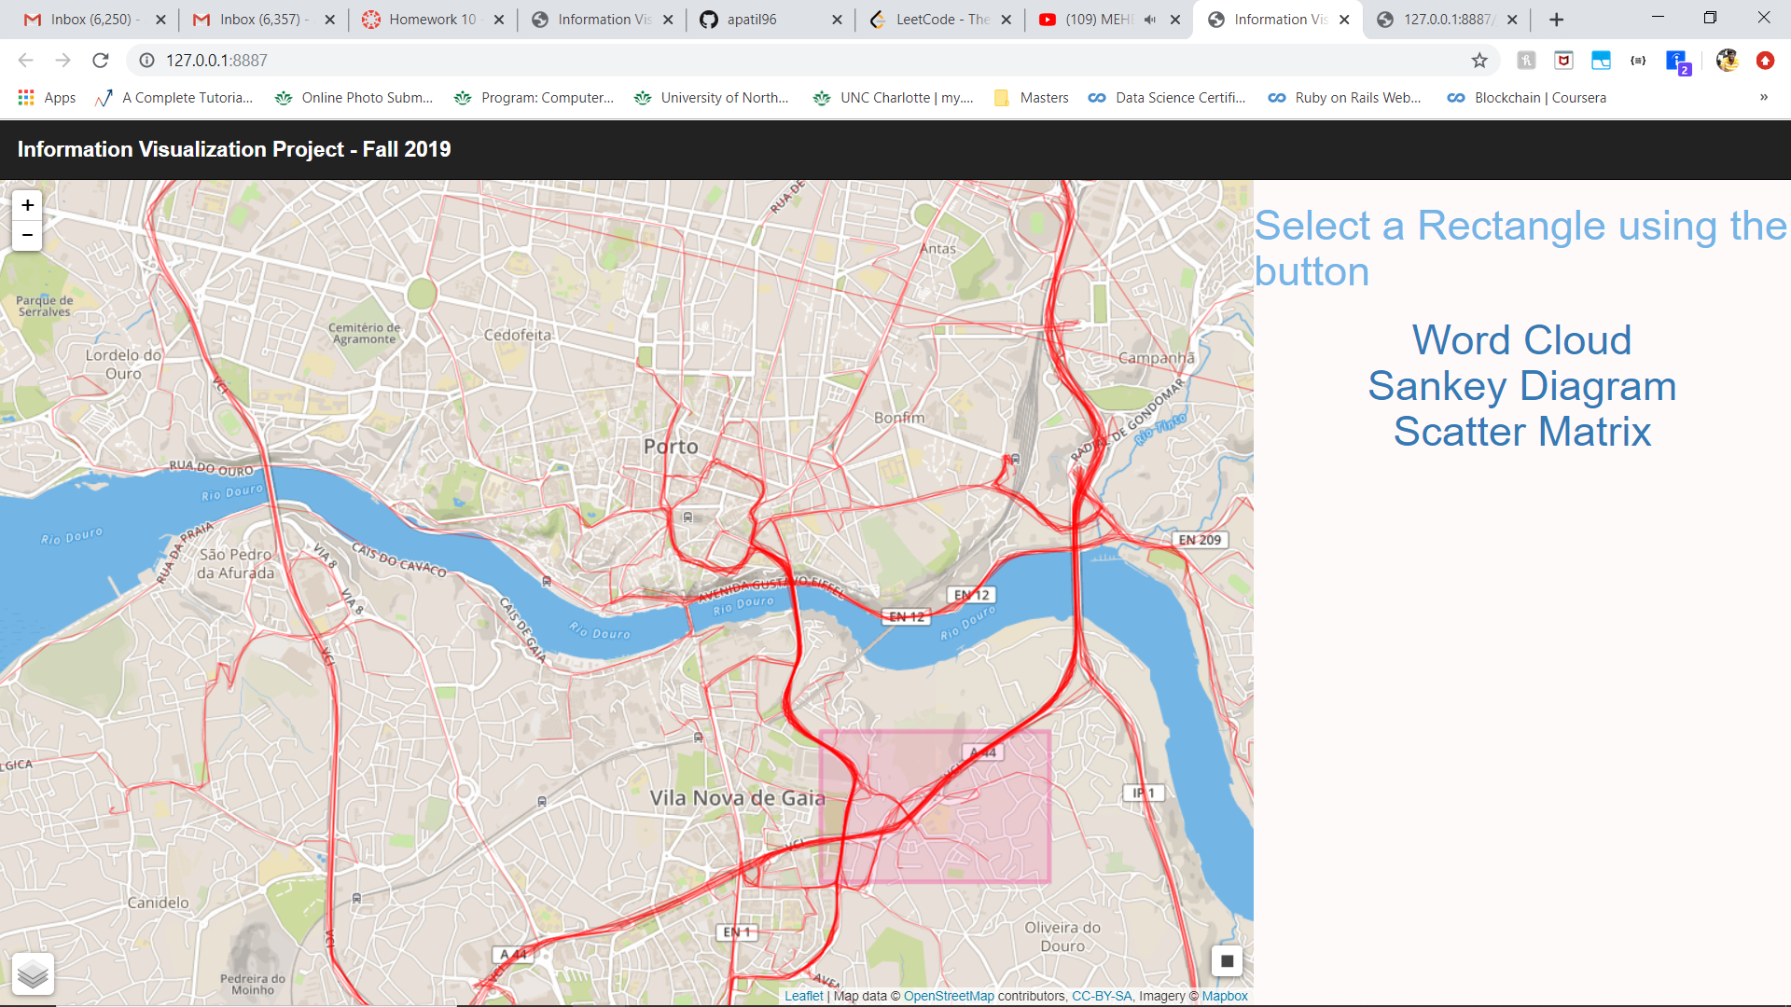

**Word Cloud**: This Visualization will show the most frequent street names by using the interactive Word Cloud , the bigger the size of the text the more frequent is the place mentioned.

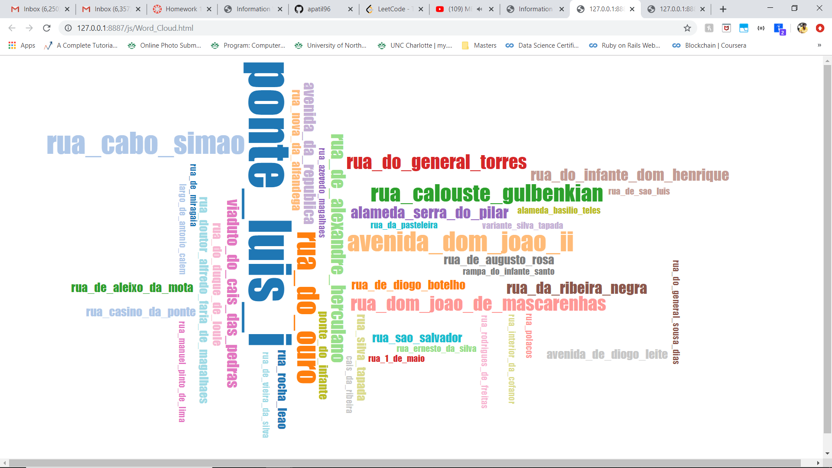

**Sankey Diagram:** Sankey Diagram shows the topmost pickup and drop off street names

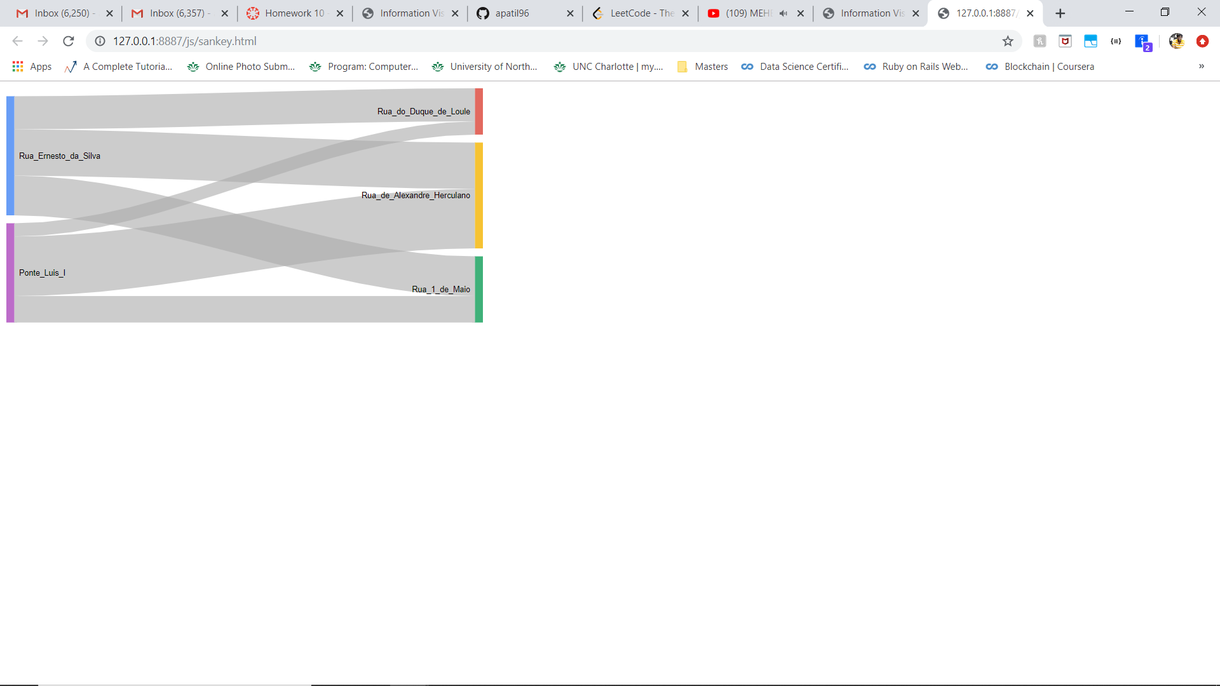

**Scatter Matrix:** In the Scatter matrix plot I have used an excel sheet which stores the average speed (Avspeed),distance ,duration and MaxSpeed and uses these attributes as the scatter plot dimensions.

