Aegis — Agentic Cloud Governance Plane
Solution Design — IEP Techathon: Agentic AI Hackathon 2026
Author: Anand Patil · Beyond Bank Australia · Date: 30 July 2026 · Version 1.0
Theme: a natural-language AI agent that runs everyday cloud operations across Azure and GCP — where the agent proposes changes and humans approve them, so it is powerful enough to adopt and safe enough to sign off on.

1. Executive Summary
Enterprises want agentic AI to operate their cloud, but security and risk teams will not approve agents that mutate infrastructure directly. Aegis resolves this by inverting the model: the agent is architecturally incapable of changing production. It can only PROPOSE changes as Infrastructure-as-Code (IaC) pull requests and REQUEST approvals through IT Service Management (ITSM). Every action is least-privilege, versioned, approved and reversible.
Because the three layers that matter — the tool interface (Model Context Protocol, MCP), the apply layer (Terraform) and the approval layer (ITSM) — are all cloud-neutral, the same agent governs both Microsoft Azure and Google Cloud with no per-cloud rewrite. The hardest link (request → approval → exact entitlement resolution → IaC PR → apply) is already proven working, so this is a demonstrated pattern rather than a concept.

2. Problem & Opportunity
Everyday cloud operations — access grants, cost/FinOps questions, tag and compliance remediation, incident triage — are slow, manual and ticket-driven, and are duplicated separately for every cloud. The AI that could automate this is blocked at the door because direct-action agents are a compliance non-starter in regulated environments.
The opportunity is the “last mile” of enterprise agentic AI: an agent that is useful enough to adopt and safe enough to approve — and that works consistently across clouds. This unlocks the segment that needs agentic automation most and trusts direct-action AI least: regulated, multi-cloud enterprises.

3. Solution Overview
You ask in plain English (“give me temporary Tier-2 access to payments non-prod”, “why doesn’t our cloud bill reconcile this month”, “fix the untagged VMs”). Aegis interprets the intent, validates it against policy, and produces the exact, reviewable change — identically for either cloud. Nothing is applied until a human approves and merges.
- Propose, never mutate — the agent emits a Terraform PR and an ITSM approval request; a human approves and the pipeline applies.
- Cloud-neutral by construction — the agent reasons in capabilities; the MCP gateway maps each to Azure or GCP.
- Governed by design — least-privilege, versioned, auditable, reversible and segregation-of-duties-friendly are emergent properties of the architecture, not bolt-ons.

4. Why This Qualifies as an Agentic AI Solution
- Goal-directed autonomy — it takes a high-level intent and decides how to achieve it at runtime, not via a fixed script.
- Reasoning over dynamic state — decisions depend on live cloud, identity, cost and ITSM state (e.g. resolving the exact identity group for the target).
- Tool use to act on the environment — through MCP it queries clouds, resolves entitlements, generates IaC and raises approvals; it closes the perceive-decide-act-observe loop.
- Multi-agent collaboration — an orchestrator plans; specialist capability agents execute; a policy/guardrail agent can actively veto unsafe actions.
- Bounded autonomy with human-in-the-loop — the agent owns the reasoning and the proposal; humans own the commit.
- Generalisation across environments — the same agents operate over Azure and GCP by reasoning in cloud-neutral capabilities.

5. Solution Architecture
The architecture is organised as five layers. The vertical flow is request → reasoning → gateway → cloud tools; all writes are diverted through the governed change path (layer 4); and audit (layer 5) spans everything.
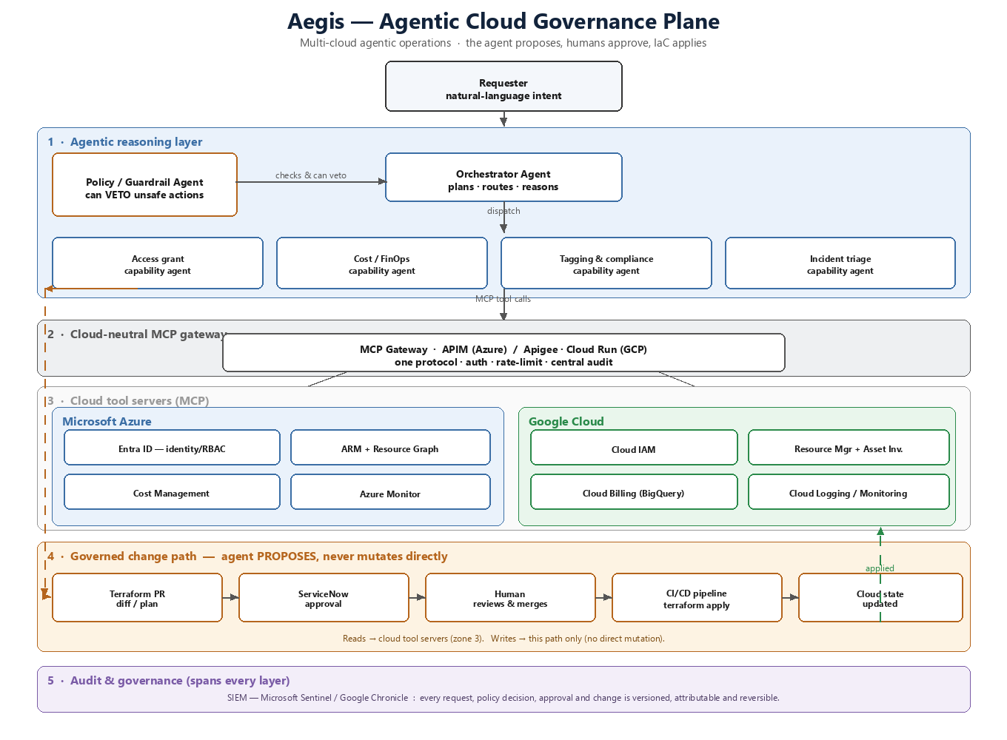
Figure 1 — Aegis reference architecture (multi-cloud, propose-don’t-mutate).

5.1 Component breakdown
Layer | Components | Responsibility
1 · Agentic reasoning | Orchestrator agent, Policy/Guardrail agent, Capability agents (access, cost, tagging, incident) | Interpret intent, plan, validate against policy (with veto), and drive the capabilities.
2 · MCP gateway | Azure API Management (native MCP) / GCP Apigee or Cloud Run | Single governed entry point: authentication, rate-limiting, central audit; one protocol to all tools.
3 · Cloud tool servers | MCP servers on Azure Functions / GCP Cloud Functions/Run fronting Entra, ARM/Resource Graph, Cost Management, Monitor (Azure) and IAM, Resource Manager/Asset Inventory, Cloud Billing, Logging (GCP) | Read live state and prepare changes; cloud-specific behind a neutral capability contract.
4 · Governed change path | Terraform + Git PR + ServiceNow approval + CI/CD apply | Every write is a proposal: PR → ITSM approval → human merge → pipeline apply. No direct mutation.
5 · Audit & governance | SIEM (Microsoft Sentinel / Google Chronicle), policy-as-code | Every request, decision, approval and change is versioned, attributable and reversible.

6. End-to-End Request Flow (worked example)
Example intent: “Grant me temporary Tier-2 access to the payments non-prod environment for a debugging task.” The same flow runs whether the target is Azure or GCP:
- Orchestrator agent interprets the intent and plans the steps.
- Policy/Guardrail agent validates it (correct tier, non-prod, justification present) and may veto.
- Capability agent (access) reads live identity state via MCP and resolves the exact target — an Azure AD group or a GCP IAM binding.
- It generates a Terraform pull request (the change as a reviewable diff) and raises a ServiceNow approval.
- A human (segregated from the requester) approves in ServiceNow and merges the PR.
- The CI/CD pipeline runs terraform apply; the cloud state is updated.
- The full trail — request, policy decision, approval and change — is recorded to the SIEM.

7. Multi-Cloud Capability Mapping
Capability | Azure | Google Cloud | Common layer
Access grant | Entra ID group / RBAC | Cloud IAM binding / Google Group | Terraform PR + ServiceNow approval
Cost / FinOps | Cost Management | Cloud Billing (BigQuery export) | Reconciliation + tag-coverage check
Inventory / compliance | Resource Graph | Cloud Asset Inventory | Tag/label remediation PR
Incident triage | Azure Monitor | Cloud Logging / Monitoring | ITSM ticket + RCA summary
The neutrality is real, not a sticker: MCP normalises the tools, Terraform is the common apply layer, and ITSM is a cloud-independent approval gate.

8. Security & Governance Model
- Propose-don’t-mutate: the agent has no write path to cloud control planes; it only opens PRs and approvals.
- Least privilege: changes are scoped, tier-aware and time-bound where applicable.
- Segregation of duties: requester ≠ approver; approvals are human and in ITSM.
- Full auditability: IaC version history + ITSM records + SIEM give a complete, reversible trail.
- Policy-as-code guardrails: OPA/Rego in the guardrail agent, backed by Azure Policy / GCP Organization Policy.
- Secrets isolation: Azure Key Vault / GCP Secret Manager; OAuth2/OIDC with Entra App Registrations / GCP Workload Identity.

9. Technology Stack
Layer | Technologies
Agentic AI / reasoning | Claude (Anthropic API; deployable via Azure AI Foundry / Google Vertex AI), Model Context Protocol (MCP), multi-agent orchestration
Gateway & tool hosting | Azure API Management (native MCP) / GCP Apigee or Cloud Run; MCP servers on Azure Functions / GCP Cloud Functions/Run
Cloud integrations | Azure: Entra ID, ARM + Resource Graph, Cost Management, Azure Monitor. GCP: Cloud IAM, Resource Manager + Asset Inventory, Cloud Billing, Cloud Logging/Monitoring
Change & apply (neutral) | Terraform, Git (Azure DevOps / GitHub / Cloud Source Repos), CI/CD (Azure DevOps Pipelines / GitHub Actions / Cloud Build)
Approval (neutral) | ServiceNow — Service Catalog, approvals, REST/OAuth
Policy / secrets / audit | OPA/Rego, Azure Policy / GCP Org Policy; Azure Key Vault / GCP Secret Manager; Microsoft Sentinel / Google Chronicle
Languages / clients | Python (MCP servers + agents); MCP-capable clients (Claude Code / Desktop / IDE) + optional web chat UI

10. Benefits

10.1 Qualitative
- Makes agentic AI approvable in regulated cloud — the agent cannot touch production directly.
- Least-privilege and fully auditable by construction.
- Far better requester experience — plain-language self-service instead of ticket-chasing.
- One capability, every cloud — build once, govern Azure and GCP consistently.
- Lower operational risk — guardrail agents veto unsafe requests before a human sees them.

10.2 Quantitative (target outcomes)
- Access/tagging/triage cycle time: from days of ticket-shuffling to minutes (approval still human).
- Engineering toil: a large share of repetitive platform requests offloaded from engineers’ queues.
- Audit coverage: every agent-driven change carries a complete, automatically-generated trail.
- Multi-cloud efficiency: capability built once, roughly halving build-and-maintain versus per-cloud automation.
- FinOps accuracy: continuous reconciliation shrinks the reported-vs-invoice gap and improves cost attribution.

11. Hackathon Delivery Plan

11.1 MVP (must-demo)
- Orchestrator + policy/guardrail agent + one capability (access grant).
- Cloud-neutral MCP gateway + MCP tool server.
- Terraform-PR output + ServiceNow (or mocked) approval, working fully on one cloud.
- The same code path producing a GCP pull request to prove multi-cloud.

11.2 Stretch
- Cost-reconciliation capability across both clouds.
- Second cloud live end-to-end.
- Audit timeline / approval UI for requesters.

11.3 Demo script
Run the identical prompt — “grant temporary access to payments non-prod” — once against Azure and once against GCP, showing the same agent produce the correct cloud-specific Terraform PR and ITSM approval each time; then a live cost-reconciliation query across both clouds.

12. Roadmap
- Broaden the capability catalogue (quota, certificate/secret rotation, drift remediation).
- Richer policy-as-code and pre-flight simulation before proposing.
- Deeper attribution (per-user identity via App Roles / JWT) at the gateway.
- Additional clouds/providers behind the same capability contract.

