

Project Title
Softy – Soft touch robot gripper
Laboratory project Report
Course: Integrating Sensors & Actuators, (2307111T)

FY B.Tech. SEM II

SUBMITTED BY
Student Name: Ashutosh Sharma | PRN No: 202501070190
Student Name: Amruta Pawar | PRN No: 202501070177
Student Name: Samrudhi Naik | PRN No: 202501070179

DEPARTMENT OF ELECTRONICS & TELECOMMUNICATION ENGINEERING
MIT ACADEMY OF ENGINEERING, ALANDI (D), PUNE-412105
MAHARASHTRA (INDIA)

MAY 2026

CERTIFICATE
It is hereby certified that the work which is being presented in the FY B.Tech.Project Design Report entitled “Softy – Soft touch robot gripper ( Robotic Arm Gripper)”, in partial fulfillment of the requirements for the award of the Bachelor of Technology in ENTC Engineering and submitted to the School of ENTC Engineering of MIT Academy of Engineering, Alandi(D), Pune, Affiliated to Savitribai Phule Pune University (SPPU), Pune is an authentic record of work carried out during an Academic Year 2025-2026, under the supervision of Prof. Dhananjay Devare , Department of ENTC Engineering.
Student Name: Pawar Amruta | PRN No: 202501070177
Student Name: Samrudhi Naik | PRN No: 202501070179
Student Name: Ashutosh Sharma | PRN No: 202501070190
Date: 16 April 2026

Signature of Project Advisor Signature of HoD
Project Adviser: Prof Dhananjay Devare
Department of ENTC Engineering and Technology, MIT Academy of Engineering, Alandi(D), PuneMIT Academy of Engineering, Alandi(D), Pune

Signature of Internal examiner/s Signature of External examiner/s
CONTENTS
Acknowledgements |  |  | 6
Abstract |  |  | 7
1. | Introduction |  | 8
 | 1.1 | Motivation for the project
 | 1.2 | Problem Statement
 | 1.3 | Objectives and Scope
 | 1.4 | Expected Results
2. | Literature Survey |  | 10
 | 2.1 | List of Referred Books and Papers
 | 2.2 | Survey of reference literature
3. | System Design |  | 17
 | 3.1 | Block diagram of Proposed System
 | 3.2 | Circuit Design
 | 3.3 | Selection of components and mechanisms for designed project
 | 3.4 | Mathematical Expressions & Formulae for Design
 | 3.5 | Design of Cabinet or Assembly (Drawing)
 | 3.6 | Bill of Material
 | 3.7 | Hardware and Software Requirements (With Specifications)
4. | Design Verification with simulation
 | 4.1 | Final Circuit diagram
 | 4.2 | Algorithm and flowcharts
 | 4.3 | Simulation Results
 | 4.4 | Discussion on Design improvements

5. | Breadboard Implementation
 | 5.1 | Snapshots of Breadboard implementation for various inputs | 28
6. | Final Implementation
 | 6.1 | Snapshots of Final Working project with Cabinet/Assembly
7. | Results
 | 7.1 | Observation Tables
 | 7.2 | Calculations
 | 7.3 | Graphs
8. | Conclusion
 | 8.1 | Concluding Remarks
 | 8.2 | Future Scope
9. | References
10. | Appendix -1 Datasheets od Sensors & Actuators |  | 29
11. | Link for 3 minute Video of Working Project |  | 30
12 | Team Photographs (Name, PRN, Photo) |  | 31

ACKNOWLEDGEMENT

We want to express our gratitude towards our respected project guide Prof. Dhanajay Devade for his constant encouragement and valuable guidance during the completion of this project work. We also want to express our gratitude towards respected HoD, Dr. Dipti Sakhare for her continuous encouragement.
We would be failing in our duty if we do not thank all the other staff and faculty members for their experienced advice and evergreen co-operation

Thank you
- Ashutosh Sharma
- Amruta Pawar
- Samrudhi Naik

ABSTRACT

This project presents the design and implementation of a robotic arm gripper equipped with soft-touch sensing for safe and efficient object handling. The system utilizes an FSR 402 force sensor to detect the amount of pressure applied during gripping. The sensed data is processed by an ESP32 microcontroller, which continuously adjusts the grip strength through a servo motor based on real-time feedback. The servo motor enables smooth opening and closing movement of the gripper fingers for accurate object handling. The implementation of a closed-loop control mechanism ensures precise force regulation, minimizing the risk of damage to delicate objects while maintaining a firm grip.

Introduction

1.1 Motivation for the project:-
The project "Design and Implementation of a Soft-Touch Robotic Gripper using ESP32 with Force and Power Monitoring" aims With the rapid growth of automation and robotics, there is an increasing demand for intelligent and adaptive gripping systems that can handle objects safely and efficiently. Traditional robotic grippers typically operate without any feedback mechanism, which often leads to excessive force application and potential damage to delicate objects. This project is motivated by the need to develop a smart soft-touch robotic gripper that incorporates real-time force sensing and adaptive control, ensuring safer interaction with objects and improving overall system reliability.

1.2 Problem Statement:-
Design a Gripper using ESP32 to safely handle objects of varying fragility by sensing applied force in real time and dynamically adjusting grip strength to prevent slippage or damage.

1.3 Objectives and Scope:-
The main objective of this project is to design and implement a robotic gripper integrated with force sensing capability that allows for precise and controlled gripping. The system aims to achieve closed-loop control, where the gripping force is continuously monitored and adjusted in real time. Additionally, the project focuses on monitoring power consumption to ensure energy efficiency and incorporating overload protection mechanisms for safe operation.
The scope of this project is primarily focused on basic automation and educational applications, making it suitable for learning and demonstration purposes. However, it is limited to moderate precision tasks and may not be ideal for high-end industrial applications requiring extreme accuracy or speed.

1.4 Expected Results:-
A functional robotic gripper capable of accurate force-based gripping with minimal object damage, featuring smooth servo control, overcurrent protection, and reliable, consistent performance.

Literature Survey

2.1 List of Referred Books and Papers:-
- FSR 402 Datasheet
- ESP32S3 Devkit1 Datasheet
- MGR995 Datasheet
- Robotics: Modelling, Planning and Control by Bruno
- Tactile Sensing—From Humans to Humanoids
- Soft Robotics: Review of Fluid-Driven Intrinsically Soft Devices
- The Highly Adaptive SDM Hand
- IoT-Based Remote Control for Robotic Systems
- Universal Robotic Gripper Based on the Jamming of Granular Material

2.2 Survey of referred literature:-
Journal | Technique Used | Advantages | Disadvantages | Solutions
Dahiya et al., “Tactile Sensing— From Humans to Humanoids” (IEEE, 2010) | Tactile sensors including force sensitive resistors (FSRs) Distributed sensing for grip feedback | Enables controlled gripping force Prevents object damage Improves grasp stability | Non-linear sensor response Requires calibration Susceptible to noise | Use voltage divider calibration curves Implement filtering (moving average / smoothing) Apply threshold-based grip control
Polygerinos et al., “Soft Robotics: Review of Fluid-Driven Intrinsically Soft Devices” (2017).. | Pneumatic soft actuators using elastomeric materials Compliance based gripping instead of rigid joints | Safe interaction with delicate objects High adaptability to object shape Reduced need for complex control algorithms | Requires bulky pneumatic systems Limited precision compared to rigid grippers Slower response time | Replace pneumatic actuation with servo driven tendon mechanisms (as in your project) Hybrid soft-rigid designs for improved precision
Dollar & Howe, “The Highly Adaptive SDM Hand” (IJRR, 2010) | Underactuat ed mechanisms Passive adaptation to object geometry | Simple control architecture High robustness Works with minimal sensing | Limited independent finger control Reduced precision for complex tasks | Combine with sensor feedback (FSR) for better control Add servo-based actuation for finer adjustments
Brown et al., “Universal Robotic Gripper Based on the Jamming of Granular Material” (PNAS, 2010) | Passive gripping using granular jamming | Extremely adaptable Can grip irregular shapes Simple mechanism | Limited reusability in dynamic systems Requires vacuum setup | Use soft finger grippers with active control (your approach) Combine adaptability with controllability
Zhang et al., “IoT-Based Remote Control for Robotic Systems” (IEEE Access, 2019) | WiFi enabled microcontrol lers (e.g., ESP32) Web-based control interfaces | Remote accessibility Real-time monitoring Easy user interface = | Network latency Security concerns Dependence on connectivity | Use local AP mode (as in your project) Implement basic authentication Add fallback manual control

System Design

3.1 Block diagram of Proposed System:-

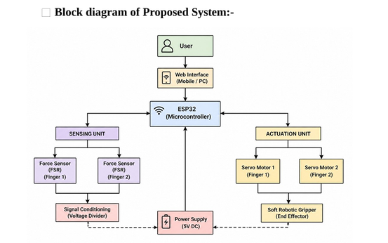

Working:
The system operates as a force-controlled robotic gripper using an ESP32 microcontroller, servo motors, and a force sensing mechanism. Upon powering on, the ESP32 initializes all components and establishes a wireless interface in Access Point (AP) mode for user control.
The system continuously waits for user commands such as “grab” or “release.” When a grab command is received, the ESP32 reads the force sensor (FSR), which is configured using a voltage divider to produce an analog signal proportional to the applied force.
If the sensed force is below a predefined threshold, the servo motors gradually close the gripper. This process continues with real-time feedback until the desired gripping force is achieved. Once the threshold is reached, the servo motion stops, maintaining a stable grip and preventing damage to the object.
The system continuously monitors the force during operation. When a release command is received, the servos move in the reverse direction to open the gripper, and the system returns to its idle state.
Thus, the system functions as a closed-loop control mechanism, where sensor feedback dynamically regulates actuator movement for efficient and adaptive gripping.

3.2 Circuit Design:-
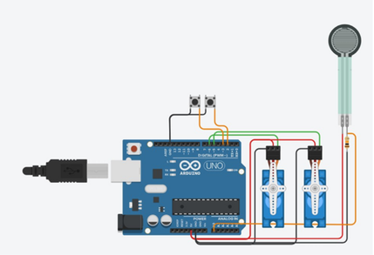

3.3 Selection of components and mechanisms for designed project:-
Electronic Component:-
- ESP32
- MG995
- FSR-402

Coding Component:-1. Arduino IDE

3.4 Mathematical Expressions & Formulae for Design:-
- Vout = Vin . Rfixed / RFSR + Rfixed
- τ = F⋅r = 1.5Nm {r = 0.15m , F = 10N}
- Ptotal=V⋅I = 10W {V = 5V , I = 1A}
- Resolution = Vref / 2n

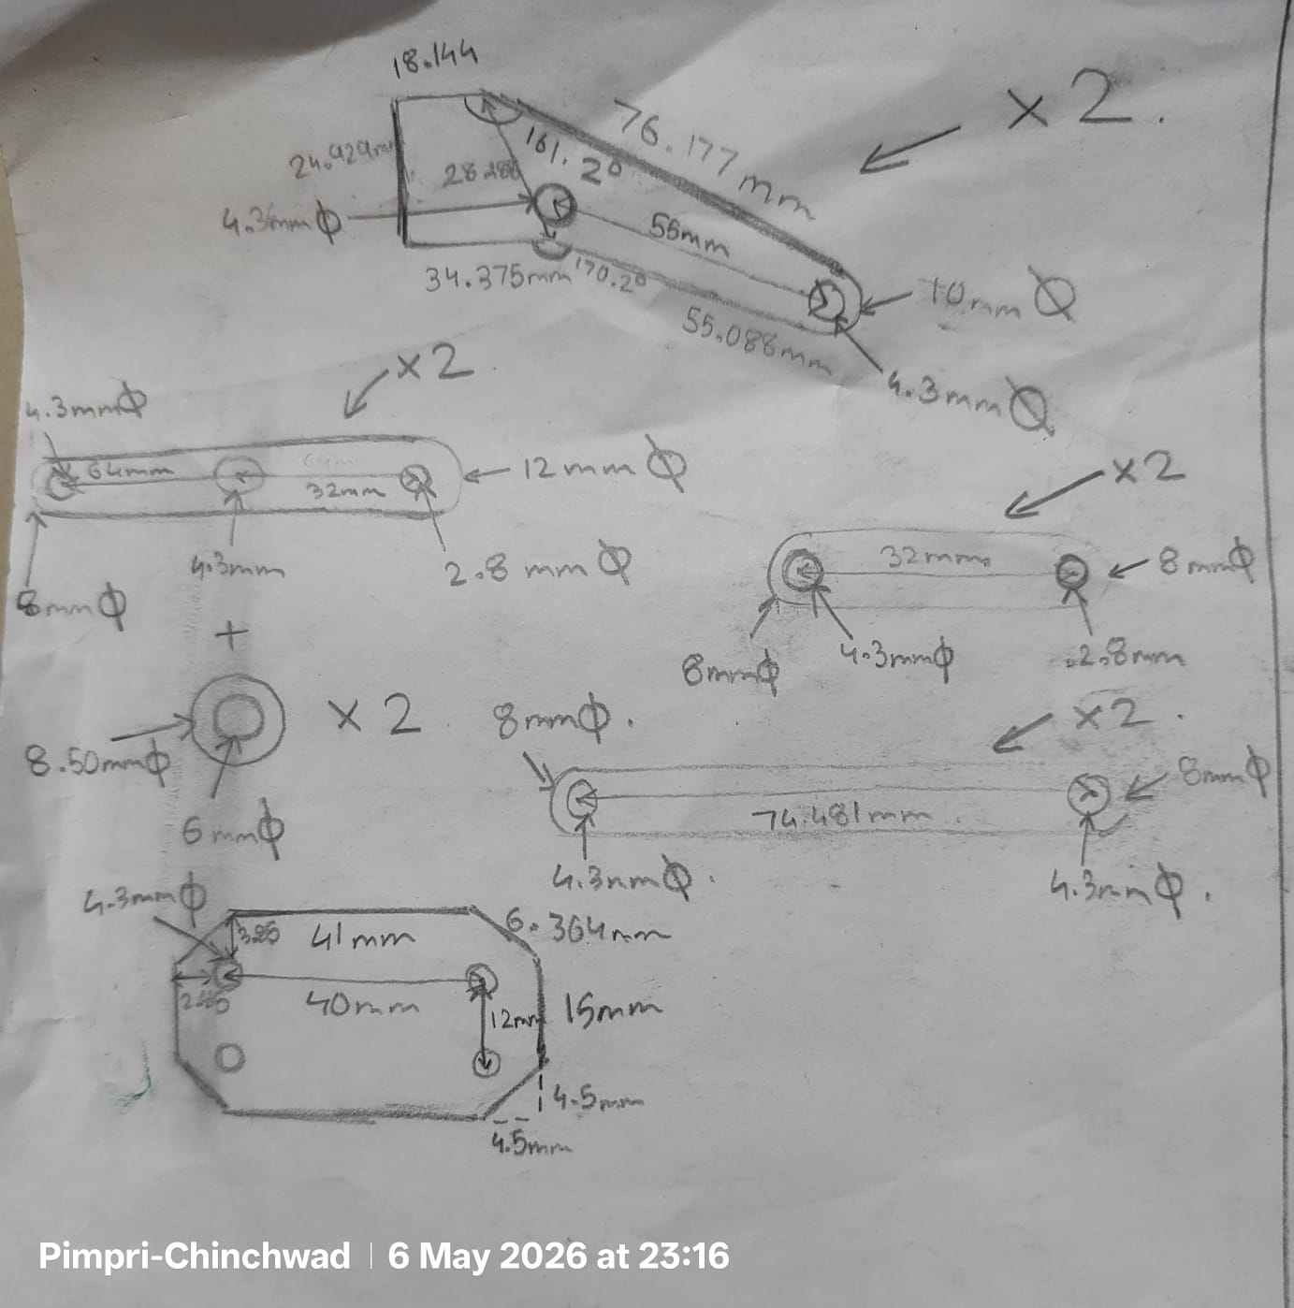
3.5 Design of Cabinet or assembly (Drawing)
3.6 Bill of Material:-
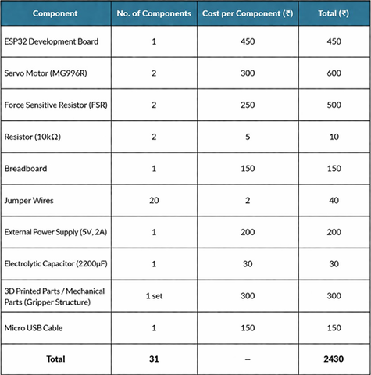

3.7 Hardware and Software Requirements:-
Hardware
- ESP32 Microcontroller
The ESP32 is a powerful, low-cost microcontroller with integrated Wi-Fi and Bluetooth capabilities. It serves as the central control unit for processing sensor data and controlling actuators.
Specifications:
- Operating Voltage: 3.3V
- Wi-Fi: 802.11 b/g/n
- GPIO Pins: Multiple digital and analog I/O
- ADC Resolution: 12-bit
- Dual-core processor for efficient multitasking

Servo Motor (MG996R or Equivalent):
Servo motors are used to actuate the gripper fingers, enabling controlled opening and closing motions.

Specifications:
- Operating Voltage: 4.8V – 7.2V
- Torque: ~9–11 kg·cm
- Control: PWM (Pulse Width Modulation)
- Rotation: Typically 0°–180°

Force Sensitive Resistor (FSR):

The FSR is used to detect applied force on the gripper fingers, allowing adaptive gripping based on object pressure.

Specifications:
Resistance Range: Variable (depends on applied force)
Operating Voltage: Typically 3.3V–5V (via voltage divider)
Response Time: < 10 ms
Output: Analog signal

Resistors (10kΩ):
Used in a voltage divider configuration with the FSR to convert resistance changes into readable voltage signals.

Power Supply (5V, 2A):
Provides sufficient current for both the ESP32 and servo motors.

Specifications:
Output Voltage: 5V DC
Current Capacity: ≥ 2A
Stable output to prevent servo jitter

Used as a bulk capacitor to stabilize voltage and reduce noise caused by servo motor current spikes.

Software:-

- Arduino IDE / PlatformIO for firmware development
- ESP32 board support package
- Servo control libraries
- Basic web server libraries (for AP mode interface)

Design Verification with simulation

4.1 Final Circuit diagram:-
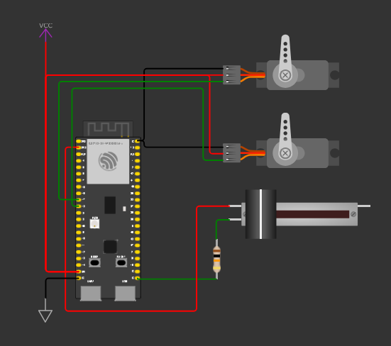
*Potentiometer is added as standin for FSR-402

4.2 Algorithm and flowcharts:-
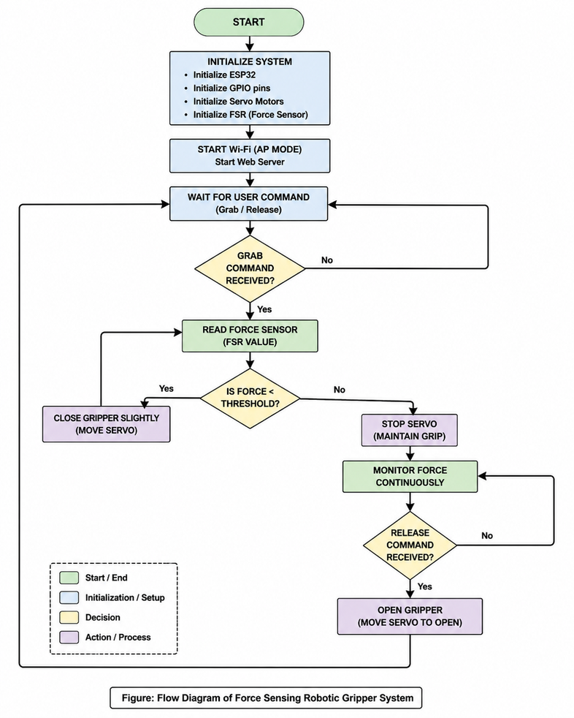

4.3 Simulation Results:-
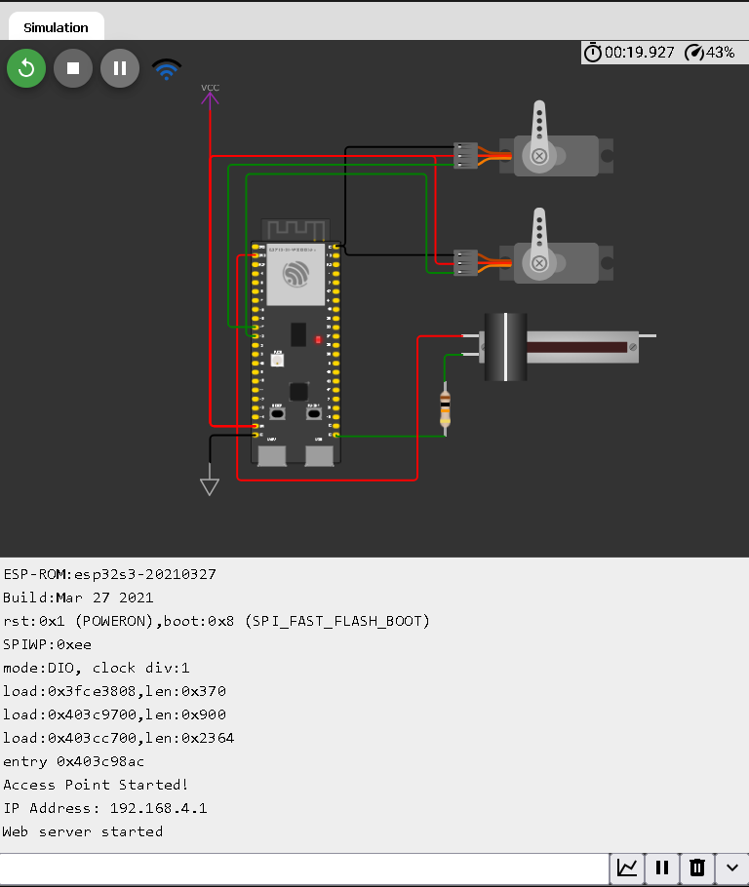

Link for Running Circuit Simulation:-

https://wokwi.com/projects/462837135965877249 https://wokwi.com/projects/460221539567272961

4.4 Discussion on Design improvement:-
- The current system demonstrates effective force-controlled gripping using ESP32, servo motors, and FSR sensors, but certain improvements can enhance performance.
- Sensor Limitations:
The FSR exhibits non-linear response and noise. This can be improved through proper calibration and filtering techniques, or by using more accurate tactile sensors.
- Actuation Improvements:
Standard servo motors may introduce limited precision and jitter. Using higher precision actuators or smoother control methods (e.g., proportional control) can improve motion accuracy.
- Mechanical Design:
The gripper structure can be optimized for better stability and durability by refining materials and design. Incorporating compliant materials can improve handling of delicate objects.
- Control System Enhancements:
The current system is user-controlled. It can be upgraded with semi-autonomous features such as object detection or automated gripping.
- Future Scope:
The system can be expanded into a multi-degree-of-freedom robotic arm, enabling advanced tasks such as object manipulation and positionin

5.Breadboard Implementation
5.1 Snapshots of Breadboard implementation for various inputs:-

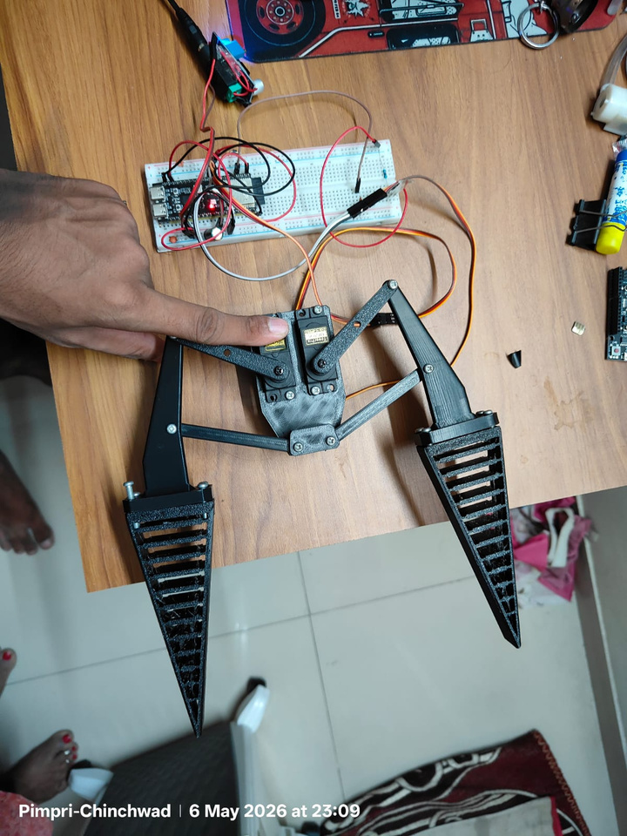 | 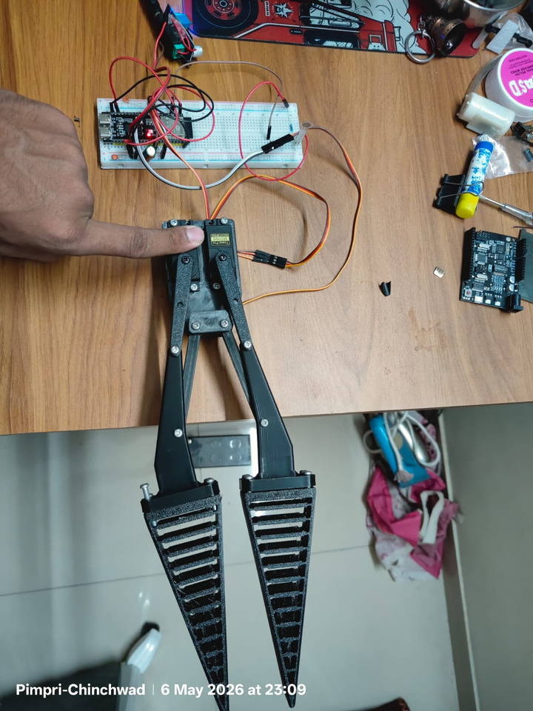

6.Final Implementation
6.1 Snapshots of Final Working project with Cabinet/Assembly:-
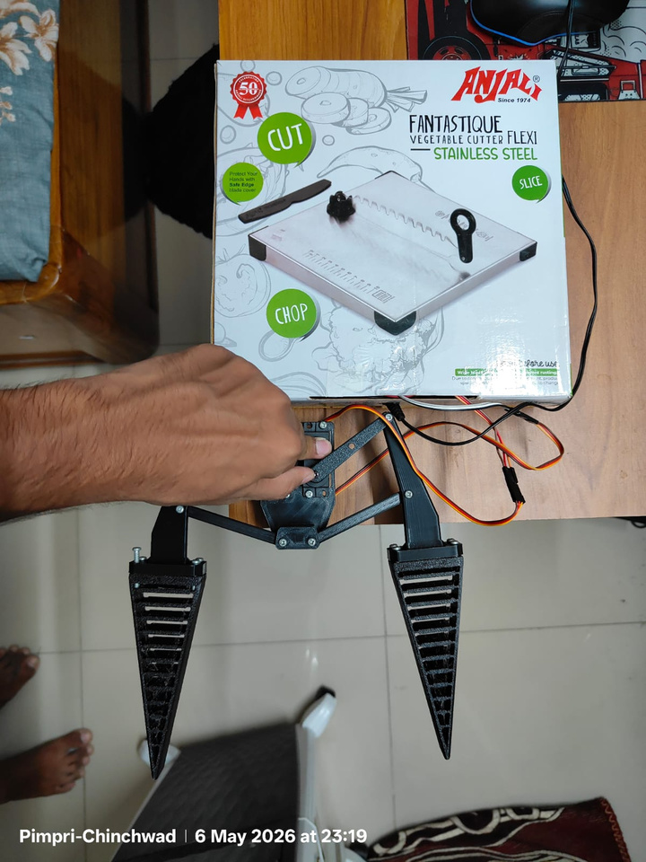 | 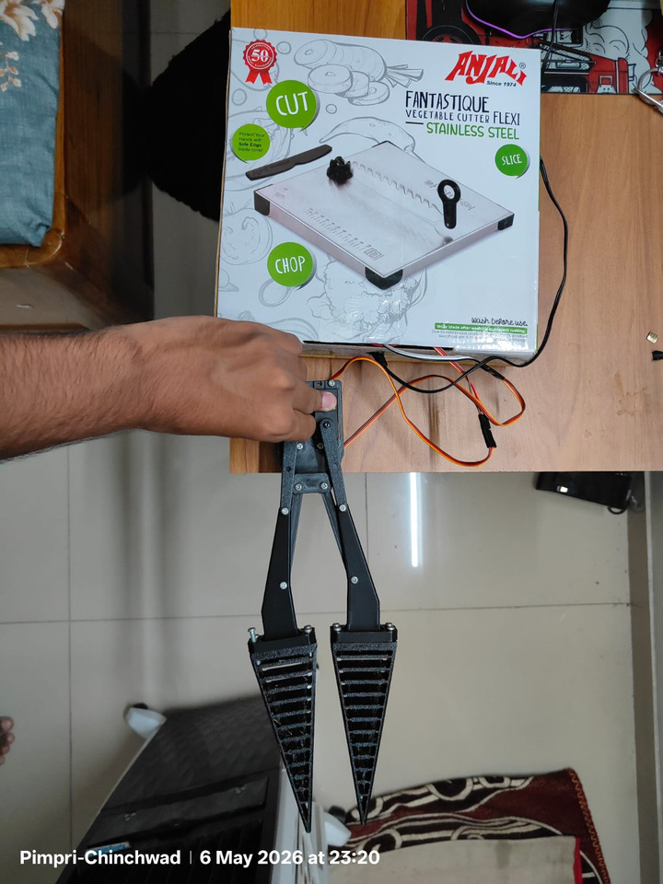

7.Results
7.1 Observation Tables
FSR Value(ADC) | Servo Angle | Gripper State
200 | 30 | Open
800 | 60 | Partially closed
1500 | 90 | Holding
2500 | 110 | Firm Grip
FSR vs Servo position
Input command | Servo Action | Result
Grabs | Servo Closes | Object gripped
Release | Servo Opens | Object released
Command vs Response
7.2 Calculations
- Vout = Vin . Rfixed / RFSR + Rfixed
- τ = F⋅r = 1.5Nm {r = 0.15m , F = 10N}
- Ptotal=V⋅I = 10W {V = 5V , I = 1A}
- Resolution = Vref / 2n

7.3 Graphs
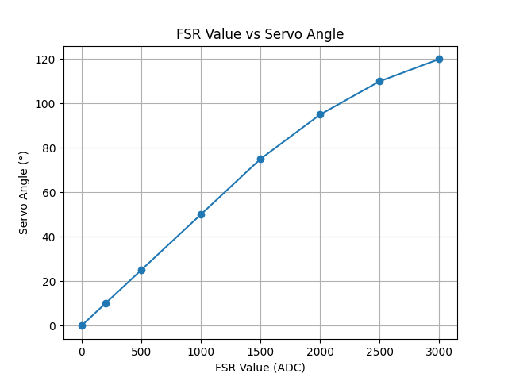

8.Conclusion
The development of the soft robotic gripper with force sensing capability demonstrates the successful integration of mechanical design, embedded systems, and sensor-based control. The system effectively utilizes an ESP32 microcontroller, servo motors, and force-sensitive resistors (FSRs) to achieve adaptive gripping, allowing it to handle objects with varying shapes and fragility. Through this project, key concepts such as real-time control, signal conditioning using voltage divider circuits, and actuator coordination were implemented and validated. The incorporation of force feedback enhances the functionality of the gripper by preventing excessive pressure and improving grip reliability. Additionally, the use of a wireless interface provides a convenient and intuitive method for user interaction. The current implementation serves as a foundational subsystem for future expansion into a fully functional robotic arm. In subsequent phases, the system can be extended by adding multiple degrees of freedom, enabling complex movements such as object manipulation and positioning. This progression highlights the scalability and adaptability of the design. Overall, the project successfully meets its objectives and establishes a practical and cost-effective approach to intelligent gripping systems, with significant potential for further development in robotics and automation applications.

9.References
- https://www.researchgate.net/publication/ 318140258_Soft_Robotics_Review_of_Fluid Driven_Intrinsically_Soft_Devices_Manufacturing_Sensing_Control_and_Applica tions_in_Human-Robot_Interaction_Review_of_Fluid Driven_Intrinsically_Soft_Robots
- https://www.researchgate.net/publication/220032969_Tactile_Sensing- From_Humans_to_Humanoids
- https://www.researchgate.net/publication/ 220122014_The_Highly_Adaptive_SDM_Hand_Design_and_Performance_Eval uation
- https://www.researchgate.net/publication/ 362043040_An_Integrated_Remote_Control-Based_Human Robot_Interface_for_Education_Application
- https://www.pnas.org/doi/10.1073/pnas.1003250107

10. Appendix -1 Datasheets od Sensors & Actuators
• FSR-402:
https://cdn.sparkfun.com/assets/8/a/1/2/0/2010-10-26-DataSheet-FSR402 Layout2.pdf
• MG99R:
https://www.electronicoscaldas.com/datasheet/MG996R_Tower-Pro.pdf
• ESP32S3:
https://docs.espressif.com/projects/esp-dev-kits/en/latest/esp32s3/esp-dev-kits en-master-esp32s3.pdf

11. Link for 3 minute Video of Working Project
https://youtu.be/d0LRWnBDcW4

12. Team Photographs (Name, PRN, Photo)

- Ashutosh Sharma(202501070190)
- Samrudhi Naik(202501070179)
- Amruta Pawar(202501070177)

