quiz_3

Alyssa Payne

November 1, 2016

## Question 1

The comparison for the correlations between ratings and raises and ratings and critical was $/Delta$ r = .43, 95% CI [.02,.82], N = 30. However, the CI is quite long, and is consistent with anywhere from no correlation to a very strongly positive relationship.

## Including Plots

You can also embed plots, for example:

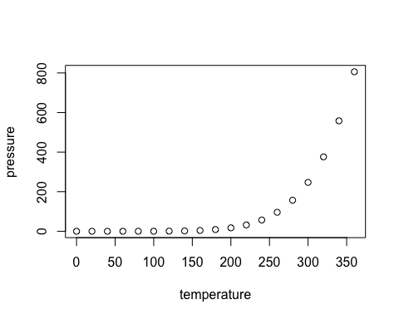

Note that the echo = FALSE parameter was added to the code chunk to prevent printing of the R code that generated the plot.