**Tip**: As you follow the instructions in this pane, whenever you see a icon, you can use it to copy text from the instruction pane into the virtual machine interface.

Windows login

Log into Windows as **Student** account with the password Pa55w.rd.

Your Azure subscription

During the lab exercise, use the following credentials to sign into the Azure subscription that is provided for you:

* **User name**: LabUser-45295525@LODSPRODMCA.onmicrosoft.com
* **Password**: SJr20!a!eD

Create all Azure resources in the **ResourceGroup1** resource group.

Module 04 lab

**Tip**: If you are asked to open a web page, copy the address into the web browser on this virtual machine.

Extract form data in Document Intelligence Studio

Azure AI Document Intelligence is able to analyze and extract information from forms and documents, then identify field names and data.

How does Document Intelligence build upon optical character recognition (OCR)? While OCR can read printed or handwritten documents, OCR extracts text in an unstructured format which is difficult to store in a database or analyze. Document intelligence makes sense of the unstructured data by capturing the structure of the text, such as key/value pairs and information in tables.

In this exercise, you'll take a look at a prebuilt model in Document Intelligence that is trained to recognize data for receipts.

**NOTE** Azure AI Document Intelligence is the new name for Azure Form Recognizer. You may still see Azure Form Recognizer in the Azure portal or Document Intelligence Studio.

Create *Document Intelligence* resource

You can use Azure AI Document Intelligence by creating either a *Document Intelligence* resource or an *Azure AI services* resource. In this exercise, you will create *Document Intelligence* resource, if you don’t already have one.

1. In another browser tab, open **Document Intelligence Studio** https://formrecognizer.appliedai.azure.com/studio, signing in with your Microsoft account.
2. Select **Settings** and select the **Resource** tab. Select **Create a new resource**.
3. On the Create resource dialog box, enter the following:
   * **Subscription**: *Your Azure subscription*.
   * **Resource group**: *Select or create a resource group with a unique name*.
   * **New resource name**: *Enter a unique name*.
   * **Location**: *Select a region. If in eastern US, use "East US 2"*.
   * **Pricing tier**: *Free F0*.
4. Select **Continue** and then **Finish**. Wait for the resource to be deployed.

**Note** If your resource is not yet displayed, you may need to **Refresh** the page.

Keep Document Intelligence Studio open.

Analyze a receipt in Document Intelligence Studio

You are now ready to analyze a receipt for the fictitious Northwind Traders retail company.

1. Select [**https://aka.ms/mslearn-receipt**](https://aka.ms/mslearn-receipt) to download a sample document to your computer. Open the folder.
2. Select **Document Intelligence Studio** to return to the **Get Started with Document Intelligence Studio** page, and under Receipts select **Try it out**.
3. In the Prebuilt drop-down list, make sure that **Receipts** is selected.
4. Select **Browse for files** and navigate to the folder where you saved the picture. Select the picture of the receipt and then **Open**. The image appears on the left side of the screen.

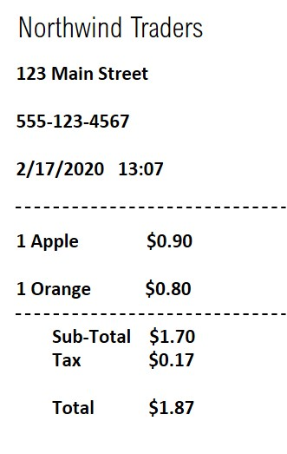

1. On the right, select **Run analysis**.
2. When the analysis has run, the results are returned. Notice that the service has recognized specific data fields such as the merchant’s name, the address, phone number, and the transaction date and time, as well as the line items, subtotal, tax, and total amounts. Next to each field is a percentage probability that the field is correct.

In this exercise you have used the Document Intelligence Studio to create a Document Intelligence resource. You then used the service to analyze a receipt. From the results that were returned, you saw how Document Intelligence was able to identify specific fields, enabling data from everyday documents to be more easily processed. Before you close Document Intelligence Studio, why not try some of the sample receipts, including those in different languages?

Clean up

If you don’t intend to do more exercises, delete any resources that you no longer need. This avoids accruing any unnecessary costs.

1. Open the **Azure portal** https://portal.azure.com and select the resource group that contains the resource you created.
2. Select the resource and select **Delete** and then **Yes** to confirm. The resource is then deleted.

Learn more

This exercise demonstrated only some of the capabilities of the AI Document Intelligence service. To learn more about what you can do with this service, see the [Document Intelligence](https://learn.microsoft.com/azure/ai-services/document-intelligence/overview?view=doc-intel-3.1.0) page.