**Tip**: As you follow the instructions in this pane, whenever you see a icon, you can use it to copy text from the instruction pane into the virtual machine interface.

Windows login

Log into Windows as **Student** account with the password Pa55w.rd.

Your Azure subscription

During the lab exercise, use the following credentials to sign into the Azure subscription that is provided for you:

* **User name**: LabUser-45559323@LODSPRODMCA.onmicrosoft.com
* **Password**: a!DreJS20!

Create all Azure resources in the **ResourceGroup1** resource group.

Module 05 lab

**Tip**: If you are asked to open a web page, copy the address into the web browser on this virtual machine.

Explore Microsoft Copilot in Microsoft Edge

In this exercise you will explore some of the ways in which Microsoft Copilot can use generative AI to help you be more productive when creating new content. In the scenario for this exercise, you will start with some high-level notes for a business idea, and use Copilot in Microsoft Edge to help you develop a business plan and a presentation for potential investors.

This exercise should take approximately **40** minutes to complete.

**Note**: This exercise assumes that you have a [personal Microsoft Account](https://signup.live.com/) (such as an outlook.com account) with which you are signed into [Microsoft Edge](https://www.microsoft.com/edge/download) on your computer.

Use Copilot to explore a document and research an idea

To start your exploration of generative AI, let's use Microsoft Copilot in Edge to examine an existing document and extract some insights from it.

1. In Microsoft Edge, browse to [OneDrive](https://onedrive.live.com/) at https://onedrive.live.com and sign in using your personal Microsoft account - closing any welcome messages or offers that are displayed.
2. In another browser tab, open the document [Business Idea.docx](https://github.com/MicrosoftLearning/mslearn-ai-fundamentals/raw/main/data/generative-ai/Business%20Idea.docx) from https://github.com/MicrosoftLearning/mslearn-ai-fundamentals/raw/main/data/generative-ai/Business%20Idea.docx. Then, when the document opens in Edge, select the option to **Save a copy to OneDrive** and save the document in your **Documents** folder in OneDrive. The document should then open in Microsoft Word online automatically.

**Tip**: If you don't see the option to save a copy of the file to OneDrive, download it to your local computer. Then, in OneDrive, open the **Documents** folder and use the **+ Add new** button to upload the **Business Idea.docx** file from your local computer to OneDrive.

1. View the text in **Business Idea.docx**, which describe some high -level ideas for a cleaning business in New York City.
2. Use the **Copilot** icon on the Edge toolbar to open the Copilot pane, as shown here:

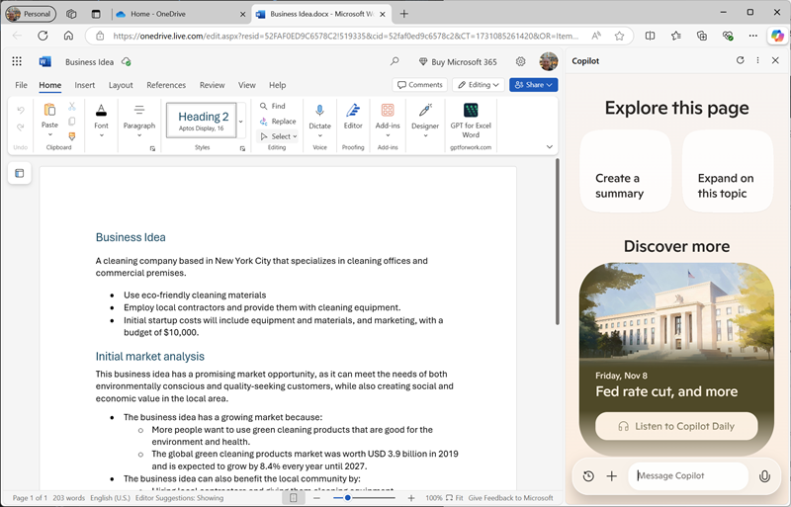

1. In the chat box at the bottom of the Copilot pane, enter following the prompt:

What is this document about?

If prompted, confirm that you want to allow Copilot to access the page.

1. Review the response from Copilot, which should summarize the main points in the document, as shown here:

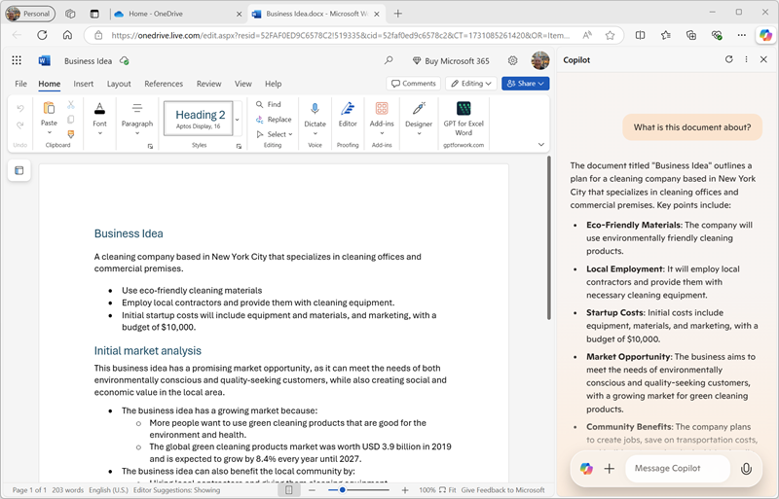

**Note**: The specific response may vary.

1. Enter the following prompt:

How do I go about setting up a business in New York?

1. Review the response, which should contain some advice and links to resource to help you get started setting up a business in New York, and may include some suggested follow-up prompts to get more information.

**Important**: The AI-generated response is based on information publicly on the Web. While it may be useful to help you understand the steps required to set up a business, it is not guaranteed to be 100% accurate and does not replace the need for professional advice!

Use Copilot to create content for a business plan

Now that you've done some initial research, let's have Copilot help you develop a business plan for your cleaning company.

1. With the **Business Idea.docx** document still open in Microsoft Edge, in the Copilot pane, enter the following prompt:

Suggest a name for my cleaning business

1. Review the suggestions and select a name for your cleaning company (or continue prompting to find a name you like).
2. Enter the following prompt, replacing *Contoso Cleaning* with the company name of your choice:

Write a business plan for "Contoso Cleaning" based on the information in this document. Include an executive summary, market overview, and financial projections.

1. Review the response. Then in the Microsoft Word pane, in the **File** menu, create a new blank document. Close the **Designer** pane if it opens and change the name of the new document from *Document* to Business Plan.
2. In the **Business Plan** document, add a heading with your chosen name for your cleaning company. Then copy the buisness plan that was generated in the Copilot pane and paste it into the document. You should end up with a business plan document, similar to this:

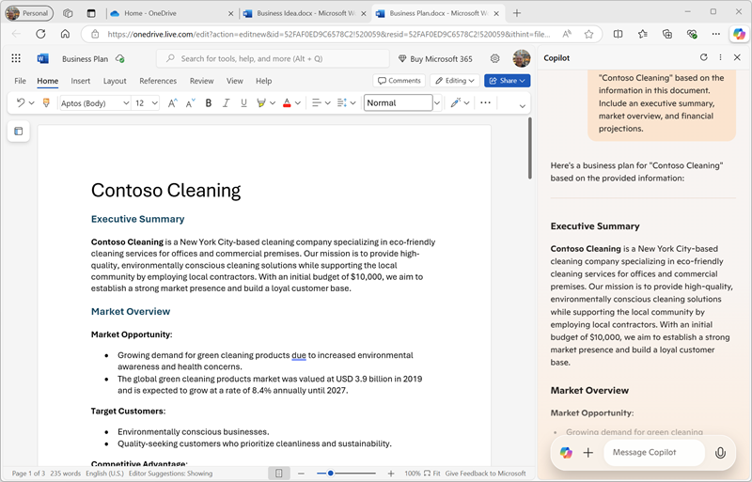

1. In the Copilot pane, enter the following prompt:

Create a corporate logo for the cleaning company. The logo should be round and include an iconic New York landmark.

1. Review the response, which should present four options for a logo created by Microsoft Designer.
2. Use more prompts to iterate on the design (for example, Make it green and blue) until you have a logo with which you are happy.
3. Right-click the generated logo and copy it to the clipboard. Then paste it into the top of the business plan document, like this:

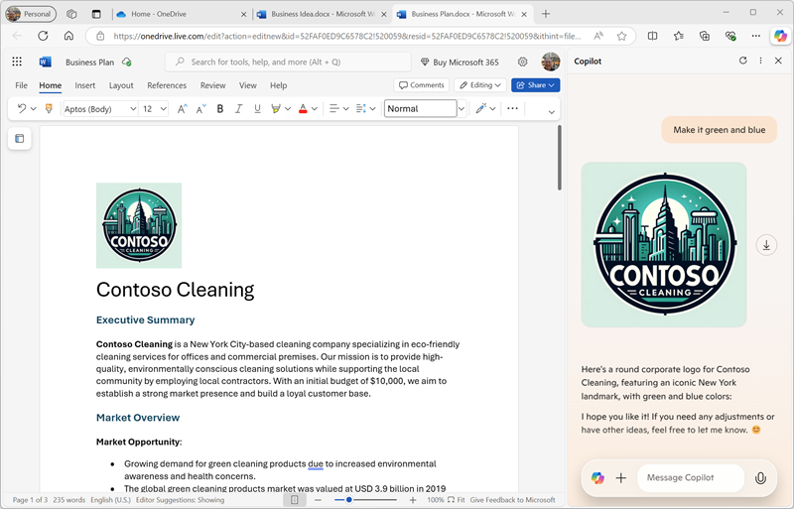

1. Close the Microsoft Word tabs and return to the **Documents** folder in your OneDrive.

Use Copilot to create content for a presentation

With Copilot's help, you've created a draft of a business plan for the cleaning business idea. Now you'll need an effective presentation to convince an investor to lend you the funding to start the business.

1. In the **Documents** folder in OneDrive, add a new **PowerPoint presentation**. If the **Designer** pane opens automatically, close it. Then change the name of the presentation from *Presentation* to Business Presentation.
2. On the title slide for the presentation, enter the the name of your cleaning company as the title, and Investor Opportunity as the subtitle.
3. Insert a new slide, using the **Two Content** slide layout (which includes a title and two placeholders for content).
4. Change the slide title to Benefits of Hiring a Commercial Cleaner.
5. In the Copilot pane, enter the following prompt:

Write a summary of the benefits of using a corporate cleaning company for your business. The summary should consist of five short bullet points.

1. Copy Copilot's response to the clipboard, and paste it into the left content placeholder. Then edit and reformat the text in the placeholder until you are satisfied.
2. In the Copilot pane, enter the following prompt:

Create a photorealistic image of a clean office.

1. When Copilot has generated an image you like, copy it to the clipboard and paste it into the content placeholder on the right of the slide.

If the **Designer** pane opens automatically, select a slide design you like. Then close the **Designer** pane.

1. Apply any additional reformatting you think is required until you have a slide that you're happy with:

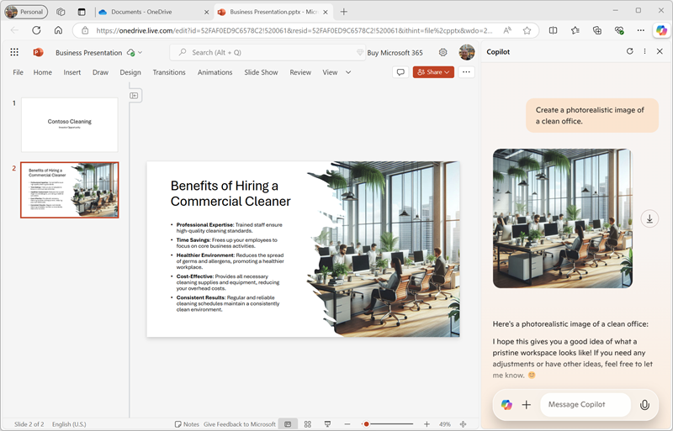

1. Close the PowerPoint tab and return to the **Documents** folder in your OneDrive.

Use Copilot to compose an email

You've created some collateral to help you get your business started. Now it's time to reach out to an investor seeking some startup funding.

1. Use the **App Launcher** at the left end of the OneDrive title bar to open **Outlook**.
2. Create a new email, and fill in the **To** box with your own email address and set the **Subject** to Business funding meeting request.
3. In the Copilot pane, enter the following prompt:

Write an email to a bank manager requesting a meeting to discuss funding for a commercial cleaning business. The email should be concise and the tone should be professional.

1. Use the generated content to complete your email, as shown here:

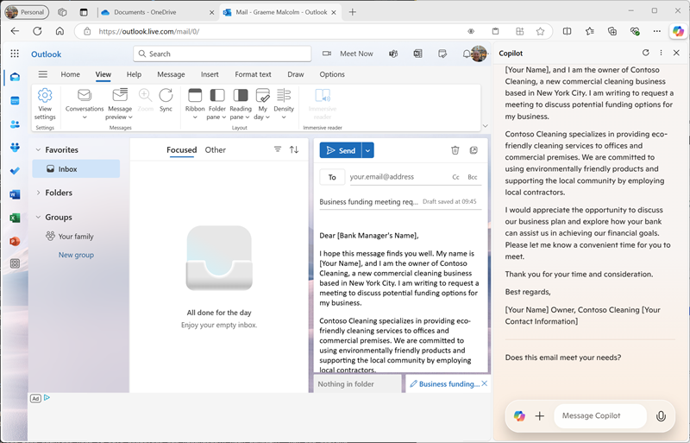

You can send the email to yourself if you wish!

Challenge

Now you've seen how to use Copilot to research ideas and generate content, why not try exploring further? To start a new Copilot session, on the **Chat** tab, select the **New topic** icon next to the prompt box, and then try using Copilot to plan an event to promote children's literacy at a local library. Some things you could try include:

* Research some tips for encouraging children to read at an early age.
* Create a flyer or poster for the event.
* Compose an email for a campaign to invite local children's authors to come and speak at the event.
* Create a presentation to start the event.

Be as inventive as you like, and explore how Copilot can help you by finding information, generating and refining text, creating images, and answering questions.

Conclusion

In this exercise, you've used Copilot in Microsoft Edge to find information and generate content. Hopefully you've seen how using generative AI in a copilot can help with productivity and creativity.

While the free services used in this exercises are undoubtedly very powerful, you can achieve even more with services like [Microsoft 365 Copilot](https://www.microsoft.com/microsoft-365/enterprise/copilot-for-microsoft-365), in which Microsoft Copilot is integrated into Windows and Microsoft Office productivity applications, providing highly contextualized help with common tasks. Microsoft 365 enables you to bring the power of generative AI to your business data and processes, while integrating into your existing IT infrastructure to ensure a manageable, secure solution.