Industrial Internship Report on
”Data Science and Machine Learning”
Prepared by
Avhijan Paul Choudhury

Executive Summary
This report provides details of the Industrial Internship provided by upskill Campus and The IoT Academy in collaboration with Industrial Partner UniConverge Technologies Pvt Ltd (UCT).
This internship was focused on a project/problem statement provided by UCT. We had to finish the project including the report in 6 weeks’ time.
- My project was Smart City Traffic Forecasting and Agriculture Crop Prediction
This internship gave me a very good opportunity to get exposure to Industrial problems and design/implement solution for that. It was an overall great experience to have this internship.

TABLE OF CONTENTS
1 Preface 3
2 Introduction 4
2.1 About UniConverge Technologies Pvt Ltd 4
2.2 About upskill Campus 8
2.3 Objective 9
2.4 Reference 9
2.5 Glossary 10
3 Problem Statement 11
4 Existing and Proposed solution 12
5 Proposed Design/ Model 13
5.1 High Level Diagram (if applicable) 13
5.2 Low Level Diagram (if applicable) 13
5.3 Interfaces (if applicable) 13
6 Performance Test 14
6.1 Test Plan/ Test Cases 14
6.2 Test Procedure 14
6.3 Performance Outcome 14
7 My learnings 15
8 Future work scope 16

Preface
This report presents the work carried out during the Data Science and Machine Learning Internship conducted by UniConverge Technologies Pvt. Ltd. in collaboration with upskill Campus. During the internship, practical exposure was gained in Python programming, data preprocessing, exploratory data analysis (EDA), visualization, and machine learning techniques.
Two real-world projects were completed during the internship:
- Smart City Traffic Forecasting
- Agriculture Crop Prediction
These projects involved working with real datasets, extracting meaningful insights, and developing predictive models using Python and machine learning libraries.
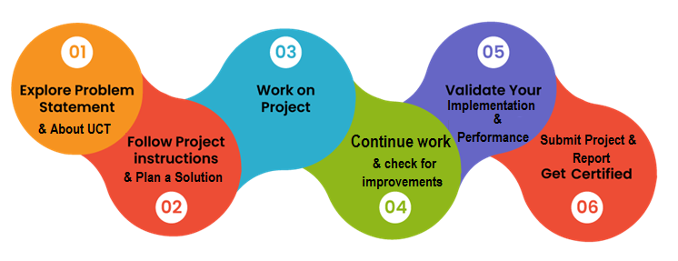
The Data Science and Machine Learning Internship provided me with valuable practical exposure to applying theoretical concepts to real-world datasets. I learned how to collect, clean, preprocess, and analyze datasets using Python libraries such as Pandas and NumPy. I gained hands-on experience in Exploratory Data Analysis (EDA), data visualization using Matplotlib and Seaborn, and building predictive models using Scikit-learn. Additionally, I improved my understanding of machine learning concepts, model evaluation, and project documentation.
Apart from technical knowledge, this internship strengthened my analytical thinking, problem-solving abilities, debugging skills, and project management. It also improved my proficiency in Git and GitHub for version control and collaboration. Overall, this internship was a rewarding learning experience that enhanced my confidence in implementing data science solutions for practical problems and motivated me to continue exploring advanced machine learning techniques.

Introduction

About UniConverge Technologies Pvt Ltd
A company established in 2013 and working in Digital Transformation domain and providing Industrial solutions with prime focus on sustainability and RoI.
For developing its products and solutions it is leveraging various Cutting Edge Technologies e.g. Internet of Things (IoT), Cyber Security, Cloud computing (AWS, Azure), Machine Learning, Communication Technologies (4G/5G/LoRaWAN), Java Full Stack, Python, Front end etc.
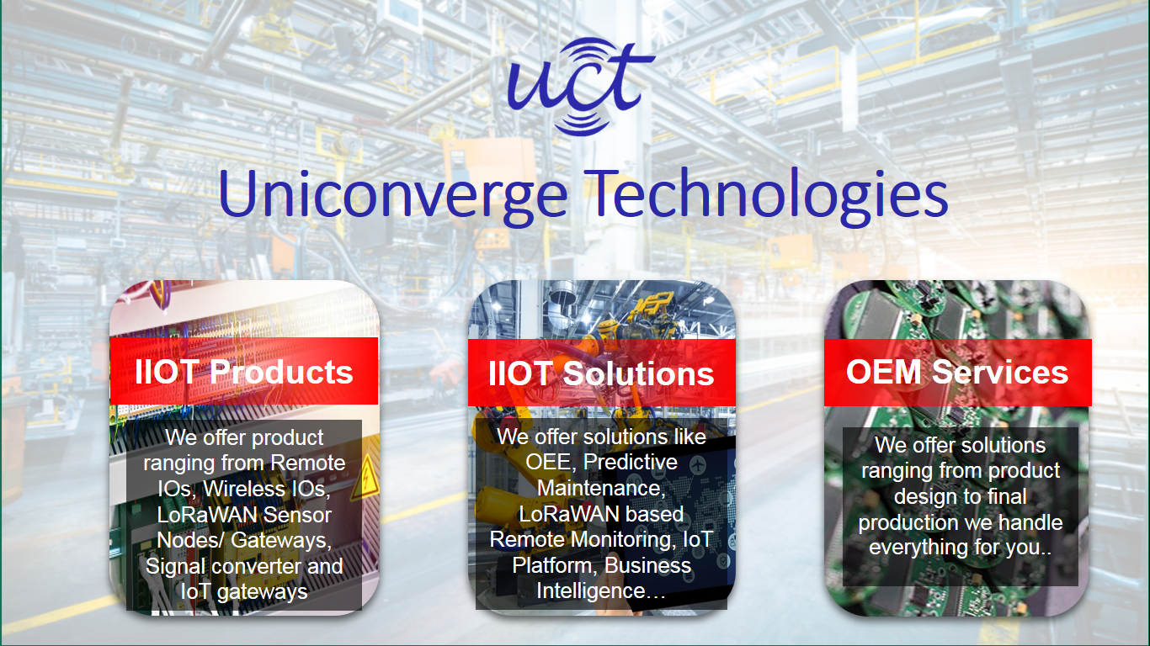
- UCT IoT Platform ()
UCT Insight is an IOT platform designed for quick deployment of IOT applications on the same time providing valuable “insight” for your process/business. It has been built in Java for backend and ReactJS for Front end. It has support for MySQL and various NoSql Databases.
- It enables device connectivity via industry standard IoT protocols - MQTT, CoAP, HTTP, Modbus TCP, OPC UA
- It supports both cloud and on-premises deployments.
It has features to
• Build Your own dashboard
• Analytics and Reporting
• Alert and Notification
• Integration with third party application(Power BI, SAP, ERP)
• Rule Engine

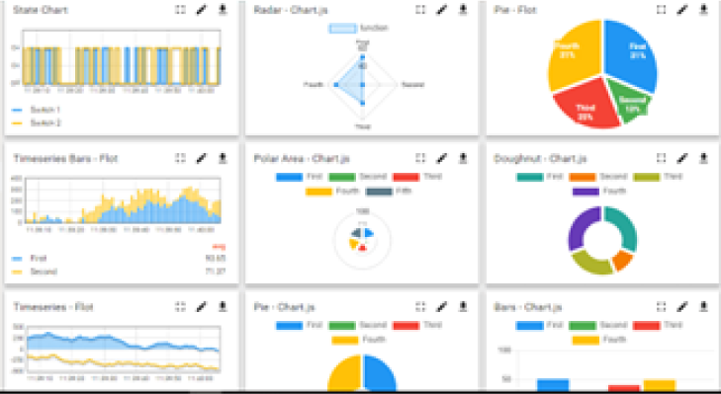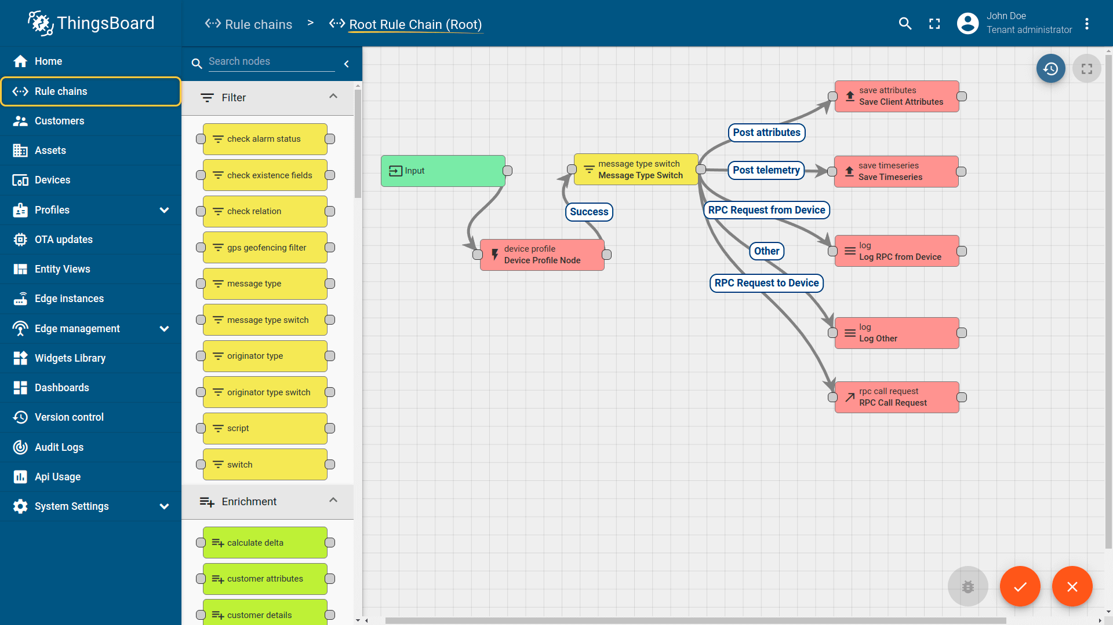

- Smart Factory Platform ()
Factory watch is a platform for smart factory needs.
It provides Users/ Factory
- with a scalable solution for their Production and asset monitoring
- OEE and predictive maintenance solution scaling up to digital twin for your assets.
- to unleased the true potential of the data that their machines are generating and helps to identify the KPIs and also improve them.
- A modular architecture that allows users to choose the service that they what to start and then can scale to more complex solutions as per their demands.
Its unique SaaS model helps users to save time, cost and money.
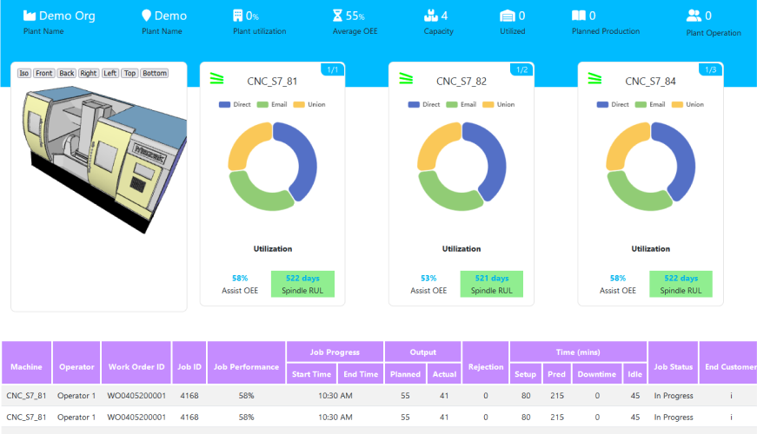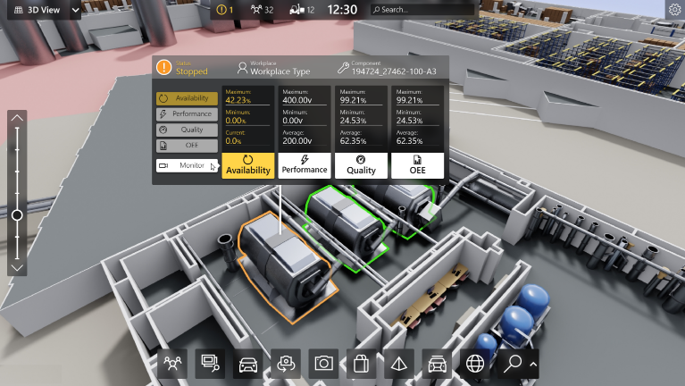

- 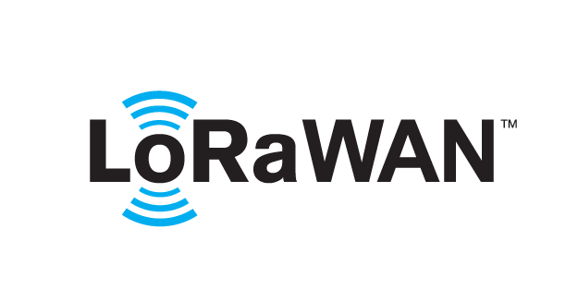 based Solution
UCT is one of the early adopters of LoRAWAN teschnology and providing solution in Agritech, Smart cities, Industrial Monitoring, Smart Street Light, Smart Water/ Gas/ Electricity metering solutions etc.
- Predictive Maintenance
UCT is providing Industrial Machine health monitoring and Predictive maintenance solution leveraging Embedded system, Industrial IoT and Machine Learning Technologies by finding Remaining useful life time of various Machines used in production process.
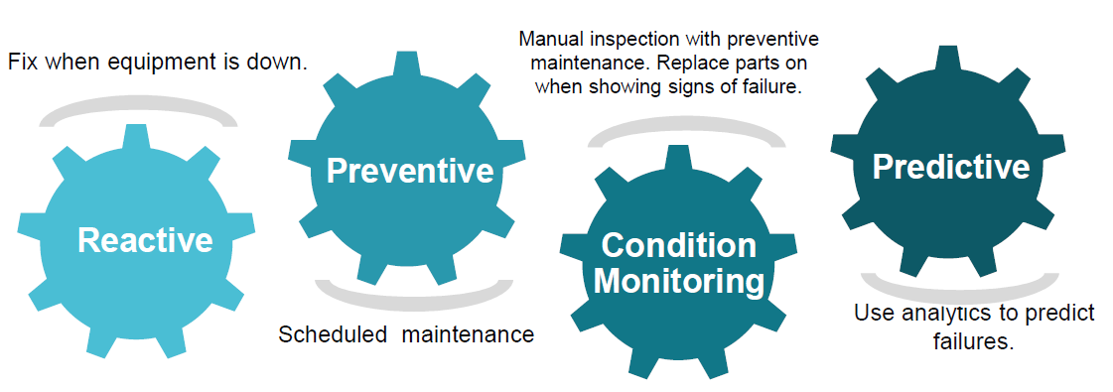

About upskill Campus (USC)
upskill Campus along with The IoT Academy and in association with Uniconverge technologies has facilitated the smooth execution of the complete internship process.
USC is a career development platform that delivers personalized executive coaching in a more affordable, scalable and measurable way.

Seeing need of upskilling in self paced manner along-with additional support services e.g. Internship, projects, interaction with Industry experts, Career growth Services
https://www.upskillcampus.com/
upSkill Campus aiming to upskill 1 million learners in next 5 year





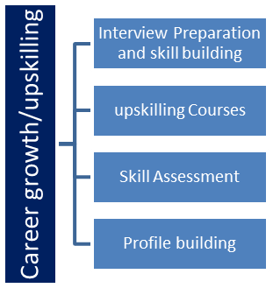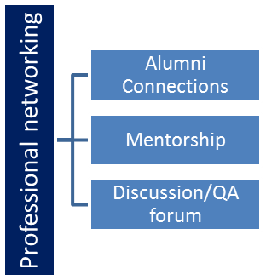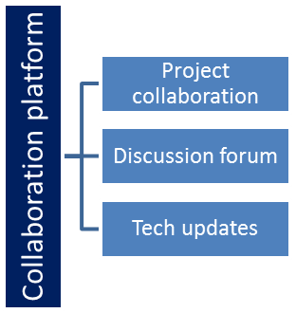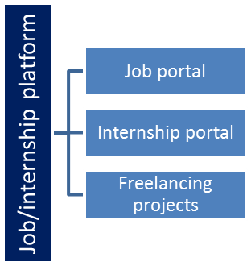

The IoT Academy
The IoT academy is EdTech Division of UCT that is running long executive certification programs in collaboration with EICT Academy, IITK, IITR and IITG in multiple domains.

Objectives of this Internship program
The objective for this internship program was to
☛ get practical experience of working in the industry.
☛ to solve real world problems.
☛ to have improved job prospects.
☛ to have Improved understanding of our field and its applications.
☛ to have Personal growth like better communication and problem solving.

Reference
[1] Python Software Foundation. Python Documentation. https://docs.python.org/3/
[2] Scikit-learn Developers. Scikit-learn Documentation. https://scikit-learn.org/stable/
[3] Pandas Development Team. Pandas Documentation. https://pandas.pydata.org/docs/

Glossary
Terms | Acronym
Artificial Intelligence | AI
Machine Learning | ML
Data Science | DS
Exploratory Data Analysis | EDA
Integrated Development Environment | IDE

Problem Statement
Project 1: Forecasting of Smart city traffic patterns
We are working with the government to transform various cities into a smart city. The vision is to convert it into a digital and intelligent city to improve the efficiency of services for the citizens. One of the problems faced by the government is traffic. You are a data scientist working to manage the traffic of the city better and to provide input on infrastructure planning for the future.
The government wants to implement a robust traffic system for the city by being prepared for traffic peaks. They want to understand the traffic patterns of the four junctions of the city. Traffic patterns on holidays, as well as on various other occasions during the year, differ from normal working days. This is important to take into account for your forecasting

Project 2: Prediction of Agriculture Crop Production in Indi
Agricuture Production in India from 2001-2014
Given Dataset Describes the Agricuture Crops Cultivation/Production in india. This is from https://data.gov.in/ fully Licensed
This Dataset can solves the problems of various crops Cultivation/production in india.
Inspiration :
Across The Globe India Is The Second Largest Country having People more than 1.3 Billion.
Many People Are Dependent On The Agricuture And it is the Main Resource.
In Agricuturce Cultivation/Production Having More Problems.
I want to solve the Big problem in india and usefull to many more people

Project 1 : Smart City Traffic Forecasting
Existing Solutions
Several existing traffic management systems rely on historical traffic records, fixed traffic signal timings, and manual monitoring. Some modern systems use GPS data and IoT sensors to monitor traffic conditions in real time. While these methods provide useful information, they have certain limitations:
- Depend heavily on expensive infrastructure such as traffic cameras and IoT sensors.
- Limited prediction capability using only historical averages.
- High installation and maintenance costs.
- Difficulty adapting to sudden traffic changes caused by holidays, accidents, or special events.
- Large amounts of raw traffic data require extensive preprocessing before analysis.
Proposed Solution
The proposed solution uses a data-driven approach to analyze traffic datasets collected from four city junctions. The project includes:
- Data preprocessing and cleaning.
- Exploratory Data Analysis (EDA) to identify traffic patterns.
- Visualization of traffic flow during peak hours and holidays.
- Building a Linear Regression model to forecast traffic volume.
- Evaluating the prediction model using testing data.
This solution demonstrates how machine learning can assist in understanding and forecasting traffic trends using historical data.
Value Addition
The proposed system offers the following improvements:
- Automated data preprocessing and analysis.
- Visual representation of traffic trends for easier interpretation.
- Prediction of future traffic volume using machine learning.
- Cost-effective solution that works with historical datasets.
- Foundation for future integration with real-time smart city traffic management systems.

Project 2: Agriculture Crop Prediction
Existing Solutions
Traditional crop production estimation mainly depends on manual surveys, historical records, and expert knowledge. Some existing digital systems use statistical models to estimate crop yield based on limited parameters. However, these approaches have several limitations:
- Manual data collection is time-consuming.
- Difficult to analyze large agricultural datasets efficiently.
- Limited use of machine learning for accurate prediction.
- Often ignores multiple influencing factors simultaneously.
- Predictions may not adapt well to changing agricultural conditions.
Proposed Solution
The proposed solution analyzes agricultural datasets from different Indian states using Python and machine learning techniques. The project includes:
- Data cleaning and preprocessing.
- Exploratory Data Analysis (EDA).
- Visualization of crop production trends across states and seasons.
- Analysis of factors such as cultivated area, production cost, and season.
- Development of a Linear Regression model to predict crop production.
The system provides a simple and efficient approach for estimating crop production based on historical agricultural data.
Value Addition
The proposed solution provides several benefits:
- Faster analysis of agricultural datasets.
- Improved understanding through graphical visualizations.
- Automated prediction of crop production using machine learning.
- Better support for data-driven agricultural planning.
- Can be extended by incorporating weather, rainfall, soil quality, and fertilizer data to improve prediction accuracy.

Code submission (Github link)
Project 1 : upskillCampus/Smart-City-Traffic-Forecasting at main · apc-codes/upskillCampus

Project 2: upskillCampus/Agriculture-Crop-Prediction at main · apc-codes/upskillCampus

Repository Link : https://github.com/apc-codes/upskillCampus

Report submission (Github link) :

Repository Link - https://github.com/apc-codes/upskillCampus

Repository - Proposed Design/ Model
The proposed solutions follow the standard Data Science workflow consisting of data collection, preprocessing, exploratory analysis, visualization, machine learning model development, and prediction. Both projects use Python-based tools and libraries to process datasets and generate predictive insights.

High Level Diagram (if applicable)
Project 1: Smart City Traffic Forecasting
Traffic Dataset → Data Preprocessing → Exploratory Data Analysis → Data Visualization → Feature Selection → Linear Regression Model → Traffic Prediction → Performance Evaluation
Project 2: Agriculture Crop Prediction
Crop Dataset → Data Preprocessing → Exploratory Data Analysis → Data Visualization → Feature Selection → Linear Regression Model → Crop Production Prediction → Performance Evaluation

HIGH LEVEL DIAGRAM OF THE SYSTEM

Low Level Diagram (if applicable)
Project 1: Smart City Traffic Forecasting
CSV Traffic Dataset → Load Dataset (Pandas) → Data Cleaning (Missing Values & Duplicates) → Feature Selection (Hour, Junction, Holiday) → Exploratory Data Analysis (EDA) → Data Visualization → Train-Test Split → Linear Regression Model → Traffic Volume Prediction → Model Evaluation
Project 2: Agriculture Crop Prediction
CSV Crop Dataset → Load Dataset (Pandas) → Data Cleaning (Missing Values & Duplicates) → Feature Selection (State, Season, Area, Cost) → Exploratory Data Analysis (EDA) → Data Visualization → Train-Test Split → Linear Regression Model → Crop Production Prediction → Model Evaluation

Interfaces (if applicable)
Software Interface
- Python 3.x
- Jupyter Notebook
- VS Code
- Git & GitHub
Libraries Used
- Pandas
- NumPy
- Matplotlib
- Seaborn
- Scikit-learn
Input Interface
Smart City Traffic Forecasting
- Traffic dataset (CSV)
- Vehicle count
- Junction number
- Time (Hour)
- Holiday information
Agriculture Crop Prediction
- Agriculture dataset (CSV)
- State
- Season
- Cultivated Area
- Production Cost
Processing Interface
- Data preprocessing
- Data cleaning
- Exploratory Data Analysis
- Data visualization
- Feature selection
- Model training
- Prediction
Output Interface
Smart City Traffic Forecasting
- Traffic trend graphs
- Peak-hour analysis
- Predicted traffic volume
- Model performance score
Agriculture Crop Prediction
- State-wise production graphs
- Crop production analysis
- Predicted production values
- Model performance score

Performance Test
The developed models were evaluated on their ability to process datasets efficiently and generate meaningful predictions. The primary constraints considered during development included data quality, prediction accuracy, computational efficiency, and scalability.
Constraints Identified
Smart City Traffic Forecasting
- Missing or inconsistent traffic records.
- Limited historical data.
- Prediction accuracy depends on data quality.
- Traffic affected by unpredictable events such as accidents and weather.
Agriculture Crop Prediction
- Missing agricultural records.
- Limited input features.
- Crop production depends on external factors such as rainfall and soil fertility.
- Seasonal variations influence prediction accuracy.

How Constraints Were Addressed
- Missing values were handled during preprocessing.
- Duplicate records were removed.
- Exploratory Data Analysis was performed to identify anomalies.
- Appropriate features were selected before model training.
- Dataset was divided into training and testing sets to evaluate performance.

Test Plan/ Test Cases
Project 1: Smart City Traffic Forecasting
Test Case | Expected Result | Status
Load traffic dataset | Dataset loads successfully | Passed
Handle missing values | Clean dataset obtained | Passed
Generate traffic visualization | Graphs displayed correctly | Passed
Train prediction model | Model trained successfully | Passed
Predict traffic volume | Valid prediction generated | Passed
Proj 2 : Agriculture  Test Case | Expected Result | Status
Load crop dataset | Dataset loads successfully | Passed
Remove duplicate records | Clean dataset obtained | Passed
Generate visualizations | Graphs generated | Passed
Train ML model | Model trained successfully | Passed
Predict crop production | Prediction generated | Passed

Test Procedure
For both projects, the following testing procedure was followed:
- Import the dataset.
- Perform data preprocessing.
- Handle missing values and duplicate records.
- Conduct exploratory data analysis.
- Generate visualizations.
- Split the dataset into training and testing sets.
- Train the Linear Regression model.
- Generate predictions on the test dataset.
- Evaluate the model using performance metrics.

Performance Outcome
Smart City Traffic Forecasting
The developed model successfully analyzed traffic patterns and generated traffic volume predictions using historical data. Data preprocessing significantly improved the quality of the dataset, while visualization helped identify peak traffic hours and traffic variations across different time periods.
Agriculture Crop Prediction
The model successfully analyzed agricultural production data and estimated crop production using selected input features. Data cleaning and feature selection improved prediction reliability. The project demonstrated the usefulness of machine learning techniques in agricultural data analysis.
Although both models used a basic Linear Regression algorithm, they provided satisfactory results for educational purposes and established a strong foundation for implementing more advanced machine learning models in future work.

My learnings
This internship provided me with practical exposure to the complete Data Science and Machine Learning lifecycle. I learned how to work with real-world datasets by performing data collection, preprocessing, cleaning, exploratory data analysis (EDA), visualization, feature selection, model development, and performance evaluation.
Working on the Smart City Traffic Forecasting and Agriculture Crop Prediction projects enhanced my proficiency in Python and libraries such as Pandas, NumPy, Matplotlib, Seaborn, and Scikit-learn. I also gained experience in implementing Linear Regression models, interpreting results, and documenting technical projects using Git and GitHub.
Beyond technical skills, the internship improved my analytical thinking, problem-solving abilities, debugging skills, and project management. It reinforced the importance of writing clean code, maintaining proper documentation, and following a structured approach to solving real-world problems.
Overall, this internship strengthened my confidence in applying data science concepts to practical applications and has provided a solid foundation for pursuing advanced studies and a career in Data Science, Machine Learning, and Software Development.

Future work scope

Although the objectives of both projects were successfully achieved during the internship, several enhancements can be incorporated in the future to improve functionality, accuracy, and real-world applicability.
- Project 1: Smart City Traffic Forecasting
Due to time limitations, the project was developed using historical traffic data and a basic Linear Regression model. Future enhancements may include:
- Integrating real-time traffic data from IoT sensors, GPS devices, and traffic cameras.
- Implementing advanced machine learning and deep learning algorithms such as Random Forest, XGBoost, LSTM, and GRU to improve forecasting accuracy.
- Including additional factors such as weather conditions, road accidents, public events, and road construction in the prediction model.
- Developing a web-based dashboard using Streamlit or Flask for real-time traffic monitoring and visualization.
- Deploying the model on cloud platforms to provide scalable traffic prediction services.
- Integrating the system with smart traffic signal management for dynamic signal optimization.

- Project 2: Agriculture Crop Prediction
The current project focuses on crop production prediction using historical agricultural data. Future improvements can further enhance prediction performance by:
- Incorporating weather parameters such as rainfall, temperature, humidity, and wind speed.
- Including soil properties, fertilizer usage, irrigation methods, and pest-related data as additional input features.
- Applying advanced machine learning models such as Random Forest, Gradient Boosting, XGBoost, and Artificial Neural Networks for improved prediction accuracy.
- Developing a user-friendly web or mobile application to assist farmers in making informed agricultural decisions.
- Integrating satellite imagery and remote sensing data for large-scale crop monitoring.
- Providing crop recommendations and yield optimization suggestions based on predicted production.

- Overall Future Scope
Both projects can be extended into full-scale intelligent decision support systems by incorporating larger datasets, real-time data acquisition, cloud deployment, and advanced artificial intelligence techniques. These enhancements would improve prediction accuracy, scalability, and practical usability, making the systems suitable for real-world smart city management and precision agriculture applications.

Thank You !

