KMT, Ideal v. Real Gases, Graham’s Law, Van der Waal’s Equation

1. KINETIC MOLECULAR THEORY OF GASES- Gases are made up of small tiny particles. This particles move in a random fashion, continuously.
- There is no attractive force in between gas particles and their movement is random without the influence of the other.
- The number of particles is very large and hence we can apply the statistical treatment like Boltzmann distribution.
- The volume occupied by the particles added up all together is negligible comparing with volume of the container.
- During their movement, the particles collide with each other as well as with the volume of the container. This collision is perfectly elastic.
- Pressure is generated due to the collision of gas particles with the wall of the container.
2. Maxwell Boltzmann Distribution Curve
It is a distribution of velocities of gas particles in a particular temperature. It is obtained by plotting a graph between fraction (Δn/N) of molecules having different speeds against the speeds of the molecules (along x-axis). This curve is known as Maxwell's Boltzmann distribution curve.
The important features of which are:
- It is a normal distribution curve that is the fraction of molecules have very high speed or very low speed is very small.
- The speed possessed by the maximum fraction of molecules is called as most probable speed
- The most probable speed increases with increase in temperature.
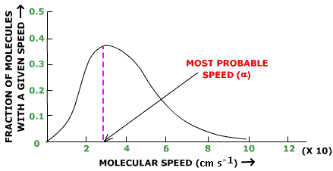
The kinetic molecular theory along with Boltzmann distribution can explain various gas laws.

2. Boyle’s- When the volume is decreased the particles are squeezed together and have a greater opportunity to collide with the walls of the container creating greater pressure.

3. Charles’ – When the temperature is increased the particles move with greater velocity and they collide with the walls with more force. Remember that pressure must be kept constant in this law. In order to keep the pressure from increasing, the volume increases to compensate.
Approximation of Absolute Zero and Charles’ Law
Volume (ml) | Temperature (K)
25 | 250
30 | 300
35 | 350
40 | 400
45 | 450

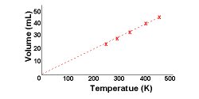

Can you figure out why this is just an approximation?

4. Gay- Lussac- when the temperature increases the particles are moving faster and they hit the walls of the container with more force, thus increasing the pressure.

5. Temperature is the average kinetic energy of the particles of gas in a sample. Therefore some are moving faster than others.
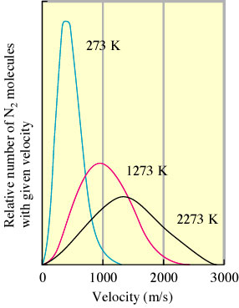
Maxwell Boltzmann Distribution Curve
Increasing the temperature will increase the velocity and shift the curve to the right.

Notice as the temperature increases more particles have high velocity.

5. Root Mean Square Velocity- an average of the velocities of the gas particles in a sample at a certain temperature. Remember temperature is the average kinetic energy of the particles
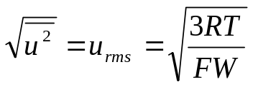
R = 8.3145 J/k-mol T= Temperature in Kelvin FW = Molar Mass in KILOGRAMS

Exercise 19 Root Mean Square Velocity
Calculate the root mean square velocity for the atoms in a sample of helium gas at 25ºC.

1.36 x 10³ m/s
6. Diffusion- the mixing of gases.
Effusion- the passage of gas particles through a small opening.
Rate of Effusion – the speed at which particles move through the opening.
The rates of effusion of two gases are inversely proportional to the square roots of their molar masses at the same temperature and pressure.
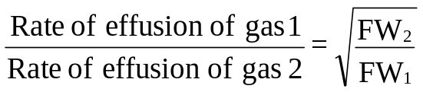
Heavy particles – slow
Light particles – fast
Exercise 20 Effusion Rates
Calculate the ratio of the effusion rates of hydrogen gas (H₂) and uranium hexafluoride (UF₆), a gas used in the enrichment process to produce fuel for nuclear reactors.

13.2

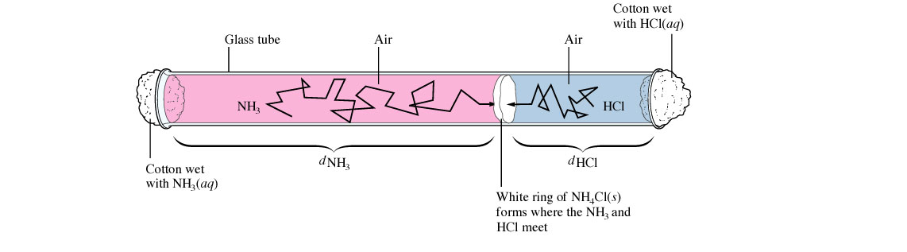

Distance traveled by NH₃ = u_{rms}for NH₃ 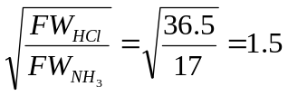 =
Distance traveled by HCl u_{rms} for HCl

7. Ideal v. Real Gases- All experiments were bases on ideal gases, which like a perfect world, don’t exist. We can approximately ideal gases by manipulating real gases.

High Temperature- at low temperatures, the particles move closer to each other and start to interact. A gas deviates the most from ideal behavior when it is close to its condensation point.

Low Pressure- means the gas isn’t compressed and the particles don’t get close enough to interact (ie. Low attractive forces)

Low Molar Mass and Non-polarity are the conditions that come the closest to making a real gas ideal.

Deviations from ideal behavior are due to intermolecular attractions among gas molecules. These forces are very distance-dependent. The closer the particles, the more frequent the collisions, the greater the deviation.

8. Van der Waals Equation- Corrects for flaws in KMT and gases. Not necessary to solve the equation. Just know which part corrects for which flaw. Corrects Pressure Corrects Volume
