# Supernova Chemistry

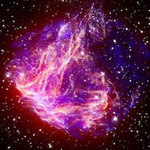

### Introduction

Atomic spectroscopy is an extremely important tool for scientists. Because the electron patterns around every kind of atom are unique, and because these electrons interact with light in different ways because of their different positions, you can determine what kinds of atoms are present in a substance by the kind of light absorbed or emitted by the substance. Every atom has a kind of "fingerprint" in the normal light spectrum that is measured with a device called a Spectrometer. This instrument uses a diffraction grating as a prism, splitting the incoming light into its composite colors.

As an example, a marine ecologist may suspect that the reason many bottom dwelling organisms are dying in a local harbor is because of a chemical pollutant. She samples the mud and chemically extracts a type of metal ion, but she’s not sure what kind of metal it is. She injects the metal ions into the hot flame of an atomic emission spectrometer and observes two line spectra. The lines correspond to the wavelengths of 563 nanometers (nm) and 615 nm. This combination is the "fingerprint" for tin. The ecologist may then trace the tin to a particular type of ship's paint or a nearby industrial source.

In this lab, your task is a bit easier than separating metal ions from sea mud. You are observing various light sources including tubes that have been filled with various types of gases. As electricity passes through these tubes, the gas glows and light is given off. You will compare the spectra of these gas tubes with incandescent (regular light bulb) sources and fluorescent light fixtures. Specifically, you will be asked to identify the gas that is used to fill fluorescent light tubes.