**Work Breakdown Structure (WBS)**

**Apelo Dental Clinic System**

**Apelo Dental Clinic**

**203 Dr. Arcadio santos Avenue,**

**Parañaque City, 1700**

**April 20, 2023**

# Introduction

The Work Breakdown Structure presented here represents all the work required to complete this project.

# Outline View

1. ADENICSY
   1. Initiation
      1. Evaluation & Recommendations
      2. Develop Project Charter
      3. *Deliverable:* Submit Project Charter
      4. Project Sponsor Reviews Project Charter
      5. Project Charter Signed/Approved
   2. Planning
      1. Create Preliminary Scope Statement
      2. Determine Project Team
      3. Project Team Kickoff Meeting
      4. Develop Project Plan
      5. Submit Project Plan
      6. *Milestone:* Project Plan Approval
   3. Execution
      1. Project Kickoff Meeting
      2. Verify & Validate User Requirements
      3. Design System
      4. Procure Hardware/Software
      5. Install Development System
      6. Testing Phase
      7. Install Live System
      8. User Training
      9. Go Live
   4. Control
      1. Project Management
      2. Project Status Meetings
      3. Risk Management
      4. Update Project Management Plan
   5. Closeout
      1. Audit Procurement
      2. Document Lessons Learned
      3. Update Files/Records
      4. Gain Formal Acceptance
      5. Archive Files/Documents

# Hierarchical Structure

|  |  |  |
| --- | --- | --- |
| Level | WBS Code | Element Name |
| 1 | 1 | ADENICSY |
| 2 | 1.1 | Initiation |
| 3 | 1.1.1 | Evaluation & Recommendations |
| 3 | 1.1.2 | Develop Project Charter |
| 3 | 1.1.3 | Deliverable: Submit Project Charter |
| 3 | 1.1.4 | Project Sponsor Reviews Project Charter |
| 3 | 1.1.5 | Project Charter Signed/Approved |
| 2 | 1.2 | Planning |
| 3 | 1.2.1 | Create Preliminary Scope Statement |
| 3 | 1.2.2 | Determine Project Team |
| 3 | 1.2.3 | Project Team Kickoff Meeting |
| 3 | 1.2.4 | Develop Project Plan |
| 3 | 1.2.5 | Submit Project Plan |
| 3 | 1.2.6 | Milestone: Project Plan Approval |
| 2 | 1.3 | Execution |
| 3 | 1.3.1 | Project Kickoff Meeting |
| 3 | 1.3.2 | Verify & Validate User Requirements |
| 3 | 1.3.3 | Design System |
| 3 | 1.3.4 | Procure Hardware/Software |
| 3 | 1.3.5 | Install Development System |
| 3 | 1.3.6 | Testing Phase |
| 3 | 1.3.7 | Install Live System |
| 3 | 1.3.8 | User Training |
| 3 | 1.3.9 | Go Live |
| 2 | 1.4 | Control |
| 3 | 1.4.1 | Project Management |
| 3 | 1.4.2 | Project Status Meetings |
| 3 | 1.4.3 | Risk Management |
| 3 | 1.4.4 | Update Project Management Plan |
| 2 | 1.5 | Closeout |
| 3 | 1.5.1 | Audit Procurement |
| 3 | 1.5.2 | Document Lessons Learned |
| 3 | 1.5.3 | Update Files/Records |
| 3 | 1.5.4 | Gain Formal Acceptance |
| 3 | 1.5.5 | Archive Files/Documents |

# Tabular View

|  |  |  |
| --- | --- | --- |
| Level 1 | Level 2 | Level 3 |
| 1 ADENICSY | 1.1 Initiation | 1.1.1 Evaluation & Recommendations  1.1.2 Develop Project Charter  1.1.3 Deliverable: Submit Project Charter  1.1.4 Project Sponsor Reviews Project Charter  1.1.5 Project Charter Signed/Approved |
| 1.2 Planning | 1.2.1 Create Preliminary Scope Statement  1.2.2 Determine Project Team  1.2.3 Project Team Kickoff Meeting  1.2.4 Develop Project Plan  1.2.5 Submit Project Plan  1.2.6 Milestone: Project Plan Approval |
| 1.3 Execution | 1.3.1 Project Kickoff Meeting  1.3.2 Verify & Validate User Requirements  1.3.3 Design System  1.3.4 Procure Hardware/Software  1.3.5 Install Development System  1.3.6 Testing Phase  1.3.7 Install Live System  1.3.8 User Training  1.3.9 Go Live |
| 1.4 Control | 1.4.1 Project Management  1.4.2 Project Status Meetings  1.4.3 Risk Management  1.4.4 Update Project Management Plan |
| 1.5 Closeout | 1.5.1 Audit Procurement  1.5.2 Document Lessons Learned  1.5.3 Update Files/Records  1.5.4 Gain Formal Acceptance  1.5.5 Archive Files/Documents |

# Tree Structure View

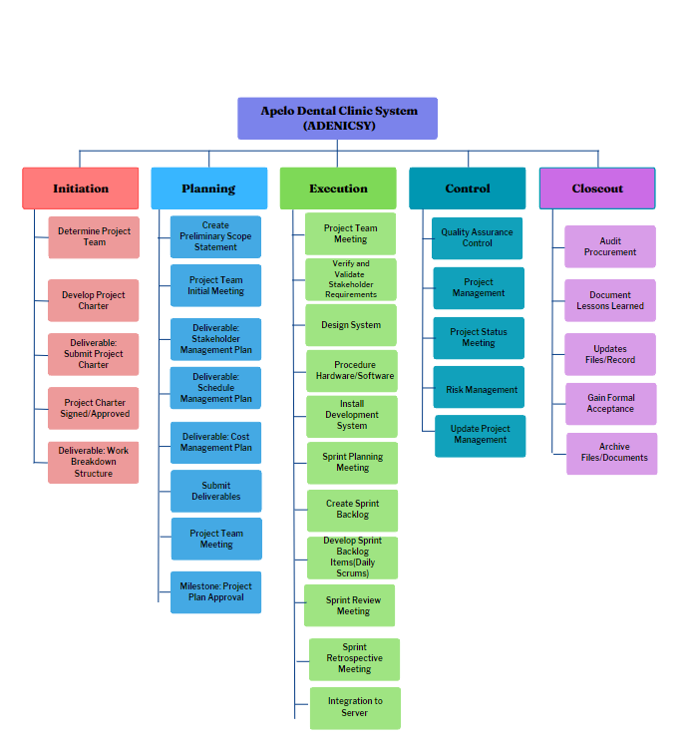

# WBS Dictionary

| Level | WBS Code | Element Name | Definition | Duration |
| --- | --- | --- | --- | --- |
| 1 | 1 | ADENICSY | All work to implement a new widget management system. | 28 days |
| 2 | 1.1 | Initiation | The work to initiate the project. | 2 days |
| 3 | 1.1.1 | Evaluation & Recommendations | Working group to evaluate solution sets and make recommendations. | 7 days |
| 3 | 1.1.2 | Develop Project Charter | Project Manager to develop the Project Charter. | 10 days |
| 3 | 1.1.3 | Deliverable: Submit Project Charter | Project Charter is delivered to the Project Sponsor. | 1 day |
| 3 | 1.1.4 | Project Sponsor Reviews Project Charter | Project sponsor reviews the Project Charter. | 1 day |
| 3 | 1.1.5 | Project Charter Signed/Approved | The Project Sponsor signs the Project Charter which authorizes the Project Manager to move to the Planning Process. | 1 day |
| 2 | 1.2 | Planning | The work for the planning process for the project. | 21 days |
| 3 | 1.2.1 | Create Preliminary Scope Statement | Project Manager creates a Preliminary Scope Statement. | 5 days |
| 3 | 1.2.2 | Determine Project Team | The Project Manager determines the project team and requests the resources. | 14 days |
| 3 | 1.2.3 | Project Team Kickoff Meeting | The planning process officially started with a project kickoff meeting including the Project Manager, Project Team, and Project Sponsor (optional). | 7 days |
| 3 | 1.2.4 | Develop Project Plan | Under the direction of the Project Manager the team develops the project plan. | 7 days |
| 3 | 1.2.5 | Submit Project Plan | Project Manager submits the project plan for approval. | 3 days |
| 3 | 1.2.6 | Milestone: Project Plan Approval | The project plan is approved, and the Project Manager has permission to proceed to execute the project according to the project plan. | 3 days |
| 2 | 1.3 | Execution | Work involved executing the project. | 14 days |
| 3 | 1.3.1 | Project Kickoff Meeting | Project Manager conducts a formal kick off meeting with the project team, project stakeholders and project sponsor. | 2 days |
| 3 | 1.3.2 | Verify & Validate User Requirements | The original user requirements are reviewed by the project manager and team, then validated with the users/stakeholders. This is where additional clarification may be needed. | 7 days |
| 3 | 1.3.3 | Design System | The technical resources design the new widget management system. | 21 days |
| 3 | 1.3.4 | Procure Hardware/Software | The procurement of all hardware, software and facilities needed for the project. | 25 days |
| 3 | 1.3.5 | Install Development System | Team installs a development system for testing and customizations of user interfaces. | 10 days |
| 3 | 1.3.6 | Testing Phase | The system is tested with a select set of users. | 14 days |
| 3 | 1.3.7 | Install Live System | The actual system is installed and configured. | 10 days |
| 3 | 1.3.8 | User Training | All users are provided with a four-hour training class. Additionally, managers are provided with an additional two-hour class to cover advanced reporting. | 14 days |
| 3 | 1.3.9 | Go Live | System goes live with all users. | 2 days |
| 2 | 1.4 | Control | The work involved the control process of the project. | 3 days |
| 3 | 1.4.1 | Project Management | Overall project management for the project. | 2 days |
| 3 | 1.4.2 | Project Status Meetings | Weekly team status meetings. | 7 days |
| 3 | 1.4.3 | Risk Management | Risk management efforts as defined in the Risk Management Plan. | 3 days |
| 3 | 1.4.4 | Update Project Management Plan | Project Manager updates the Project Management Plan as the project progresses. | 5 days |
| 2 | 1.5 | Closeout | The work to close-out the project. | 2 days |
| 3 | 1.5.1 | Audit Procurement | An audit of all hardware and software procured for the project ensures that all procured products are accounted for and in the asset management system. | 3 days |
| 3 | 1.5.2 | Document Lessons Learned | The Project Manager and the team perform a lesson-learned meeting and document the lessons learned for the project. | 1 day |
| 3 | 1.5.3 | Update Files/Records | All files and records are updated to reflect the widget management system. | 10 days |
| 3 | 1.5.4 | Gain Formal Acceptance | The Project Sponsor formally accepts the project by signing the acceptance document included in the project plan. | 4 days |
| 3 | 1.5.5 | Archive Files/Documents | All project related files and documents are formally archived. | 4 days |

# Glossary of Terms

Level of Effort: Level of Effort (LOE) is how much work is required to complete a task.

WBS (Work Breakdown Structure) Code: A unique identifier assigned to each element in a Work Breakdown Structure for the purpose of designating the element's hierarchical location within the WBS.

Work Package: A Work Package is a deliverable or work component at the lowest level of its WBS branch.

WBS Component: A component of a WBS located at any level. It can be a Work Package or a WBS Element as there is no restriction on what a WBS Component is.

WBS Element: A WBS Element is a single WBS component, and its associated attributes are located anywhere within a WBS. A WBS Element can contain work, or it can contain other WBS Elements or Work Packages.