Change Management Plan

**Rams E-Caf**

**Asia Pacific College Humabon 3, Makati Kalakhang Maynila**

**March 12, 2023**

**Table of Contents**

Introduction 2

Change Management Approach 2

Definitions of Change 2

Change Control Board 3

Roles and Responsibilities 4

Change Control Process 4

**INTRODUCTION**

The Rams E-Caf project aims to introduce an alternative online ordering system for the APC cafeteria. The project involves significant changes to the current traditional ordering system used by customers and food concessionaires. These changes require careful planning and execution to ensure successful adoption by all stakeholders. The change management plan outlines the strategies and actions that will be taken to manage the transition from the traditional to the alternative ordering system, including communication, training, and support to all stakeholders. By implementing an effective change management plan, the project team can minimize resistance to change and maximize the chances of success for the project.

**CHANGE MANAGEMENT APPROACH**

The change management approach for the Rams E-Caf project will involve the following steps:

1. Change Request Submission: Any change requests should be submitted through the project management team. Change requests may come from any stakeholder including the project team, sponsors, vendors, or customers.
2. Change Request Review: The project management team will review all change requests to determine the impact on the project scope, schedule, and budget. The review will be completed by the project manager, technical leads, and other key stakeholders.
3. Change Request Approval: Once a change request has been reviewed, it will be approved or rejected. If approved, the change will be documented and implemented.
4. Change Request Implementation: The project team will implement approved changes as quickly as possible without sacrificing quality. Any changes to the project plan will be communicated to all stakeholders.
5. Change Request Documentation: All approved changes will be documented in the project plan and other relevant project documents. This documentation will be used to track changes and report on the impact of those changes.
6. Change Request Tracking: The project management team will track all change requests and their status throughout the project lifecycle. This will ensure that all changes are properly documented, implemented, and tracked.
7. Change Request Closure: Once a change request has been implemented, it will be closed. All documentation related to the change will be updated and the change will be communicated to all stakeholders.

By following this approach, the Rams E-Caf project team will be able to manage changes effectively and ensure that any changes to the project are properly reviewed, approved, and implemented. The approach will also ensure that all stakeholders are kept informed of any changes and their impact on the project.

**DEFINITIONS OF CHANGE**

Changes are inevitable in any project, and Rams E-Caf project is no exception. The following are the types of changes that may be requested and considered for the project:

* + Schedule Change: This change is related to the project timeline or deadlines. This type of change may be necessary if unforeseen circumstances arise, such as the unavailability of a key team member or delays in the delivery of materials.
  + Budget Change: This change is related to the project budget. The budget may need to be adjusted if there are unforeseen expenses or if the scope of the project changes.
  + Scope Change: This change is related to the project scope. The scope may need to be adjusted if new requirements arise, or if there are changes to the project objectives or goals.
  + Project Document Changes: This change is related to any changes in the project documentation, including project plans, requirements, specifications, and other project-related documents.

All types of changes will be considered by the project team and reviewed by the project manager and the change control board before a decision is made. Any changes that are approved will be documented, and all stakeholders will be notified of the change. It is important to note that any changes to the project will have an impact on other areas of the project, and these impacts must be considered before any changes are approved.

**CHANGE CONTROL BOARD**

The Change Control Board (CCB) for the Rams E-Caf project will be responsible for reviewing and approving or rejecting all proposed changes to the project. The CCB's primary objective is to ensure that any changes made to the project are consistent with the project's objectives, scope, and constraints, and to minimize the impact of these changes on the project's timeline, budget, and quality.

|  |  |  |
| --- | --- | --- |
| **Name** | **Position** | **CCB Role** |
| Bernadette Sison (APC Center) | Rams E-Caf Project Sponsor | CCB Chair |
| Corneliani Melo | Rams E-Caf Project Manager | CCB Member |
| Jamir Sia | Rams E-Caf Technical Lead | CCB Co-Chair |
| Corneliani Melo | Rams E-Caf Project Operations Lead | CCB Member |

The CCB will review proposed changes regularly, and decisions will be made by consensus. If consensus cannot be reached, the project manager will make the final decision. All decisions and actions taken by the CCB will be documented in the project's change management plan, and all stakeholders will be informed of the decisions and actions taken.

**ROLES AND RESPONSIBILITIES**

Roles and Responsibilities for Change Management Process: Role: Project Manager Responsibilities:

* + Develop and manage the change management plan.
  + Ensure all changes are properly documented and tracked.
  + Ensure changes are reviewed and approved by the change control board.
  + Ensure changes are implemented as approved.
  + Communicate changes to project stakeholders. Role: Change Control Board Members Responsibilities:
  + Review proposed changes and provide approval or rejection.
  + Evaluate the impact of proposed changes on the project.
  + Ensure changes align with project goals and objectives.
  + Provide guidance and support to project team members regarding changes. Role: Project Team Members Responsibilities:
  + Identify potential changes and submit requests for changes.
  + Provide information on the impact of proposed changes on project scope, schedule, and budget.
  + Assist in evaluating the impact of proposed changes.
  + Implement approved changes.
  + Communicate changes to stakeholders. Role: Project Sponsor Responsibilities:
  + Review and approve changes that require sponsor approval.
  + Provide guidance and support to the change control board and project team regarding changes.
  + Ensure changes align with overall project goals and objectives.
  + Communicate changes to senior management and other stakeholders as appropriate.

**CHANGE CONTROL PROCESS**

Change Control Process for Rams E-Caf Project:

1. Identify the Change: Any member of the project team may identify the need for a change. The individual should document the request in the change request form, which includes details such as the reason for the change, the impact on the project, and the proposed solution.
2. Evaluate the Change: The Project Manager and the Change Control Board will evaluate the change request to determine its feasibility, impact, and urgency. They will analyze the potential impact of the change on the project, including its effect on cost, schedule, scope, quality, and risk.
3. Review and Approve: If the change is approved, the Project Manager will update the project plan and schedule, assign resources as needed, and communicate the change to all stakeholders. If the change is not approved, the requestor will be informed of the decision, and the request will be closed.
4. Implement the Change: Once the change is approved, the Project Manager will work with the project team to implement the change. This may include modifying project deliverables, updating project documentation, and communicating the change to stakeholders.
5. Verify the Change: The Project Manager and the Change Control Board will review the implementation of the change to ensure that it was completed according to the approved plan. They will verify that the change has achieved the intended results and that it has not had any adverse effects on the project.
6. Close the Change Request: The Project Manager will update the project documentation to reflect the change and close the change request. The change request form and all supporting documentation will be stored in the project repository for future reference.

**Sponsor Acceptance**

Approved by the Project Sponsor:

Bernadette L. Sison Staff at APC Center

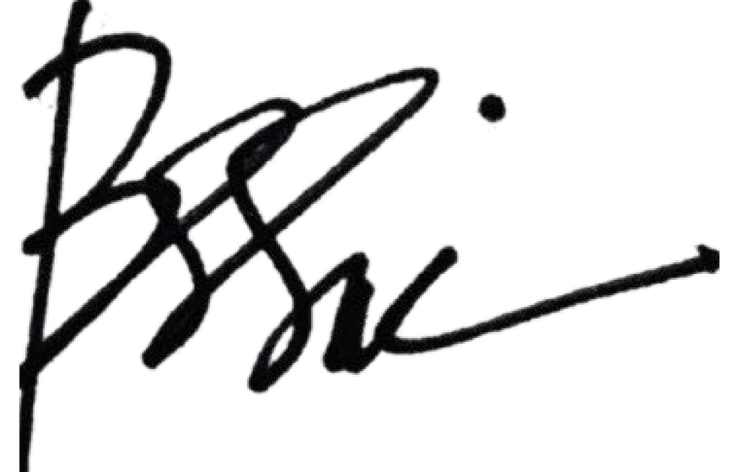

Date:

13 March 2023