**Stakeholder Management Strategy**

**Manpower Allocation and Planning System (MAPS)**

**Traves Maintenance and Services Incorporated**

**90b Stanford st., Brgy E.Rodriguez,**

**Cubao, QC**

**05/09/2023**

**Table of Contents**

1. Introduction 3

2. Identify Stakeholders 3

3. Key Stakeholders 4

4. Stakeholder Analysis 5

# Introduction

The Stakeholder Management Strategy is a crucial component of the project management approach for the implementation of the web-based system at Traves Maintenance and Services Incorporated. Effectively managing stakeholders is essential for the success of any project and should never be overlooked. It allows for gaining support, anticipating potential challenges, and addressing conflicts or competing objectives among stakeholders.

The goals and objectives of the Stakeholder Management Strategy are to ensure that all stakeholders are identified, engaged, and managed throughout the project's lifecycle. By doing so, the project team aims to:

**Gain Support:** Engaging stakeholders from the early stages of the project helps build support and buy-in for the proposed web-based system. By involving stakeholders in the decision-making process and addressing their concerns, the project team can foster a sense of ownership and commitment to the project's success.

**Anticipate Resistance:** Identifying potential sources of resistance or opposition among stakeholders is crucial for effective project management. By understanding stakeholders' perspectives, concerns, and competing objectives, the project team can proactively address these issues and mitigate potential conflicts that may arise during the implementation phase.

**Manage Expectations:** Stakeholders often have different expectations and requirements from a project. The Stakeholder Management Strategy aims to identify and understand these expectations, ensuring that they are effectively managed and aligned with the project's objectives. Clear communication and regular updates help manage stakeholder expectations and minimize misunderstandings.

**Foster Collaboration:** Effective stakeholder management promotes collaboration and cooperation among different stakeholder groups. By creating a platform for open communication, the project team can encourage stakeholders to work together towards a common goal, enhancing the overall success of the project.

**Mitigate Risks:** Stakeholder management helps identify potential risks and challenges that may impact the project's success. By actively engaging stakeholders, the project team can anticipate and address these risks, minimizing their impact and ensuring a smoother project implementation.

Proper stakeholder management is a fundamental aspect of project management, and its importance cannot be overstated. By implementing a robust Stakeholder Management Strategy, Traves Maintenance and Services Incorporated can navigate potential obstacles, gain stakeholder support, and ensure the successful implementation of the web-based system.

# Identify Stakeholders

The identification of stakeholders is a critical step in the Stakeholder Management Strategy for the successful implementation of the web-based system at Traves Maintenance and Services Incorporated. The project team will employ a comprehensive methodology to ensure that all stakeholders, regardless of their significance, are identified and categorized appropriately. This approach is crucial as omitting stakeholders can lead to unforeseen obstacles and delays during the project's lifecycle.

The methodology for stakeholder identification will involve the following steps:

**Stakeholder Mapping:** The project team will conduct a thorough analysis of the company's internal and external environment to identify individuals, groups, or organizations that have a vested interest in or are affected by the project. This mapping exercise will help identify stakeholders from various departments, such as management, employees, clients, developers, suppliers, shareholders, regulatory authorities, competitors, and the local community.

**Stakeholder Definition:** Once stakeholders are identified, the project team will define each stakeholder's role, influence, and level of interest in the project. This will help categorize stakeholders based on their importance and impact on the project's success. Stakeholders will be classified as primary stakeholders (directly affected by the project), secondary stakeholders (indirectly affected), or key stakeholders (with significant influence or interest).

**Stakeholder Engagement:** After stakeholders are identified and categorized, the project team will develop a tailored approach to engage and communicate with each stakeholder group. This may involve regular meetings, feedback sessions, surveys, or other communication channels to ensure that stakeholders are informed, involved, and supportive of the project's objectives.

**Continuous Monitoring:** Stakeholder identification is an ongoing process throughout the project's lifecycle. The project team will continuously monitor and reassess stakeholders to identify any new stakeholders that may emerge or changes in stakeholder dynamics. This will help address any evolving needs, concerns, or expectations and ensure effective stakeholder management throughout the project.

Great care and effort will be dedicated to this step of the Stakeholder Management Strategy to ensure that all stakeholders are identified, regardless of their significance. By employing a comprehensive methodology, Traves Maintenance and Services Incorporated can proactively manage stakeholder expectations, address concerns, and mitigate potential obstacles that may arise during the implementation of the web-based system.

# Key Stakeholders

In the context of the project to develop a web-based system for Traves Maintenance and Services Incorporated, several key stakeholders have been identified. These stakeholders have been determined to be key due to their potential influence over the project and the impact the project may have on them. Additionally, their involvement and feedback are crucial for effective communication and management throughout the project's lifecycle.

The key stakeholders for this project include:

1. **Company Owner:** The owner of Traves Maintenance and Services Incorporated is a key stakeholder as they have a vested interest in the success and profitability of the company. They will benefit from the improved efficiency of the business process and the potential for expansion and increased client base.
2. **Management Team:** The management team, including the supervisor and coordinators, are key stakeholders as they are responsible for overseeing the daily operations and scheduling of technicians. The web-based system will greatly assist them in manpower allocation, planning, and task delegation, leading to improved communication and performance.
3. **Technicians:** The technicians themselves are key stakeholders as they will be directly impacted by the implementation of the web-based system. The system will provide them with clear assignments, schedules, and job progress tracking, making their jobs more manageable and planned.
4. **Clients:** Rely on Traves for maintenance and services. A more efficient Traves supports reliable service delivery.

**Stakeholder Register / Profile**

|  |  |  |  |  |
| --- | --- | --- | --- | --- |
| Name | Position | Internal/External | Project  Role | Contact Information |
| Romel Espineda | President | Internal | Project Sponsor | [respineda28@yahoo.com](mailto:respineda28@yahoo.com) |
| Raymond Pacia | Supervisor | Internal | Internal user of the system | [travesmain@gmail.com](mailto:travesmain@gmail.com) |
| Traves  Coordinators | Coordinators | Internal | Internal user of the system | [travesmain@gmail.com](mailto:travesmain@gmail.com) |
| Traves Technicians | Technicians | Internal | Internal user of the system | [travesmain@gmail.com](mailto:travesmain@gmail.com) |
| Traves  Contractee | Traves Client | External | Potential External user of the system | none |

# 

# Stakeholder Analysis

By conducting this analysis, the project team can identify key stakeholders, understand their level of influence and power, and assess their potential impact on the project. This stakeholder analysis is crucial to understand the impact each stakeholder may have on the project's success. Identified stakeholders, the project team will categorize and group them based on their level of power, influence, and involvement in the project.

**Stakeholder Analysis**

|  |  |  |  |
| --- | --- | --- | --- |
| Name | Power/Interest | Current Engagement | Potential Management Strategies |
| Romel Espineda | High/High | Supportive | Romel is very obliging and agreeable. He does not ask frequently but he likes to be updated about the current progress. Always communicate the project’s progress and keep him updated with development in order to keep him informed and engaged. |
| Raymond Pacia | High/Low | Neutral | Raymond is experienced with managing the employees and their current system. It would be in in everyone’s advantage to make him aware of the possible changes will help him be on top of managing and communicating with him will help generate insights that would be helpful to the project. |
| Traves  Coordinators | Low/High | Neutral | They coordinate with the clients and also micromanage tasks that are needed by the technicians and supervisor. They should be made aware about the project’s development to make them adjust and adapt to it early. They can also help generate ideas that will help the project. |
| Traves  Technicians | Low/Low | Neutral | They are deployed for the services. It would be necessary to let them know about the project’s development to familiarize them. |
| Traves Contractee | High/Low | Neutral | They are the main client of the company who takes Traves as a contractor. Notifying them about the project would be discreet and to one’s advantage for future references. |

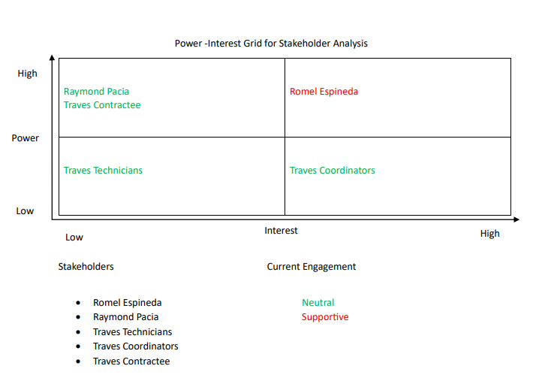

**Sponsor Acceptance**



Approved by the Project Sponsor:

Date: September 12, 2023

Romel Espineda

Traves Maintenance and Services Incorporated President