Periodic Topological Deep Learning for Polymer Design and Discovery
Speaker: Yasharth Yadav

Division of Mathematical Sciences, School of Physical and Mathematical Sciences, Nanyang Technological University, 50 Nanyang Avenue, Singapore 639798

Keywords: Topological Deep Learning, Simplicial Message Passing, Polymer Informatics, Structure-Property Relationships

Extended Abstract
Motivation. Molecular machine learning has largely relied on graph representations, with atoms as nodes and covalent bonds as edges. While effective, graphs are inherently restricted to pairwise interactions and cannot directly encode many-body structural relationships among three or more atoms. Topological deep learning (TDL) addresses this limitation by extending message passing from graphs to richer topological domains, such as simplicial complexes, cell complexes, sheaves and hypergraphs, enabling information exchange between objects of different dimensions and allowing molecular representations to incorporate higher-order structural information. These capabilities have shown promise in molecular property prediction. However, unlike small molecules with fixed structures, polymers are periodic chains of repeating chemical subunits that can extend to macromolecular length scales, with properties governed by both local chemistry and structural relationships across adjacent repeat units. Existing TDL frameworks can capture higher-order structure but treat polymers as finite molecular fragments and do not incorporate their periodic nature. This gap motivates a polymer-specific TDL framework that jointly encodes periodic chain structure, many-body interactions, and multi-scale spatial relationships.

Approach and Methodology. Here we introduce Periodic-TDL, a framework that captures both periodicity and higher-order interactions across multiple spatial scales. At its core is the periodic Vietoris–Rips complex representation of polymers, which encodes interactions between atoms across adjacent repeating units under periodic boundary conditions, representing both covalent and non-covalent interactions through higher-dimensional simplices. To learn from this representation, we develop the Hierarchical Simplicial Message Passing (HSMP) encoder, which operates over a nested filtration of simplicial complexes and propagates information from coarser to finer scales in a chemically motivated direction. At its finest filtration level, HSMP reduces to a standard molecular graph, enabling direct integration into established self-supervised pretraining pipelines designed for conventional graph encoders. This compatibility is particularly valuable given the scarcity of labelled polymer data. To equip higher-order simplices with meaningful features, we further introduce curvature-based featurization using Forman's discretization of Ricci curvature, which generalizes naturally to simplices of any dimension.

Results. Pretrained on one million unlabelled polymers and finetuned on nine labelled datasets, Periodic-TDL achieves state-of-the-art performance across electronic, optical, physical, and thermal polymer properties. Beyond predictive accuracy, we assessed the chemical credibility of the model by testing whether the predicted trends are consistent with established structure-property relationships. We examined the effects of ester-to-amide substitution and alpha-methylation on the glass transition temperature of acrylate- and acrylamide-based polymers. Periodic-TDL predicts that (meth)acrylamides exhibit higher glass transition temperature than their corresponding (meth)acrylate, and that methacrylates and methacrylamides exhibit higher glass transition temperature than the corresponding acrylates and acrylamides, respectively. Both trends were confirmed using eight literature-reported and three independently synthesized polymers absent from the training set.

Conclusions and Outlook. A distinctive feature of Periodic-TDL is its integration of multiscale interactions across filtration levels. Existing deep learning frameworks that incorporate filtration typically treat each cutoff independently and obtain a final molecular representation by pooling and concatenating features across cutoffs. In contrast, the HSMP encoder processes all cutoffs within a unified hierarchical pipeline. Information propagates from coarser to finer spatial scales through cross-scale refinement, such that atom and bond representations at the covalent scale already incorporate contributions from higher-order simplices and long-range interactions. This design preserves compatibility with established graph-based pretraining workflows, allowing HSMP to replace conventional graph encoders without requiring new pretraining objectives. To our knowledge, this work is also the first to incorporate discrete curvature into a TDL framework. In particular, Forman-Ricci curvature provides a principled initial signal for simplices of any dimension, which is necessary for message passing to operate meaningfully on higher-order topological domains.

References
- Debra J Audus and Juan J de Pablo. Polymer informatics: opportunities and challenges. ACS macro letters, 6(10):1078–1082, 2017.
- Matteo Aldeghi and Connor W. Coley. A graph representation of molecular ensembles for polymer property prediction. Chemical Science, 13(35):10486–10498, 2022.
- Theodore Papamarkou, Tolga Birdal, Michael Bronstein, Gunnar Carlsson, Justin Curry, Yue Gao, Mustafa Hajij, Roland Kwitt, Pietro Lio, Paolo Di Lorenzo, et al. Position: Topological deep learning is the new frontier for relational learning. Proceedings of machine learning research, 235:39529, 2024.
- Michael T Schaub, Jean-Baptiste Seby, Florian Frantzen, T Mitchell Roddenberry, Yu Zhu, and Santiago Segarra. Signal processing on simplicial complexes. In Higher-order systems, pages 301–328. Springer, 2022.
- Forman. Bochner’s Method for Cell Complexes and Combinatorial Ricci Curvature. Discrete & Computational Geometry, 29(3):323–374, 2003.

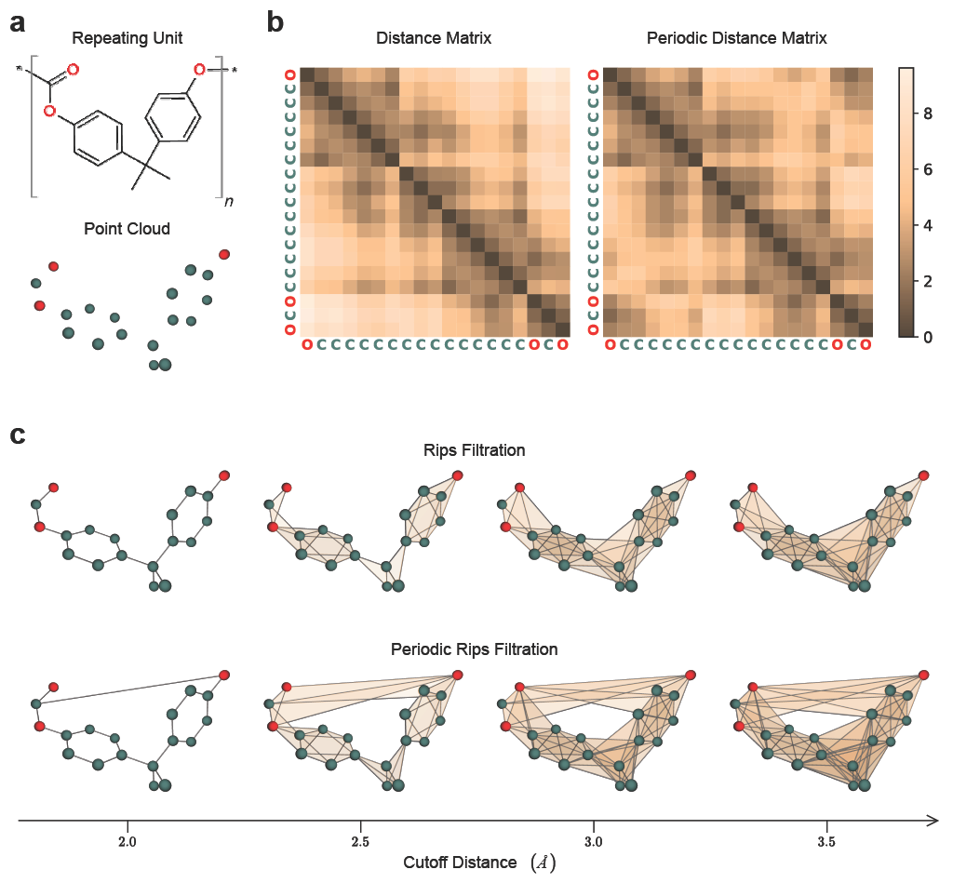
Figure 1. Example of periodic Vietoris-Rips complex representation on poly (bisphenol A carbonate). (a) Repeating unit of poly (bisphenol A carbonate), together with its corresponding three-dimensional atomic point cloud. (b) Pairwise distance matrices computed from a single repeating unit (left, intra-monomer distance matrix) and from its translated copes (right, periodic distance matrix). The periodic distance matrix restores the correct spatial proximity between atoms that lie near the boundaries of a chosen repeating unit but are adjacent in the actual polymer. (c) Comparison of Vietoris–Rips filtration constructed using the intra-monomer distance matrix (top row) and the periodic distance matrix (bottom row) at increasing cutoff distances.

