Understanding Complex Systems via Network, Data, AI
Keywords: Complex systems, Network Science, Data Science, AI, Statistical Physics

Extended Abstract
In this talk, I will present some examples of how different methods (Data science, Network science, AI) are being used to understand complex systems, which are considered to be the challenges of the 21st century.
Specifically, I will explain how network science can be used to discover biological drugs,
how data science can be used to determine the existence of the golden rule in the arts,
and how AI can be used to discover the conservation laws of physics and hidden interaction in the complex system.

References
- P.-J. Kim, D.-Y. Lee, T.Y. Kim, K.H. Lee, H. Jeong, S.Y. Lee, S. Park, "Metabolite essentiality elucidates robustness of Escherichia coli metabolism", Proc. Nat. Acad. Sci. USA. 104 13638 (2007)
- S. Hwang, S.-W. Son, S. C. Kim, Y. J. Kim, H. Jeong, D. Lee, "Protein interaction network associated with asthma" J. Theo. Biology 252 722 (2008)
- B. Lee, M.K. Seo, D. Kim, I.-s. Shin, M. Schich, H. Jeong, and, S. Han, "Dissecting landscape art history with information theory", Proc. Nat. Acad. Sci. USA (2020)
- S. Ha, and H. Jeong, "Discovering invariants via machine learning", Phys. Rev. Res. 3 L042035 (2021)
- S. Ha, and H. Jeong, "Unraveling hidden interactions in complex systems with deep learning", Sci. Rep. 11 12804 (2021)
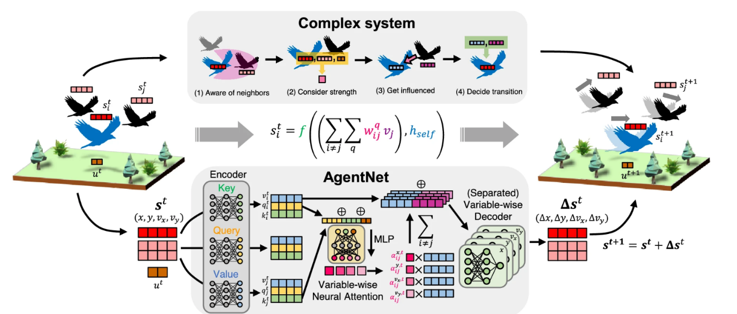

Figure 1. Overview of system formulation and the neural network architecture of the proposed AgentNet

