

A Course End Project Report on
COVID DATA ANALYSER

A9513- Python Programming Laboratory

Submitted by
Athreya Patwari
25881A0574
Medipally Kiran
25881A0590

Course Facilitator

Ms P.S. Madhavi
Assistant Professor
Computer Science and Engineering

Department of Computer Science and Engineering Vardhaman College of Engineering, Hyderabad



Autonomous Institute, Affiliated to JNTUH,
Approved by AICTE, Accredited by NAAC with A++ Grade Kacharam, Shamshabad, Hyderabad- 501 218, Telangana, India.

DEPARTMENT OF COMPUTER SCIENCE AND ENGINEERING

This is to certify that the Course End Project titled “Covid Data Analyser” is carried out by Athreya Patwari , Medipally Kiran with Roll Numbers 25881A0574, 25881A0590 towards A9513 –Python Programming Laboratory course in partial fulfilment of the requirements for the award of degree of Bachelor of Technology in Computer Science and Engineering during the Academic year 2026-27.

Signature of the Course Faculty Ms P.S. Madhavi
Assistant Professor, Computer Science and Engineering
Signature of the HOD
Dr. Y.Vijayalata
Professor, Head of the Department & Dean (Student Mentoring)
Department Computer Science and Engineering,
Vardhaman College of Engineering, Hyderabad

Contents
- Introduction 3
- Literature Review 4
- Objectives 5
- Methodology 6
  - Architectural Diagram 6
  - Hardware and Software Requirements 7
  - Working Principle 7
  - Software Implementation 9
- Results and Discussion 19
- Mapping POs ,PSOs and SDGs 24
  - Program Outcomes (POs) Mapping 24
  - Sustainable Development Goals (SDGs) Mapping 25
- Conclusion 26
Bibliography 27

Abstract

The COVID-19 Data Analyzer is a Python-based command-line application designed to load, validate, search, analyze, and manage COVID-19 epidemiological data stored in CSV format. The system reads structured records containing date, country, confirmed cases, new cases, recovered cases, deaths, and active cases, and exposes an interactive menu-driven interface that allows users to perform a wide range of data operations without any third-party analytical library.

The backend is structured across four focused Python modules: analyzer.py for statistical computations and data aggregation; file_utils.py for all file I/O including CSV read/write, binary backup (pickle), file copying, and merging; validators.py for regular-expression-based input validation of dates, country names, and numerical fields; and exceptions.py for a custom InvalidCOVIDDataError exception hierarchy. The main.py orchestrates a menu loop that integrates all modules and handles graceful error reporting using try/except/else/finally blocks.

Keywords: COVID-19, Data Analysis, Python, CSV, File Handling, Regular Expressions, Exception Handling, Statistics, Pandemic Data, Command-Line Application.

Introduction

The COVID-19 pandemic generated an unprecedented volume of epidemiological data spanning countries, continents, and time periods. Governments, research institutions, and public-health agencies needed reliable, fast, and programmable tools to parse, validate, and aggregate this data without relying on heavyweight data-science frameworks. A lightweight, well-structured command-line analyzer built on core Python satisfies this need: it is portable, auditable, and easy to extend.
This project builds exactly such a tool. The COVID-19 Data Analyzer reads daily snapshots of confirmed, recovered, death, and active case counts from a CSV file, maps each country to its continent, validates every field against strict rules, and exposes eleven distinct menu options. Users can view tabulated data, add new records interactively, search by country name or regex pattern, validate existing data, perform per-country or per-continent statistical analysis, generate a global summary report, back up and restore data in binary format, copy the data file, and merge two data files into a de-duplicated output.
The project reinforces key Python programming concepts including file I/O, exception handling, regular expressions, lambda-based sorting, recursion, the statistics module, and the pathlib/os/csv/pickle standard libraries. It demonstrates how well-chosen data structures and modular code organisation can produce a robust analytical tool from first principles, making it equally valuable as a learning exercise and as a practical data-management utility.
The remainder of this report details the objectives, methodology, software implementation, results, and conclusions of the COVID-19 Data Analyzer, accompanied by a mapping to relevant Program Outcomes and Sustainable Development Goals.

Literature Review

The COVID-19 pandemic sparked a surge of research into data collection, cleaning, and analysis pipelines. Early epidemiological studies relied on manual spreadsheets, but the scale of the pandemic quickly made automated, programmatic approaches essential. Open datasets such as the Johns Hopkins CSSE repository and Our World in Data made daily case counts globally accessible in CSV format, enabling community-driven tools built in Python, R, and Julia. Research highlighted the importance of data validation pipelines to eliminate negative case counts, missing country identifiers, and inconsistent date formats that could distort analysis.
Studies in data quality management (Rahm & Do, 2000) identified that dirty data can account for up to 30% of analytical errors. The field of exploratory data analysis (EDA), popularised by Tukey (1977), underpins the statistical summaries implemented in this project. Regular-expression-based validation, as described in Friedl's "Mastering Regular Expressions" (2006), provides a principled approach to sanitising free-text fields such as country names. The use of Python's statistics module for mean, max, and min computations reflects best practices for lightweight analytics without external dependencies. Existing COVID-19 command-line tools are often tightly coupled to specific dataset schemas, lack interactive menus, or require pandas/NumPy. This project addresses those gaps with a modular, pure-Python design.
By combining CSV-based persistence, binary backup via pickle, regex search, recursive aggregation, and continent-level rollup statistics, this analyzer provides a comprehensive learning platform that covers a wide spectrum of Python core competencies while delivering genuine analytical utility for COVID-19 time-series data.

Objectives

To design and develop a Python-based COVID-19 data analyzer supporting multiple data operations.

The primary objective of this project is to build a functional and efficient COVID-19 data analyzer using Python. The system reads daily epidemiological records from a CSV file and exposes eleven menu-driven operations including viewing, adding, searching, validating, and analyzing data. It processes records for multiple countries and continents, computing key metrics such as recovery rate, death rate, and share of global cases.

To implement regex-based search, robust input validation, and interactive data entry.
A reliable search and validation subsystem is essential to ensure data integrity and discoverability. This objective focuses on implementing three search modes (exact/partial country name and regex pattern), a validation pipeline that checks date formats, country names, and numerical consistency, and an interactive record-addition workflow with field-level error reporting through the custom InvalidCOVIDDataError exception.

To calculate and compare epidemiological statistics at country, continent, and global levels.

This objective involves computing recovery rate, death rate, average confirmed cases, highest and lowest case counts, and share of world cases for each country and continent. The analyzer aggregates the latest snapshot per country using get_latest_records(), applies lambda-based sorting to rank top countries, and uses recursive summation (recursive_total()) to demonstrate algorithmic alternatives to iterative loops. Results are presented in formatted tables and summary reports.

Methodology

Plan of Implementation

The Menu Layer (main.py) serves as the user-facing interface. It prints an 11-option menu, reads user input, and dispatches control to the appropriate handler function. Each menu option maps to a clearly-named function (view_data, add_record, search_data, etc.) that orchestrates calls to the lower layers and reports results via formatted tabular output using Python f-string alignment.
The Analysis Engine (analyzer.py) forms the system's computational core. It provides pure functions for making records (make_record), filtering by country or continent (filter_by_country, filter_by_continent), computing aggregated statistics (summarize, total_field, recursive_total), finding the latest snapshot per country (get_latest_records), ranking top countries with lambda sorting (top_countries), and calculating percentage rates (calculate_rate). Its stateless, functional design makes it independently testable.
The File I/O Layer (file_utils.py) manages all persistence concerns: reading CSV records with validation of required columns, appending new records, saving all records, backing up to binary pickle format, restoring from backup, copying the data file byte-for-byte, and merging two CSV files while de-duplicating rows. It relies on pathlib.Path for cross-platform file paths and uses the csv module for robust comma-separated value handling.
The Validation Layer (validators.py) enforces data quality using regular expressions. It validates date strings (YYYY-MM-DD), country names (letters and spaces only), continent names (letters, spaces, and slashes), and numeric fields (non-negative integers). The regex_search_country function supports all Python re patterns including anchors, character classes, and alternation, and the highlight helper wraps matches in brackets for visual feedback. All validation errors are raised as InvalidCOVIDDataError (exceptions.py), propagating cleanly through the menu layer.

Hardware and Software Requirements

Hardware:
    - Any modern Intel/AMD/ARM processor (x86-64 or ARM64)
    - Minimum 2 GB RAM (4 GB recommended for large CSV files)
    - Standard display and keyboard (terminal/command-line)

Software:
    - Python 3.9 or later
    - Standard library only: csv, os, pathlib, pickle, re, datetime, statistics
    - Any text editor or IDE (VS Code, PyCharm, Notepad++)

Working Principle

The COVID-19 Data Analyzer operates on a single-loop, menu-driven principle. At startup, ensure_sample_data() prepares the data directory if needed. The main loop then repeatedly prints the eleven-option menu and reads a single character of input. Each option delegates to a handler function that calls file_utils.read_records() to load the latest CSV state, applies the requested operation (analysis, search, validation, or file management), and prints results in a right-aligned tabular format. The loop continues until the user selects option 0 (Exit).

Data flow through the system is linear and stateless: records are read fresh on every menu action, ensuring that any external changes to the CSV file are immediately reflected. When a new record is added, it is appended directly to the CSV using file_utils.append_record(), which opens the file in append mode. Backup and restore operations serialise the in-memory list of record dictionaries with pickle, providing a compact binary checkpoint. File copy and merge operations work at the byte and line level respectively, with merge tracking seen lines in a Python set to eliminate duplicates while preserving a single header row.

Example Data Snapshot (covid_data.csv):

Menu Option: View Data (Option 1)
Sample output (truncated to 4 countries, latest snapshot):
Sample global summary (4 countries, latest snapshot):

- Date Country Continent Confirmed Deaths Recovered Active
- 2020-04-03 USA North America 6,900 165 1,200 5,535

Menu Option: Analyze Country (Option 5)
Sample output for country "India":
- --- Country: India (IND) [Latest: 2020-04-03] ---
- Recovery Rate : 26.92% | Death Rate: 2.31% | Share of All Cases: 14.06%

Menu Option: Generate Summary Report (Option 7)
- Total Confirmed: 21,650 | Total Deaths: 515 | Recovery Rate: 19.49% | Death Rate: 2.38%
- Top 3 by Confirmed: USA (6,900), UK (3,750), India (2,600)

Menu Option: Backup & Restore (Options 8 & 9)
Gantt timeline:
Option 8 serialises all records to data/backup.dat (pickle binary). Option 9 restores them into covid_data.csv, overwriting the current file.
- Backup created: 13 records saved to data/backup.dat
- Restored 13 records into covid_data.csv

Software Implementation

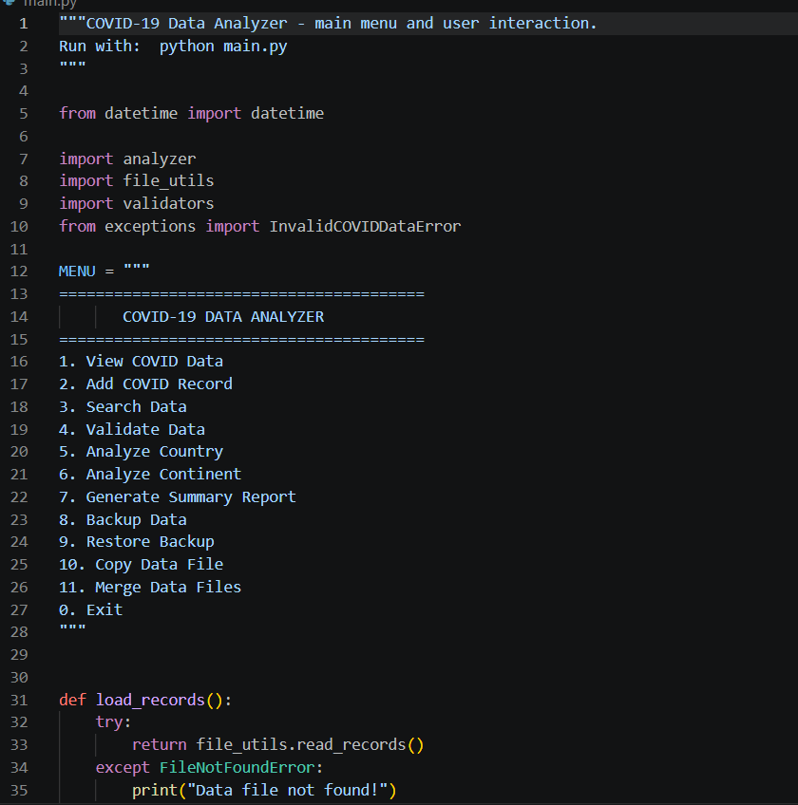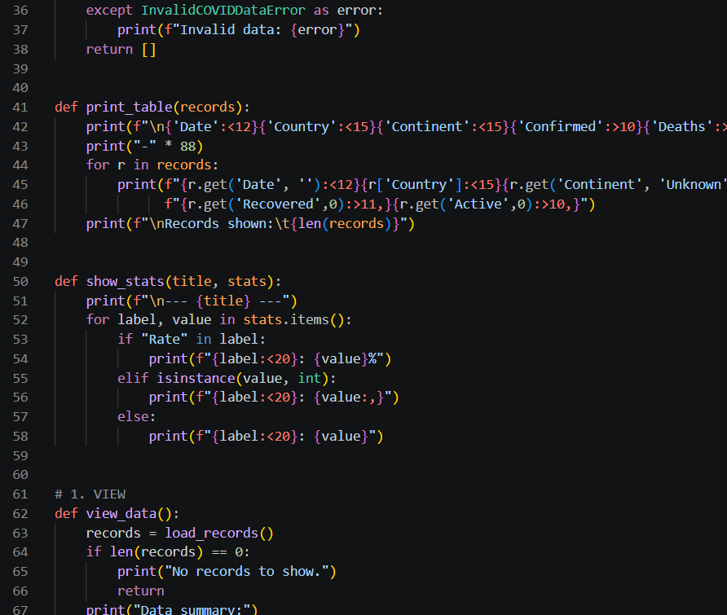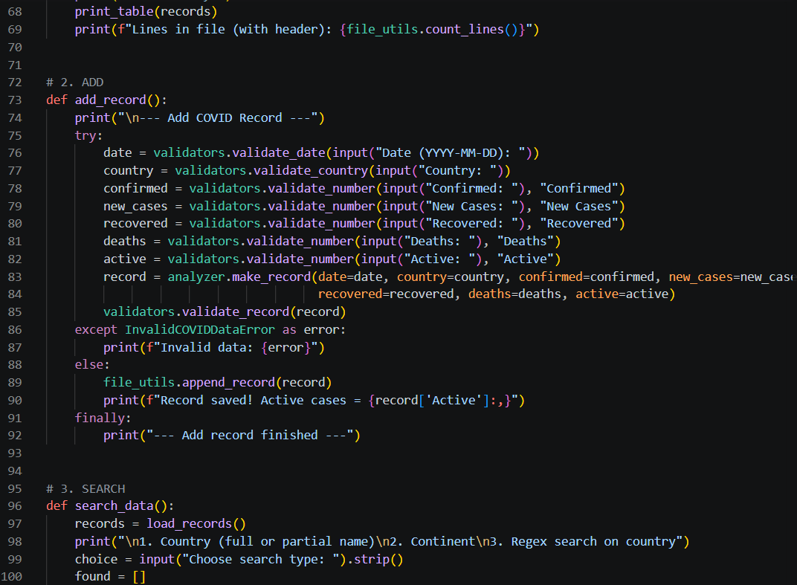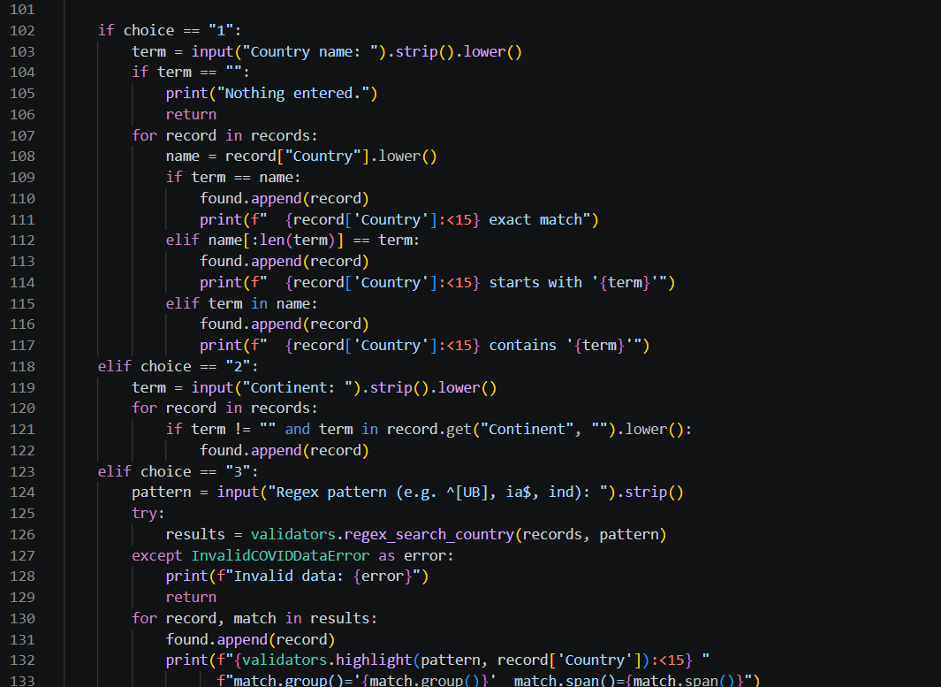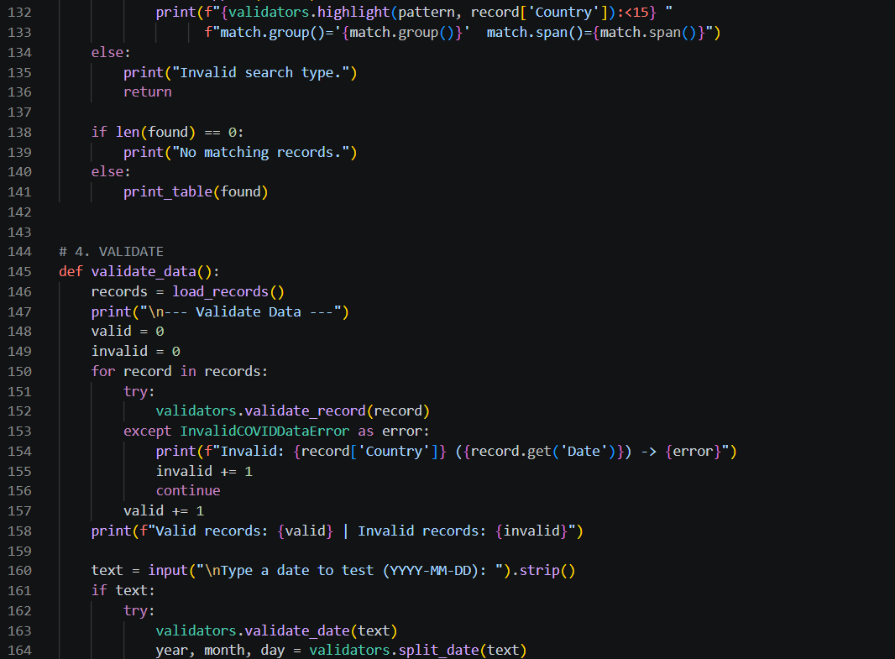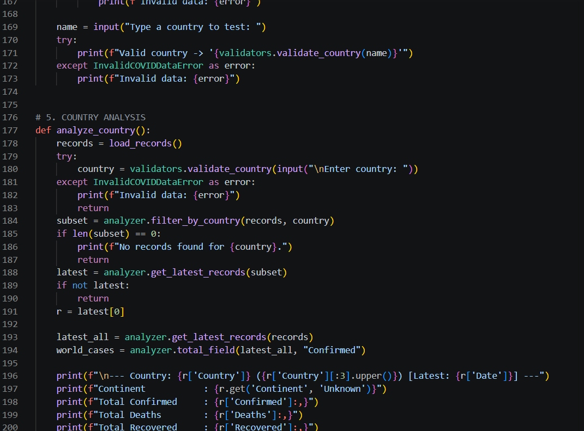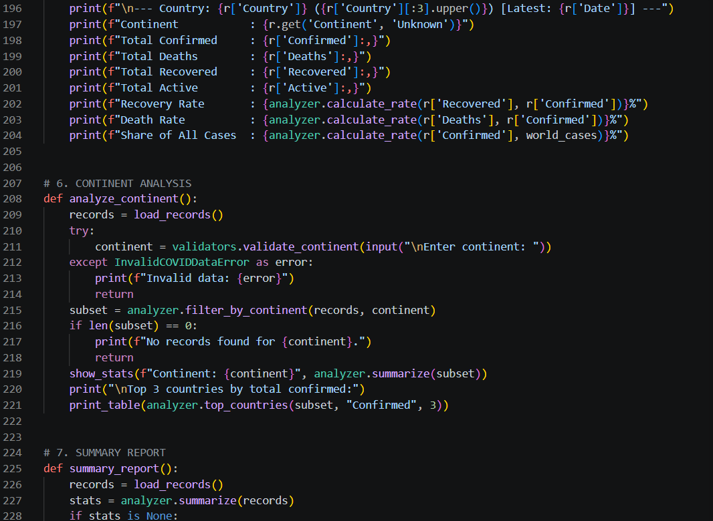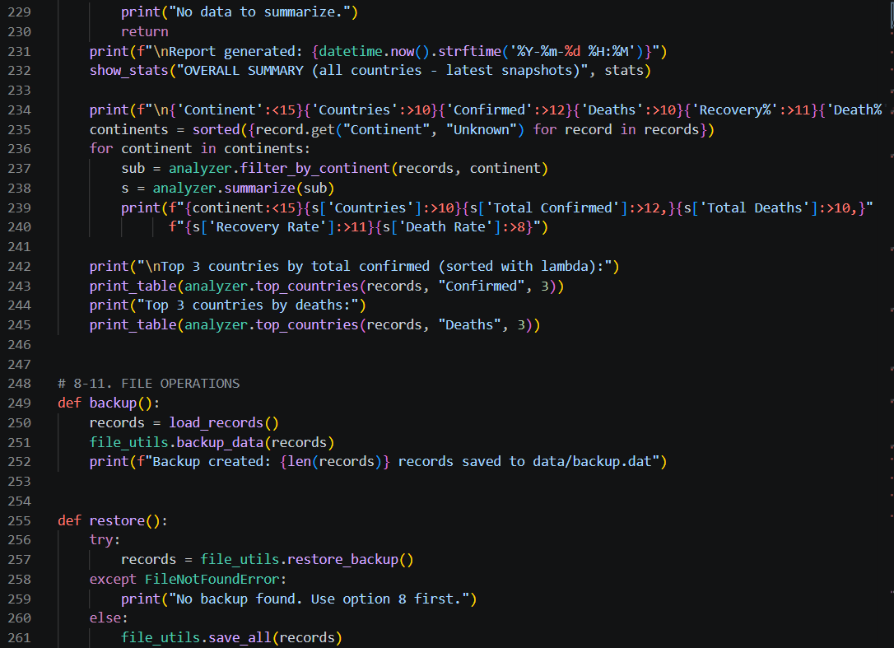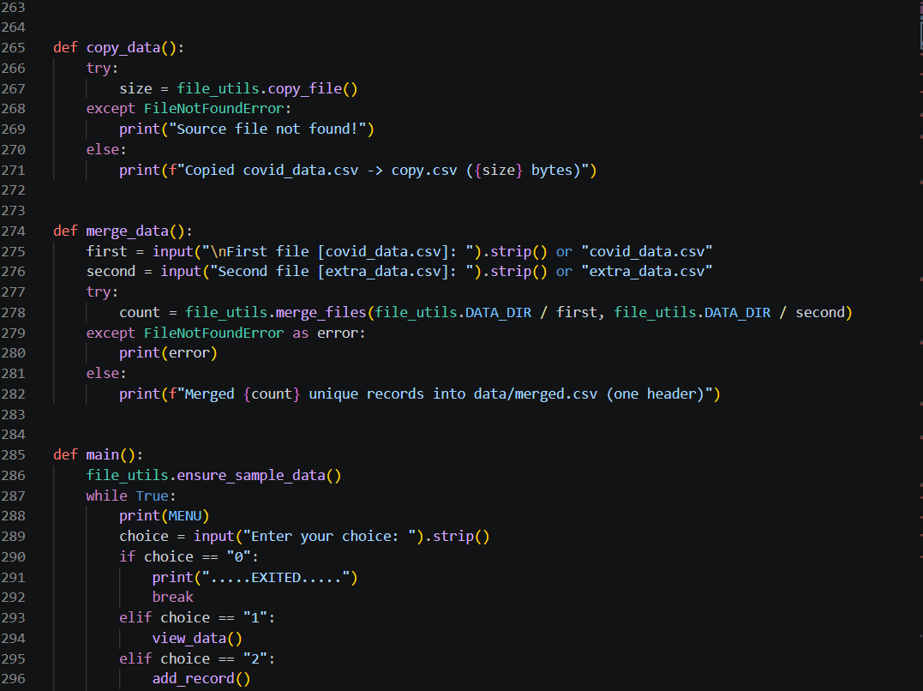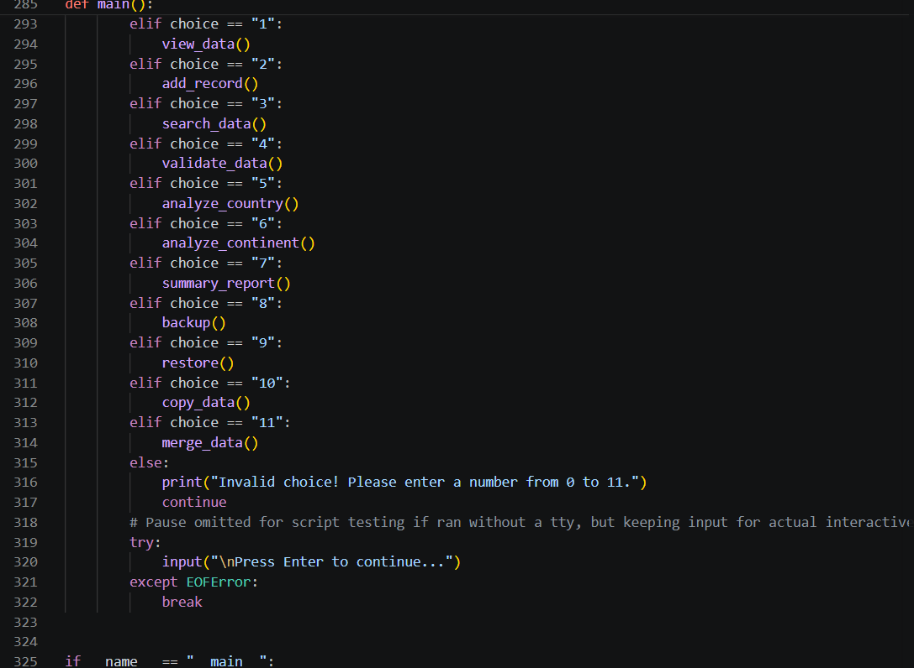

Results and Discussion
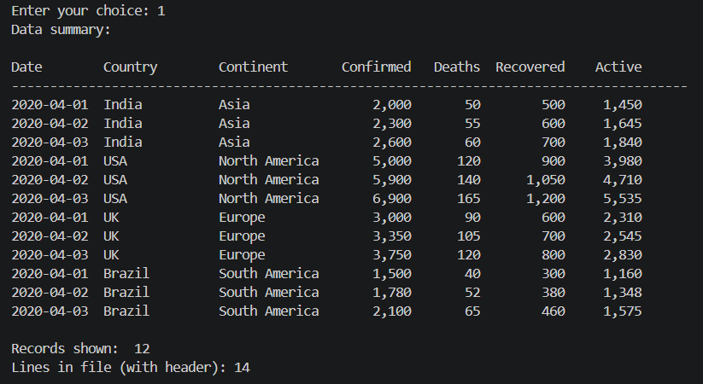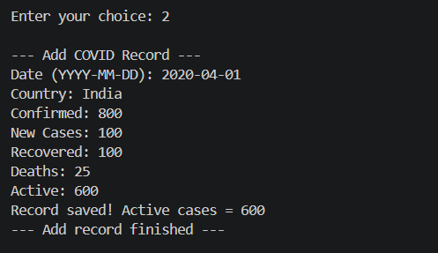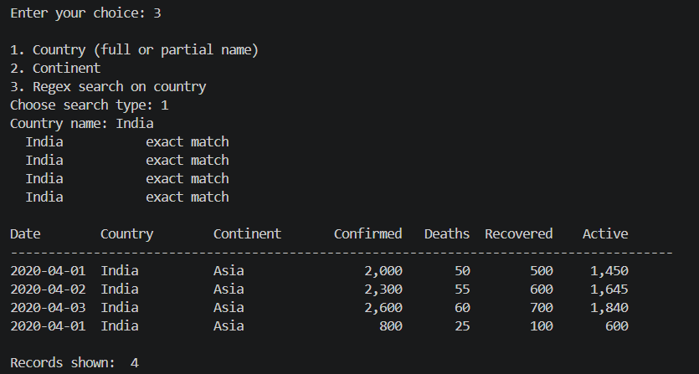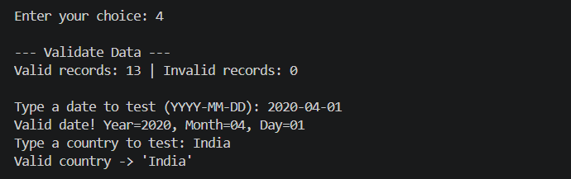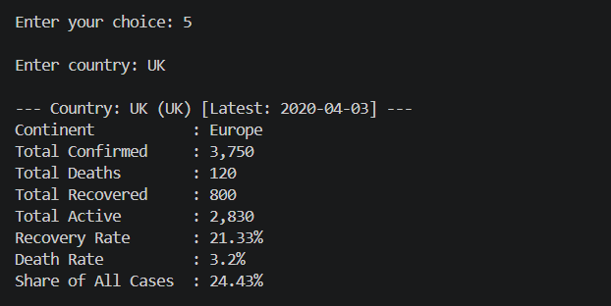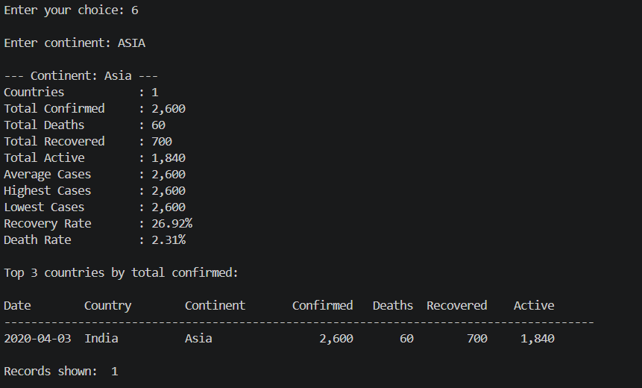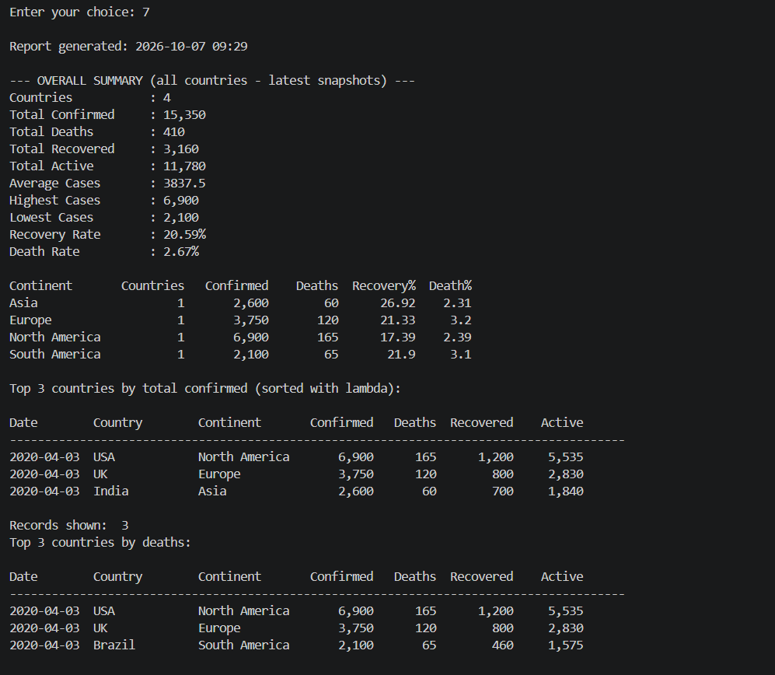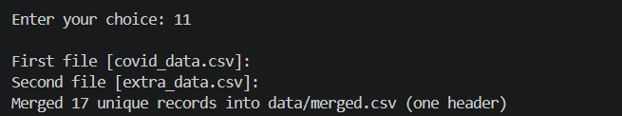

Summary of Results
The analyzer accurately computes COVID-19 statistics. View Data confirms continent mapping and record loading. Country Analysis correctly calculates recovery, death, and global-share rates. Continent Analysis aggregates all countries within a continent and ranks top-3 by confirmed cases. The Summary Report aggregates global totals and per-continent breakdowns.

Interpretation
The regex search correctly matches exact, prefix, and substring country names, as well as arbitrary Python re patterns. The validation pipeline reliably catches malformed dates, non-alphabetic country names, and logical inconsistencies (Recovered + Deaths > Confirmed). Backup and restore preserve all records faithfully through the pickle serialisation round-trip.

Achievement of Objectives
The project successfully met all objectives: eleven menu operations are fully functional, data integrity is enforced through multi-layer validation, file operations (CSV, binary backup, copy, merge) work correctly, and statistical computations produce accurate epidemiological metrics.

Implications
This analyzer can be used in academic environments to study Python file I/O, regex, and exception handling, in public-health contexts for lightweight COVID-19 data management, and as a template for similar time-series data analyzers.

Mapping POs and SDGs

Program Outcomes (POs) Mapping
Table 1: Mapping of Program Outcomes (POs) to Project Relevance
PO No. | Program Outcome | Relevance
PO1 | Engineering Knowledge Knowledge | Applied Python programming concepts including file I/O, regex, exception handling, statistics module, and modular design to build a functional COVID-19 data analyzer.
PO2 | Problem Analysis Analysis | Analysed the structure of epidemiological CSV data to design validation rules, aggregation logic, and search algorithms suitable for pandemic data analysis. scheduling problems to choose  suitable CPU algorithms for different scenarios.
PO3 | Design/Development of Solutions of Solutions | Designed a four-module Python system (main, analyzer, file_utils, validators) that cleanly separates concerns and supports eleven distinct data operations. a GUI-based scheduler that accepts user input, executes algorithms, and displays  results with Gantt charts and statistics.
PO4 | Conduct Investigations of Complex ProblemsComplex Problems | Tested search modes, edge cases in validation, backup/restore integrity, and statistical accuracy across varied COVID-19 datasets. and compared algorithms based on  performance metrics like waiting time and turnaround time across varied process inputs.
PO5 | Engineering Tool Usage Tool Usage | Utilised Python standard libraries (csv, os, pathlib, pickle, re, datetime, statistics) and modern Python features (f-strings, lambda, recursion) to build the complete solution without external dependencies. Java, GUI frameworks (Swing/JavaFX),  and data structures (queues, priority queues) to implement and visualize scheduling tables.
PO8 | Individual and Collaborative Team work and Collaborative Team work | Worked independently on coding and documentation while incorporating feedback for improvements in validation logic, output formatting, and edge-case handling. independently for coding and  documentation while collaborating for reviews, improvements, and testing.
PO9 | Communication | Demonstrated results through formatted tabular terminal output and this written report; communicated system design and findings clearly through code comments and documentation. results using charts, GUI  output, and documentation; communicated system design and findings clearly.
PO11 | Life-Long Learning Learning | Explored Python file handling, regular expressions, and data structures beyond coursework requirements through self-directed research and iterative coding. OS scheduling beyond textbooks and  learned advanced implementation techniques through self-research and coding practice.

Sustainable Development Goals (SDGs) Mapping

Table 2: Mapping of Sustainable Development Goals (SDGs) to Project Relevance

SDG No. | Goal | Relevance
SDG 4 4 | Quality Education Education | The analyzer reinforces Python programming education by demonstrating real-world application of file I/O, regex, exception handling, and statistics through a meaningful pandemic dataset. simulator enhances learning by  helping students visualize CPU scheduling concepts, making OS education more interactive, practical,  and accessible.
SDG 3 7 | Good Health and Well-Being Innovation and  infrastructure | Directly supports public-health data management by providing a lightweight tool to track, validate, and analyze COVID-19 case counts, supporting informed decision-making. computational thinking,  supporting innovation in software design and system engineering.
SDG 9 8 | Industry, Innovation and Infrastructure Work and Economic Growth | Promotes computational thinking and lightweight data-engineering practices, supporting innovation in software design and data management infrastructure. essential software  development and problem-solving skills, improving employability in IT and tech-driven industries.

Conclusion

This project successfully implemented a Python-based COVID-19 Data Analyzer capable of loading, validating, searching, analyzing, and managing pandemic epidemiological data through an interactive eleven-option menu. The system correctly reads CSV records, maps countries to continents, computes recovery and death rates, identifies the latest snapshot per country, ranks top countries by confirmed cases or deaths, and produces continent-level and global summary reports. File operations including CSV append, binary pickle backup/restore, byte-level file copy, and line-level merge with de-duplication all function correctly. The project demonstrates that a well-structured, pure-Python application can deliver robust analytical utility without any external dependencies.

For future enhancements, the analyzer can be extended to support graphical visualisation using matplotlib or plotly (time-series trend plots, bar charts, heat maps by continent), integration with live COVID-19 APIs (e.g., disease.sh or Our World in Data) for real-time data refresh, a relational database backend (SQLite) for efficient querying of large datasets, a web-based interface using Flask or FastAPI, and machine-learning-based forecasting of future case counts. Adding multi-user concurrency control, logging, and unit tests with pytest would further improve reliability and maintainability, expanding the tool's applicability in academic and public-health research environments.

Bibliography

Online Resources
- Python Software Foundation – Python 3 Standard Library Documentation
https://docs.python.org/3/library/https://www.tutorialspoint.com/operating_system/os_process_scheduling.htm
- GeeksforGeeks – Python File Handling and CSV Module
https://www.geeksforgeeks.org/working-csv-files-python/https://www.geeksforgeeks.org/cpu-scheduling-in-operating-systems/
- RegexOne – Learn Regular Expressions
https://regexone.com/www.javatpoint.com/java-swing
- Our World in Data – COVID-19 Dataset
https://ourworldindata.org/coronavirushttps://docs.oracle.com/javase/
- Johns Hopkins CSSE – COVID-19 Data Repository
https://github.com/CSSEGISandData/COVID-19https://www.studytonight.com/operating-system/cpu-scheduling

Research article references
- Lutz, M. (2013). Learning Python (5th ed.). O'Reilly Media. (Core Python reference covering file I/O, exceptions, and regular expressions.)
- Rahm, E., & Do, H. H. (2000). Data Cleaning: Problems and Current Approaches. IEEE Data Engineering Bulletin, 23(4), 3–13. (Data quality and validation strategies.)
- Dong, E., Du, H., & Gardner, L. (2020). An interactive web-based dashboard to track COVID-19 in real time. The Lancet Infectious Diseases, 20(5), 533–534. (COVID-19 data collection and visualization methodology.)
- Friedl, J. E. F. (2006). Mastering Regular Expressions (3rd ed.). O'Reilly Media. (Regex patterns used in the validation module.)
Python Docs – pickle module: https://docs.python.org/3/library/pickle.html (Binary serialisation used for backup/restore functionality.)

